Working with the Underprivileged Communities
Students were placed into a rural clinic for a week so that we could work with the native doctors and learn the different diagnostic and treatments that were used in the Dominican Republic. Every group also gave informal talks (charlas) to topic that was most problematic in their surrounding community.
As part of the program, we visited part of a Haitian community in the ghettos. The community was made out of cardboard, aluminum, and scrap metals. There was one outdoor bathroom for a community of 30 people. Although it would only cost one US dollar to deliver clean water to the people monthly, the community could not afford this luxury so the people survived with no running water or plumbing. The CIEE students including myself were able to play with the kids, but many of the knowledgeable adults gave us Americans no attention. The adults were used to people, especially Americans visiting and just leaving. It was just a form of tourism to them. They live with no hope of a better life.

“Depression is a privilege.”
-Dr. David Simmons
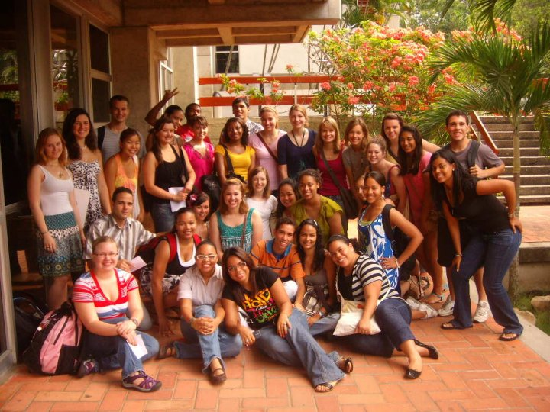
CIEE: Verano 2010 (Includes American Students of CIEE and PUCMM Student Ambassadors)

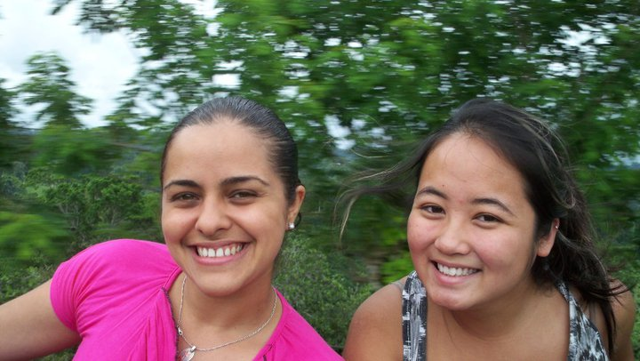
Dr. Nieves Jimenez and I riding home to the “La Guama” clinic

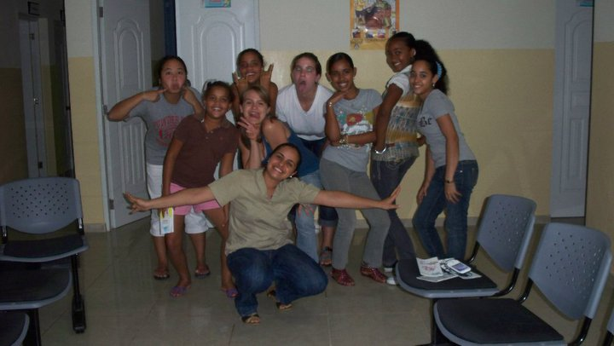
Adolescent girls that my group and I gave charlas to about teen pregnancy prevention
(Charlas: Spanish word for informal educational talks)

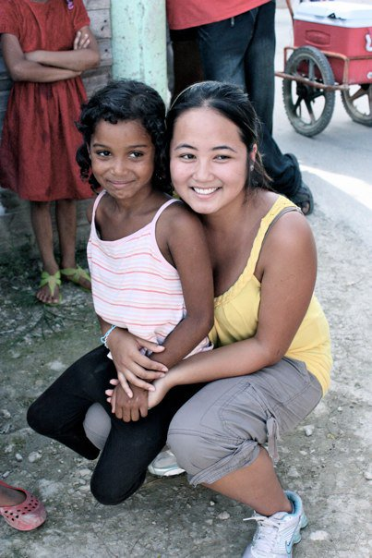
Myself playing with the orphaned Haitian kids in the ghettos

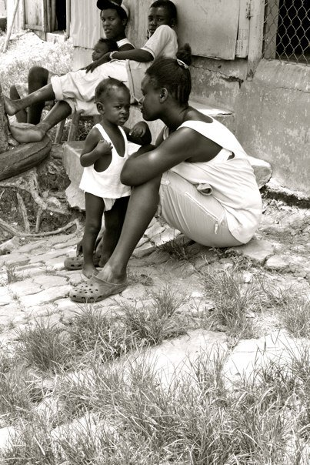
Underprivileged Haitian family in the community we visited
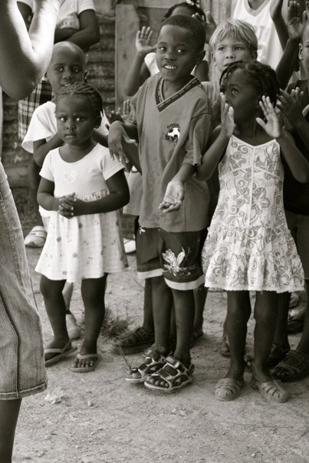
The orphaned Haitian children performed for us.
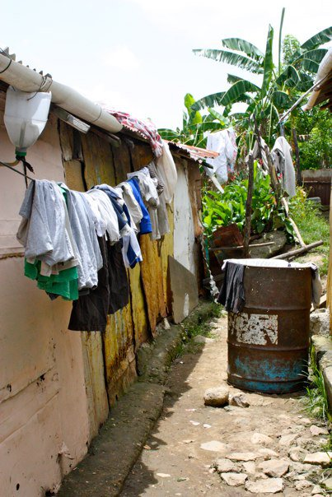
Living conditions of Haitians in the ghettos
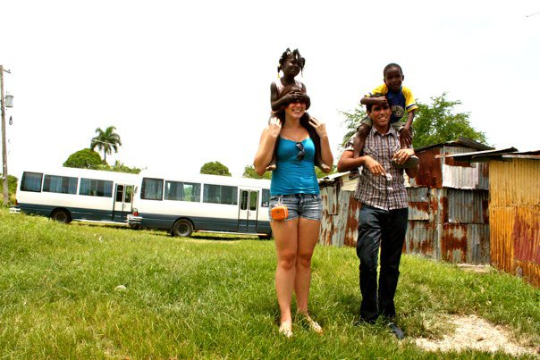
Katy and Mohammed playing with the kids

