Brand: La Belle Femme
Joy. Perseverance. Happiness. Dedication. Love.
Always a Lady.
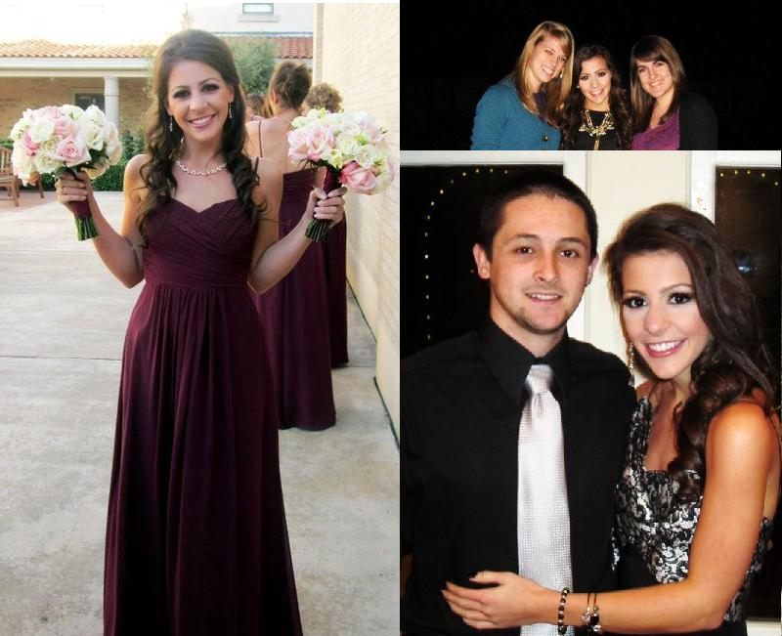
Can a fashionista be a tactful leader? Can a playful, fun young-woman benefit your business? Can an employee be a caring friend? Yes. I can be a leader, a friend, as well as the heart of your company. Do you want an employee that is hardworking, fresh, dedicated, and personable? Look no further. I believe I possess these qualities. I vow to continue to embody these attributes in any situation I’m placed in. I was raised on the foundation of love and I am passionate in everything I do. I have overcome adversity, consistently had a positive mindset, and have been
unwaveringly loyal in my life. This has prepared me to be a successful and loyal employee to
you. I vow to be a safe haven and a positive impact for you. With La Belle Femme representing your company, life will be tres magnifique!

Brand: La Belle Femme
Always a Lady.
Laura Littlejohn
Brand Me Strategic Message Planner
Title: LA BELLE FEMME
Client and Product: I am the client. I may come in a small package of five foot two, but I have the energy and spirit the size of a giant. My brand name, “La Belle Femme,” is French for “the beautiful lady.” The brand name reflects what I stand for. While I’m still learning to feel beautiful in my own skin, I love helping others feel fabulous about themselves. I try and see the beauty in everyone and everything. Life is a gift and needs to be admired just as much as a person does. While I lovingly live my life, I present myself as a lady and I handle every situation with grace and poise. I have high morals and respect for myself and other people. I can give a company a fresh and unique perspective that would stand out to all. I’m compassionate, reliable, and hard-working. I will accomplish anything I set my mind to, and will do it in style. Though “La Belle Femme” represents me, I think it is relatable for every lady.
Target Audience: The target audience is leaders of companies who are hiring young public relations professionals. Ideally, these companies are non-profit organizations or a designer in the fashion industry. They are caring businesses that want to help others less fortunate and will allow me to help them on their mission to give back to the community.
Benefits: With my different attributes, I can benefit a company’s image, public relations, and efficiency. I am caring, considerate, and a friend to all. This would help not only with the company’s relationship with the community, but also with the company’s employee relations. I love to help others and am very dedicated and passionate toward everything I set my mind to. I’m fashionable, personable, and outgoing. I was once told that I have a contagious positive spirit, and I would be honored to share my spirit with you and your company.
Current Brand Image: Currently, I have the image of being fun, creative, compassionate, and happy. I’m like a set of pearl earrings, the perfect accompaniment for anyone or anything.
Desired Brand Image: I am happy with my current brand image, but I also would like to prove to future employers that besides being a joyful young woman, I am also ambitious, hard-working, and charismatic. I will be a friend and a strong leader.
Direct Competitors Images: My competitors are other aspiring public relations professionals. Most prospective employees share the same qualities; they are responsible young adults that excel in reading and writing skills. I possess these qualities but I have my own incomparable spunk and style.
Indirect Competitors Images: Advertising majors that possess some of the same qualities as public relations majors but are not trained with the same skills as PR.
Advertising Goal: My goal in my advertisement is to represent myself honestly and find a company that wants to hire me for the person I truly am.
Strategic Message: I would be a beneficial asset to your company because I am a personable young woman who is unique, enthusiastic, and tactful.
Message Support: I am a kind and intelligent lady that would flawlessly represent your company and help it excel.

