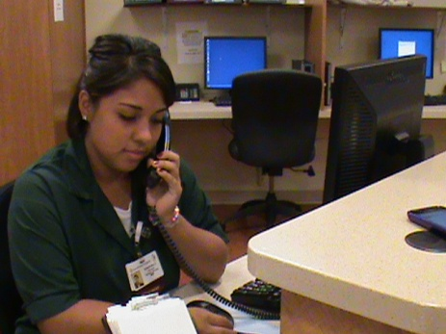
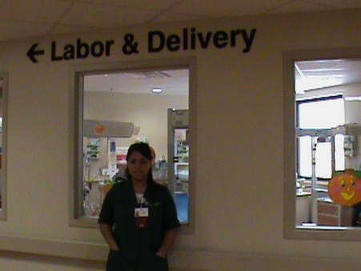
5761 W. Cortez St.
Glendale, AZ 85304
(623) 412-0596
pantherc_2011@yahoo.com
December 8, 2010

Mrs. Sandy Chilese
18701 N. 67th Ave.
Glendale, AZ 85308

Dear Mrs. Chilese:

I would like to thank you for the opportunity you gave me to do complete my internship learning experience at Arrowhead Hospital. I learned many things that would assist me in future employment and career opportunities. As an intern in the Couplet Care, I gained experience in a variety of clerical skills and for that I am thankful.
I loved assisting the nurses when they needed help. Another thing I really liked learning was how to bathe the babies after they were born. I really love babies and enjoyed doing my internship in Couplet Care. I was able to assist not only the nurses but also the secretary, the moms and care for the babies.
You should be proud. The staff was very friendly with me and they were also very thankful. I really enjoyed going to my internship and seeing the staff every time I went. Once again, I thank you for the opportunity and I hope I will be able to volunteer again.
Sincerely,

Chanthall Calderon

