How to write a Neo-Formalist poem
Step 1: Know what a Neo Formalist poem is:
Neo-Formalist poetry= Typically Neo-Formalist poems separate the speaker from the poem and the speaker’s emotions are not implanted within the poem. These poems tend to be about philosophical or religious ideas that are controversial.
It is different from free-verse poetry because of this and because in Neo-Formalist poetry there are rhyme schemes and usually the lines are written in Iambic Pentameter, or some other pattern.
Examples:
Neo-Formalist poem Free Verse Poem
The Endless Conversation
by Michael R. Burch
Here the living and the dead convene,
and here the Book of Life is read.
Each fallen grain of wheat, life's bread,
and the trampled grape, love's wine. Serene,
the clouds of witnesses, the Host,
speak to the heart. They seem, almost,
like mortal men, their eyes more keen
for having wept yet seen, half blind.
There is no rancor; they are kind.
In childhood man was ever green,
if prone to pine. They only say
such words as men at close of day
might say—of distant visions seen
beyond themselves: ahead, afar . . .
Can they be wiser than we are?

Fog by Carl Sandburg
The fog comes
on little cat feet.

It sits looking
over harbor and city
on silent haunches
and then moves on.

Step 2: Get familiar terms found in Neo Formalist poems
Meter= pattern of syllables within a line of poetry
Foot= basic unit of measurement in a line of poetry.(http://www.lisgar.net/hale/lit_terms/literary_terms_f.htm)
Iamb= a metrical foot that has an unstressed then stressed syllable
Iambic Pentameter= 10 syllables per line= 5 unstressed, 5 stressed. It is also a foot of verse. Iambic Pentameter is the most common form of meter in English verse and William Shakespeare is commonly associated with this form.
Example 1: I wish I were a shooting star so far
up high into the sky without a care
in the world.

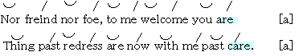
Example 2

- In the first example the first two lines are both 10 syllables and are unstressed, stressed. They are in Iambic Pentameter. The second example is also in Iambic Pentameter and the syllables are unstressed, stressed.

Example 3: da DUM | da DUM | da DUM | da DUM | da DUM
This form is an example of Iambic Pentameter as well, with unstressed, stressed syllables.
Other forms of meter are:
monometer = one foot to a line
Dimeter = two feet to a line
Trimeter = three feet to a line
Tetrameter = four feet to a line
Pentameter = five feet to a line
(http://www.lisgar.net/hale/lit_terms/literary_terms_f.htm)

Other forms used in Neo-Formalist poems besides Iamb:
There are several forms which can be used in Neo-Formalist poems.
They are:
- Trochee
Example: DA dum or (BREAKfast)
- Spondee
Example: DA DUM or (Black HAT)
- Anapest
Example: da da DUM or (like a HOOF)
- Dactyl
Example: DA da DUM or (CUT the SASH)
- Pyrrhic
Example: da dum or (and the) (-ing the)

More examples of the forms:
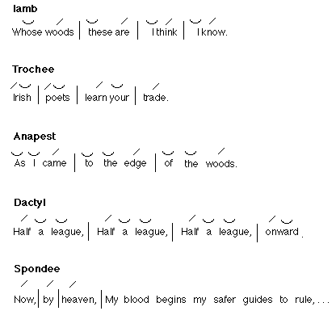

Step 3: Know about Rhyme Schemes
For example:
The True Story of Humpty Dumpty
by Anna McKeay
Humpty Dumpty sat on a wall, (A)
Humpty Dumpty had a great fall. (A)
All the king's horses and all the king's men, (B)
Couldn't put Humpty back together again. (B)

The main Rhyme Schemes in poetry are:
Cinquain: ABABB
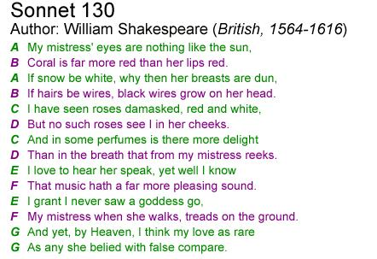
Clerihew: AAB B
Couplet: A, A or B,B or C,C, or D,D etc.
Enclosed Rhyme: AB BA
Keatsian: ABABCDECDE
Limerick: AABBA
The Raven: ABCBBB
Rondelet: AbAabba
Forms specifically in Sonnets:
Petrarchan Sonnet: ABBA ABBA CDE CDE
or ABBA ABBA CDC DCD
Shakespearean Sonnet: ABAB CDCD EFEF GG
Spenserian Sonnet: ABAB BCBC CDCD EE

Step 4: Pick which form you want to follow for Neo-Formalist poem.

Step 5 : Decide what you want to write about
- Come up with a list of ideas that you would want to discuss in your poem. It helps if you decide to write about something you are interested in/ or have strong feelings about.

- Try not to put your emotions in the poem, but to convey the message about what you are discussing.
Step 6: Write your poem in the closest way possible to your form. Make the syllables match up with your form and make sure they follow the rule on the stress of the syllables for the form you chose.
Step 7: Make sure the line endings match which form you wanted. Adjust the lines endings if they do not.
Step 8: Reread your poem several times and get the kinks out of it. Try to use some figurative language, similes, metaphors, and other literary techniques. Also, make sure your language is not repetitive and use a variety of words.
Step 9: Share your poem and or try to get it published.

Works Cited
Unknown. Literary Terms F-R
http://www.lisgar.net/hale/lit_terms/literary_terms_f.htm

