Voter turnout in Christiansburg

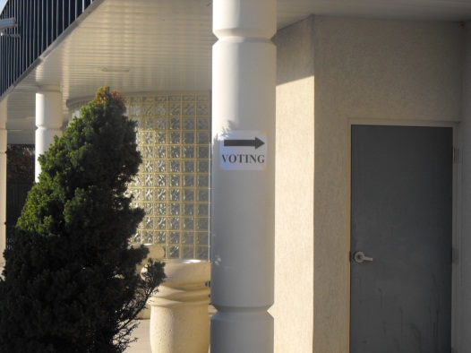
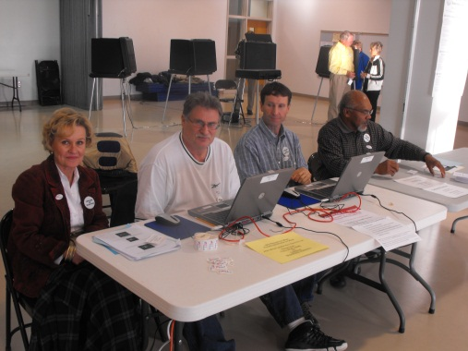
It was a steady election pace this morning at the Christiansburg Recreation center in the heart of Montgomery County. A veritable melting pot of Virginia voters ranging from senior citizens to children accompanying their parents arrived voted and departed in rhythmic and timely fashion. And while most only came to vote, a few local picketers stood outside the recreation center in order to help influence the voters by providing insight, and ballots with the names of their select candidates. But even a helpful picketer is powerless to persuade the masses of registered individuals that still chose not to vote in this mid-term election.
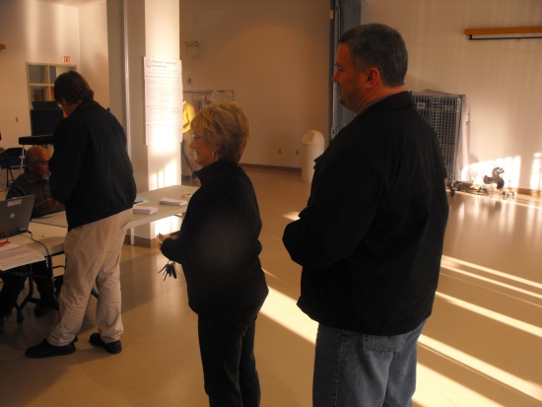
According to the Virginia State Election Boards Website, only 48% of the registered Montgomery County voters managed to cast their ballot today, and while not normally surprising for a mid-term election, in comparison to the district's almost 70% in 2008's presidential election, it is a staggering difference. So what was the reasoning behind such a lofty disparity in voter turnout?
"I voted for the one that is going to get the job done," stated Junior Bothe, a retired warehouse worker with a disability. "I can't afford to pay for my house after I injured my neck, so I am really pulling for the tax relief bill." The focus on change and healthcare reform that drove the 2008 election has been replaced by the equally important, but grossly overlooked issue of tax relief on veterans, disabled elderly citizens and the expansion of the rainy day fund.
“I support the rainy day fund and don’t mind paying more taxes to help bolster our economy,” stated small business owner Jeff Hoge. “The problem with most individuals is that they want to lower taxes and while raising infrastructure, and that just doesn’t work.” Small business owners and veterans like Hoge and Bothe are just a fraction of the population that chose not to vote during this mid-term election.
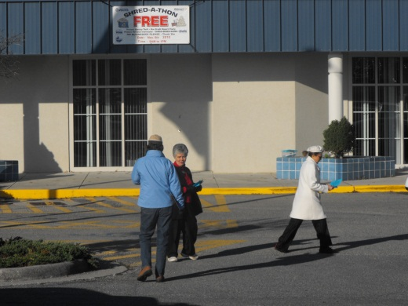
"People are not well enough informed about the issues facing our country today," said Boucher picketer, Ann Hess. "I think that over the past two years, individuals have become susceptible to all the healthcare reform fear mongering and people don't realize that the issues present today are just as important as any other issue."
But these results do not come as a total surprise. This election year was projected to be significantly lacking in voter turnout compared to the years past. Hopefully, Montgomery county's 2012 election will not result in the same voter turnout stagnation.

