Executive Summary
Prepared for Mr. Edgar Goldsmith,
VP Business Development of Platinum Investment Limited
December 20, 2010

Namhyun Kim, Probationary Analyst
Business Development Team, International Marketing

Competitiveness of Safaricom Ltd.,
Kenya Mobile communication Industry
Meanwhile, we have been working for a stable investment. But, Now we We take the risk and should be entered on the African market.
Safaricom is a leading provider of converged communication solutions, operating on a single business driver that has a peerless understanding of voice, video and data requirements.
They are a “one stop shop” for integrated and converged data and voice communication solutions. Safaricom, with its countrywide network, is the only network that can provide broadband high-speed data to its customers through its 3G network, Wimax and fibre.

Our research and analysis looks into the possibility of partnering with Safaricom Ltd. for entry into the lucrative Africa Mobile communication industry.

Our primary focus is on two competitive advantages of the company:

< Worldwide mobile communications company sales and growth status Top 10 (2009) >
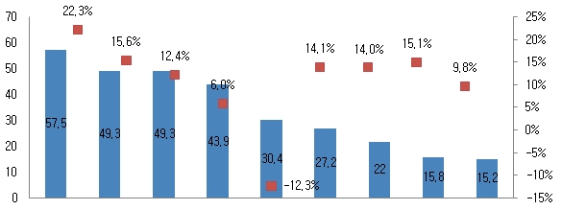
China AT&T Verizon NTT Sprint KDDI T-mobile Orange Softbank
Mobile Docomo
<Safricom will soon be included in top 10>

- Market share: Safaricom ranks 1st in the mobile communication company of Kenya, but out of the top10 in world. Our forecast points out the company is poised to Top 10, respectively within the next 5 years.

- Financials: Through aggressive international funding, the company has secured stable financial cash flow resulting in positive total cash flow which is sustainable for the next 3 years. African mobile market has been growing continuously, net income has increased 15.1% on from 2009-2010.;
Executive Summary
Prepared for Mr. Edgar Goldsmith,
VP Business Development of Platinum Investment Limited
December 20, 2010

Page 2 0f 2

<Mobile Penetration Across Africa(%) in September 2010>
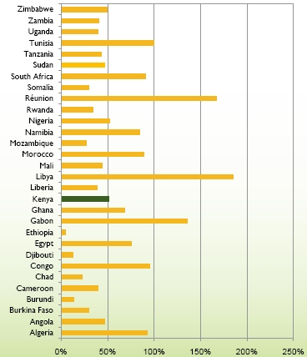

- Safaricom operates in the world’s fastest growing mobile market with a diversity of consumer needs.
- SIM penetration in Kenay > 50% as at 30 th September 2010
- Data penetration still below 10%
- With declining Voice ARPUs, focus is now on Data
- Value added services and Data products deemed to be the game changers

To initiate our partnering with Safaricom Ltd., I recommend immediate action to the following recommendations:

- Establish a Joint-Venture task-team to foster ties with Safaricom
- Set in motion a MOU preliminary meeting with Safricom executive managers
- Contact Kenya Ministry of Trade for direct investment in the Mobile communication industry
- Appoint me as the company’s Point of Contact in the Kenya given my exclusive knowledge on the nature of the business we are venturing into

KEY WORDS: Mobile Communication Industry, Kenya, Safricom, Foreign Direct Investment, Data penetration.

