Executive Summary
Prepared for Mr. Edgar Goldsmith, VP Business Development of Platinum Investment Limited
December 21, 2010

Hwa-Jin Choi, Senior Analyst
Business Development Team, International Marketing

Competitiveness of MTN group Ltd., Telecommunication Industry

My research and analysis looks into the growth potential of MTN group. I recommend you to invest in MTN group Ltd. My primary focus is on two competitive advantages of the company:

- Market share: The company market share in Nigeria is 51% and in South africa market share recovery to 36%. Also market share in Ghana is 56%. Our forecast points out the company market share is gioing up because of their quality of service and segmental value propositions.

2. Financial: Group data revenue growth 46.0% from 2009 and Nigeria revenue growth
over 100% due to the launch of Blackberry services. Iran 32.3% revenue growth due
to uptake up in GPRS services. Ghana 63.3% revenue growth due to investment in 3G
and increase in smartphones (500k) on network. Syria revenue growth over 100% due
to better value proposition for both pre and postpaid market. The company cash flow
shows that core operation are generating business

Africa grows fast in population, currently 900 million plus. As one of regions where telecom industry develops the most rapidly, mobile communication in Africa is progressing exceedingly fast. At present, there are approximately 390 million cell phone subscribers, but with less than 45% penetration rate. Thereby, it still has great potential for further development. Mobile prepay users take the majority of Africa’s subscribers, a single subscriber may have several cards; so, the real penetration rate is less than that aforementioned. Economic improvement and open-up of telecom industry drive the rapid growth of Africa telecom industry.
MTN’s two most important assets are in Nigeria and South Africa. First, we’ll discuss Nigeria. Nigeria is materially cash flow positive now. The Nigeria market has 3 main players, with MTN at 48%, with Zain and Globacom in the estimated 20% to 30% range.
There are three main operators in the South African market, with Vodacom at 55%, MTN at 37% and Cell C at 9%. The 3-competitor nature of the South African market should prevent excessive competition from eroding cash flow. The other note to keep in mind is that the South African government is in the process of reducing interconnection rates in South Africa. Interconnection rates refer to the revenue the company receives when it connects calls from other networks to its network. South Africa has among the highest interconnection rates in the world, and these rates are in the process of being lowered. While serious, the potential interconnection rate cuts are fairly minor in the whole scheme of things. UBS has a 50% cut in South African interconnection rates reducing MTN’s valuation by 2%.
Executive Summary
Prepared for Prepared for Mr. Edgar Goldsmith, VP Business Development of Platinum Investment Limited
December 21, 2010

Page 2 0f 2

I found all information about MTN group on the internet and literary sources. My research and analysis finds that investing in this company would make money. With Nigeria at 36% penetration, and other up-and-coming countries like Iran, Ghana, etc. increasing their share of total MTN EBITDA, growth should continue at a similar pace over the next few years. And MTN is a business where EBITDA and earnings are very likely to grow materially over the next several years, and I don’t think that the valuation multiples will contract as the business grows. So the stock should go up. The table below shows that MTN group’s Share price information.
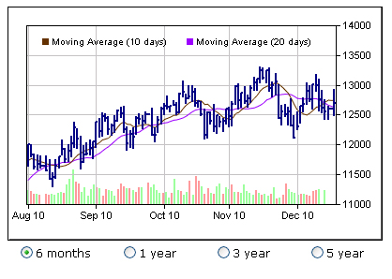
I recommend immediate action to the following recommendations:

- Make a decision on how much will you invest in MTN group
- Telecommunication industry in Africa is progressing exceedingly fast so Research the other telecom company in Africa
- Invest in MTN group !!

KEY WORDS: Telecommunication industry, MTN group Ltd, Africa, Stock market, Investment, Nigeria telecom market

