Executive Summary
Prepared for Edgar Goldsmith, VP business Development of Platinum Investment Limited
December 20, 2010

Lee so-young, Senior Analyst
Pany-pany Team, business Development of Platinum Investment Limited

Vision of South America No.1 Colombia’s Oil-industry Ecopetrol

I’ll explain Ecopetrol which is company of Colombia. Colombia is start-up stage, yet. But Colombia is market to high development perspective. And Ecopetrol record the largest production and export for this year. My research shows competitive and financial situation of Ecopetrol.

- Market share: Ecopetrol ranks 222th on world business list. Specifically, sales of Ecopetrol are 14.26($bil), profits are 2.40, assets are 27.20 and market value is 54.14.
Ecopetrol ranks 38th on world oil business list.

- Financial: Ecopetrol’s Income statement improves for 2010. Net income is 1,954,330 in the first quarter. And Net income record 3,721,396 and 5,444,867 in the second and third quarter. That is, Net income of Ecopetrol is as increase as 3,490,537 for this year. Cash flow of Ecopetrol is upward tendency too. Cash from operating activities is as increase as 6,486,732 for this year.

Experts predict that oil production of Colombia is 80 ten thousands (barrel) in 2010 and 100 ten thousands in 2015. Ecopetrol is also doing environment-friendly project. Ecopetrol invests 3600 ten thousands (dollar) in Barrancabermeja region for production biodiesel. Ecopetrol expects to do project improving diesel oil’s quality. Ecopetrol pushes ahead with The other environment-friendly project. It is La Primera Linea that utilizes oil’s residue for making energy. Ecopetrol uses this energy for company’s power consumption, so decreases power consumption.

According to KOTRA, Colombia takes the best country to do business in South America.
Colombia was ranked 86th on the world business in 2006. But Colombia grows quickly from 2006 to 2010. Colombia ranks 49th on the world business and 2th on the South America in 2009. And Colombia ranks 37th on the world business and 1th on the South America in 2010. For such a good result, people expect that Colombia fights well in attraction overseas business and foreign trade part. Especially, encouraging fact is that expects highly appreciate Colombia and take notice of Colombia.

Ecopetrol is oil’s company of Colombia. And oil part is one of the best-industry in Colombia. Especially, oil’s price is keeping on high price because of Southern Europe’s financial crisis. So It expects that production and export increase in connection with oil industry. Ecopetrol is one of the best-company in Colombia. Therefore Ecopetrol’s prospects are good.

I spent roughly 5 hours surveying about Ecopetrol. I used website of Ecopetrol and searching site such Google or Naver. Following graphic is stock behavior of Ecopetrol. The left graphic is Ecopetrol’s share behavior. And the right graphic is to compare Ecopetrol’s share behavior with IGBC behavior. IGBC is the price index of stocks of Colombia.
Executive Summary
Prepared for Ronto, VP International Marketing
December 20, 2010

Page 2 0f 2

When you see the left graphic, Ecopetrol’s share behavior is increasing continually after January 2008. Ecopetrol’s share behavior is increasing from 0.86 to 1.15 for 2008. Its source is Colombia stock exchange. Then when you see the right graphic, Ecopetrol’s share behavior is higher than IGBC behavior as a whole. Especially, the gap between from Ecopetrol’s share behavior to IGBC behavior is getting wider and wider after February 2008.
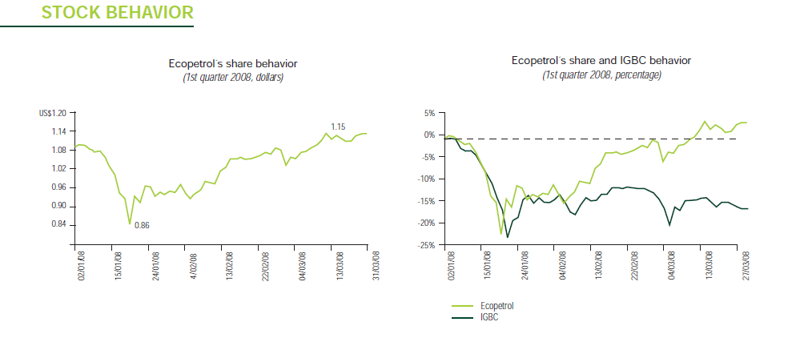

I recommend you following recommendations. I want to keep following recommendations in your mind.

- Invest Ecopetrol by indirect way to invest in stocks.
- Contact Ecopetrol’s stockholder and manager for indirect investment.
- Engage me as a person in charge for indirect investment.

KEY WORDS: Ecopetrol, Colombia, Oil industry, start-up stage, Environment-friendly, KOTRA ranking, Stock behavior, IGBC

