EXECUTIVE SUMMARY

Mr. Edgar Goldsmith, VP Business Development of Platinum Investment Limited

CHANG-GEUN LEE, Senior Analyst, Department of the research , Dec 22, 2010

Energy of Brazil to Energy of the world, do you know the Petrobras?

Human can’t live without energy, especially oil. So our research target is the Petrobras. Petrobras is a state and private enterprise of Brazil. Getúlio Dorneles Vargas who was the President of Brazil founded Petrobras in 1953. We examine two key points.

- They rank No.1 in South American enterprise.

- They earned 104.1 billion U.S. dollars

Last July, America economia, mid-south American major magazine, reports <2009 Latin America 500 comapanies>. In the research Petrobras ranked No.1. It is not surprising. Because they are 3rd market capitalization in the world. Petrobras earned 104.1 billion U.S. dollars in 2009. This is why you must invest in Petrobras.

Recently, much large deep-sea oil is found in the East Coast. Deep-sea oil estimates is approximately 80 billion barrels. So Petrobras increases investments for offshore exploration and development, refinery total 44 billion U.S. dollars. In 2008 and 2009 they ranked No.1 by investing each year 29.1 billion U.S. dollars, 34.7 billion U.S. dollars.

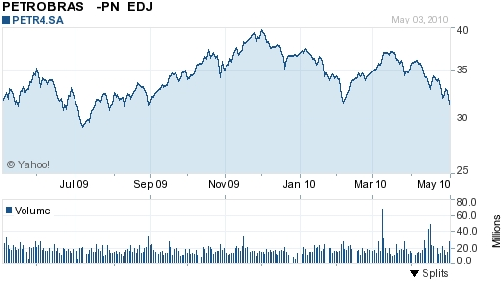
Petrobras’ stock price

We find this information at internet and many researches. All say that Petrobras will be best of the world oil company. We surely trust this company No.1 oil company. If you decide to invest Petrobras, your choice is best of best.

Key Words: Brazil, energy, oil, deep-sea oil, the East Coast, state and private enterprise

