Executive Summary
Prepared for Mr. Edgar Goldsmith, VP Business Development of Platinum Investment Limited
Dec 22, 2010

Park Ji Ae, Senior Analyst
Business Development Team, International Marketing

Financial deficit and Emerge in finance part

My research and analysis are focus on Tata Motor that holding company is TATA SUNS. Tata Motor is the most famous automatic company in India. My primary focus is on two competitive advantages of the company.

- Management : TATA Motor is managed by TATA SONS that has TATA Groups stock of 3%. Almost of their benefits are entering a charity foundation that makes TATA Group. They do charity active such as funded elementary school and middle school of twenty. They also funded India-science investment.
- Financials : They are the biggest company that occupy above 3% of DSP. They are 3rd in for riding and 1st in for common. TATA Motor is the biggest company and makes the most benefits in TATA Group. But recently their financial part turns red light because of buying stocks unreasonably.

I research about TATA Motor. Because TATA Motor is the biggest automatic company in India. In researching I found the fact that TATA Motor bought all of DEAWOO’s stock. The other word, DEAWOO sold out their all of stock to TATA Motor. I interested in this fact so researched more about TATA Motor’s financials and management. After more research I found another new fact that TATA Motor bought Ford and Jaguar which are the best automatic companies in Luxury part. At first I surprised their decision but I saw their Income statements and cash flow, I felt they made too unreasonable decision. Because after they bought Ford and Jaguar’s stock, their financial turns on red light.

I researched TATA Motor for about 2 weeks, and I found these facts through analysis. TATA Motor took financial deficit about five hundred million during 2008-2009. In below chart you can check the fact that operating income of income statement seems to minus. This conclusion caused by decreasing of demanding of bus and truck, decreasing of high salary selling power in advanced country and decreasing of preferring of SUV in European and American. Nevertheless this fact, TATA Motor bought Ford and Jaguar’s stock. And people claim these active of TATA Motor. To solve financial deficit, TATA Motor will close England product-company of Jaguar and Ford, cut down employee and have showcase about Jaguar and Ford to attack India automatic market.
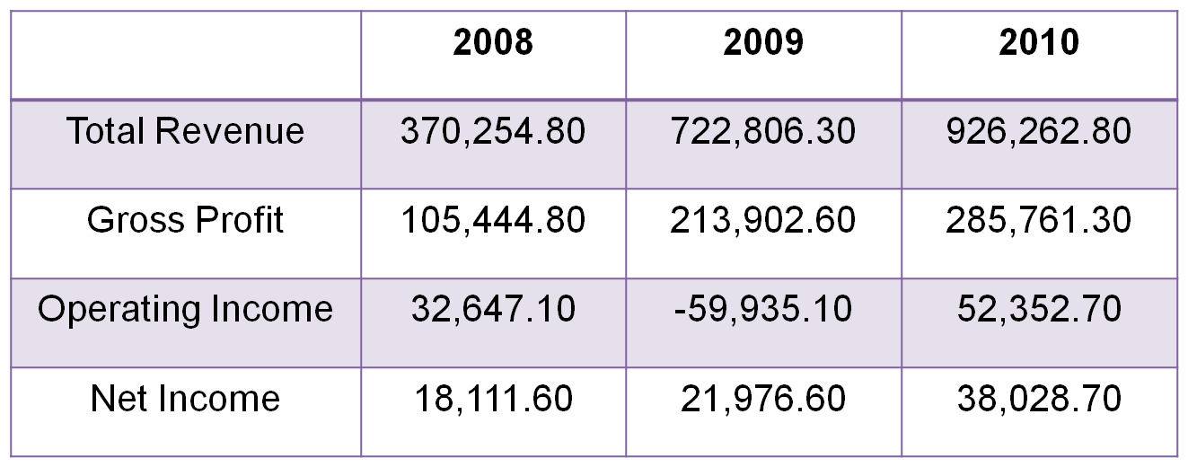

- Establish Park Ji Ae during 2010 12.15~22
- Contact me for direct analysis about TATA Motor.
- Appoint me as the one of person that analysis TATA Motor’s financial all over the world.

KEY WORDS: TATA, TATA Group, TATA MOTOR, Financial deficit, Operating Income, Emerging Finance,

