Executive Summary
GaHee Lee, senior Analyst, AD Team, Dec 23, 2010

Mr. Edgar Goldsmith, VP Business Development of Platinum Investment Limited

Our analysis looks into suitable company to invest with Saudi Aramco. Our primary focus is the company as a proportion of the world's oil companies in the world. For examples:

- S-oil as the largest shareholder owns 35% stake.
- The world in terms of oil reserves and production is the largest oil companies.
- It has not hesitated to cooperate with foreign partners in research and development technology and is active.

Saudi Aramco, the oil was discovered in Bahrain in 1932, turning the oil concession to the United States was founded. Aramco was the name of the time. At that time, it was almost U.S. companies. Aramco in Saudi Arabia in 1980 to purchase all shares in 1988 was renamed as Saudi Aramco. Saudi Aramco is primarily divided into six business lines which report directly to the president and chief executive officer: Exploration & Producing; Refining, Marketing & International; Engineering & Project Management; Operations Services; Finance; and Industrial Relations. Also reporting directly to the president & CEO are Law, Management Services and Corporate Planning.

We went to the Saudi Aramco company and interviewed with executives. Our research and analysis finds that company type is a Government-owned Headquarters so exempt from many rules and laws. And Saudi Aramco, the world in terms of oil reserves and production is the largest oil companies, 8.5 million barrels per day of crude oil production of the world largest, Natural gas production sector within the world top 10. It means most of the world’s largest oil company in terms.

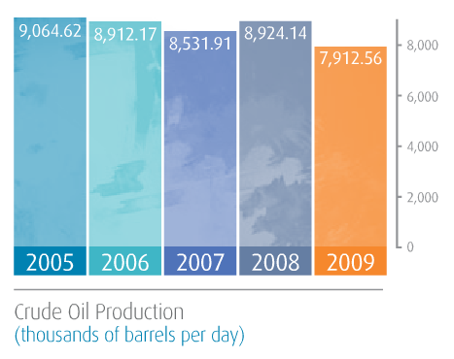

Therefore, I recommend this company because of following reasons.
- The world's largest single hydrocarbon network entrepreneurs 'Master Gas System' own
- Oil exports Organization (OECD) is responsible for more than 30% of production origin
- In terms of oil reserves and produces the world's largest oil company

Key words: Largest Shareholder, the world’s largest oil company, 8.5million, government owned headquarters

