How to Get the Information to Put in the Spreadsheet for the NAH Email Database.

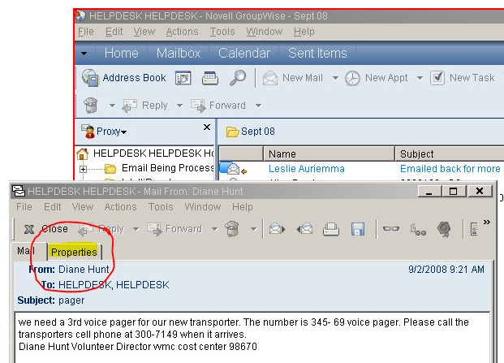
Step 1 – Getting There
In GroupWise, bring up the completed E-mail tab, and select the month you are working with.
Select the E-mail document where you want to begin from the list on the right.
In the pop up, select the Properties tab.

Step 2 – Copy and Paste
Select the information that is needed on the form. Copy and paste it to an empty Notepad document.
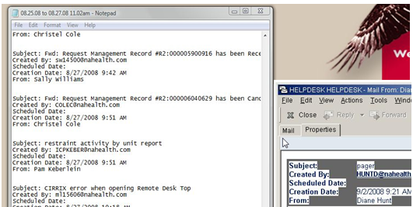

Note: When highlighting the fields that you want start at the end of the last name and go to the tip of the screen under the mail tab (see illustration). This ensures that you will always copy two empty lines (see the Notepad document in the illustration). The macro that converts this data to fields expects to find those two empty lines.
You can now switch back and forth between Groupwise and Notepad without having to go back to the Groupwise mailbox. After you’ve pasted an item into Notepad, re-activate the Groupwise message and click on the “Next” icon below the menubar. You’re now ready to copy another message.

Step 3 – Cleanup is Easy
When you get all the information in the Notepad doc, you’ll want to “clean it up”.

This is what we’ve got:
Subject: Kathleen Horner MD
Created By: COOPERS@nahealth.com
Scheduled Date:
Creation Date: 7/29/2008 5:39 PM
From: Susan Cooper

Subject: Fwd: Kimberly Alexander
…

Subject: re: citrix program neighborhood
…

Subject: 10.190.35.17 : ups: The InfraStruXure Manager server lost communication with the agent
…

So, change: “re: “, “fwd: “, “:ups: “, and “: “
And this is what we want:

Subject;Kathleen Horner MD
Created By;COOPERS@nahealth.com
Scheduled Date;
Creation Date;7/29/2008 5:39 PM
From;Susan Cooper

Subject;Fwd Kimberly Alexander
…

Subject;re citrix program neighborhood
…

Subject;10.190.35.17 ups The InfraStruXure Manager server lost communication with the agent
…

To: “re;”, “fwd;”, “;ups;”, and “;”.

The colons won’t be able to be used as field separators because of the colon in the time format. The spaces after the colons would be imported as leading spaces in the data and would make searches difficult. So we clean up the data a bit before importing.
To do that you go to Edit, then to Replace… and then perform the four replace operations given at the bottom of the preceding chart (see following illustration).
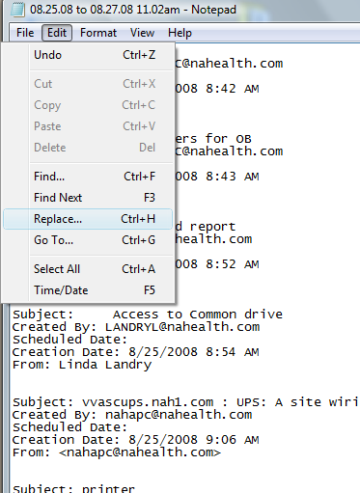
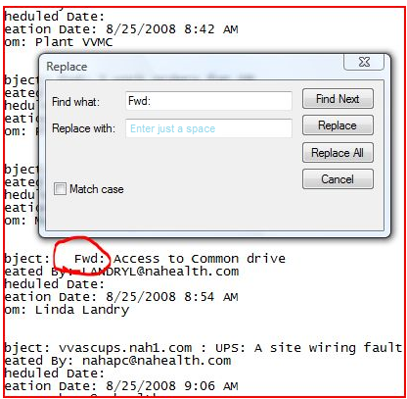

Step 4 - Save
Now you save the information on the note pad. Make sure to put it in a place that would be easy to get to.
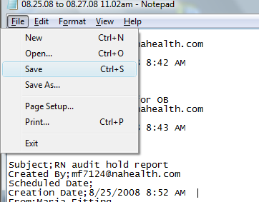

Step 5 - Import
Open the Groupwise_out.xlsm spreadsheet. Select the Data tab. Select the Get External Data from Text button.
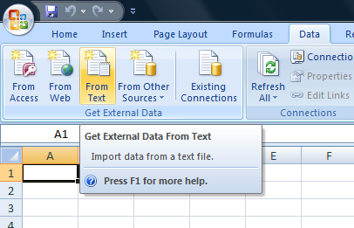

In the pop up box make sure the Delimited option is checked, and click the Next button.
The default delimiter is “Tab”. Make sure that “Semicolon” is selected. And then just roll with the defaults.
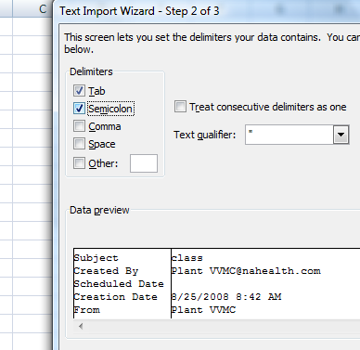

On the Import Data box select ok.
The imported data should look like this on the worksheet (note the two empty rows between items):
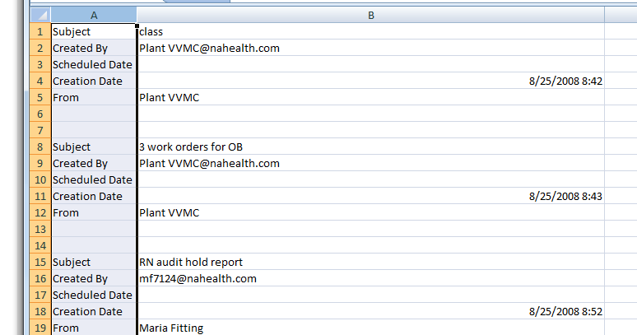
This is what we imported but it’s not what we want. Every email has it’s own fields arranged by rows. We want them to share fields and be arranged by columns. Enter the macro.

Step 6 – Macro power!
Select the B1 box selected on this sheet and select the first open cell in column A on sheet 2. Go back to sheet 1 and press Ctrl + b buttons to activate the Macro. This will copy and paste 100 emails at a time into the proper format on sheet2. If it doesn’t look right; find the missing empty row, fix it, and run it again. At 100 emails at a time, it won’t take long to get it right.
The macro above will process 700 rows of source data at a time. If you have less than that and don’t want to process empty space, there’s another macro (Ctrl + a) that will process 10 emails at a time. (Ctrl + D) will process 1 email.

Your end result should look something like this:
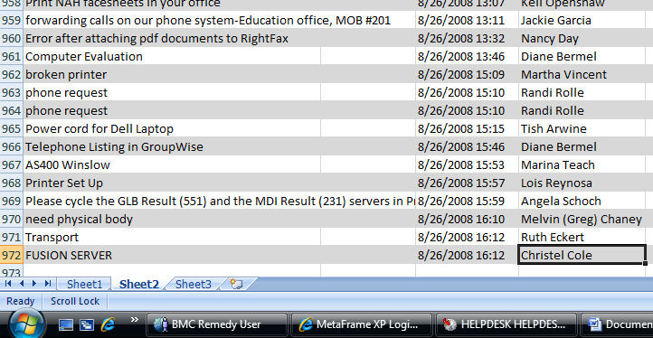

You are now done with the received emails.
The procedure for sent emails is similar. The sent emails are all in the same folder in Groupwise. They’re not separated into folders by month. You can just delete the scratch worksheet that the received emails were imported into in Groupwise_out.xlsm and import the sent items after the same cleaning up process.
When you run the macros, make sure that the selected cell on sheet2 is the first blank cell at the bottom of column F.

