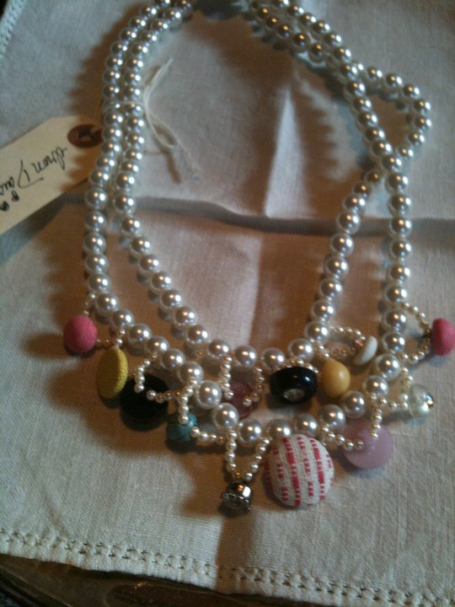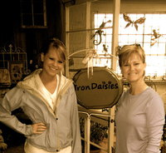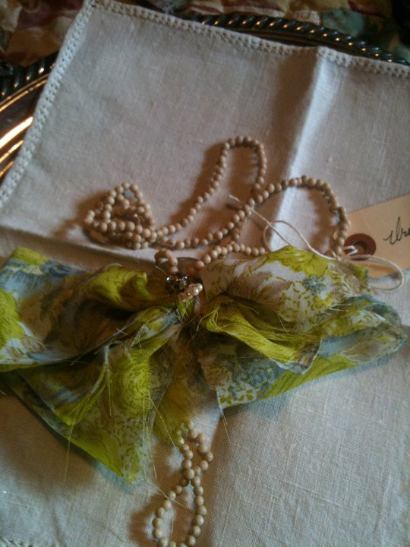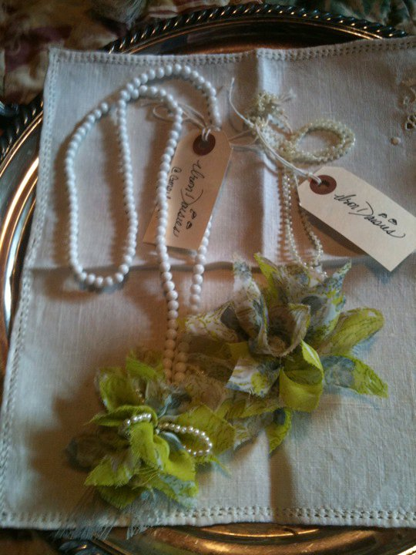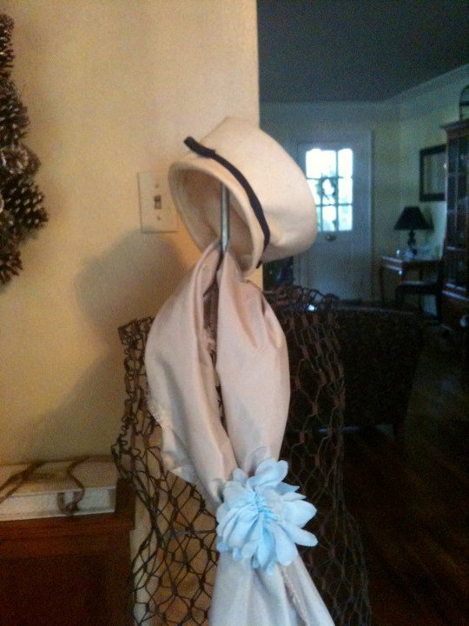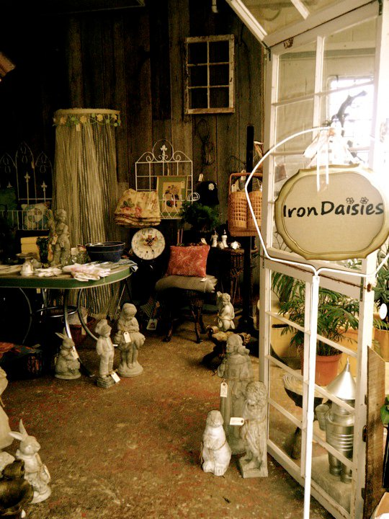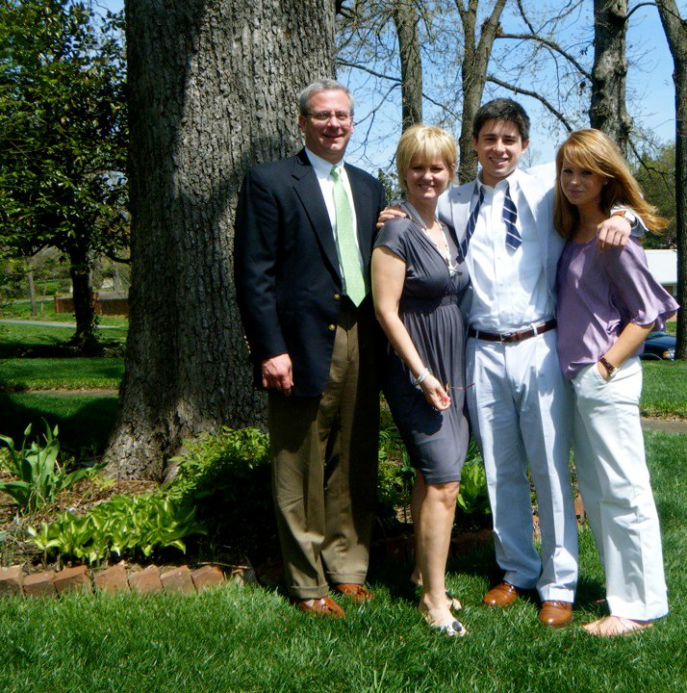

What a better combination than wine and jewelry. Enjoy a glass!

##### Wagner Wine

June 5th, 2011

May 6th, 2011

Need that last minute gift for the perfect mom? Join us for our sale and receive 20% off!

April 25th, 2011

##### 1st Anniversary!

##### Mother’s Day Sale

#### Save the Date!

Welcome to Iron Daisies and the first issue of our semi-annual newsletter. In April of 2010 we proudly opened this unique boutique inside the Shades of Green garden center in Mayfield.

Iron Daisies is owned and operated by mother-daughter team by Lucy Lee and Shelbt McClure. Thank you for visiting and we hope you find as much pleasure in our creations as we find in you.

Iron Daisies loves giving back. As part of our commitment to ongoing community service we’re helping to support Mayfield animal shelter. Now you can help too.

With every $50 purchase you make, Iron Daisies will donate 5% of the total purchase to the shelter.

# *Iron Daisies* Volunteers

Join us for our year anniversary celebration! Enjoy our sweet treats and coffee.

# WELCOME!

Lucy Lee and Shelby McClure

;

Iron Daisy

Spring 2011

### the

Who ever said scarves were for fall only clearly hasn’t seen the soft and romantic spring scarves Iron Daisies is bringing to the store this spring. With soft pastels and sweet spring floral accents, these scarves will be a must have for your best collection. From Sunday afternoon brunch to Easter day, these scarves will be the perfect accent.

Shown bottom-left floral soft pink scarf with white flower $25

## Greens and Pinks

Greens and pinks will be the colors of this upcoming spring season. With soft roses in strands of pearls and ribbon you won’t want to miss these lovely creations.

Shown top-right: pink pearls with green ribbon $15

Shown bottom-right: pink pearls with green flower-yo-yos $20

## Shades of Green

## Spring Scarves

# Iron Daisies

Shades of Green is the perfect place to create and finish all your gardening desires. From bedding plants to a complete nursery and garden center, Shades of Green offers all you need for your gardening adventure. Interested in learning how to plant a garden, or what flowers are in season? Shades of Green offers classes, from intro level to expert.

###### And it’s spring collection

**Pictured below:**

**McClure family pet, Scarlett.**

Working with their trademark ribbons and pearls, the co-founders of Iron Daisies, pictured above, answer readers frequently asked questions.

**Q: Can you tell us more about Iron Daisies?**

Shelby McClure: Iron Daisies is our vision for a small retail shop where the community can find those one of a kind pieces. We’re connecting vintage with glamour.

**Q: What prompted you two to create a niche shoppe?**

Lucy Lee McClure: We have always loved to shop, to search for and discover, hidden treasures at local antique stores. And I always dreamed of owning my own jewelry store. In Iron Daisies, we’ve found a way to bring our favorite vintage pieces back to life and fill a need we saw in the community.

**Q: Are the men of the family involved, or is this strictly a mother-daughter business?**

Lucy Lee McClure: Oh no, the boys are definitely involved! Mark, my husband, builds furniture and has added some of the most unique pieces to the store.

Shelby McClure: Yes, and my brother Drew loves to paint. He’s an amazing artist, so he’s always selling us “latest creation” to use for the store. Well, when he’s not in Canada that is.

Have a question about fashion, jewelry, gardening or home decorating? Each issue of the *Iron Daisy* will include answers to your questions! Send them to: [irondaisies@gmail.com](mailto:irondaisies@gmail.com)

# Meet the Iron Daisies Family



**2 teaspoons dry yeast**

**½ cup lukewarm water**

**2 tablespoons dry parsley**

**2tablespoons-minced garlic**

**11/2-cup chicken broth**

**3 tablespoons honey**

**1 egg**

**5-6 cups whole wheat flour**

*Preheat oven to 350 F*

*In a large bowl, dissolve yeast in warm water. Stir in the parsley, garlic, broth, honey and egg. Gradually blend in the flour, adding enough to form a stiff dough. Transfer to a floured surface and kneed until smooth. Shape the dough into a ball and roll to ¼-inch thick. Using small bone shape cookie cutters, make biscuits!*

*Bake for 30 minutes. Turn over bisques and bake for another 15 minutes. Let cool and freeze.*

# Scarlett’s Bisques

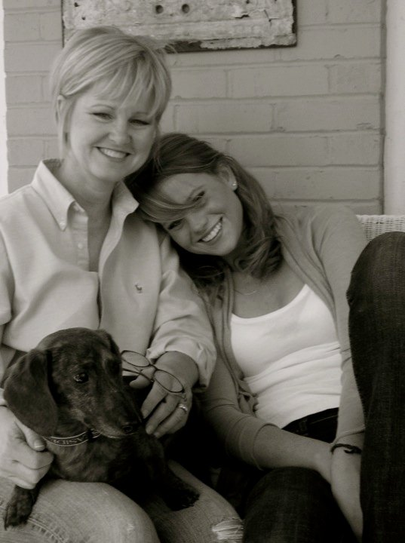

Postage

**Find us on Facebook and Twitter**

Email Us: [IronDaisies@gmail.com](mailto:IronDaisies@gmail.com)

In our short time here tucked in the corner of “Shades of Green”, we have tried to create a truly tantalizing shoppe unmatched by others in the area. From shabby chic to organic sparkle, Iron Daisies can outfit your home with fashion and decor. Thank you for sharing in our passion and considering a few of our traditions. We hope enjoy the sweeter things in life along with our entire family.

A “Love Note” to Friends and Customers from Shelby

Love, Shelby

Spring 2012

Iron Daisy Vol I Issue I

Iron Daisies

2582 State Route 45 North

Mayfield, Kentucky