CIRCLE | CRAFT | SENSORY TABLE
Music/Song/Fingerplays:  - “If all the Snowflakes were candy bars  and milkshakes”  - “It is Snowing”  Book:  Snowballs by Lois Ehlert  Show pictures of different types of  snowpeople. Ask children to point out  snowman’s eyes, nose, etc. and then  their own eyes nose, etc.  Group Activity:  Children take turns placing facial features  and winter clothing on the life-sized paper  snowman they painted together during the  previous class. | Shaving Cream Snowman:  Children paint with a mixture of shaving  cream and glue, using brushes or hands.  Then place eyes, carrot nose, mouth on  top of shaving cream.  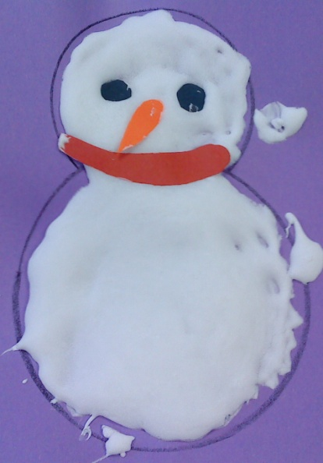 | “Sno-dough”:  White play dough mixed with white and  silver glitter.  - rolling pins  - cookie cutter shapes  (snowman, snow ball, tree, star, etc.)

Supplies: Supplies: Sno-dough Recipe:
- Snowballs by Lois Ehlert book - shaving cream and glue mixture 1 cup flour, 1/2 cup salt
- various colored construction paper - brushes 1/3 cup white powdered tempera paint
for facial features and clothing items - various colored construction paper 1/3 cup silver and/or white glitter
- brown paper snowman painted white for eyes, nose, mouth 2 Tbsp. oil, 1 Tbsp. cream of tartar
1 cup hot water

