MCj02295490000[1]

*”Helping Organizations Rise to the Top”*

**Communication Audit of Big Siblings**

Rachel Cave

Collin Dalle-Tezze

Kenzie Higgins

Amanda Bereznay

Cristina Field

Table of Contents

**Mission Statement4**

**Executive Summary5**

**Introduction6**

**Organizational Strengths7**

Value to the Community

Dedication to Little Sibling

Relationship Between Members

**Areas for Improvement9**

Lack of Clarity

Type of Communication

Organizational Awareness

**Recommendations12**

More Meetings

Required Training

Campus Promotions

**Summary of Interview and Survey Results14**

**Appendices15**

Interview Questions

Survey Questions

Survey Open Ended Response 1

Survey Open Ended Response 2

**List of Illustrations**

**Comfort level with members 8**

**Attendance at training 10**

**Mission Statement**

We are compiled of innovative and reliable individuals who uphold and develop worthwhile organizations. Our goal is to promote these organizations all may benefit from their upstanding beliefs.

**Executive Summary**

In this communication audit, the Sierra Consultant Agency has conducted an analysis of the Big Siblings organization at Longwood University. From data collected through observations, interviews, and surveys, the Sierra Consultant Agency has assembled a detailed analysis of the organizations strengths, areas for improvements, and recommendations to help further improve their organizations communication between within the organization.

Strengths

Through our observations, interviews, and surveys, the Sierra Consultant Agency has found three major strengths of the Big Siblings program. The dedication that the members show for their organization was apparent in the interviews. Another strength that we observed from the interviews was each member’s devotion to helping change the lives of the children they work with. Another strength that our survey results also concluded that the members of the organization feel comfortable with their fellow members.

Areas for Improvement

Throughout the course of this audit our Agency noted three main areas for improvement for the Big Sibling organization. Through observations and interviews, we noticed how the communication within the organization lacked structure and clarity. Another difficulty the organization seems to be facing which came to our attention during the interviews is how the members obtain their information. The majority of the times, the members only have their information relayed to them through email which can cause confusion. The third improvement could be made in how the organization publicizes themselves to the Longwood students. The lack of publicity hinders other students from being involved and gaining further help in the Farmville community.

Recommendations

Based upon our observations, interviews, and surveys, the Sierra Consultant Agency has compiled a few recommendations in order to further improve the Big Sibling organization on Longwood’s campus. These recommendations include ideas such as having monthly face-to-face meetings with all of the members, having a required attendance at the first Big Sibling meeting at the beginning of the semester, as well as having different types of advertising for the organization to gain more members.

**Introduction**

The purpose of this report is to inform The Big Siblings organization at Longwood University the strengths and weaknesses of the organization and how to improve the overall communication. After this report the Big Siblings organization will gain an overall understanding of their strengths and areas of improvement and how they can improve communication. The aspects of communication we focused on were information exchange, media and technology, identity, and funding. This report was authorized by the president of the organization, Amanda Mason, on September 24, 2009 in their student program directory meeting. In order to do this we observed the organizational meetings, conducted a survey for the group members as well as held interviews.

Research Methods

In order to conduct this communication audit we obtained information from the organization’s members through observations, interviews, and surveys. All of the members of the Big Sibling organization were given the opportunity to be interviewed as well as complete the online survey.

Observations

Members of the Sierra Consultant Agency attended two of the Big Sibling program’s meetings. The first observations that we made was at the student program director’s weekly Thursday meeting at 4:00PM. The second meeting we observed was their 2009-2010 training session for all new and returning members. During these meetings we gathered information on how the members interact, exchange information, and how their meetings affect the membership towards the organization.

Interviews

We held our interviews in Java City Café from October 26, 2009 to October 30, 2009. During the interviews we asked the members of the organization questions in order to better understand each member’s views on the communication within their organization. We also asked questions pertaining to the relationships between the member and their little, their position in the organization as well as everyone else’s role in the organization.

Survey

On November 9, 2009, we conducted an online survey where we asked a series of questions regarding the communication within the organization and between the big siblings and their little’s. The survey was available to all members of the organization for the duration of one week.

**Organizational Strengths**

Value to the Community

Through our interviews we concluded that out of all of the members who were interviewed each had the same common sense of value for the community while doing their service for the organization. Group members firmly believe in the cause of helping and connecting with the children in the Farmville community as well as bettering the community of Longwood University.

Dedication to Little Siblings

Each big sibling appreciates the time they spend with their little sibling and the opportunity they have to make a difference in their little’s lives. We gathered this information from our observations and the interviews we conducted with the organization’s members. While conducting the interviews, we saw a constant trend among the members. All of the members referred back to how much they care about their little’s in their interviews and specifically stated that they wanted to spend more time with their littles. We believe this to be a strength because in this organization, believing in the cause of helping children is a key component in success.

Relationship Between Members

Another strength of the organization is that the majority of the members stated in both their interviews and surveys that they feel comfortable talking with the other members of the organization about their problems and ideas.

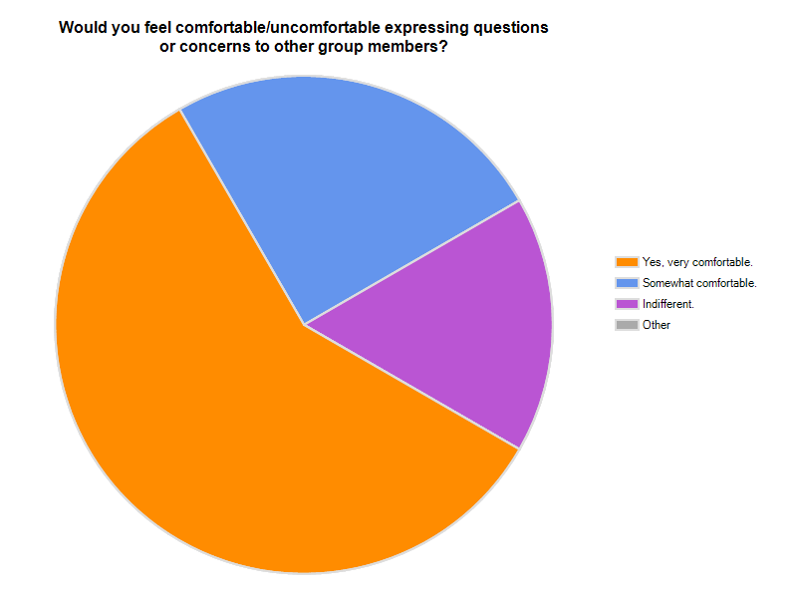

**Areas for Improvement**

Lack of Clarity

The main organization areas for improvement that we noticed were the lack of structure and clarity of the communication within the organization. Because of this, the group members were left confused about certain tasks such as what to do when they were with their littles. One of the interviewees was quoted as saying “If communication was stronger, I would have felt more prepared on the first day.” During the interviews we noticed many of the members were concerned with their responsibilities during the time they spent with their little. At the training session in the beginning of the semester, members were taught what they can and cannot do with their littles but need more ideas for activities. The graph below shows that over 50% of the group members did not attend the training session at the beginning of the year. This is one reason for the lack of clarity among the members.

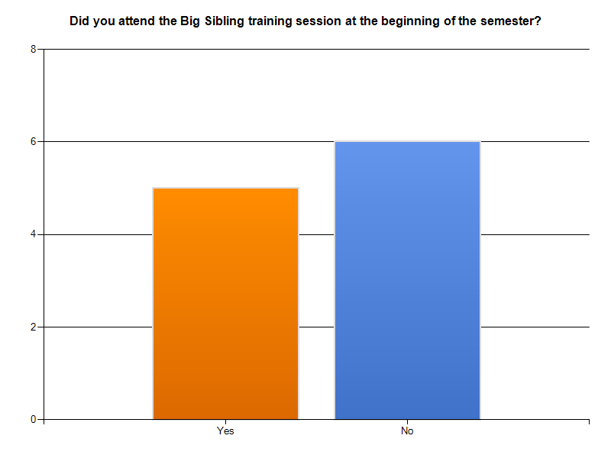

Type of Communication

Communication only through email could also be improved and coincide with the idea of having more meetings. Also, some members spoke about how not every member receives the emails, which can cause more confusion within the group. Most feel that if they had meetings as well as information through emails they could clear up questions that they have and be able to exchange information between members more. Communication only through emails provides an underload of information. This means that people are left confused with the minimal information they are given. An example of this was shown in the interview when a group member stated, “Emails make it hard to establish a bond. You can’t ask questions on the spot. I think monthly meetings would be helpful, some people are still confused about things.”

Organization Awareness

In the interviews, group members brought up how they wish that their organization was better known throughout Longwood’s campus. Since the members feel so strongly about their organization, they want more students to become involved. In one interview, a member stated that they had friends who wanted to join the organization but could not find the information in order to get involved. If the Big Sibling program was better known on Longwood’s campus then the possibility of obtaining more members would be greater which would in turn allow for a greater positive effect on the children in the Farmville community. When asked in the survey how the members heard about the organization, no one answered the question. This lead to us to believe that there is no concrete promotional tactics for the organization (To see question, refer to Appendix B, Question 3).

**Recommendations**

More Meetings

In order to improve on these areas of concern we believe monthly face-to-face meetings would greatly help the organization’s communication. These meetings would include time to bring ideas to the group about different activities to do with their little siblings as well as provide time to clear up issues and confusions members may have. These meetings would also be a time to establish bonds with the organization members. The emails that are currently being sent should still occur but these meetings would reinforce the ideas and information that the emails are providing. Members stated in the online survey how they wished for more meetings, such as a monthly meeting where all the members would get together and share ideas (Answers to survey question, see Appendix C). In order to have all the majority of members at these monthly meetings, the dates and times should already be established at the first meeting/training session.

Required Training

Required attendance of the first Big Sibling training session, we believe, would greatly benefit the organization as a whole. Because the training session has high ambiguity, which means the information provided at it is very important, mandatory attendance should be required for members. This refers to the media richness theory which categorizes different types of information into more important and less important which concludes what type of information is needed for certain media, for instance, face-to-face communication vs. emails. The training session would prepare the members for interacting with their sibling and cause less confusion. Members would be able to present their questions or areas of confusion at this training session prior to meeting their littles for the first time. This meeting should be interactive and not just handing out a list of do’s and don’ts. A possible idea to make the training session more interactive would be to have big siblings that have already been a member of the organization get in a group with new members and talk to them about different ideas that they do with their little and problems that have come up in their experiences and how they have handled them.

Campus Promotions

Advertising the organization will also help this organization because it will allow for more members which will in turn help the community in a greater way. In order to advertise, members could create a t-shirt. T-shirts are fairly inexpensive and would be paid for by the members themselves, not the organization. Having a booth at the involvement fair in the beginning of the semester would help promote the organization. Around the same time as the involvement fair, flyers and or posters could be put up to advertise for a Big Sibling interest meeting that would also be held early in the semester. Adding to idea of advertising with flyers, the organization could also have their interest meeting advertized in Longwood’s weekly announcements e-mail that is sent out to all of the students.

Summary of Interview and Survey Results

Overall Results

Overall, we found that Longwood University’s Big Sibling program has a strong belief in bringing value to the Farmville community. There is also a clear dedication between the members which means that the members feel comfortable talking with one another. The members also believe in having a strong relationship with their little. They have a strong desire to help better the lives of the children in the community.

We also found, however that this organization lacks a strong communication structure. There is a lack of clarity on what needs to be done and how it should be done. Also, the type of communication could be improved. Sharing information only through email can sometimes make things difficult because it can be harder to explain information through writing. Lastly, having more advertising for the organization would help them grow and gain awareness not only on Longwood’s campus but also in the Farmville community.

New Challenges

Problems that might arise from our recommendations are that members may not attend the mandatory training or the monthly face-to-face meetings. This has been a problem in the past which is why the organization stopped having meetings. We believe that starting up the meetings again is necessary and we found through our interviews and surveys that the majority of members would find them beneficial. In order to make sure members continue to attend the meetings would be to establish the importance of these meetings in the beginning and hold strong to the overall message.

Appendices

Appendix A

Interview questions

1. Describe your position in the organization.
2. What factors tend to facilitate your effectiveness on the job? Please give me an example
3. Describe the chain of command in this organization.
4. Describe the way decision are made in your organization
   1. What decisions do you normally make?
5. Describe the organization’s/ unit’s primary objectives for this year.
   1. What are your own personal objectives?
6. What are the major communication strengths of the organization? Be specific
7. What are the major communication weaknesses of the organization? Be specific
8. What do you see as the greatest unresolved problem of this organization?
9. What would one like to see done to improve communication here?
   1. Why has this not been implemented yet?
10. How does Communication here affect productivity?
11. Is there anything I left out that I should have included or you would like to discuss?

Appendices

Appendix B

Survey Questions

1. How frequently is each medium of communication utilized in your organization?

Face to face

Email

Text Message

Telephone

1. How satisfied are you with the amount of communication through the following channels:

Emails

Group Meetings

Individual Meetings

Organizational Events

1. How did you hear about the Big Siblings Program at Longwood

University?

Organization Relationships

1. Would you feel comfortable/uncomfortable expressing questions or concerns to other group members?

Very comfortable

Somewhat comfortable

Indifferent

Somewhat uncomfortable

Very uncomfortable

1. Would you feel comfortable/uncomfortable expressing questions or concerns to the organization directors?

Very comfortable

Somewhat comfortable

Indifferent

Somewhat uncomfortable

Very uncomfortable

1. How satisfied are you with the current communication between you and:

Your student program director

Your fellow group members

Your little sibling

Participation and Preparation

1. How prepared do you feel to interact with your little sibling based on the information provided by your organization?

Very prepared

Somewhat prepared

Indifferent

Somewhat unprepared

Very unprepared

1. Did you attend the Big Sibling training session at the beginning of the semester?

Yes

No

1. If the communication associated with your job could be changed in any way to make you more productive, please tell how.
2. What do you feel is the biggest unresolved issue within your

organization?

Demographics

1. How long have you been a member of this organization?

First year

Second year

Third year

More than three years

1. What is your position in the organization?

Appendices

Appendix C

Survey Open Ended Response 1

|  |  |  |
| --- | --- | --- |
| **Results of Open Ended Question 1** | | |
| *Members who desire more meetings and communication* | *Members who are satisfied with current communication* | *Members who are indifferent or have no opinion* |
| "Maybe have one meeting a month where all the bigs and program directors get together and come up with some group activities or discuss any issues." | "Compared to previous years, the training is much better." | "They don't really tell us much, especially at the beginning of the year, but i understand that was because there were some major changes that happened." |
| "Just more interaction between the members and program directors" | "The emails are good" | "What do you mean by job?" |
| "I feel that we should had more information meetings. The President was not there at the meeting. If the president had been able to attend, maybe the information would have been executed in a better way. I also think that, as a first time Big Sibling, I needed more instructions" | "It's fine" | "Easier communication with the family of my Little" |
| "I would want things to be explained in more detail to the big siblings. I think some of us were confused on different activities we could do with them and when to pick them up/drop them off." |  |  |
| "It would be nice if we had recap meetings once a month." |  |  |

Appendices

Appendix D

Survey Open Response 2

|  |  |  |
| --- | --- | --- |
| **Results of Open Ended Question 2** | | |
| *Members who feel there are unresolved issues* | *Members who feel there are no unresolved isses* | *Members who are indifferent or have no opinion* |
| "Just not a lot of communication" | "I don't really have one" | "N/A" |
| "Getting more volunteers to join Big Siblings." | "To be honest, this is not an organization that much communication is required. Big Sibs is not a normal organization. It is not necessary for us to meet every week nor have monthly meetings it would grow rather annoying to do so. The campus directors are there for references and resources--not like a typical organization who the members must rely on the presidents, vps, etc. I think this program is very unique in that sense." | "None" |
| "Communication is very weak and unclear." |  |  |
| "I guess who's in charge." |  |  |
| "I feel that the communication aspect should be more clear." |  |  |
| "There aren't any meetings to discuss issues that may arise." |  |  |