Placing you on higher ground.

Longwood University’s Inter-Fraternal Council
Communication Audit

December 8, 2009

Denali Communication Consultation

Kelsi Hairfield
Katie Hicks
Brittany Holloman
Casey Neeley
Becky O’Connell
Amy Sanjanwala
Table of Contents

Introduction and Overview 3

Research Methods 4-5

Organizational Strengths 6-7

Organizational Opportunities of Improvement 9-13

Recommendations 15-18

Conclusion 18

Appendix

-Interview Questions 19

-Non-Greek Male Survey Questions 20-21

-Social-Greek Male Survey Questions 22-23

-IFC Survey Questions 24-26

Team Denali has found that the Inter-Fraternity Council (IFC) has many communication strengths as well as areas in which they should improve. The following are our recommendations for this organization to take into consideration.

Overview

Strengths

From the data that we have collected we have found that the IFC prefers face-to-face and text-message communication. The members work cohesively as a unit rather than as individual members of separate fraternities. Overall as a team the group is able to come up with positive ideas to improve Greek life at Longwood and really wishes to communicate the purpose of fraternities to Longwood’s community.

Opportunities for Improvement

Our data results showed that e-mail communication between members of the IFC, on-campus chapters, and Billy Boulden has been an area where frequent communication is used however it is not often checked. Because of this, many responses claimed that information was lost or discovered late since e-mail was checked infrequently. Many members of the IFC are easily distracted or lack motivation when planning events or carrying out campus-wide ideas. Though they wish to communicate a positive image of Greek life to Longwood’s campus survey results showed that many non-Greeks feel that IFC is not effectively portraying that image. Survey results also showed that image could be improved by being more informative to non-Greek males about Greek-sponsored events around campus.

Recommendations

Through analysis of both areas of strength and improvement within IFC we have created several recommendations to help the council improve their communication skills within the organization and the campus. Some of the recommendations we came up with include checking e-mail regularly and responding promptly to any time-sensitive notifications. Furthermore, within IFC, tasks need to be better delegated and carried out within executive positions to prevent burnout in higher up positions and work under-load in lower positions. In order to increase morale and motivation within the executive council retreats and brotherhood activities could be done to build trust and communication within the group. To build a more Panhellenic atmosphere between the male fraternities on campus, IFC could host different events and require that a certain number of brothers from each fraternity attend. Events that involve all IFC fraternities for recruitment could help boost the number of new members each fraternity receives each semester and build a more Panhellenic image. Adding more formality to IFC meetings could also help the organization better arrange events, such as recruitment events, and complete them in a timely manner.

Research Methods

The purpose of the communication audit is to analyze the effectiveness of communication within IFC. Such analysis will help IFC better communicate within the organization and with the Longwood community by giving an overview of strengths to continue and areas for improvement.

This audit was conducted by the Denali Communication Consultation. The members, Kelsi Hairfield, Katie Hicks, Brittany Holloman, Casey Neeley, Becky O’Connell, and Amy Sanjanwala, researched communication within IFC throughout the fall 2009 semester. The methods used were surveys and face-to-face interviews. Surveys were sent to all members of the student body and four men holding high positions within the Greek community were interviewed. Out of the entire male student body, 163 social and non-social Greeks responded to the appropriate survey. Each member of the Denali team played an integral role in gathering data through interviews and survey completion. A final compilation of the report was submitted on December 8, 2009.

Throughout the semester, Denali worked to gather data for the report. The surveys that were created for Longwood males were sent out by Tim Pierson to the entire student body. Groups with the links were made through the social networking site, Facebook, as well. The different surveys used to gather data included a survey for non-Greek males, social-Greek males, and IFC members. Out of the 163 respondents total, 75 non-Greek males responded, 83 social-Greek males responded, and 5 members of IFC took the survey. The interviewees were chosen based on their level of commitment to the organization and their positions within their fraternity and/or IFC. The interviews consisted of questions asking for an overview of the organization, perceived strengths and weakness, and desires for the organization as a whole. For a complete list of the interview questions used, please see Appendix A. The survey questions covered many facets of the organization including outside, non-Greek perceptions, internal Greek perceptions, and IFC perceptions. For the complete listing of surveys and questions, see Appendices B, C, and D.

During the course of the communication audit, the Denali team members felt that there were some issues that prevented us from gathering a full scope of the organization and thus affected our conclusions and subsequent recommendations. Accessibility of members became an issue for our liaison because of infrequent e-mail checks. Also some of the surveys, such as the IFC survey, were not able to give the team a holistic view of the feelings IFC members held as a whole toward the organization because only half of the members responded. Because we were only allotted a semester to complete the audit and it was during their last semester holding the executive positions, some of the information and data gathered was not as in-depth or potentially as accurate as we hoped it could be going in to the audit.

Denali’s purpose is to establish better lines within IFC that will help the organization to promote a better image that translates into higher recruitment numbers. We felt that identifying areas of strength and improvement would help us make recommendations that will benefit the organization as a whole and help us achieve our goal.

Organizational Strengths

Strengths

- Members get along well and work as a cohesive unit, not members from different fraternities
- Able to brainstorm and come up with ideas positively
- Communicating the purpose of fraternities to the Longwood community
- Communicating with fraternities

One of the first strengths we discovered is that members of the organizations get along well and do not allow their respective affiliations get in the way of working as one collective unit. During our observations of their meetings, we have noticed that they joke around with one another, which provides a laid-back environment. We feel that this type of environment can be positive and that group members do not feel better or above others because of their fraternity affiliations.

During our observations, we also noticed that since the group has a positive working environment, they can successfully (brainstorm) and discuss ideas. We noticed this in particularly during their discussion of how they will approach taking over the “Best Man on Campus” event which was formally put on by Zeta Tau Alpha sorority. The IFC members were trying to decide on a new name. We saw that they shouted out ideas to each other in a productive manner. They joked about some ideas and encouraged each other to continue brainstorming until they found a name which was suitable. We have found that both strengths we discovered through observations were also mentioned by members in our IFC survey.

In our survey of Greek men at Longwood, when answering an open-ended question, many participants said that they were drawn to fraternities and wish to stay a member because of the leadership roles they can obtain and the experiences theses roles can give them. We feel that the IFC has successfully communicated to the community the purposes and benefits of a fraternity. Many participants in the non-Greek survey said that the purposes of a fraternity are to form a brotherhood and to meet more people. These are positive images as opposed to viewing fraternities as a drinking club (which was the third most popular answer and is listed in our Areas for Improvement list) (see graph p.?).

Another strength that we found through our survey of social-Greek males is the communication between IFC and fraternities. 70% of males surveyed feel as though the communication is either effective or highly effective. This shows that the efforts that IFC is currently making are good and they should continue with their current methods (see graph below).
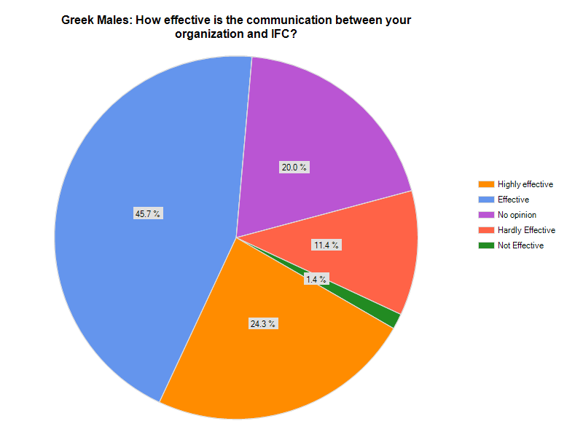

Organizational Opportunities of Improvement

Areas for Improvement

- Finding a successful communication channel when it is not convenient to meet face-to-face.
- Lack of motivation
- Easily distracted
- Not effectively communicating the purpose of a fraternity to the campus as a whole
- Inform non-Greek males of Greek-sponsored events around campus

According to our interview and survey results, we have found that the members of IFC (as well as members of individual fraternities) are often unresponsive to e-mails, even after they have received a text message telling them to check their e-mail. This is not productive within the organization, and also when other members of the Longwood community wish to contact the IFC.

According to our IFC interviews as well as the survey, the members of IFC lack motivation to complete tasks. During his interview, the president of the IFC has informed us that he often delegates tasks out to the other members. Although these members say they will be dedicated to the task assigned to them, many times it is not completed and the president ends up taking the task back and completes it himself. This leads to the president being over-loaded on work and other members under-loaded. During an interview with the president of Alpha Sigma Phi, we were informed that he also has similar difficulties with the brothers of his fraternity. Many times, the brothers will commit to an event or task, but will not begin to work on it until the week it is due or even a few days before.

During all or most of our personal interviews as well as our observations during IFC meetings, we have found that the members are very easily distracted and have a difficult time focusing on the task at hand. During our personal interviews, we found that the members were frequently checking their phones, texting, and distracted by other stimuli such as friends walking by. Although our interviews were held in Lankford Student Union café where such distractions do occur, we feel that the members should be committed to helping Team Denali help them, and should be able to focus on the interview. We also found the same problem to be true during meetings, which took place in an empty room and with the door closed. Members frequently got off topic and began discussing things such as the weekend or mutual friends which were not applicable to the topics of the meetings.

Though we stated above that the IFC effectively communicates the purpose of fraternities to the campus, we feel that perhaps they are targeting a section of the Longwood community rather than Longwood as a whole. We feel this way because of results from the non-Greek survey. The third popular answer (given by 56.1% of participants) when asked the purpose of a fraternity was to join “a drinking club”. Though the majority of participants answered this question positively, we feel that this is also an area for improvement (see graph below).
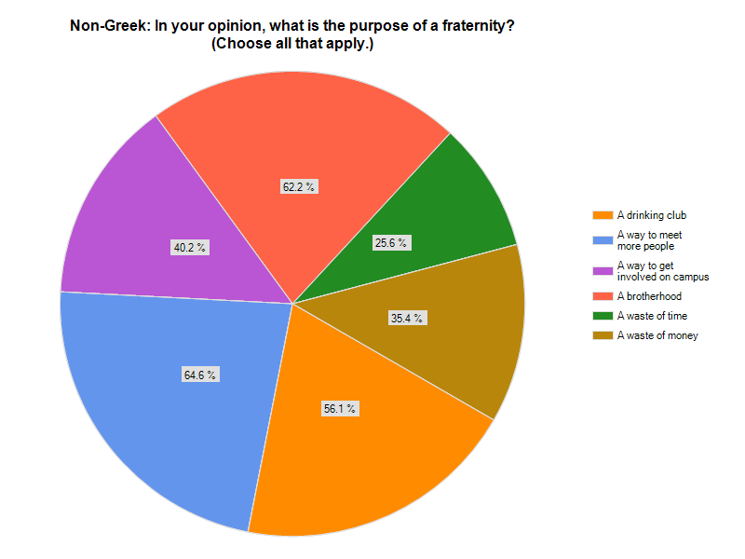

Our survey of non-Greek males showed that 46.9% of males feel as though they are somewhat informed of Greek sponsored events on campus. However, an additional 46.9% either had no opinion or felt as though they were rarely or never informed. We feel as though this is an area for improvement because just under half of the males surveyed were unaware of events going on. The more aware men are of events that are going on around campus, the greater the turnout will be and the more likely the numbers for recruitment are to go up (see graph below).

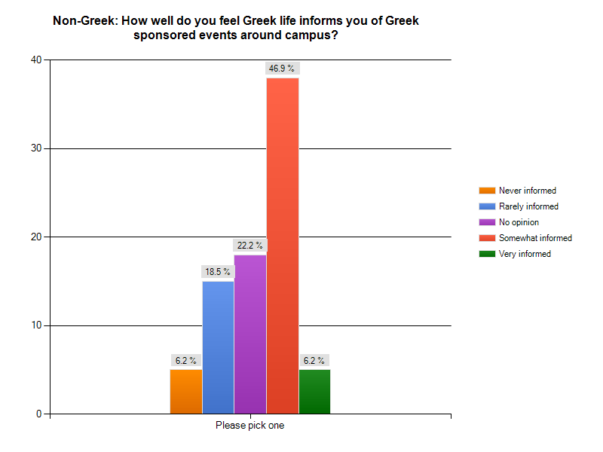

Survey Results

- Non-Greek Males
  - Our survey results showed when asked why they chose not to join a fraternity the overwhelming majority responded that fraternities hold a negative image and did not seem as though they would benefit the individual through membership. One survey respondent replied, “Greek life has turned into something I don’t want to be a part of.” Another respondent listed reasons such as, “Image; Characteristics of Organization as Perceived by Campus Society.”

  - Though the majority of those surveyed replied that they had “no opinion” of Greek life, the second most chosen answer at 29.3% said they “don't like most aspects of the Greek community.”

  - When asked the best way to persuade non-Greek men to attend Greek-sponsored events several respondents replied with answers such as, “Better inform us about Greek events.”, “Show me something that would show me it's not a waste of time.”, “Host as many events as possible- promotion events that show what Greek life is all about. Limit the number of party-type events and try to outweigh the negative connotations of Greek life with the positives.”, “Not much persuading needed just maybe more advanced notice of events.”, “The service that they do for the community.”

- Greek Males
  - When asked why they chose to join a fraternity respondents gave positive answers such as, “I wanted to make connections. I wanted to network. I also wanted to be surrounded by a brotherhood of friends.”, “The fact that the organization that I was trying to join truly stood up for what they believed in.”, “A group of men with an interest to change this campus and this community into the best it can be.”, “close group of brothers, represented what I was about as a person.”, “I wanted to get more involved on campus and meet new people.”, “Friends who were already brothers, activities that brothers were involved with, image/values that the fraternity presented/displayed on campus.”, ” I was friends with many of the brothers and liked what the fraternity stood for. The parties didn't hurt either.”, and “Because I wanted to apply myself into an organization and learn what I could from the organization and give back to it as much as I could as well.”

  - Seven respondents replied that “beer” and “parties” were their sole motivation for joining a fraternity

  - When questioned as to what could be improved about Greek life respondents said, “Not allowing favoritism in IFC.”, “I would enforce the rule that off campus frats and sororities would not be able to advertise membership/wear letters around campus. Mainly because they promote hazing, failure, anarchy, while standing for everything

Longwood does not.”, “I would like to see all Greeks treated equally and held to high standards by the community and the Office of Fraternity and Sorority Life. I would like to see punishments for breaking the rules enforced and not reduced.”, “The laziness of some of the members.”, “I would make it mandatory for all brothers to attend and participate in a certain number of events each semester or they could face fraternal suspension.”, “We need ways to boost our numbers and get more people involved on campus like sororities and non-Greeks.”, “I would get rid of hazing entirely. It does not build brotherhood, it simply makes pledge classes their own ‘mini-fraternities’.”, “I'd make the Greek system closer. Many organizations hold grudges against each other for various reasons and I would like to see that end.”, “Tough question probably how we interact with each other I think it would be nice if we were more inter-fraternal.”

  - Six respondents stated that the “negative image” of Fraternities needs to be changed.

  - The majority of Greek males believe that their organization is perceived as “positive” or “okay”, however when non-Greek males responded to how they perceive Greek life, the majority had “no opinion” while the second most popular answer was, “Don’t like most aspects of the Greek community.” (see graphs below)

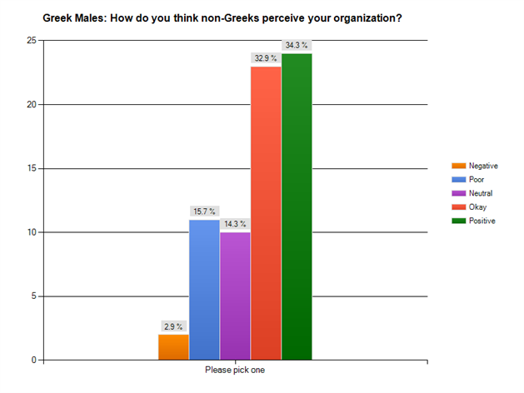

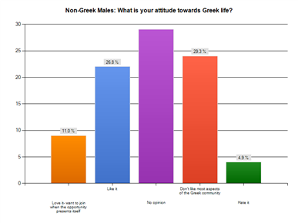

Inter-Fraternal Council
- Some of the internal responses from IFC members concluded that, IFC didn’t hold certain organizations accountable for their actions, morale declined the closer terms come to an end, e-mail isn’t checked often which results in a lack of follow through and events, and IFC does little to involve non-Greeks in different events. From the IFC survey, out of the five respondents, three responded that they were neutral on how well they communicate with the non-Greek community and two stated that they feel IFC communicates poorly with the non-Greek community (see graph below.)

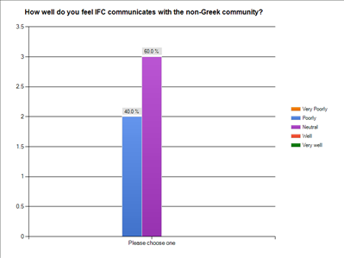

- 100% of the members who took the IFC survey stated that e-mail is the best method of communication with the different chapters. However, only five men on IFC took our survey that was e-mailed out to them, the other five received the same e-mail but they
never took the survey. Also, throughout our time gathering data, e-mail communication seemed to be the hardest way to contact some members. Text messages seemed far more effective in eliciting a response. Our results also showed that the best method of communication between members on the executive board is face-to-face communication (see graphs below.)

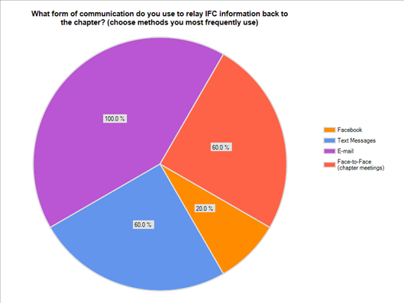

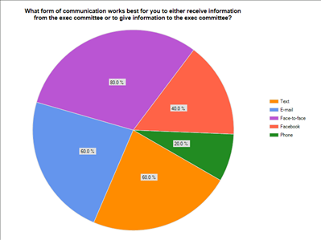

Recommendations
- Members should begin to incorporate a stronger use of other communication mediums such as email. Email should be checked frequently to ensure prompt and efficient communication between multiple audiences. The media richness theory explains that communication comes in multiple levels; the men expressed that they often have face-to-face interactions and send many mass text messages, but we feel that more frequent usage of the email system will serve as an effective medium between the richer face-to-face interaction and the less rich text messages (Adrian, 2004, 57).
  - E-mail Receipt
  - Required to read your e-mail

- More effective task delegation could really help boost this organization’s potential. From the interviews, we found that many of the tasks ultimately fell to higher positions as motivation waned throughout the semester. This means that the higher positions tended to produce a sense of overload while the lower positions were under-loaded. “Load refers to the frequency and amount of communication that takes place” (Adrian, 2004, 52). The communication and amount of work is seemingly handed over to the higher up positions as other positions begin to falter on their work load. Consistent task delegation and maintenance of roles could help decrease this overload in the future.

- Motivation also seems to be a challenge for the organization. As motivation falters, so does the quality of work and willingness to participate. “Communication from top management plays the strongest role in determining commitment” (Adrian, 2004, 72). If the adviser mandated more bonding, team-building events between the executive members, there may be an increase in morale. If the members are able to bond in friendship, there will be more than business that pulls them together and meetings will seem far more interesting. Also, team building exercises that are organized can help increase the sense of dedication and commitment from other members by enlisting their participation and stock in the organization.

- Our research showed that many Greek males feel as though each fraternity is very separated and “cliquey”. In order to create a more Panhellenic atmosphere between the male fraternities on campus IFC could host different events and require that a certain number of brothers from each fraternity attend. Different events that can be enacted are having all of the new members for each semester do a trust-building exercise, such as attend a ropes course. IFC could hold a cook-out where each fraternity is able to interact and get to know each other. Another idea is to have everyone do a community service project, which would also help change the poor perception of Greek life.

- Collectively, the men that we interviewed and surveyed stated that they want to increase the number of men going through the recruitment each semester. The Denali team has come up with several different ideas for events that can be held and different ways to

encourage non-Greek males to go through recruitment. Some of our ideas consist of, hosting an “Eat and Greet” where each brother will bring at least one non-Greek male to a cook out so they can meet the brothers of their fraternity and see what it’s like to hang out with them in a relaxed atmosphere. A prime time for many fraternities to reach non-Greeks is in March and April, so that they can go through recruitment the following fall, Fraternities can hold a March Madness event where non-Greeks can watch basketball games with the brothers and get to know them better. Many of the non-Greeks that we surveyed stated that they wish to join a fraternity to gain leadership skills, one idea we had is for the men in different fraternities that hold different positions to record videos showing things they do and the experiences they have that help them gain leadership skills. We feel as though the recruitment chair from each fraternity should meet with IFC once a month in order to inform them of the recruitment events they are hosting. This will ensure that IFC is aware of all of the events going on and they can approve them.

- One area for improvement we found is that IFC members need to be more formal during their meetings. From our interview results we found that there are a lot of side conversations and often times some members’ ideas are ignored. There can be a set behavior moderator who will ensure that the meeting is going smoothly and that no one is texting or having side conversations. If any member of IFC has an idea, everyone should consider their idea equally, regardless of their position in the organization. Also, men who were interviewed stated that they often don’t know what they are going to be discussing in meetings. The secretary of IFC should send out an agenda a day before the meeting so that all of the members will be aware of what is going to happen in the meeting so they can prepare anything they wish to add.
Appendix A
Complete list of interview questions

1. Describe your position in the organization.
a. How long have you been a part of this organization?
b. What are your chief responsibilities and duties?
c. With whom or with what positions do you regularly communicate?
d. What factors tend to facilitate your effectiveness on the job? Please give me an example.
e. What, if anything, inhibits your effectiveness?
2. Describe the organization’s/unit’s primary objectives for this year.
a. How does the organization know when it has done a good or a bad job? What are the criteria for success?
b. What are your own personal objectives?
c. What communication strategies does one use to achieve them?
3. Describe the way decisions are made in your organization.
a. What decisions do you normally take?
b. What information do you need to make these decisions?
c. Are these formal or informal policies that determine how you get information?
4. How would you evaluate the communication from top management?
5. How would you evaluate your supervisor in terms of:
a. Openness to new ideas?
b. Willingness to share information?
c. Ability to clarify expectations?
d. Ability to coordinate the work in the unit?
6. How timely is the information exchanged between units and departments within? What, if anything, could be done to alleviate any particular problems in this regard?
7. What are some strengths of communication within your organization?
a. What are some weaknesses that you have noticed?
8. What do you see as the greatest unresolved problem of this organization?
9. When conflict occurs, how is it resolved? What normally causes conflict here? Give examples.
10. What would one like to see done to improve communication here?
a. Why hasn’t it been done already?
b. What are the major obstacles?
c. If you had a suggestion to improve communication, how would you make it?
11. What affects your own commitment to this organization?

Appendix B
Non-Greek Males Survey Questions

- Why have you not chosen to join a socially Greek organization?
- What factors come into play with reasons why you have not chosen to join a socially Greek organization?
  - Money
  - Grades
  - Other (please specify)
- Have you ever participated in an IFC rush event?
  - Yes
  - No
- If yes, what organization?
  - Alpha Chi Rho
  - Alpha Sigma Phi
  - Phi Kappa Tau
  - Sigma Nu
  - Sigma Phi Epsilon
  - Tau Kappa Epsilon
  - Theta Chi
- If yes, what event(s) did you attend?
- If yes, what influenced you to attend?
  - Greek friends
  - Non-Greek Friends
  - For community service
  - To make friends
  - Other (please specify)
- Are the majority of your friends …? (fill in the blank)
  - Greek
  - Non-Greek
  - About the same amount
- (according to your response in the previous question) How has that influenced you to go Greek?
- What is your attitude towards Greek life?
  - Love it- want to join when the opportunity presents itself
  - Like it
  - No opinion
  - Don’t like most aspects of the Greek community
  - Hate it

- In your opinion, what is the purpose of a fraternity? (Check all that apply.)
  - A drinking club
  - A way to meet more people
  - A way to get involved on campus
  - A brotherhood
  - A waste of time
  - A waste of money
- If you were to join an existing chapter, which would you choose?
  - Alpha Chi Rho
  - Alpha Sigma Phi
  - Phi Kappa Tau
  - Sigma Nu
  - Sigma Phi Epsilon
  - Tau Kappa Epsilon
  - Theta Chi
- What do you think is the best way to persuade you to attend or get involved in Greek events?

Appendix C
Social-Greek Males Survey Questions

- When in your college career did you join a social fraternity?
  - Spring Freshman year
  - Fall Sophomore year
  - Spring Sophomore year
  - Fall Junior year
  - Spring Junior year
  - Fall Senior year
- What influenced you to join a fraternity?
- Are you happy with your decision to join a social Greek fraternity, why or why not?
- How did you find out about formal rush events?
  - Friends/peers
  - Social outings or events with Greek organizations
  - Paper fliers
  - Facebook groups
  - E-mail
  - Mail
  - Other (please specify)
- What attracted you to the event?
- Were you invited to participate in informal rush events?
  - Yes
  - No
- If so, what influenced you to attend the informal rush events?
- If so, what types of informal events did you attend before you rushed?
- Did you have any concerns such as financial, time management, grades, etc. before you went through recruitment?
- If you could change anything about the Greek system, what would you change and why?
- What do you think is a good way to notify non-Greeks about Greek events and rush?
- How do you think Greek life is perceived on campus?
  - Negative
  - Poor
  - Neutral
  - Okay
  - Positive
- How do you think non-Greeks perceive your organization?
  - Negative
  - Poor
  - Neutral
  - Okay
  - Positive

- If you think there is a poor perception, what do you think could be done to change the perception of Greek life on campus?
- How was your GPA affected by going Greek
  - Significantly improved
  - Slightly improved
  - No Significant difference
  - Slightly lowered
  - GPA dropped significantly
- Do you think GPA concern keeps people from joining Greek Organizations?
  - Yes
  - No
- How effective is communication between your organization and IFC?
  - Highly effective
  - Effective
  - No opinion
  - Hardly effective
  - Not effective

Appendix D
IFC Survey Questions

- What do you think are some of the communication strengths within the Inter-Fraternal Council and the Executive board? (please list at least TWO positive aspects of the organization)
- What do you feel are some common weaknesses of the organization? Please give at least one example of an aspect you dislike, an example of a communication misunderstanding, etc.
- What efforts do you make to involve non-Greek men in Inter-Fraternal activities? (Please list as many as possible. If you cannot think of any, please state that.)
- When trying to tell the campus about the Dodge Ball Tournament, what ways did you try to inform students about the event? (i.e.: When it would be, where, price, when and where to sign-up, etc.)
  - Facebook
  - Flyers/posters around campus
  - Flyers on D-hall tables
  - Word-of-mouth
  - Other (please specify)
- How well do you feel IFC communicates with the non-Greek community?
  - Very poorly
  - Poorly
  - Neutral
  - Well
  - Very Well
- I feel that IFC makes a strong effort to be panhellenic with the entire Greek community.
  - Strongly disagree
  - Disagree
  - Neutral
  - Agree
  - Strongly Agree
- What form of communication do you use to relay IFC information back to the chapter? (choose methods you most frequently use)
  - Facebook
  - Text messages
  - E-mail
  - Face-to-face (chapter meetings)
  - Other (please specify)

- There could be a more effect way to communicate such information.
  - Strongly agree
  - Agree
  - Neutral
  - Disagree
  - Strongly disagree
- How well do you feel communication flows between Exec and the delegates?
  - Very well
  - Well
  - Neutral
  - Poorly
  - Very Poorly
- What form of communication works best for you to either receive information from the exec committee or to give information to the exec committee?
  - Text
  - E-mail
  - Face-to-face
  - Facebook
  - Phone
  - Other (please specify)
- Do you feel you are overloaded, under-loaded or content with the amount of work that you’re responsible for in your position?
  - Under-loaded
  - Slightly under-loaded
  - Content
  - Slightly overloaded
  - Overloaded
- I pledged my fraternity in...
  - Spring 2007
  - Fall 2007
  - Spring 2008
  - Fall 2008
  - Spring 2009
- I am a…
  - Senior
  - Junior
  - Sophomore

- Which fraternity are you a member of?
  - Alpha Chi Rho
  - Alpha Sigma Phi
  - Phi Kappa Tau
  - Sigma Nu
  - Sigma Phi Epsilon
  - Tau Kappa Epsilon
  - Theta Chi
- Do you have a specific role within IFC? If so, what is your title?
  - No specific role
  - President
  - Vice President
  - Secretary
  - Treasurer
  - Advisor

