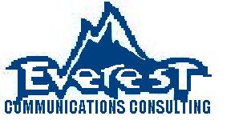

Improving Communication and Efficiency for our Clients

Allison Dobson, Amanda Jean Wessell, AJ Panneton, Chloe Abshire, Liz Ries, Sara Cole, Whitney Fleming

Table of Contents
Introduction…………………………………………………………………………………….3
Executive Summary………………………………………………………………………………………..3
Organizational Strengths………………………………………………………………………………………..4
Organizational Areas of Concern…………………………………………………………………………………………8
Recommandations………………………………………………………………………………12
Conclusion………………………………………………………………………………………13
Appendix………………………………………………………………………………………...14
Archival Information…………………………………………………………………………….29
Works Cited……………………………………………………………………………………………..35

Introduction
The purpose of this report is to provide feedback for the client regarding their organizational communication practices. As a result of this report, a better understanding of the client ’s organizational strengths and weaknesses should be grasped by all recipients of this report. In addition to greater understanding of organizational strengths and weaknesses, a list of recommendations will be offered. This report was authorized by the client , Dr. Bill Stuart, Dr. Eric Laws, and the members of Everest Communications Consulting Group. This report will address organizational satisfaction and commitment, effective leadership and decision making, and adequacy of information, as well as conflict resolution. Furthermore, this report will address organizational areas of improvement which include satisfaction with conduction of meetings, awareness of information prior to meetings, receiving positive feedback, and feeling a sense of accomplishment. This report utilized weekly observational data collection methods, a 26 question survey instrument, and interviews to analyze organizational strengths and areas of improvement. For further information regarding the interview and survey questions, see attached appendixes. It is important to note that all information included within this report is based upon perceptions of members, and thus may not accurately reflect reality. Furthermore, the themes and findings presented within this report are based upon observations taking place over a several month period, and may not be entirely representational of the organization, as the time for communication auditing was limited.

Executive Summary
The client ’s participation in the survey was mediocre, however reflected the overall commitment we saw from the overall organization. Due to the organization not having a complete and definite list of membership, we do not know the percentage of participation that resulted from the survey.

Twelve members completed the survey, making it difficult to interpret definite data from the survey alone. The basis of our data and research existed in what was pulled from our interviews with the client , in addition to trend identification through our survey analysis.

The relationship between the members of the client organization appears to be comfortable and open, explaining the environment of their meetings. The members reported that they believe their communication climate is collaborative and open.

Some weak areas of the organization include low satisfaction with conduction of meetings, agenda items not being known to members prior to meetings, an overall lack of organizational feedback when tasks are accomplished, and overall lack of feelings of accomplishment reported by organizational members.

Some organizational strengths identified include high organizational satisfaction and commitment, which facilitates open and informal communication practices, effective leadership, adequate dissemination of information, and effective conflict resolution strategies.

Overall, Everest Communications Consulting Group found many organizational strengths, as well as several areas of improvement for. Furthermore, several recommendations have been put forth for consideration and utilization by the client in this report.

Organizational Strengths

Organizational Commitment
Overall, both the interview and survey data suggest high organizational satisfaction and commitment, which is extremely important to organizational success and the facilitation of open communication. We found this to be true when sitting in on their executive board meetings as well as when we sat in on their general body meetings. We also found this out through our interviews and surveys. All the members of the organization feel that they can speak freely and honestly about their opinions on matters that concern their organization. We also found this to be proven true through the members’ answers to the survey which they completed. The entire organization strongly agreed that they feel comfortable voicing their opinion as well as asking questions. We believe this to be an organizational strength because open communication is vital to an organization running smoothly. If the organizations members don’t feel satisfied with their participation within the organization, or they are not committed, then they will not feel that they have a voice or role within the organization. Nor will they feel like they have a part in the decision making process.
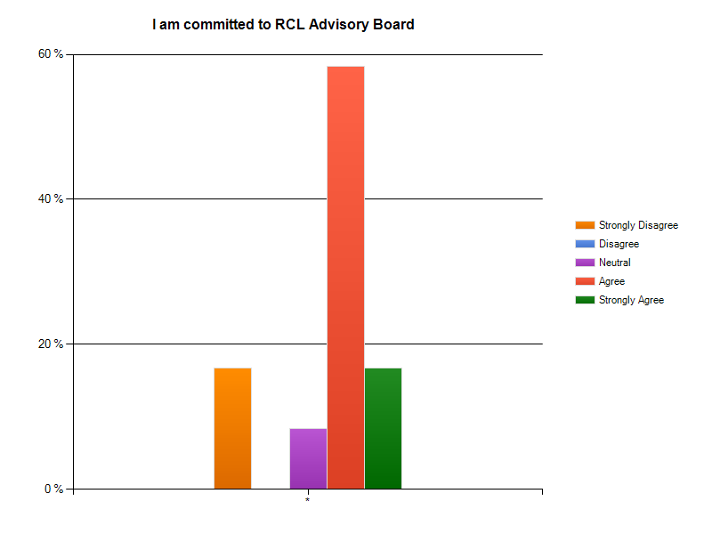

Effective Leadership and Decision Making
Through our interviews we learned that the majority of members were satisfied with the leadership and decision making processes of the client . This data was confirmed through our survey results which found very high ratings of satisfaction for both levels of leaders concern with organizational members and their understanding of general members’ problems. Furthermore, nearly 80 percent of survey respondents are satisfied with how decisions are made within the client organization. We believe effective leadership and decision making abilities are organizational strengths because without effective leadership and delineation of tasks/decision making procedures, an organization cannot thrive. Leadership and decision making are two of the most vital and integral aspects of an organization’s functioning and communication.
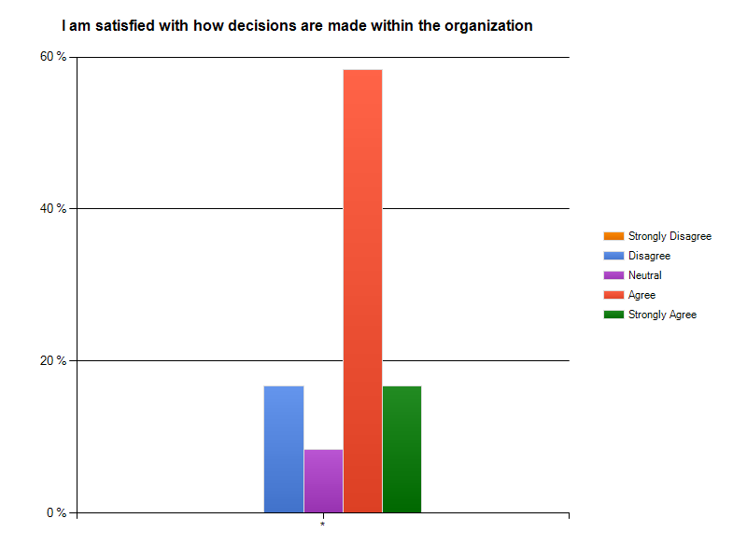

Adequacy of Information
Another organizational strength of the client organization is the adequacy of information exchange. According to interview results and survey results the client is very satisfied with the information they receive.
One critical aim of communications is the circulation of information, and every organization should set their sights on circulating the right type of information, at the right time, in order to promote the proper information load (Downs & Adrian, 2004, p. 52). We believe that having all 12 survey respondents report agreeing or strongly agreeing to having adequate dissemination of information is a statistically relevant data point, as adequacy of information exchange within an organization is key to organizational success.
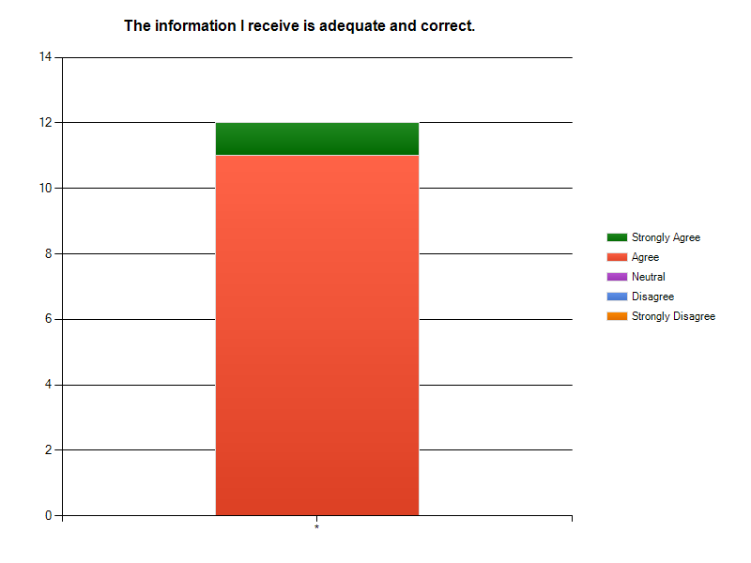

Conflict Resolution
It was also found that the client rarely has conflict, and when it does arise it is dealt with in an orderly and Socratic method. The disagreement is discussed until the conflict is nonexistent any longer. We discovered these results through multiple interviews with members of the client and through sitting in on their weekly meetings. This is strength because dealing with conflict in an organized way as well as making sure every member has a chance to voice their opinions is important to keeping the gateways of communication open while also keeping relationships between members amicable and friction free.

Organizational Areas of Concern

Satisfaction of How Meetings are Conducted
The overall satisfaction of how the general and executive body meetings are being conducted is essential to the development of further member participation and activeness. While gathering observational data and surveys, the team was able to identify structural errors within the weekly meetings.
According to all the interviews that were conducted, members of the organization believe that everyone values the idea of speaking freely on certain topics. However, after analyzing the results from the surveys, 41.7% or 5 out of 12 participants are strongly dissatisfied with how the meetings are officiated. This assumption can be made due to the fact that meetings are
This study found that the different forms of analysis of how efficient meetings are run appear to be in opposition. After interviewing the 7 executive board members, it is suggested that there are direct correlations of satisfaction problems among the general body members. This statement can be supported by the results illustrated in the graph below.

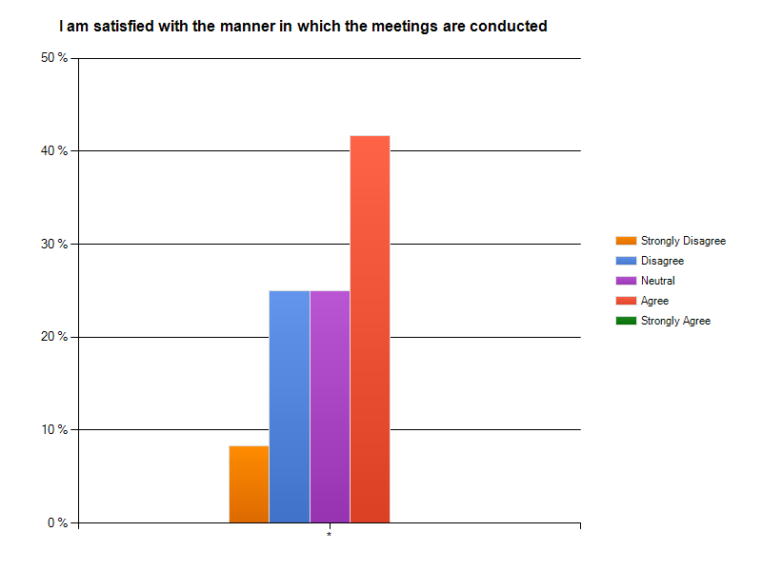

The graph above depicts the levels of satisfaction with how the meetings are conducted. The highest scoring response is strong agreement placing at 41.7 percent. As seen, the majority of the participants expressed their responses to be in disagreement and neutral at 25 percent. Lastly, 8 percent of the organizational members are in strong disagreement.

Awareness of Agenda Items Prior to Meetings
One area of concern that expresses a significant need for revamping is the awareness of agenda items to prior meetings. This study revealed that a great majority of the members of the organization are unaware as to what is scheduled for the weekly executive and general body meetings. The lack of the availability of minutes and tentative schedules from prior meetings creates this sense of unawareness and uncertainty.

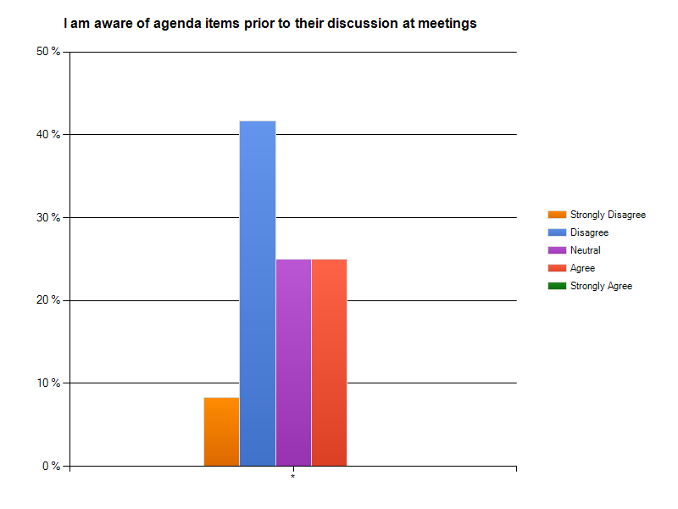

By looking at the bar graph above, it can be assumed that the analyzed results have concluded that many members of the organization are not being informed about the outline resulting in 41.7 percent of the organizational members. The overall satisfaction with the appropriateness of information is 50 percent (25 percent neutral & 25 percent agree). The results from this survey conducted displayed that there is a lack of information distributed among the organization.

Receiving Feedback Upon Completion of Tasks
The neutrality of receiving feedback upon completion of tasks is a strong indicator of ambiguity within the organization. Overall, the results found in this study showed that there are a large percentage of people,67.7 percent, that are neutral about the feedback received about the delegation and completion of tasks in the organization. The majority of the information can be found throughout the surveys that were completed. The spread of responses that were given shows a substantial amount of difference of opinion when discussing receiving of information.

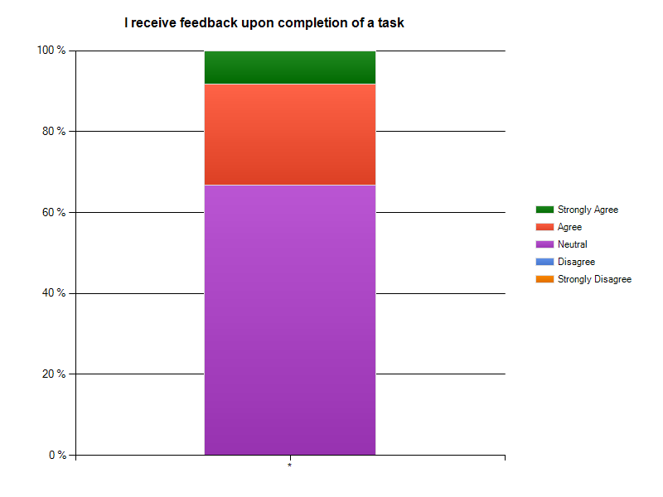

The illustration above shows the variation of responses among the organizational members. This graph represents that there is a serious lack of feedback that is being administrated. In this graph, it is displayed that 8.3 percent of the members receive feedback upon completion of task. 41.7 percent of the organization agreed that they receive a substantial amount of feedback. By making a quick consensus of the responses given from the survey it is suggested that the overall satisfaction of providing feedback to the completion of objectives is fairly low.

Accomplishments After Meeting
The overall satisfaction with the organization shows that members feel as if the tasks that are being delegated are able to be accomplished effectively. The members of the organization have revealed through surveys and interviews, that they agree that the executive board members manage to allocate sufficient amounts of time for tasks to be accomplished by tentative dates.
While looking at the interview data alone, the executive board members provided a generous amount of examples of projects that are in progress and how smoothly they are being accomplished. This study, in addition to, also found that 36.4 percent of the participants, having combined the two levels of disagreement, found that tasks were not being accomplished after the meetings.

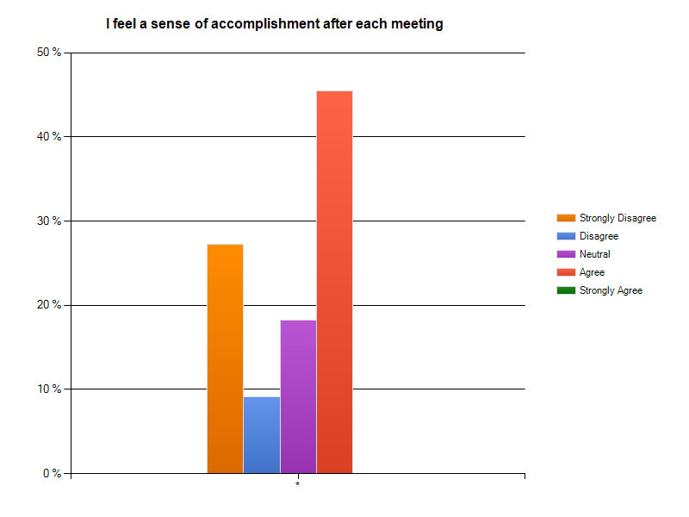
The survey that was distributed provides a beneficial amount of insight due to the spread of the information that was found. After looking at a number of graphs that were created, this survey demonstrated an obvious need for an increase in motivational assignments and tasks in order to increase the moral and enthusiasm among the organizational members.

Recommendations
Based on the interview data from the interviews that Everest Communications Consultants conducted with the client organization’s members we were able to develop several recommendations for this communication audit.

- Weekly Meetings
  - In order to increase the amount of participation, formal face-to-face communication, and feedback and to eliminate the disconnect between the General Body and the Executive Board we suggest having General Body meetings and Executive Board meetings every week. The most efficient way to do this would be to schedule the Executive Board meeting immediately before the scheduled time of the General Body meeting. For example, if the General Body meeting is scheduled for every Wednesday at 4 pm, the Executive Board would meet every Wednesday at 3:30 pm. By allotting the Executive Board a thirty minute time frame it will increase time management and efficiency within the meetings. With the General Body meeting immediately following the Executive Board meeting, information and ideas will be fresh in everyone’s mind increasing productivity within the meeting.
- Agenda
  - To increase efficiency and organization of information communicated to all members. An agenda will provide structure to both Executive Board meetings and General Body meetings. President will create agenda for each weekly meeting. The agenda should include issues to be discussed, tasks to be completed, an allocation of time for each issue, and a delegation of each task to either Executive Board members or General Body members. This agenda should be emailed out to all members; both Executive Board and General Body members to eliminate disconnect between the two and create a collaborative environment.
- Evaluation System
  - With the increase of events and programs on campus an evaluation system will provide useful feedback about the event/program to the organization. A suggested way to do this is through surveys. Once a template for the evaluation is developed it should be used for every event put on by the organization. This evaluation should be distributed to all members. An evaluation of events will provide constructive feedback for current members as well as become a planning tool for future members.
- Minutes
  - To provide efficiency and availability of information. Typing the minutes during the meeting and emailing them to all members immediately following the meeting. Delegate this task to the secretary. By taking advantage of the technology that is available through the use of laptops, typing the minutes during the meeting will increase efficiency and accuracy of the information, as well as allowing the information to be more readily available to all members of the organization.
- Parliamentarian
  - Structure and regulation of meetings will improve the efficiency and productivity of weekly meetings. This role should be an elected position and attendance at every meeting should be required. The purpose of a parliamentarian would be to regulate the discussion of the meetings and conduct/count votes following Roberts Rules. This position is not to be seen as the “bad guy” but more of a regulator and or mediated within the organization to keep meetings on task.
- Member attendance
  - Regular attendance of all members which includes the general body should be enforced. The enforcement of regular attendance for all members will create a more unified, cohesive organization. With this will also come an increase in participation from all members as well as increase the diversity of members. A spreadsheet should be created with all members names. By delegating the task of “calling role” to the secretary will allow for consistency of attendance being accounted for. An attendance policy of only two unexcused absences should be implemented and a meeting with a few members from the Executive Board will follow if more than two meetings are missed.

Conclusion
The commitment from the advisors and executive committee members seems to be high through observation, however since the general body only meets every other week the commitment level of general body members is much lower. The results from the survey showed an overall satisfaction with the organization, which differed from the data and trends that were noted in the interviews.
In analyzing the interviews and survey results, it seems that the members of the organization have a general respect for the organization and value for the purpose of the organization. Although there was an overall positive attitude about the organization, Everest Communications Consultants noticed some responses to interview questions that contradicted the survey results, which inferred that the image the members have of their organizations is not a true reflection.
Recommendations have been provided to the organization to improve all aspects that Everest Communications Consultants believe would improve any weaknesses of the communication within the client organization.

Appendix

Graphs
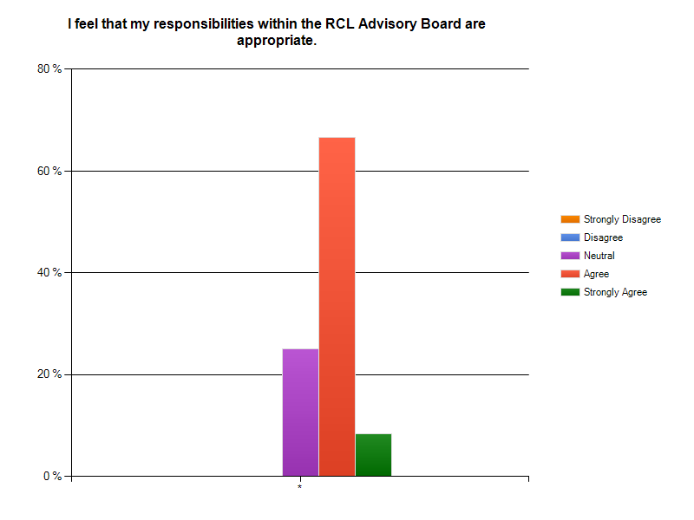
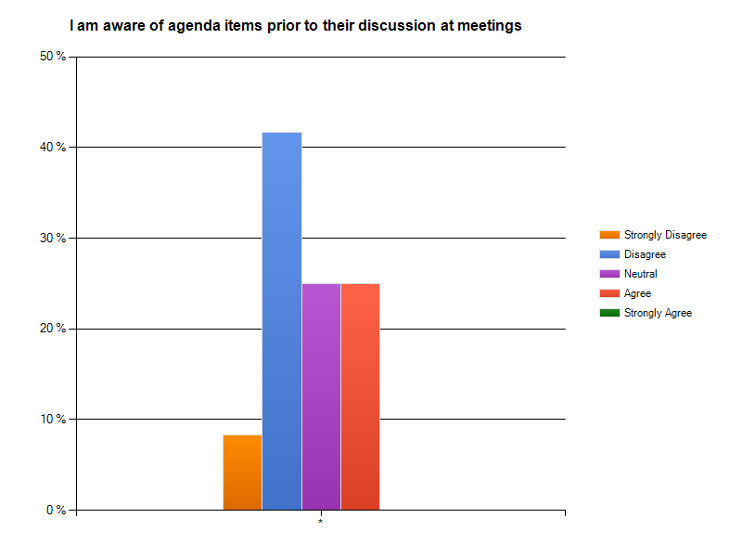

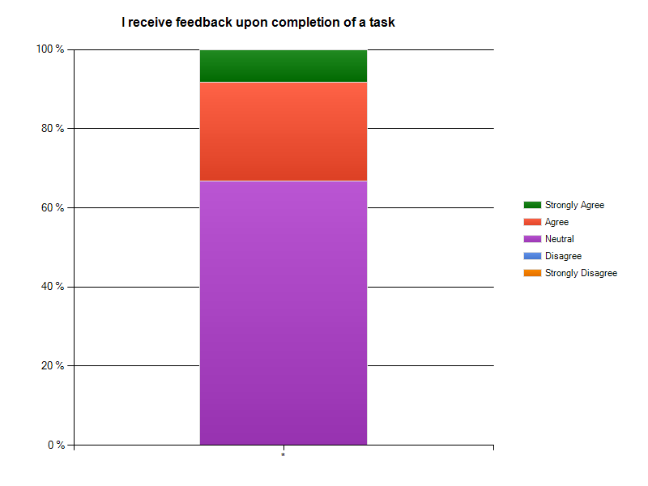

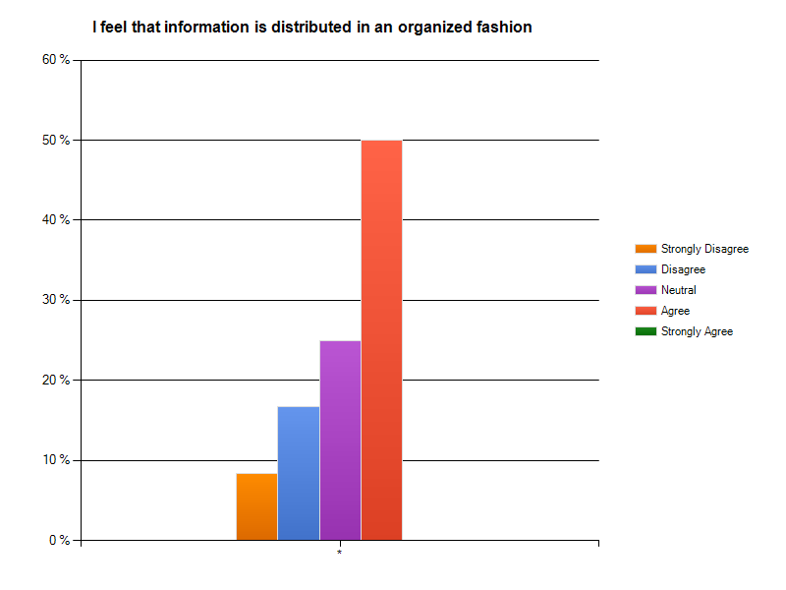
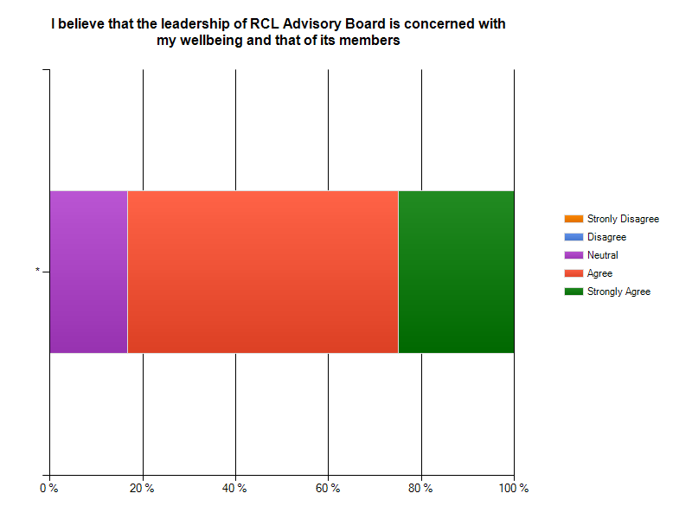

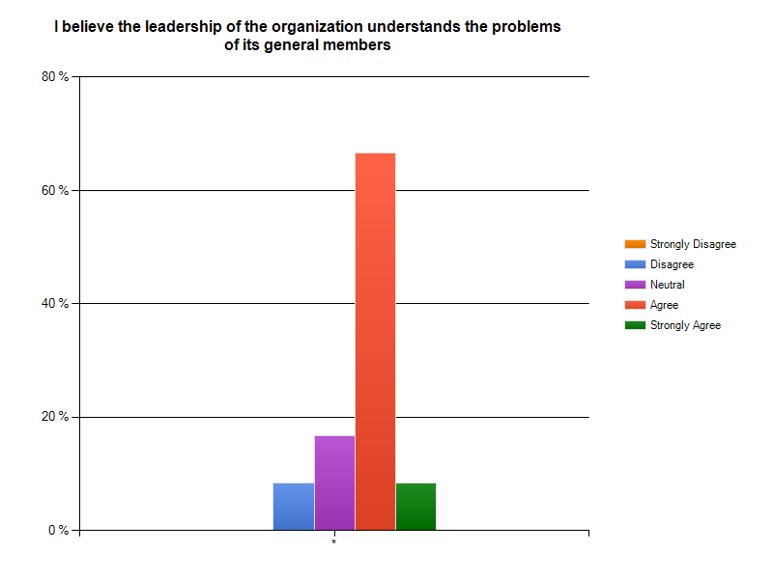

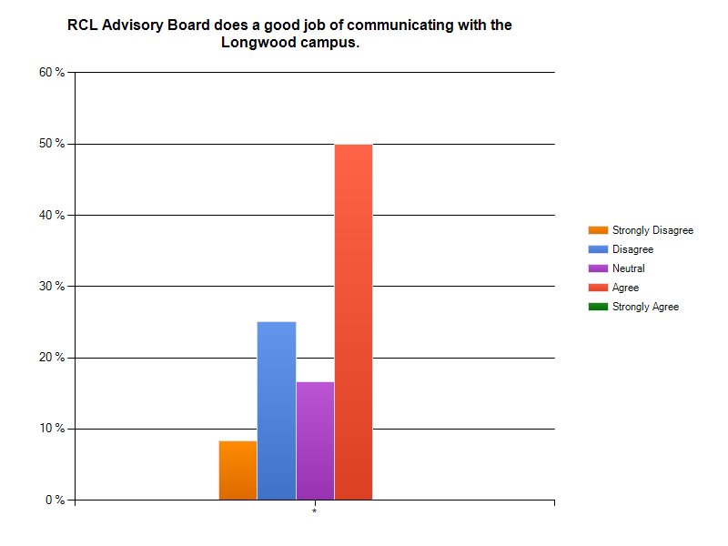
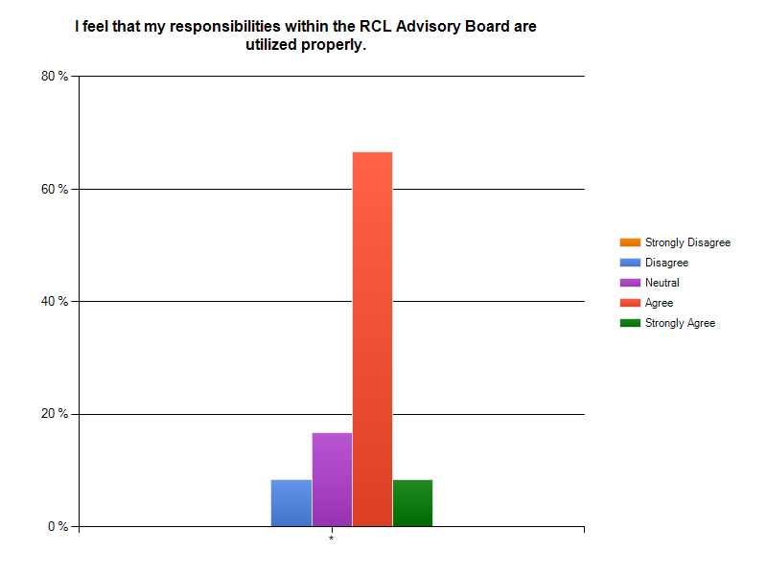
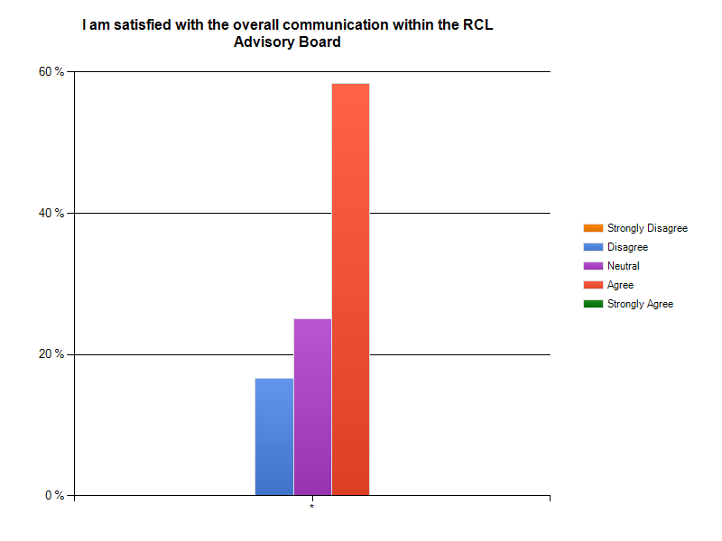

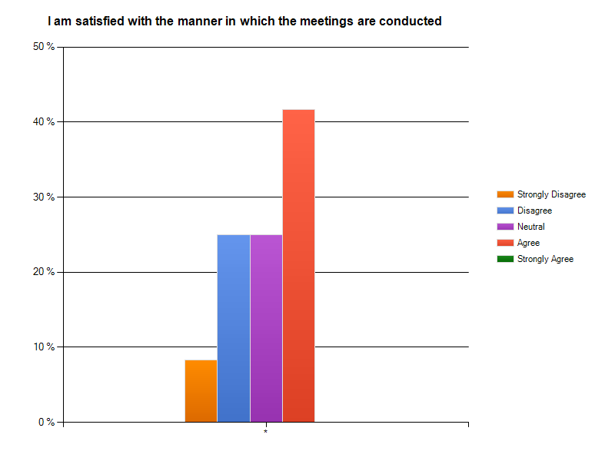
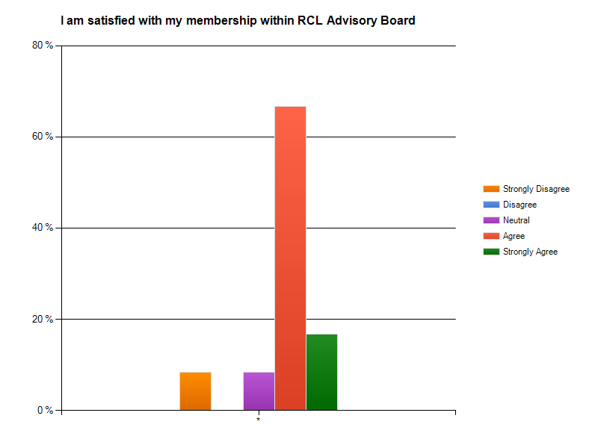
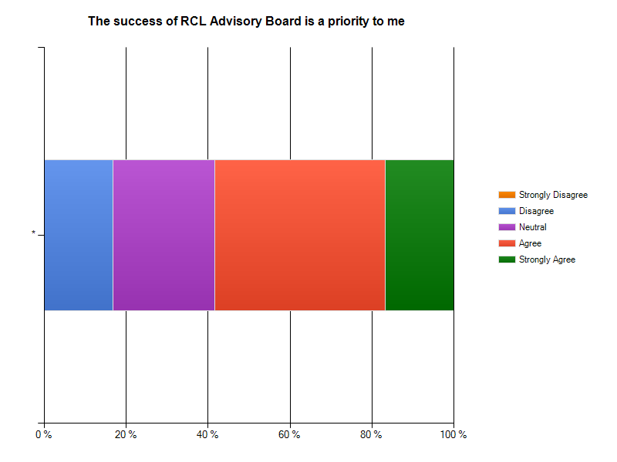
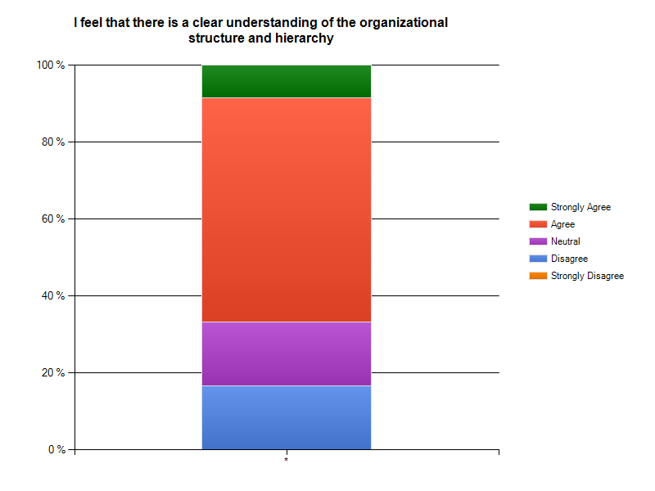

Interview Questions
Questions in interview guide adapted/taken from:
Downs C. W. & Adrian A. D. (2004). Assessing organizational communication; strategic
communication audits. The Guilford Press. New York, New York.

1. Describe your position in the client organization
- What are your chief responsibilities?
- With whom or with what positions do you regularly communicate?
- What factors tend to facilitate your effectiveness on the job? Please give an example.
- What, if anything, inhibits your effectiveness?

2. Describe the client organization’s primary objectives for this year
- How does the organization know when it has done a good or a bad job? What are the criteria for success?
- What are your own personal objectives?
- What communication strategies does one use to achieve them?

3. What kinds of communication are necessary for you to have with other work units? How well does this interdependent communication work?

4. Describe the formal channels through which you typically receive information. What kinds of information do you tend to receive, and how often?

6. Describe the informal channels through which you typically receive information.
- What kind of information do you hear?
- How active are informal channels?

7. What are the major communication strengths of the organization? Be specific

8. What are the major communication weaknesses of the organization? Be specific.

9. What do you see as the greatest unresolved problem of this organization?

10. What would one like to see done to improve communication here?
- Why hasn’t it been done already?
- What are the major obstacles?
- If you had a suggestion to improve communication, how would you make it?

11. When conflict occurs, how is it resolved? What normally causes conflict here? Give examples.

12. Describe the communication relationship you have with:
- Your president
- Your advisors
- Your colleagues
- The general assembly

13. How would you evaluate your president in terms of:
- Openness to new ideas?
- Willingness to share information?
- Ability to clarify expectations?
- Ability to coordinate the work in the organization?

14. How would you evaluate the communication from the president and your advisors?

15. How would you describe the general communication climate here?

16.How often do you receive information of little value? Give an example.
- How often are you overloaded with information?
- How often do you feel you get too little information?

17. How does communication here affect your productivity? Is this typical for others?

18. If you were to advise me as to what to look for to get the greatest insight into this organization, what would that be?

19.Describe the chain of command in this organization and how it operates.

Online Survey for Distribution

Introduction

Your participation in this survey will help identify communication strengths and weaknesses as well as assist in providing detailed information regarding the overall communication within the Residential and Commuter Life Advisory Board.

The survey should take you about 15 minutes to complete. Your confidentiality is assured. When you are ready to start the survey click ‘NEXT’ at the bottom of this page.

Thank you for your feedback.

Statement of Informed Consent

This communication satisfaction survey is being administered by students in COMM. 364, Applied Organizational Communication as part of the requirements for the course.

Your responses to the survey are anonymous. Each of the members of the audit team working with your organization has signed an anonymity agreement, the violation of which would result in Honor Code sanctions.

If you have any questions about this survey, the assessment process overall, or the course, please contact Dr. Bill Stuart at 434-395-2467, or at stuartwd@longwood.edu

* By indicating your willingness to participate below, you are acknowledging that your participation in this survey is voluntary.
- I provide my consent to participate. b) I do not wish to participate.

Survey Questions

- I am committed to the client organization.
a) Strongly Agree b) Agree c) Neutral d) Disagree e) Strongly Disagree

- I am satisfied with my membership within the client organization.
- Strongly Agree b) Agree c) Neutral d) Disagree e) Strongly Disagree

- I am satisfied with the overall communication within the client organization.
- Strongly Agree b) Agree c) Neutral d) Disagree e) Strongly Disagree

- The success of the client organization is a priority to me.
- Strongly Agree b) Agree c) Neutral d) Disagree e) Strongly Disagree

- I feel that my responsibilities within the client organization are appropriate.
a) Strongly Agree b) Agree c) Neutral d) Disagree e) Strongly Disagree

- I feel that my responsibilities within the client organization are utilized properly.
a) Strongly Agree b) Agree c) Neutral d) Disagree e) Strongly Disagree

- I believe the leadership of the organization understands the problems of its general members.
- Strongly Agree b) Agree c) Neutral d) Disagree e) Strongly Disagree

- I believe that the leadership of the client organization is concerned with my wellbeing and that its members.
- Strongly Agree b) Agree c) Neutral d) Disagree e) Strongly Disagree

- I am satisfied with the manner in which the meetings are conducted.
- Strongly Agree b) Agree c) Neutral d) Disagree e) Strongly Disagree

- I feel that information is distributed in an organized fashion.
- Strongly Agree b) Agree c) Neutral d) Disagree e) Strongly Disagree

- I receive information through informal communications channels.
- Strongly Agree b) Agree c) Neutral d) Disagree e) Strongly Disagree

- The information I receive is adequate and correct.
a) Strongly Agree b) Agree c) Neutral d) Disagree e) Strongly Disagree

- I feel comfortable voicing my opinions and asking questions.
- Strongly Agree b) Agree c) Neutral d) Disagree e) Strongly Disagree

- I feel that there is a clear understanding of the organizational structure and hierarchy.
- Strongly Agree b) Agree c) Neutral d) Disagree e) Strongly Disagree

- I feel that I have a voice in the organizational decision making process.
a) Strongly Agree b) Agree c) Neutral d) Disagree e) Strongly Disagree

- I am satisfied with how decisions are made within the organization.
a) Strongly Agree b) Agree c) Neutral d) Disagree e) Strongly Disagree

- I believe that pertinent information is distributed to all members in a timely fashion.
a) Strongly Agree b) Agree c) Neutral d) Disagree e) Strongly Disagree

- I am aware of agenda items prior to their discussion at meetings.
a) Strongly Agree b) Agree c) Neutral d) Disagree e) Strongly Disagree

- I receive adequate informative minutes regarding weekly meetings.
a) Strongly Agree b) Agree c) Neutral d) Disagree e) Strongly Disagree

- I feel a sense of accomplishment after each meeting.
a) Strongly Agree b) Agree c) Neutral d) Disagree e) Strongly Disagree

- I feel that the organization works as a cohesive group.
a) Strongly Agree b) Agree c) Neutral d) Disagree e) Strongly Disagree

- I receive feedback upon completion of a task.
a) Strongly Agree b) Agree c) Neutral d) Disagree e) Strongly Disagree

- The client organization does a good job of communicating with the Longwood campus.
a) Strongly Agree b) Agree c) Neutral d) Disagree e) Strongly Disagree

- I am satisfied with the extent to which communication from my immediate supervisor motivates me to help the organization achieve its goals.
a) Strongly Agree b) Agree c) Neutral d) Disagree e) Strongly Disagree

- I feel that the client organization effectively publicizes its events and operations on campus.
a) Strongly Agree b) Agree c) Neutral d) Disagree e) Strongly Disagree

- Please provide any additional information/comments/concerns you may have regarding the client organization that were not mentioned within the survey.
* Open ended response

Archival Documents

Meeting Minutes 10/6/10
- Jean ordered swag!
- Rally towels, wrist bands, megaphones
- Should have them by October 25
- Wristbands help promote Hunger Awareness Program-Red and Green class
- Night without a home-November 19, 6pm-6am
- Possibly Stubbs Lawn-reserve through Conferencing and Scheduling
- FSSW-help sell bracelets/committee meeting
- Grant-said D-Hall could donate soup, water, and crackers free!
- Commuter Luncheon-Wednesday, November 10, 11:30am-1:30pm
- Food ordered
- We need to send out invitations-commuter students
- Invite Tim Pierson, Kim Perkins, Larry Robertson, Angela Jackson to speak
- Emily-RSVP person
- Announcement at Commuter Luncheon about Hunger Awareness Week
- Methods 3-Social Work with Communities-need money for speaker
- Traditionally clubs-maybe
- Jean will email Mary Hoyt
- Business School
- Cookout to network and see organizations
- Possibly need help with funding
- More details later
- Village Campus Wide-Farmvegas
- Use margarita glasses for Mocktails
- funding?-cosponsor-
- Fundraiser after village uses them? Or give away?
- Can we split between club account and SGA?
- Club account-$1643.63
- Lancer Park staff thanks us for their Sand Soccer Tournament

Meeting Minutes 10/13/10
- Updates
- Commuter Luncheon invites are done-Emily will email them this week
- Just for commuters and the organization
- Lunch is confirmed-ABC rooms, estimated price is $1155.00 to feed 100 people
- Housing and Rental Fair- in Ballroom at the same time as Commuter Luncheon
- Invited to Club/Organization dinner
- Wednesday, October 20 at 5:00pm in Grand Dining Hall
- Four executive members and advisor
- Business/Semiformal Attire
- Emily will RSVP
- Hunger Awareness Week
- Wristbands, towels, and megaphones are here
- Food
- Next meeting decide: How long are we serving food? Who is serving the food and who is supervising?
- Phi Beta Sigma
- Advertising
- Find out at next committee meeting: How are they involved? What is each organization doing?
- Need to reserve table in D-Hall for selling wristbands
- Village Campus Wide Program
- SGA (Alyssa) will find out when cups will be purchased
- Blue 8 oz cups: 200 cups for $1.68 each, 500 cups for $1.66 each, 1000 cups for $1.63 each
- Blue 2 oz cups: 500 cups for 85¢ each
- Blue 8 oz cups with lit bases: 200 cups for $1.32 each
- Village needs about 150 for program
- Vote on next week: buy village 200 with SGA funds and worry about buying more for Spring Weekend later

Meeting Minutes 10/20/10
- Collegiate Link
- Email Emily if you did not get the email
- Commuter Luncheon
- Tim Pierson, President Finnegan, Angela Jackson, Larry Robertson
- Night Without a Home
- Supplies needed?
- 5 tables, 15 chairs, 12 trashcans
- Jean will get security
- Screen, projector, cable, speakers-Jesse will ask Susan Sullivan
- Food heaters from D-Hall, bowls
- Sustainability Office
- Can provide recycling bins
- Present tentative schedule
- Box competition-prizes for categories
- Have movie and speaker on stairs in front of Stubbs
- Sell wristbands
- Each organization can take some and sell them
- Remainders in the office
- If you take some, let Brittany know
- $2.00 each
- Village Campus Wide Event
- 200 glasses-$264 out of SGA account-approved
- Meeting time for next semester-doodle poll
- High Rise Hoedown-Saturday 23rd at 3pm-5pm
- Arc/Stubbs Campus Wide-Masquerade Ball
- SGA announcements-President Finnegan is meeting with each class to get feedback

Meeting Minutes 10/27/10
- Commuter Luncheon reminder
- Only one with no response-Dr. Perkins
- $1750 total which is still under the budget
- Village Campus Wide- “Roaring Night in Farmvegas”
- 20’s theme
- Please come
- If you can help let Gigi know
- Night Without a Home
- Wristbands-Brittany in charge of money
- Will sold 5! YAY!
- APO wants to sell some
- Reserving Stubbs Lawn-proposal is in, waiting for response
- SGA Announcements
- Initiative to ban skateboards from 7am to 5pm
- Complaints about bodily harm to pedestrians and riders
- Right now they are gauging reactions
- RCL exec opinions will be used in SGA meeting
- Go smoke free initiative
- Two year process
- SGA is creating committee with Peer Health Educators
- General Finnegan
- Tuesday, November 2nd at 7pm
- Speaking on Honor and Integrity
- T-shirt swap-bring t-shirts from other schools and swap them for Longwood shirts

Meeting Minutes 11/3/10
General Body Meeting
- Commuter Luncheon Reminder
  - Passed around sign-up sheet for organization members
- Night without a home update
  - Need volunteer for fliers (contact Brittany)- Will Nixon
  - Wrist bands- none
  - Need to reserve D-hall table for the week of, Tuesday and Thursday
  - Walmart card $10- to purchase sheets for advertisement
  - Dean’s student advisory board college of business and economics has volunteered to help sell wrist bands and to publicize
  - Still have not received confirmation for Stubbs Lawn
  - Jesse will check on putting advertisement in d-hall napkin holders
  - Do not need police security during the night
  - Weekly e-mail, Nathan will take care of sending it in
- Financial Update
  - High Rise Hoe Down, used nearly $1000.00, Jean is processing receipts now
  - Approx. 1500.00 for Commuter Luncheon
- Student Affairs proposal (coming from Gigi)
  - Men’s committee- provide wellness kits to males on campus including information and giveaways
  - Asking for $600 to purchase
  - Will vote during next meeting
- Proposal from Jen Cox
  - Outdoor movie at Lancer Park in the Spring
  - LP and Campus Recreation are already cosponsoring. Would need $700-850 for the movie rights. Total cost $1700
  - Will vote during next meeting
- Doodle Poll
- Help desk filters interrupting network connections, get feedback from residents

Meeting Minutes 11/17/10
- Sleepout for the Homeless
- Stubbs Lawn reserved
- Movie-LP company for screen and projector
- Pursuit of Happiness
- Honorarium for speaker Charles Fitzgerald
- $50 to Mr. Fitzgerald (gift card), $100 to Embrace
- Need invoice
- Prizes for box competition
- Bowling alley gift card
- Charley’s
- Barnes and Noble Bookstore
- Categories: Most Creative, Sturdiest, Most Resourceful
- Conferencing and scheduling-microphone
- Advertise!
- Manpower
- Set up at 4:30
- Meet behind student union
- Distributing boxes
- Soup kitchen
- Judges for box home
- Good weather!
- December 2-Rally towels at women’s basketball game
- 6:00pm to 7:00pm
- Game starts at 7:00pm
- Could be the 1st or 2nd of December
- Children’s Holiday Party-not doing this year
- Gigi-Men’s Health
- $6.00 for bags
- We cannot support right now
- Jen Cox-Friday March 25
- Movie at Lancer Park-Sandlot
- $700-$850 for movie rights
- Match their fundraising up to the full amount

Works Cited

Downs C. W. & Adrian A. D. (2004). Assessing organizational communication; strategic
communication audits. The Guilford Press. New York, New York.

