SENIOR NIGHT!

MEN’S SOCCER GAME

NOVEMBER 6TH AT 6PM

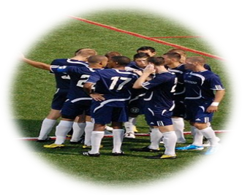

**AGAINST HIGHPOINT**

