Cranberry Orange Scones and Modifying Fat

A Research Paper
Submitted to Cassondra Burgess, MS, RD and Jodie Seybold, MS, RD
In Partial Fulfillment of the
Requirements for
FDNT 362 Experimental Foods

Rachel Knepp
Indiana University of Pennsylvania
December 13th, 2010
Abstract
Reduced fat bake goods do not have the same overall acceptability as traditional bake goods. Finding a fat substitute, that creates the same taste as a traditional bake good is extremely difficult to achieve. Previous research studies suggest, the functions of fats, affect the volume, flavor, texture of the baked product. The purpose of this experiment is to determine the effect of fat on the volume, tenderness, mouth feel, texture and flavor on cranberry orange scones. The research experiment was conducted for three weeks. The variations of recipes were judged subjectively by five sensory panelists. For the objective evaluation, a penetrometer was used for tenderness, and the v-caliper measured volume. Specific volume and density were also measured. All data was collected, and data analysis was analyzed using SPSS version 17.0.

Acknowledgements

I would first like to thank my mother and father for all their love and support they have given me through out my college career, and especially this semester. This project, would of not been possible without my parents guidance, thank you!
Secondly, I would sincerely like to thank both, Mrs. Strawser and Mrs. Seybold for the wonderful experience I had in FDNT 362 Experimental Foods.
Mrs. Strawser, thank you for your endless help through out the semester, especially with this project. The material that you taught me in lecture was extremely valueable, something that I will have and use in my future career.
Mrs. Seybold, thank you for your willingness to help and answer questions about my experiment. All the hands-on lessons I completed while being in lab, has allowed me to build a solid foundation of food principles, that I will be able to apply in my career.
Dr. Bill Barker, thank you for taking time out of your busy day to teach us SPSS, as well as how to interpret our collected data.
Lauren , thank you for taking on the task of going grocery shopping for all the classes ofFDNT 362! The grocery shopping was the most cruicial and important part of our experiments, and the wonderful job of making sure everyone had all the proper ingredients for their experiments. I truly appreciate it.
Sensory panelsits, thank you for your dedication with doing multiple taste-testing of each one of my varied cranberry orange scones for three weeks!
Also, I would like to especially thank my classmates, Jaynetta Joyner and Sarah Harper, for their encouragement and positive attitudes they brought to class everyday; truly making this class a joy!

TABLE OF CONTENTS

CHAPTER I: THE PROBLEM 6
Introduction 6
Statement of the Problem 6
Research Statment 6

CHAPTER II: RESEARCH QUESTIONS……………………………………………7
Introduction……………………………………………………………………...7
Research questions………………………………………………………………7

CHAPTER II: REVIEW OF THE LITERATURE 8

Introduction 8

Prader-Willi Syndrome and Health 9

Functions of Fats in Bake Goods 9

Fat and Flavor 9

Volume Bake Goods 10

Dough Characteristics 11

Conclusion 11

CHAPTER III: METHODS 12
Introduction 12
Procedure 12
Control Recipe………………………………………………………………..14
Subjective Evaluation 16
Sensory Panel 17
Scorecard……………………………………………………………………..18
Objective Evaluation 19
Data Analysis 20
Conclusion 21

CHAPTER IV: RESULTS 22
Table of Means 22
Consistency……………………………………………...................................22
Differences Between Recipes…………………………………………………23
Specific Volume and Density…………………………………………………24

CHAPTER V: Conclusion
Introduction 26

CHAPTER VI: Discussion 27
Strengths 27
Recipe Modification …………………………………………………………27
Limitations 28
Recommendations for Future Research 28

REFERENCES 29

APPENDICES 31

Appendix A – Nutrient Analyses Information 31
Appendix B – Original Recipe 39
Appendix C – Market Order 40
Appendix D – SPSS output 41
Appendix E – Design of Sample Plate 43
Appendix F – Concept Map 44
Appendix G – Dough Characteristics 47
Appendix H – Shape of Scone 48

Chapter I
The Problem
Introduction
Imagine, always having those grueling morning hunger pains, and not able to have achieve satiety because you were restricted to consuming a low calorie reduced fat meal every day. This is the life of person with Prader Willi Syndrome. Prader Willi Syndrome (PWS) because is an inherited genetic disorders that relies heavily on nutrition intervention (Pereira, Schalk & Geraghty, 2009). The genetic defect, at a certain stage, makes people with PWS always feeling hungry, thus seeking food constantly (Pereira et al., 2009). Obesity is common in people with Prader Willi Syndrome, requiring them to consume fewer calories, and reduced fat foods than a normal person (Ekaitis, n.d.). In fact, PWS people have decreased mobility, increasing their risk for health complications, making diet modification extremely important (Sode-Carlsen & Farholt, 2009). Foods that are reduced fat, and/or fat-free have a different taste than foods with a high fat content. Baked goods, in particular; contain high amounts of fat, therefore making it extremely difficult to make a successful reduced-fat or fat free baked product. Making a reduced fat product often results in increased volume, with a decreased weight; resulting in an altered, undesirable texture (Wekwete & Navder, 2008). Modifications of fat in recipes, sometimes don’t work because of the extreme stickiness of the dough, or increase in viscosity, due to the low fat content (Wekwete & Navder 2008).
Although there is a lack of studies with fat modification, modifying fat to make a reduced fat bake good overall results in lack of acceptability from the person consuming the product. The purpose of this experiment is to determine the effect of fat on the volume, tenderness, mouth feel, texture and flavor on cranberry orange scones.
CHAPTER II

Research Questions
Research Questions
When manipulating the fat content of the (heavy cream) control recipe, with half and half, 2%, and fat free milk, questions relating to the manipulation of fat and its effect on volume, tenderness, mouth feel, texture, and flavor arose. In conducting this experiment, these research questions were the driving force of finding answers on the effect of cranberry orange scone when manipulating fat.
- Will judges notice the difference in flavor in the half-and-half scone compared to the scone made with heavy cream?
- When substituting whole milk for heavy cream, what occurs to the tenderness of the product?
- Will judges prefer the mouth feel of the scone made with fat free milk or the scone made with heavy cream?
- Will the judge prefer the texture of a scone made with heavy cream, or a scone made with whole milk?
- When substituting heavy cream for Slim n Trim fat free milk, what occurs to the volume of the scone?

Chapter III
Review of the Literature
Introduction
Almost all baked goods today, are high in fat, which can aide in the prevention of obesity with people that have Prader-Willi syndrome. It is important to modify the fats of a baked good so they contain a lower fat content. Although, modifying the fat of a baked good is relatively easy, the challenge is finding a “fat replacement” which yields the same taste as a baked good high in fat. When fats modified in a baked good, studies show it has an effect on volume, flavor, color, texture, and tenderness of the overall product.
Prader-Willi Syndrome and Health
People with Prader-Willi syndrome need a special restricted diet. One part of the restricted diet with this genetic disorder is a reduced fat diet. The study Lindmark, Trygg, Giltvedt and Kolset (2010) found children 2 years of age (24% of energy from fat) , and 3-4 years of age (25% of energy from fat) with Prader-Willi syndrome consumed a lower amount of saturated and monounsaturated fats than the recommendations from the Nordic Nutrition Recommendations for the general population (Lindmark and Trygg, 2010).
One with prader-willi syndrome that is obese has a significant decrease in mobility, which can lead to increased health complications. Sode-Carlsen, Farholt, Rabben, Bollerslev,Sandahl Christiansen and Höybye (2009) studied the BMI of PWS patients, and their activity level. Sode-Carlsen and Farholt found a correlation in the reduction of physical activity performance (walking 10 m and rising in a chair) with patients that have a high BMI and body fat mass (Sode-Carlson and Farholt, 2009). Stressing the importance of a restricted diet, such as consuming low-fat food items so physical activity can be achieved will help decrease the chances of PWS patients to develop cardiovascular disease, diabetes and other health complications related to obesity and lack of physical activity.
Functions of Fats in Bake Goods
Fat plays many major roles in the outcome of a baked product (McWilliams, 2008).. Fat adds flavor to a product. Fat adds richness in terms of flavor, and many different fats add a distinct flavor such as butter and olive oil and lard (McWilliams, 2008).. Fat also has a huge influence on texture (McWilliams, 2008).. Depending on the type of product, fat plays a vital role in the overall texture, for butter pieces in a pastry, creates a flaky texture (McWilliams, 2008). Fried foods, which use oil, have a crisp texture due to the high temperature of cooking. Tenderness is one of the main functions of a fat in a product (McWilliams, 2008). Fat acts as an inhibitor of gluten development, acting as an effective tenderizing agent (McWilliams, 2008).
Fat and Flavor
The percentage of milk fat content added to a mixture has an effect on the flavor release of the final product (Roberts & Pollien, 2006). During the lipid phase, the lipid particles attract to aroma compounds, resulting in flavor release (Roberts & Pollien 2006). In the study of Roberts, Pollien, and Watzke (2006) they studied the effect of flavor release, and the size of the fatty acid chain in coconut oil, medium-chain triglycerides and hydrogenated palm fat compared to milk fat. Roberts, Pollien, and Watzke (2006) found at all lipids being 90% to 100% liquid, with the exception of hydrogenated palm fat at 30%t, it supported that there was no significant difference of absorption of aroma compounds between variables,which supports the concept that flavor release is not determined by the fatty acid chain length of the variables studied accordingly. Another study by Linforth, Cabannes, Hewson, Yang, and Taylor studied the Effect of Fat Content on Flavor Delivery during Consumption…” Using a triangle based study; participants of the study were to determine the odd sample that contained a high level of orange flavoring, from two samples that contained the same levels of orange flavoring. The results for the study concluded 12 of the 21 participants were able to detect the odd sample; signifying flavor intensity is significantly detectable with a mixture of the same fat content (Linforth & Cabannes, 2011). Linforth, Cabannes, Hewson, Yang, and Taylor also found in the study, with 40 participants, 26 were able to detect the similarity between the sample of 1% fat, with low concentration of orange flavoring, and the 10% fat sample with high concentrations of flavoring. This particular experiment in the study supports that a low-fat product produces the flavor similarity/acceptability to a high fat product when adjusting the amount of flavor concentration of a product (Linforth & Cabannes, 2011).
Volume Baked Goods
Smith and Johansson (2004) studied and used water-oil emulsion variables of 0% solid fat, 20% , 40% , 60% and 80% when baking bread. In the sample of 20% fat, volume was 1771 ml, and the sample of 60% solid fat was 1888 ml (Smith & Johansson, 2004). Also, the difference in volume of the 0% solid fat sample to the 80% solid fat loaf, there was a 30% increase difference (Smith & Johansson, 2004). They found that the greater amount of (saturated fat) solid fat there is in a loaf of bread, the greater the volume (Smith & Johansson, 2004). The study also concluded that as the volume increased, the weight of bread decreased (Smith & Johansson, 2004). They found a 10% or (2g) difference in the weight of the sample with 0% solid fat and 80% solid fat (Smith & Johansson, 2004). In the study Wekwete and Navder (2008), “the control cookie had decreased height after baking compared to the reduced fat cookies” (Wekwete & Navder 2008). The fat replacer, avocado had the greatest height, which resulted in a more “cake-like” texture (Wekwete & Navder 2008).
Dough Characteristics
Wekwete and Navder (2008) studied cookies, using 100% butter, and then replacing 50% of the butter with fat replacers avocado, and Oatrium (Wekwete & Navder 2008). When using the avacodo and Oatrium the fat content was reduced by 35% and 39%, thus producing a reduced fat cookie (Wekwete & Navder 2008). When mixing the dough, they noted a greater significance in dough stickiness with the reduced fat mixtures (Wekwete & Navder 2008).
Conclusion
There has been limited research done with fat modification and bake goods, especially milk substitutes in bake goods. This experiments design contains a procedure, subjective and objective evaluations with different milk substitutes, in hopes that this study design t can be used for future research.

Chapter IV
Methods
Introduction
First, the recipes wss onverted from English to metric units, to ensure accuracy and precision with the recipes. Second, the ingredients were weighed out prior to lab to allow proper amount for all procedures. All four recipes control, half and half (variable 1), 2% milk (variable 2), fat free milk (variable 3) cranberry orange scone recipe were baked (Table 1). After the scones were baked, subject and objective evaluations took place. All subjective and objective evaluation data was collected as well as, the same procedure took place for three weeks to eliminate invalid data. Data analysis occurred after all three weeks.
Table 1. Identification key for all four recipes used in the experiment.
Control | Variable 1 | Variable 2 | Variable 3
MARTIN’S Heavy Cream | Martins Half and Half | Martins 2% Milk | Slim n Trim Fat Free Milk

Procedure
Baker is dressed in proper lab attire. Proper lab attire is black or blue pants, white short-sleeve shirt, apron, with ball cap or hair net. Hands are clean, fingernails are groomed, with no nail polish or fake nails.
During the trial week, there were a few adjustments made to the recipe as well as the procedure. 190 grams of flour was added to the original recipe, as well as an additional 20 grams of all-purpose flour added for the cutting board surface when the dough is being rolled. The flour modifications were made because during the trial week, the control and variable recipes had substantially runny, sticky dough. The recipe, with theses flour modifications were cut in half for experiment weeks solely due to lowering the total cost of the experiment.
The orange glaze (orange juice + confectioner sugar) was not used during the experiment weeks. During the trail week, it was decided from other panelists, that it was difficult to judge flavor (acidic/sweet), one of my subjective measurements. The “sprinkle” of granulated sugar was also removed from this recipe for the same reason for the orange glaze. In addition, the egg wash (1 medium egg + water) was not used in the experiment weeks. Egg wash was not used during the experiment weeks because it had an effect on color, the other subjective measurement in the experiment.
Before preparing the baking ingredients for the cranberry orange scones, gather the following materials: one large mixing bowl, a wooden spoon, electronic grams scale, milliliter cylinder, oven, two oven mitts, cooling rack, parchment paper, timer, electric mixer with paddle attachment, micro plane (skin peeler for orange zest) 3 inch round cutter, rolling pin, cutting board, ruler, cookie sheet.
Now that the needed cooking equipment is gathered, gather the needed ingredients to make cranberry orange scones (Table 2). Refer to appendix B for the original cranberry orange scones recipe in English and metric prior to experiment recipe modifications.

Table 2: The control recipe and variable recipes used during the experiment.
Amount | Ingredient
330.63g | Generic All-Purpose Flour
60.0g | General All-Purpose Flour for surface
25g | Generic Granulated Sugar
14g | Generic Baking Powder
6g | Generic Kosher Salt
170.10g | Generic Unsalted Butter Sticks
118.3ml | Heavy Cream*
20g | Name brand Ocean Spray Dried Cranberries
112g | Extra Large Eggs
3g | Grated Orange Zest
Variables (* = control ingredient)
118.3ml | Half and Half
118.3ml | 2% Milk
118.3ml | Fat free milk
Note. The recipe used was halved from the original recipe in Appendix B. Ingredients from the original were also not used in the experiment recipe due to time and money constraints.
Measure out the 118.3 ml of the Martins heavy cream using the ml cylinder. Read the ml cylinder when placed on a flat surface at eye level. Read at eye level making sure the liquid read at the meniscus. Pour heavy cream into bowl. Rinse out ml cylinder with water. Dry out cylinder with paper towel. Gather microplane tool and two medium sized oranges, rub microplane up and down on outside of orange peel over small bowl for the orange zest. Spoon the grated orange zest into small bowl on electronic gram scale until it reads 3 grams. Set aside. Next, sift the flour using the sifter into one of the measuring bowls. ZERO the electronic scale, the screen will read 0.0 g. Spoon the sifted flour, onto the small bowl that is one the zeroed electronic grams scale until it reads 330.63 grams. Place flour in electric mixing bowl and set aside. Zero Scale with small bowl placed on scale. Electronic scale will read 0.0 g. Spoon Martins baking powder into small bowl until scale reads 14 g. Set aside. Place a new small bowl on scale and zero scale. Weigh out Martins salt until the scale reads 6 g. Set aside. Place a new small bowl on scale and zero scale (0.0 g). Carefully spoon Martins sugar into small bowl until it reads 25 grams. Set aside. Place a clean dry small bowl onto electronic scale and zero. Scale will read 0.0 g. Cut pieces of cold unsalted butter and place into small bowl until it reads 170.10 g. Set aside. Place a clean dry small bowl onto scale. Zero Scale (0.0 g). Crack 6 large eggs in small bowl. Wisk eggs together for 30 seconds in bowl. Place a clean dry bowl on scale. Zero Scale (0.0 g). Spoon whisked egg onto bowl on scale until it reads 112 grams of eggs. Place a new bowl onto electronic gram scale. Zero Scale (0.0 g). Spoon the grated orange zest into small bowl on electronic gram scale until it reads 6 grams. Set aside. Place a new bowl onto electronic grams scale. Zero scale (0.0 g). Spoon out Ocean spray cranberries until the scale reads 40 grams. Set aside.
Measure ingredients three more times, for a total of four varied recipes. Replace the control with half and half (variable 1), 2% MARTINS milk (variable 2), and fat free milk (variable 3) with each recipe. Refer to appendix G for pictures of the control, variable 1, variable 2, and variable 3 ingredients. Use the same measuring procedure as the control as described above.
According to Garten (2006),
Preheat oven to 400 degrees Fahrenheit. Combine in the electric mixing bowl, 330.63 Martins all-purpose flour, 25 g of Martins granulated sugar, 14 grams of baking powder, 6 grams salt, and 3 grams orange grated orange zest. Then add the 170.10 grams of unsalted butter. Attach paddle attachment to electric mixer. Attach bowl to electric mixer, and mix at speed 1 (the lowest speed possible). When butter gets to be pea sized, slowly add the 112 grams of eggs, and control (heavy cream) to the mixture (all-purpose flour, granulated sugar, salt, grated orange zest and unsalted butter, egg and the control (heavy cream). The mixture (dough) will be lumpy. Add the 20 grams of cranberries, and ¼-cup flour to the mixture, and mix on speed 1 until the cranberries and flour are blended.
Spread 60 g of flour onto cutting board. Put dough from electric mixing bowl, onto well-floured surface. Knead the dough into a ball. Flour the rolling pin, and hands. Roll dough until ¾ inch thick. Confirm thickness with ruler. Small pieces of butter will show in dough. Be sure to keep the dough on a flour surface to prevent the dough from sticking. Flour a 2 inch round cutter. Cut into the dough using the 3 inch round flutter tool. Cut 15 scones. If needed, use the scrape of dough, and re-roll on the floured surface and rolling pin and cut using the flutter tool to make more scones. Place scones on parchment paper. When all the scones are cut into 3 inch round flutters, place on cookie baking sheet. Spread scones at least one inch apart. Place in oven, with oven mitt on your hand, the 15 scones for 23 minutes. Set timer for 23 minutes. After 23 minutes, pull scones out of the oven using an oven mitt. Allow scones to cool for 15 minutes.
Repeat baking steps three times. First, replace the control (heavy cream) with the MARTIN’s half and half (variable 1), second time with the MARTIN’S 2% milk (variable 2), and the third time with Slim n Trim fat free milk (variable 3). After the cranberry scones are baked, it is time perform the subjective and objective evaluation. Subjective evaluation consisted of mouth feel, texture and flavor, while objective evaluation consisted of tenderness, and volume (Appendix F).
Subjective Evaluation
For the subjective evaluation five petition boards were set up each containing the sample plate (Appendix E), one score card, a pencil, and judges will be advised prior to bring a glass of water at room temperature. The subjective data judged by the panelists were flavor, texture, and mouth feel based on a 1-5 scale (Fig. 1). Every variable was assigned a different three digit number to ensure that there was no bias.
Sensory Panel
The five same panelists evaluated the samples for the three weeks of experimentation. The panelists were students, in the Tuesday lab for Experimental Foods Class; FDNT 362. All panelists were females, and were between 19 to 22 years of age.
Figure 1. Scorecard for Cranberry Orange Scones
The Scorecard for Cranberry Orange Scones
- Review the characteristics being evaluated
- Taste each one of the samples, and put the appropriate number in the box using the scale for each characteristic.
- Fill out and review scorecard to the best of your ability.
Characteristic | Sample 214 | Sample 323 | Sample 619 | Sample 926
Mouth feel
Flavor
Texture

Mouth Feel:
Circle the number that applies:
Smooth 1 2 3 4 5 Gritty
Flavor:
Circle the number that applies:
Sweet 1 2 3 4 5 Acidic
Texture:
Circle the number that applies:
Moist 1 2 3 4 5 Dry
(Ms. Seybold, 2010, Sensory Evaluation Sheet)
Figure 1. The scorecard given to the sensory panelists. They were asked to score using the 1-5 scale accordingly for mouth feel, flavor, and texture.
Objective Evaluation
Objective measures in this study include volume, and tenderness (Appendix X). The penetrometer was used to measure tenderness, while the v-caliper was used to measure volume. With the volume measurement and mass of the scone density of the scone, and specific volume were also measured.
To perform the V-Caliper test:
First weigh in grams the four samples individually. Prior to measuring, be sure the screw is loosened, making the scale easily adjustable. When the scale moves up or down a “stiff-bar” gets longer/shorter in length. Also, be sure the scale reads 0 before starting. Stick the “stiff-bar” on the left side of the scone until the end of the v-caliper is touching slightly touching the top of the scone. How to read the measured value:
- “Read the centimeter mark on the fixed scale to the left of the 0-mark on the vernier scale. (10mm on the fixed caliper)” (Tresna, 2008).
- “ Find the millimeter mark on the fixed scale that is just to the left of the 0-mark on the vernier scale. (6mm on the fixed caliper)” (Tresna, 2008).
- “ Look along the ten marks on the vernier scale and the millimeter marks on the adjacent fixed scale, until you find the two that most nearly line up. (0.25mm on the vernier scale)” (Tresna, 2008).
- “To get the correct reading, simply add this found digit to your previous reading. (10mm + 6mm + 0.25mm= 16.25 mm)” (Tresna, 2008).
Repeat this step for the right side of the scone. To get the volume of each sample, total together the left and right side measurements, and divide by two. Repeat for every sample.
To perform the penetrometer test:
Cut the scone in half. Throw top half away in the trashcan and use the bottom half of the scone. “With instruction, ensure the needle begins at zero. After the sample is placed underneath, squeeze and hold the lever for one minute then release. Tap the needle pad lightly until it stops moving. Record the reading...” (Seybold, 2010). Repeat for every sample
Specific volume and density were measured using the standard formulas (Table 3) The numbers calculated for specific volume and density of each of the variables (control, half and half, 2% and fat free) was added together and divided by the total number of samples (3) to get an average of each variables specific volume and density.
Table 3: The formulas used for each scone to find specific volume and density of a scone.
To Measure: | Formula
Specific Volume | Average volume of the scone/Mass of the sample
Density | Mass of scone in grams/average volume of the sample

Data Analysis
After the subjecting and objective results were gathered from all three experiment weeks, the program SPPSS was used for data analysis. Test of with-in subject effects, measured the consistency of making the recipes, as well as judging. Testing of between subject effects, measured the significance in the difference of the control, and recipe variable s 1, 2, and 3. T-tests were then ran to determine the significance between recipes with texture, flavor and mouth
feel. When looking at the SPSS data sheets, the frequency table concluded that the data was within all normal ranges, allowing for further data analysis tests (with-in subject effects, between subject effects) to be interpreted. After all scones were baked, subjective and objective evaluation occurred, and SPSS data analysis testing occurred, the results from all three experiment weeks were interpreted. In addition, USDA handbook 8 was used for nutrient analysis of the control, and three variable recipes.

Chapter V
Results

Table 4. The mean and standard deviation of the three sensory evaluations mouth feel, flavor, and texture for the control, half and half (variable 1), 2% milk (variable 2), and fat free milk recipes (variable 3) for all three experiment weeks.
Dependent Variable | Condition | Mean | Standard Deviation
Mouthfeel | Control- Heavy Cream | 2.93 | 1.116
 | Half and Half | 2.4 | 0.894
 | 2% Milk | 2 | 0.471
 | Fat Free Milk | 2.87 | 0.803
Flavor | Control- Heavy Cream | 3.33 | 0.624
 | Half and Half | 2.93 | 0.641
 | 2% Milk | 2.73 | 0.435
 | Fat Free Milk | 2.6 | 0.548
Texture | Control- Heavy Cream | 3.33 | 0.816
 | Half and Half | 2.53 | 0.298
 | 2% Milk | 1.8 | 0.38
 | Fat Free Milk | 2.73 | 0.279

Consistency
After running SPSS 17.0 Statistical Output “with-in subject effects” tests, there was not a significant difference (p-value >.05) between judging from the sensory panelists, as well as making the recipes. With a p-value of .108, this concludes that there was consistency of judging, as well as making the recipes for all three experiment weeks (Table 5). Data was valid for consistency, therefore, it was appropriate to continue running data analysis.

Table 5: Data for level of significance for consistency of judging and making recipes during all three trial weeks.
Tests of with-in subject effects: | P- Value
Consistency of judging and making recipes | .108
Note. P-value >.05 was not significant*
Differences between Recipes
The test of between subject effects; determined the level of significance in terms of differences between the control; variable 1, variable 2, and variable 3. There was a significant difference (p-value <.05) between all four recipes. With a p-value of .000, it concludes there are variable s between the recipes (See Table 6). Running independent t-tests of data determined the difference of recipes in terms of flavor, texture and mouth feel. There is a significant difference (p value of .009) in texture between the half-and-half (variable 1) and 2% milk (variable 2) (Table 7). There is a significant difference (p value of .002) in texture between the 2% milk (variable 2) and fat free milk (variable 3) (Table 8). There were no significant differences (p-value>.05) in mouth feel and flavor between all four recipes.
Table 6. After running SPSS- test of between subject effects, results showed significant differences between all four recipes.
Test of between subject effects: | P-Value:
Variable between Recipes (control, variable 1, variable 2, variable 2) | .000
Note. p–value >.05 was not significant*

Table 7. After running SPSS- independent sample t-tests, results showed there was significant differences in texture with the half and half recipe and 2% milk.
Independent Sample T-Tests: TEXTURE | P-Value
Recipes: Half and Half (Variable 1) and 2% Milk (Variable 2) | .009
Note. p-value <.05 is significant*
Table 8. After running SPSS- independent sample t-tests, results showed there was significant difference in texture with the 2% milk and fat free milk.
Independent Sample T-Test: TEXTURE | P-Value
Recipes: 2% Milk (Variable 2) and Fat Free Milk (Variable 3) | .002
Note. p-value <.05 is significant*
Specific Volume and Density
There was a difference in terms of average density, between the control recipe and fat free milk. The control recipe had a greater density than the fat free milk (variable 3). There was minimum difference in density with half and half (variable 1) and 2% milk (variable 2) (Table 9). Average specific volume of the recipe variables did not yield conclusive results, concluding that specific volume results are not as applicable as the results for average density (Table 10). In appendix I, it is evident in the picture, that the control recipe, and half-and-half variable had a more structured cone.
Table 9. The average scone density for the control, half and half, 2% and fat free mil recipes.
Condition | Mean Density
Control | 20.8
Half and Half | 17.868
2% | 17.81
Fat Free Milk | 15.97

Table 10. The average scone density for the control, half and half, 2%, and fat free milk recipes.
Condition | Mean Specific Volume
Heavy Cream (Control) | .052
Half and Half (Variable 1) | .174
2% Milk | .0537
Fat Free Milk | .158

Chapter VI
Conclusion
Significant testing, showed that the dependent variables; flavor and mouth feel between all four recipes were similar. The dependent variable; texture. showed differences between recipes.
The results support that when manipulating fat, there is no difference in the detection of flavor in the product as supported by the study Linforth and Cabennes (2011). Flavor between recipes went undetectable, probably due to the overpowering sweetness of the cranberries, and the acidity of the orange zest added to the scones.
With regards to texture, cranberry orange scones made with half and half were moister than cranberry orange scones made with 2% milk, due to the higher fat content of the half and half. Cranberry orange scones made with 2% milk were textural different than the fat free milk; probably due to the absence of fat in the fat free recipe.
In conclusion to this experiment, cranberry orange scones made with half and half instead of heavy cream produce a similar product in terms of mouth feel, texture, and flavor, and contains almost a third less saturated fat than the heavy cream, therefore making it a successful fat substitute for scones. See appendix A for nutrient analysis of control, and the three variable recipes. Although 2%, and fat free milk would be the more preferred substitute because it contains only 2% and 0% fat, it had significant differences in texture, therefore making it an acceptable fat substitute from the panelists.

Discussion
Chapter VII
Strengths
All five panelists used proper judging when scoring samples, because they were all classmates that were taught and trained in FDNT 263 experimental foods on how to be a sensory panelists, resulting in consistent judging of the cranberry orange scones. One experimenter performed all procedures for all three experiment weeks, resulting in consistency of all four varied recipes. Bias was eliminated due to the samples being assigned different numbers each week so panelists could not identify the recipe with the sample while judging. Variables used had a wide range of percentage of fat, allowing for comparison of subject and objective evaluation between recipes.
Results of Recipe Modifications
There was one recipe modification that did not work prior to baking. The fat free milk (variable 3) recipe had extreme dough stickiness, making it extremely difficult to mold a scone . Appendix H shows the characteristics of the fat free milk variable (variation 3) dough and the 2% milk variable and how it differed from the control, and the half and half recipe. As supported from the study conducted by Wekwete and Navder (2008), the reduced fat modifications were significantly stickier. Heavy cream and half and half contain cream, while the 2% and fat free milk contain no cream and have significantly lower amounts of fat, attributing to the characteristics of the sticky dough. After baking, all variations were edible and physically appealing. In appendix I, it is evident when looking at the picture, that the control recipe, and half-and-half variable had a more structured cone, making it more physically appealing to the eye.
Limitations
One limitation of this study was the lack of space and equipment limitation while doing the experiment. The lack of space forced experimenters to share space, resulting in an extremely messy and unorganized experimental environment. Originally, the instrument, planimeter was to be used instead of the v-caliper. The equipment replacement was due to the weak logistics of the planimeter. Another limitation of the study was the fact that all the judges were in the same age range of 19-22 years old. If there was a wider age range, results may have varied; for example, if children were part of the sensory panelists, they may have more sensitivity to fat modification in terms of flavor, texture and mouth feel than an adult. For objective evaluation, validity of the results for tenderness is not valid due to equipment failure of the penetrometer during the third week of experiments. Tenderness was accounted for in results, due to equipment failure.
Recommendations
For future research on cranberry orange scones and fat modification, consider the following recommendations:
- Increasing the number of experiment weeks to create more precise results.
- Add a fourth variation (e.g. whole milk) to compare with the control recipe, in hopes of finding additional acceptable fat substitutes.
- Identify every sensory panelist for in-depth analysis of comparing judges scores.
- Be prepared for equipment failure, with back up equipment

References

Ekaitis, B., DTR. (n.d.). A Prader Willie Food Guide Pyramid. In The Prader Willie Syndrome Association: Still Hungry for a Cure. Retrieved September 11, 2011, from http://www.pwsausa.org/syndrome/foodpyramid.htm

Garten, I. (2006). Cranberry Orange Scones [Recipe]. Retrieved October 4, 2010, from Food Network website: http://www.foodnetwork.com/recipes/ina-garten/cranberry-orange- sconesrecipe/index.html

How to Use and Read a Viener Caliper. (2007-2008). TRESNA: Quality and Measuring Instruments [Retail Store ]. Retrieved November 25, 2010, from Tresna Instruments website: http://www.tresnainstrument.com/how_to_read_a_vernier_caliper.html

Lindmark, M., Trygg, K., Giltvedt, K., & Kolset, S. (2010). Nutritient intake of young children
with Prader-Willi syndrome. Food & Nutrition Research, 541-6. doi:10.3402/fnr.v54i0.2112

LINFORTH, R., CABANNES, M., HEWSON, L., YANG, N. Y., & TAYLOR, A. (2011, May
10). Effect of Fat Content on Flavor Delivery during. Journal of Agriculture and Food Chemisty, 58(11), 6905-6911. doi:10.1021/jf100643d

McWilliams, M. (2008) Foods: Experimental Perspectives (6th ed.) Upper Saddle River, NJ: Pearson Prentice Hall.

Pereira, R., Schalk, A., & Geraghty, M., PhD, RD, LD. (2009, October).Prader Willie Syndrome: A review for Pediatric Professionals. ICAN: Infant, Child and Adolescent, 1-7. Retrieved from http://can.sagepub.com/content/1/5/282

Roberts, D., POLLIEN, P., & WATZKE, B. (2006, October 6). Effect of Fat Content on Flavor
Delivery during. Journal of Agriculture and Food Chemisty, 51(1), 189-193. Retrieved from American Chemical Society database. (JF025646K)

Seybold, J., Mrs. (2010). Objective Evaluation Lab Sheet (Version I-Drive) [Data file].

Seybold, J., Mrs. (2010). Sensory Evaluation Lab Sheet (Version I-Drive) [Data file].
Smith, P., & Johansson, J. (2004). INFLUENCES OF THE PROPORTION OF SOLID FAT IN A SHORTENING ON LOAF VOLUME AND STALING OF BREAD. Journal of Food Processing & Preservation, 28(5), 359-367. doi:10.1111/j.1745-4549.2004.23079.x.
Sode-Carlsen, R., Farholt, S., Rabben, K., Bollerslev, J., Sandahl Christiansen, J., & Höybye, C. (2009). Assessment of physical function in adults with Prader-Willi syndrome. Disability & Rehabilitation, 31(21), 1780-1784. doi:10.1080/09638280902751980.
Wekwete, B., & Navder, K. (2008). EFFECTS OF AVOCADO FRUIT PUREE AND OATRIM AS FAT REPLACERS ON THE PHYSICAL, TEXTURAL AND SENSORY PROPERTIES OF OATMEAL COOKIES. Journal of Food Quality, 31(2), 131-141. doi:10.1111/j.1745-4557.2008.00191.x.
.

Appendix A
Nutrient Content of Experimental Recipes
Cranberry Orange Scones– Heavy Cream (Control)
 | Heavy Cream | All Purpose Flour | Sugar- Granulated | Baking Powder | Kosher Salt | Grated-Orange Zest | Unsalted Butter | Extra Large Eggs | Dried  Cranberries | Total | Total/Serving
Amount needed | 118.3 ml | 390.63 g | 25 g | 14 g | 6 g | 3 g | 170.10 g | 112 g | 20 g
Energy (kcal) | 68.79 | 45.6 | 97 | 7 | 0 | 3 | 30.52 | 85.29 | 62 | 399.2 kcal | 57.03 kcal
Protein | 2.44 | 40.35 | 0 | 0 | 0 | .04 | 1.45 | 14.07 | .01 | 58.36 g | 8.34 g
Total lipid | 44.10 | 3.83 | 0 | 0 | 0 | ,01 | 137.97 | 10.65 | .27 | 197.82 g | 28.26 g
Saturated fat | 27.454 | .605 | 0 | 0 | 0 | .001 | 87.377 | 3.501 | .021 | 118.959 g | 16.994 g
Monounsaturated fat | 12.738 | .340 | 0 | 0 | 0 | .001 | 35.757 | 4.097 | .040 | 52.973 g | 15.135 g
Polyunsaturated fat | 1.638 | 1.613 | 0 | 0 | 0 | .001 | 5.176 | 2.140 | .132 | 10.7 g | 1.529 g
CHO by difference | 3.33 | 298.09 | 25.0 | 3.88 | 0 | .75 | .10 | .81 | 16.47 | 348.43 g | 49.78 g
Fiber | 0.0 | 10.5 | 0 | 0.0 | 0 | .3 | 0 | 0 | 1.1 | 11.9 g | 1.7 g
Sugars, total | .13 | 1.05 | 24.95 | 0.00 | 0 | 0 | .10 | .008 | 13.0 | 39.238 g | 5.605 g
Sucrose | 0 | 0 | 24.95 | 0 | 0 | 0 | 0 | O | 0 | 0 g | 0.0 g
Glucose | 0 | 0 | 0 | 0 | 0 | 0 | 0 | .008 | 0 | 0.008 g | 0.001 g
Fructose | 0 | 0 | 0 | 0 | 0 | 0 | 0 | 0 | 0 | 0 g | 0.0 g
Lactose | 0 | 0 | 0 | 0 | 0 | 0 | 0 | 0 | 0 | 0 g | 0.0 g
Maltose | 0 | 0 | 0 | 0 | 0 | 0 | 0 | 0 | 0 | 0 g | 0.0 g
Galactose | 0 | 0 | 0 | 0 | 0 | 0 | 0 | 0 | 0 | 0 g | 0.0 g
Starch | 0 | 0 | 0 | 0 | 0 | 0 | 0 | 0 | 0 | 0 g | 0.0 g
Calcium | 77 | 59 | 0 | 823 | 0 | 5 | 41 | 63 | 2 | 1070 mg | 152.86 mg
Iron | .04 | 18.13 | .01 | 1.54 | 0 | .02 | .03 | 1.96 | .11 | 21.84 mg | 3.12 mg
Magnesium | 8 | 86 | 0 | 4 | 0 | 1 | 3 | 13 | 1 | 116 mg | 16.57 mg
Phosphorus | 74 | 422 | 0 | 307 | 0 | 1 | 41 | 222 | 2 | 1069 mg | 152.71 mg
Potassium | 89 | 418 | 0 | 3 | 0 | 6 | 41 | 155 | 8 | 720 mg | 102.86 mg
Sodium | 45 | 8 | 0 | 1484 | 0 | 0 | 19 | 159 | 1 | 1716 mg | 245.14 mg
Zinc | .27 | 2.73 | 0 | 0.00 | 0 | .01 | .15 | 1.44 | .02 | 4.62 mg | 0.66 mg
Copper | .007 | .563 | .002 | 0.001 | 0 | .003 | .027 | .081 | .016 | 0.7 mg | 0.1 mg
Manganese | .001 | 2.664 | .001 | .002 | 0 | 0 | .007 | .031 | .053 | 2.759 mg | 0.394 mg
Selenium | .6 | 132.4 | .1 | 0.0 | 0 | 0 | 1.7 | 34.4 | .1 | 169.3 mcg | 24.19 mcg
Vitamin C | .7 | 0.0 | 0 | 0.0 | 0 | 4.1 | 0.0 | 0.0 | 0.0 | 4.8 mg | 0.69 mg
Thiamin | .026 | 3.066 | 0 | 0.0 | 0 | .004 | .009 | .045 | .001 | 3.151 mg | 0.45 mg
Riboflavin | .131 | 1.930 | .005 | 0.0 | 0 | .003 | .058 | .512 | .003 | 2.642 mg | 0.377 mg
Niacin | .046 | 23.063 | 0.000 | 0.0 | 0 | .027 | .071 | .084 | .198 | 23.489 mg | 3.356 mg
Pantothenic acid | .304 | 1.711 | 0.000 | 0.0 | 0 | .015 | .187 | 1.717 | .043 | 3.977 mg | 0.568 mg
Vitamin B-6 | .031 | .172 | 0 | 0.0 | 0 | .005 | .005 | .190 | .008 | 0.411 mg | 0.059 mg
Folate, total | 5 | 715 | 0 | 0 | 0 | 1 | 5 | 53 | 0 | 779 mcg | 111.29 mcg
Vitamin B-12 | .21 | 0 | 0 | 0 | 0 | 0.00 | .29 | 1.00 | 0 | 1.5 mcg | 0.21 mcg
Vitamin A, IU | 1752 | o | 0 | 0 | 0 | 13 | 4251 | 605 | 0 | 4869 IU | 695.57 IU
Vitamin E (alpha-tocopherol) | 1.26 | .23 | 0 | 0 | 0 | .01 | 3.95 | 1.18 | .21 | 6.84 mg | 0.98 mg
Vitamin D | 32 | o | 0 | 0 | 0 | 0 | 102 | 92 | 0 | 194 IU | 27.71 IU
Vitamin K | 3.8 | 1.2 | 0 | 0 | 0 | 0 | 11.9 | .3 | .8 | 18 mcg | 2.57 mcg
0

Nutrient Content of Experimental Recipes
Cranberry Orange Scones– Half and Half (Variable 1)
 | Half and Half | All Purpose Flour | Sugar- Granulated | Baking Powder | Kosher Salt | Grated-Orange Zest | Unsalted Butter | Extra Large Eggs | Dried  Cranberries | Total | Total/Serving
Amount needed | 118.3 ml | 390.63 g | 25 g | 14 g | 6 g | 3 g | 170.10 g | 112 g | 20 g
Energy (kcal) | 157 | 45.6 | 97 | 7 | 0 | 3 | 30.52 | 85.29 | 62 | 487.41 kcal | 69.63 kcal
Protein | 3.58 | 40.35 | 0 | 0 | 0 | .04 | 1.45 | 14.07 | .01 | 59.5 g | 8.5 g
Total lipid | 13.89 | 3.83 | 0 | 0 | 0 | ,01 | 137.97 | 10.65 | .27 | 167.61 g | 23.94 g
Saturated fat | 8.647 | .605 | 0 | 0 | 0 | .001 | 87.377 | 3.501 | .021 | 100.152 g | 14.307 g
Monounsaturated fat | 4.012 | .340 | 0 | 0 | 0 | .001 | 35.757 | 4.097 | .040 | 44.247 g | 12.642 g
Polyunsaturated fat | .516 | 1.613 | 0 | 0 | 0 | .001 | 5.176 | 2.140 | .132 | 9.578 g | 1.368 g
CHO by difference | 5.19 | 298.09 | 25.0 | 3.88 | 0 | .75 | .10 | .81 | 16.47 | 350.29 g | 50.04 g
Fiber | 0.0 | 10.5 | 0 | 0.0 | 0 | .3 | 0 | 0 | 1.1 | 11.9 g | 1.7 g
Sugars, total | .19 | 1.05 | 24.95 | 0.00 | 0 | 0 | .10 | .008 | 13.0 | 39.298 g | 5.614 g
Sucrose | 0 | 0 | 24.95 | 0 | 0 | 0 | 0 | O | 0 | 0 g | 0.0 g
Glucose | 0 | 0 | 0 | 0 | 0 | 0 | 0 | .008 | 0 | 0.008 g | 0.001 g
Fructose | 0 | 0 | 0 | 0 | 0 | 0 | 0 | 0 | 0 | 0 g | 0.0 g
Lactose | 0 | 0 | 0 | 0 | 0 | 0 | 0 | 0 | 0 | 0 g | 0.0 g
Maltose | 0 | 0 | 0 | 0 | 0 | 0 | 0 | 0 | 0 | 0 g | 0.0 g
Galactose | 0 | 0 | 0 | 0 | 0 | 0 | 0 | 0 | 0 | 0 g | 0.0 g
Starch | 0 | 0 | 0 | 0 | 0 | 0 | 0 | 0 | 0 | 0 g | 0.0 g
Calcium | 77 | 59 | 0 | 823 | 0 | 5 | 41 | 63 | 2 | 1070 mg | 152.86 mg
Iron | .08 | 18.13 | .01 | 1.54 | 0 | .02 | .03 | 1.96 | .11 | 21.88 mg | 3.13 mg
Magnesium | 12 | 86 | 0 | 4 | 0 | 1 | 3 | 13 | 1 | 120 mg | 17.14 mg
Phosphorus | 115 | 422 | 0 | 307 | 0 | 1 | 41 | 222 | 2 | 1110 mg | 158.57 mg
Potassium | 157 | 418 | 0 | 3 | 0 | 6 | 41 | 155 | 8 | 788 mg | 112.57 mg
Sodium | 50 | 8 | 0 | 1484 | 0 | 0 | 19 | 159 | 1 | 1721 mg | 245.86 mg
Zinc | .62 | 2.73 | 0 | 0.00 | 0 | .01 | .15 | 1.44 | .02 | 4.97 mg | 0.71 mg
Copper | .012 | .563 | .002 | 0.001 | 0 | .003 | .027 | .081 | .016 | 0.705 mg | 0.101 mg
Manganese | .001 | 2.664 | .001 | .002 | 0 | 0 | .007 | .031 | .053 | 2.759 mg | 0.394 mg
Selenium | 2.2 | 132.4 | .1 | 0.0 | 0 | 0 | 1.7 | 34.4 | .1 | 170.9 mcg | 24.41 mcg
Vitamin C | 1.1 | 0.0 | 0 | 0.0 | 0 | 4.1 | 0.0 | 0.0 | 0.0 | 5.2 mg | 0.74 mg
Thiamin | .042 | 3.066 | 0 | 0.0 | 0 | .004 | .009 | .045 | .001 | 3.167 mg | 0.452 mg
Riboflavin | .180 | 1.930 | .005 | 0.0 | 0 | .003 | .058 | .512 | .003 | 2.691 mg | 0.384 mg
Niacin | .094 | 23.063 | 0.000 | 0.0 | 0 | .027 | .071 | .084 | .198 | 23.537 mg | 3.362 mg
Pantothenic acid | .349 | 1.711 | 0.000 | 0.0 | 0 | .015 | .187 | 1.717 | .043 | 4.022 mg | 0.575 mg
Vitamin B-6 | .047 | .172 | 0 | 0.0 | 0 | .005 | .005 | .190 | .008 | 0.427 mg | 0.061 mg
Folate, total | 4 | 715 | 0 | 0 | 0 | 1 | 5 | 53 | 0 | 778 mcg | 111.14 mcg
Vitamin B-12 | .40 | 0 | 0 | 0 | 0 | 0.00 | .29 | 1.00 | 0 | 1.69 mcg | 0.24 mcg
Vitamin A, IU | 428 | o | 0 | 0 | 0 | 13 | 4251 | 605 | 0 | 4869 IU | 695.57 IU
Vitamin E (alpha-tocopherol) | .40 | .23 | 0 | 0 | 0 | .01 | 3.95 | 1.18 | .21 | 5.98 mg | 0.85 mg
Vitamin D | 10 | o | 0 | 0 | 0 | 0 | 102 | 92 | 0 | 194 IU | 27.71 IU
Vitamin K | 1.6 | 1.2 | 0 | 0 | 0 | 0 | 11.9 | .3 | .8 | 15.8 mcg | 2.26 mcg

Nutrient Content of Experimental Recipes
Cranberry Orange Scones– 2% Milk (Variable 2)
 | 2% Milk | All Purpose Flour | Sugar- Granulated | Baking Powder | Kosher Salt | Grated-Orange Zest | Unsalted Butter | Extra Large Eggs | Dried  Cranberries | Total | Total/Serving
Amount needed | 118.3 ml | 390.63 g | 25 g | 14 g | 6 g | 3 g | 170.10 g | 112 g | 20 g
Energy (kcal) | 6 | 45.6 | 97 | 7 | 0 | 3 | 30.52 | 85.29 | 62 | 336.41 kcal | 48.06 kcal
Protein | .40 | 40.35 | 0 | 0 | 0 | .04 | 1.45 | 14.07 | .01 | 56.32 g | 8.05 g
Total lipid | .24 | 3.83 | 0 | 0 | 0 | ,01 | 137.97 | 10.65 | .27 | 153.96 g | 21.99 g
Saturated fat | .153 | .605 | 0 | 0 | 0 | .001 | 87.377 | 3.501 | .021 | 91.658 g | 13.094 g
Monounsaturated fat | .068 | .340 | 0 | 0 | 0 | .001 | 35.757 | 4.097 | .040 | 40.303 g | 11.515 g
Polyunsaturated fat | .009 | 1.613 | 0 | 0 | 0 | .001 | 5.176 | 2.140 | .132 | 9.071 g | 1.296 g
CHO by difference | .59 | 298.09 | 25.0 | 3.88 | 0 | .75 | .10 | .81 | 16.47 | 345.69 g | 49.38 g
Fiber | 0.0 | 10.5 | 0 | 0.0 | 0 | .3 | 0 | 0 | 1.1 | 11.9 g | 1.7 g
Sugars, total | .62 | 1.05 | 24.95 | 0.00 | 0 | 0 | .10 | .008 | 13.0 | 39.728 g | 5.675 g
Sucrose | 0 | 0 | 24.95 | 0 | 0 | 0 | 0 | O | 0 | 0 g | 0.0 g
Glucose | 0 | 0 | 0 | 0 | 0 | 0 | 0 | .008 | 0 | 0.008 g | 0.001 g
Fructose | 0 | 0 | 0 | 0 | 0 | 0 | 0 | 0 | 0 | 0 g | 0.0 g
Lactose | .61 | 0 | 0 | 0 | 0 | 0 | 0 | 0 | 0 | 0.61 g | 0.09 g
Maltose | 0 | 0 | 0 | 0 | 0 | 0 | 0 | 0 | 0 | 0 g | 0.0 g
Galactose | 0 | 0 | 0 | 0 | 0 | 0 | 0 | 0 | 0 | 0 g | 0.0 g
Starch | 0 | 0 | 0 | 0 | 0 | 0 | 0 | 0 | 0 | 0 g | 0.0 g
Calcium | 15 | 59 | 0 | 823 | 0 | 5 | 41 | 63 | 2 | 1008 mg | 144 mg
Iron | 0.0 | 18.13 | .01 | 1.54 | 0 | .02 | .03 | 1.96 | .11 | 21.8 mg | 3.11 mg
Magnesium | 1 | 86 | 0 | 4 | 0 | 1 | 3 | 13 | 1 | 109 mg | 15.57 mg
Phosphorus | 11 | 422 | 0 | 307 | 0 | 1 | 41 | 222 | 2 | 1006 mg | 143.71 mg
Potassium | 17 | 418 | 0 | 3 | 0 | 6 | 41 | 155 | 8 | 648 mg | 92.57 mg
Sodium | 6 | 8 | 0 | 1484 | 0 | 0 | 19 | 159 | 1 | 1677 mg | 239.57 mg
Zinc | .06 | 2.73 | 0 | 0.00 | 0 | .01 | .15 | 1.44 | .02 | 4.41 mg | 0.63 mg
Copper | .001 | .563 | .002 | 0.001 | 0 | .003 | .027 | .081 | .016 | 0.694 mg | 0.099 mg
Manganese | .002 | 2.664 | .001 | .002 | 0 | 0 | .007 | .031 | .053 | 2.76 mg | 0.394 mg
Selenium | .3 | 132.4 | .1 | 0.0 | 0 | 0 | 1.7 | 34.4 | .1 | 169 mcg | 24.14 mcg
Vitamin C | 0.0 | 0.0 | 0 | 0.0 | 0 | 4.1 | 0.0 | 0.0 | 0.0 | 4.1 mg | 0.59 mg
Thiamin | .005 | 3.066 | 0 | 0.0 | 0 | .004 | .009 | .045 | .001 | 3.167 mg | 0.45 mg
Riboflavin | .023 | 1.930 | .005 | 0.0 | 0 | .003 | .058 | .512 | .003 | 2.534 mg | 0.362 mg
Niacin | .011 | 23.063 | 0.000 | 0.0 | 0 | .027 | .071 | .084 | .198 | 23.454 mg | 3.351 mg
Pantothenic acid | .043 | 1.711 | 0.000 | 0.0 | 0 | .015 | .187 | 1.717 | .043 | 3.716 mg | 0.531 mg
Vitamin B-6 | .005 | .172 | 0 | 0.0 | 0 | .005 | .005 | .190 | .008 | 0.385 mg | 0.055 mg
Folate, total | 1 | 715 | 0 | 0 | 0 | 1 | 5 | 53 | 0 | 775 mcg | 110.71 mcg
Vitamin B-12 | .06 | 0 | 0 | 0 | 0 | 0.00 | .29 | 1.00 | 0 | 1.35 mcg | 0.19 mcg
Vitamin A, IU | 23 | o | 0 | 0 | 0 | 13 | 4251 | 605 | 0 | 4869 IU | 695.57 IU
Vitamin E (alpha-tocopherol) | 0.0 | .23 | 0 | 0 | 0 | .01 | 3.95 | 1.18 | .21 | 5.58 mg | 0.8 mg
Vitamin D | 6 | o | 0 | 0 | 0 | 0 | 102 | 92 | 0 | 194 IU | 27.71 IU
Vitamin K | 0.0 | 1.2 | 0 | 0 | 0 | 0 | 11.9 | .3 | .8 | 14.2 mcg | 2.03 mcg
0

Nutrient Content of Experimental Recipes
Cranberry Orange Scones– Fat Free Milk (Variable 3)
 | Fat free Milk | All Purpose Flour | Sugar- Granulated | Baking Powder | Kosher Salt | Grated-Orange Zest | Unsalted Butter | Extra Large Eggs | Dried  Cranberries | Total | Total/Serving
Amount needed | 118.3 ml | 390.63 g | 25 g | 14 g | 6 g | 3 g | 170.10 g | 112 g | 20 g
Energy (kcal) | 42 | 45.6 | 97 | 7 | 0 | 3 | 30.52 | 85.29 | 62 | 372.41 kcal | 53.2 kcal
Protein | 4.12 | 40.35 | 0 | 0 | 0 | .04 | 1.45 | 14.07 | .01 | 60.04 g | 8.58 g
Total lipid | .10 | 3.83 | 0 | 0 | 0 | ,01 | 137.97 | 10.65 | .27 | 153.82 g | 21.97 g
Saturated fat | .062 | .605 | 0 | 0 | 0 | .001 | 87.377 | 3.501 | .021 | 91.567 g | 13.081 g
Monounsaturated fat | .026 | .340 | 0 | 0 | 0 | .001 | 35.757 | 4.097 | .040 | 40.261 g | 11.503 g
Polyunsaturated fat | .004 | 1.613 | 0 | 0 | 0 | .001 | 5.176 | 2.140 | .132 | 9.066 g | 1.295 g
CHO by difference | 6.07 | 298.09 | 25.0 | 3.88 | 0 | .75 | .10 | .81 | 16.47 | 351.17 g | 50.17 g
Fiber | 0.0 | 10.5 | 0 | 0.0 | 0 | .3 | 0 | 0 | 1.1 | 11.9 g | 1.7 g
Sugars, total | 6.23 | 1.05 | 24.95 | 0.00 | 0 | 0 | .10 | .008 | 13.0 | 45.338 g | 6.477 g
Sucrose | 0 | 0 | 24.95 | 0 | 0 | 0 | 0 | O | 0 | 0 g | 0.0 g
Glucose | 0 | 0 | 0 | 0 | 0 | 0 | 0 | .008 | 0 | 0.008 g | 0.001 g
Fructose | 0 | 0 | 0 | 0 | 0 | 0 | 0 | 0 | 0 | 0 g | 0.0 g
Lactose | 6.23 | 0 | 0 | 0 | 0 | 0 | 0 | 0 | 0 | 6.23 g | 0.89 g
Maltose | 0 | 0 | 0 | 0 | 0 | 0 | 0 | 0 | 0 | 0 g | 0.0 g
Galactose | 0 | 0 | 0 | 0 | 0 | 0 | 0 | 0 | 0 | 0 g | 0.0 g
Starch | 0 | 0 | 0 | 0 | 0 | 0 | 0 | 0 | 0 | 0 g | 0.0 g
Calcium | 149 | 59 | 0 | 823 | 0 | 5 | 41 | 63 | 2 | 1142 mg | 163.14 mg
Iron | 0.04 | 18.13 | .01 | 1.54 | 0 | .02 | .03 | 1.96 | .11 | 21.84 mg | 3.12 mg
Magnesium | 13 | 86 | 0 | 4 | 0 | 1 | 3 | 13 | 1 | 121 mg | 17.29 mg
Phosphorus | 124 | 422 | 0 | 307 | 0 | 1 | 41 | 222 | 2 | 1119 mg | 159.86 mg
Potassium | 191 | 418 | 0 | 3 | 0 | 6 | 41 | 155 | 8 | 822 mg | 117.43 mg
Sodium | 61 | 8 | 0 | 1484 | 0 | 0 | 19 | 159 | 1 | 1732 mg | 247.43 mg
Zinc | .51 | 2.73 | 0 | 0.00 | 0 | .01 | .15 | 1.44 | .02 | 4.86 mg | 0.69 mg
Copper | .016 | .563 | .002 | 0.001 | 0 | .003 | .027 | .081 | .016 | 0.709 mg | 0.101 mg
Manganese | .004 | 2.664 | .001 | .002 | 0 | 0 | .007 | .031 | .053 | 2.762 mg | 0.395 mg
Selenium | 3.8 | 132.4 | .1 | 0.0 | 0 | 0 | 1.7 | 34.4 | .1 | 172.5 mcg | 24.64 mcg
Vitamin C | 0.0 | 0.0 | 0 | 0.0 | 0 | 4.1 | 0.0 | 0.0 | 0.0 | 4.1 mg | 0.59 mg
Thiamin | .005 | 3.066 | 0 | 0.0 | 0 | .004 | .009 | .045 | .001 | 3.13 mg | 0.447 mg
Riboflavin | .223 | 1.930 | .005 | 0.0 | 0 | .003 | .058 | .512 | .003 | 2.734 mg | 0.391 mg
Niacin | .115 | 23.063 | 0.000 | 0.0 | 0 | .027 | .071 | .084 | .198 | 23.558 mg | 3.365 mg
Pantothenic acid | .437 | 1.711 | 0.000 | 0.0 | 0 | .015 | .187 | 1.717 | .043 | 4.11 mg | 0.587 mg
Vitamin B-6 | .045 | .172 | 0 | 0.0 | 0 | .005 | .005 | .190 | .008 | 0.425 mg | 0.061 mg
Folate, total | 1 | 715 | 0 | 0 | 0 | 1 | 5 | 53 | 0 | 775 mcg | 110.71 mcg
Vitamin B-12 | .61 | 0 | 0 | 0 | 0 | 0.00 | .29 | 1.00 | 0 | 1.9 mcg | 0.27 mcg
Vitamin A, IU | 18 | o | 0 | 0 | 0 | 13 | 4251 | 605 | 0 | 4869 IU | 695.57 IU
Vitamin E (alpha-tocopherol) | 0.01 | .23 | 0 | 0 | 0 | .01 | 3.95 | 1.18 | .21 | 5.59 mg | 0.8 mg
Vitamin D | 0 | o | 0 | 0 | 0 | 0 | 102 | 92 | 0 | 194 IU | 27.71 IU
Vitamin K | 0.0 | 1.2 | 0 | 0 | 0 | 0 | 11.9 | .3 | .8 | 14.2 mcg | 2.03 mcg
0

Appendix B:
Garten 2006,
Metric | English | Ingredient
531.25 g | 4 cups plus ¼ cup | Generic All-Purpose Flour
54.2 g | 1/4 cup plus additional for sprinkling | Generic Granulated Sugar
27.6 g | 2 tablespoons | Generic Baking Powder
12 g | 2 teaspoons | Generic Kosher Salt
340.194 g | ¾ pound | Generic Unsalted Butter Sticks
236.6 ml | 1 cup | Heavy Cream
40 g | 1 cup | Dried Cranberries
224 g | 4 | Extra Large Eggs
6 g | 1 tablespoon | Grated Orange Zest
X | 1 | Egg beaten with 2 tablespoons water or milk, for egg wash
2 | 4 teaspoons | Freshly squeezed orange juice.
62.5 g | ½ cup | Confectioners sugar, plus 2 tablespoons

Directions: Preheat the oven to 400 degrees F.
In the bowl of an electric mixer fitted with a paddle attachment, mix 4 cups of flour, 1/4 cup sugar, the baking powder, salt and orange zest. Add the cold butter and mix at the lowest speed until the butter is the size of peas. Combine the eggs and heavy cream and, with the mixer on low speed, slowly pour into the flour and butter mixture. Mix until just blended. The dough will look lumpy! Combine the dried cranberries and 1/4 cup of flour, add to the dough, and mix on low speed until blended.
Dump the dough onto a well-floured surface and knead it into a ball. Flour your hands and a rolling pin and roll the dough 3/4-inch thick. You should see small bits of butter in the dough. Keep moving the dough on the floured board so it doesn't stick. Flour a 3-inch round plain or fluted cutter and cut circles of dough. Place the scones on a baking pan lined with parchment paper. Collect the scraps neatly, roll them out, and cut more circles.
Brush the tops of the scones with egg wash, sprinkle with sugar, and bake for 20 to 25 minutes, until the tops are browned and the insides are fully baked. The scones will be firm to the touch. Allow the scones to cool for 15 minutes and then whisk together the confectioners' sugar and orange juice, and drizzle over the scones

Appendix C
Rachel Knepp’s Market Order
Recipe: Cranberry Orange Scones (Yield 7)
Amount | Ingredient
390.63 | Generic All-Purpose Flour
25g | Generic Granulated Sugar
14g | Generic Baking Powder
6g | Generic Kosher Salt
170.10g | Generic Unsalted Butter Sticks
118.3ml | Heavy Cream*
20g | Name brand Ocean Spray Dried Cranberries
112g | Extra Large Eggs
3g | Grated Orange Zest
Variables (* = control ingredient)
118.3ml | Half and Half
118.3ml | 2% Milk
118.3ml | Skim Milk

Market Order Sheet
Ingredient | Amount Needed
Produce
Generic Orange | 2 medium-sized oranges
Name brand Ocean Spray dried Cranberries | 80g
Cold/ Dairy/ Bread
Generic Heavy whipping cream* | 118.3ml
Generic Half and Half (variable 1) | 118.3ml
Generic 2% Milk (variable 2) | 118.3ml
Generic Skim Milk (variable 3) | 118.3ml
Generic Extra Large Eggs | 448g
Generic Butter, Unsalted Sticks | 682g
Baking/Canned
Generic Kosher Salt | 24g
Generic Granulated Sugar | 100g
Generic All-Purpose Flour | 1562.6g
Generic Baking Powder | 56g

Appendix D:

Table 4. The mean and standard deviation of the three sensory evaluations mouth feel, flavor, and texture for the control, half and half (variable 1), 2% milk (variable 2), and fat free milk recipes (variable 3) for all three experiment weeks.
Dependent Variable | Condition | Mean | Standard Deviation
Mouthfeel | Control- Heavy Cream | 2.93 | 1.116
 | Half and Half | 2.4 | 0.894
 | 2% Milk | 2 | 0.471
 | Fat Free Milk | 2.87 | 0.803
Flavor | Control- Heavy Cream | 3.33 | 0.624
 | Half and Half | 2.93 | 0.641
 | 2% Milk | 2.73 | 0.435
 | Fat Free Milk | 2.6 | 0.548
Texture | Control- Heavy Cream | 3.33 | 0.816
 | Half and Half | 2.53 | 0.298
 | 2% Milk | 1.8 | 0.38
 | Fat Free Milk | 2.73 | 0.279

Table 6. After running SPSS- test of between subject effects, results showed significant differences between all four recipes.
Test of between subject effects: | P-Value:
Variable between Recipes (control, variable 1, variable 2, variable 2) | .000
Note. p–value >.05 was not significant*
Table 7. After running SPSS- independent sample t-tests, results showed there was significant differences in texture with the half and half recipe and 2% milk.
Independent Sample T-Tests: TEXTURE | P-Value
Recipes: Half and Half (Variable 1) and 2% Milk (Variable 2) | .009
Note. p-value <.05 is significant*
Table 8. After running SPSS- independent sample t-tests, results showed there was significant difference in texture with the 2% milk and fat free milk.
Independent Sample T-Test: TEXTURE | P-Value
Recipes: 2% Milk (Variable 2) and Fat Free Milk (Variable 3) | .002
Note. p-value <.05 is significant*
Table 9. The average scone density for the control, half and half, 2% and fat free mil recipes.
Condition | Mean Density
Control | 20.8
Half and Half | 17.868
2% | 17.81
Fat Free Milk | 15.97

Table 10. The average scone density for the control, half and half, 2%, and fat free milk recipes.
Condition | Mean Specific Volume
Heavy Cream (Control) | .052
Half and Half (Variable 1) | .174
2% Milk | .0537
Fat Free Milk | .158

Appendix E
Note. The plate format used that was given to the judge that contained the samples:
049
073
092
061

Appendix F
Concept Map of Dependent Variables:

Appendix G

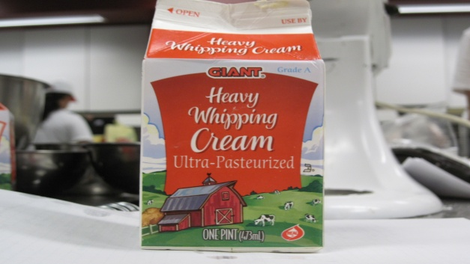
Heavy Whipping Cream used in the control recipe.

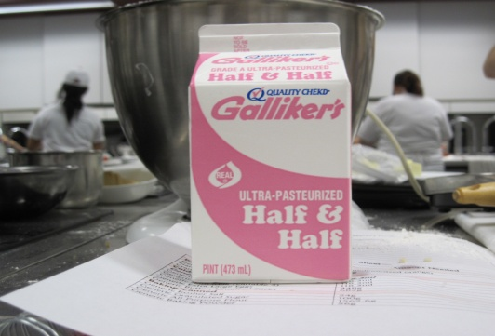
Galiker’s Half and Half used for Variable 1.
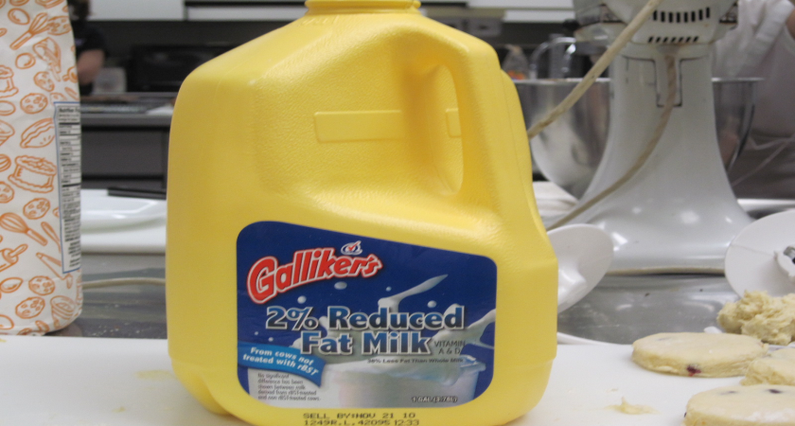
Galikers 2% Reduced Fat Milk was used as Variable 2.

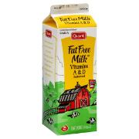
http://www.zeer.com/Food-Products/Giant-Vitamin-A--D-Fat-Free-Milk/000092681
Fat Free Milk used for variable 3

Appendix H
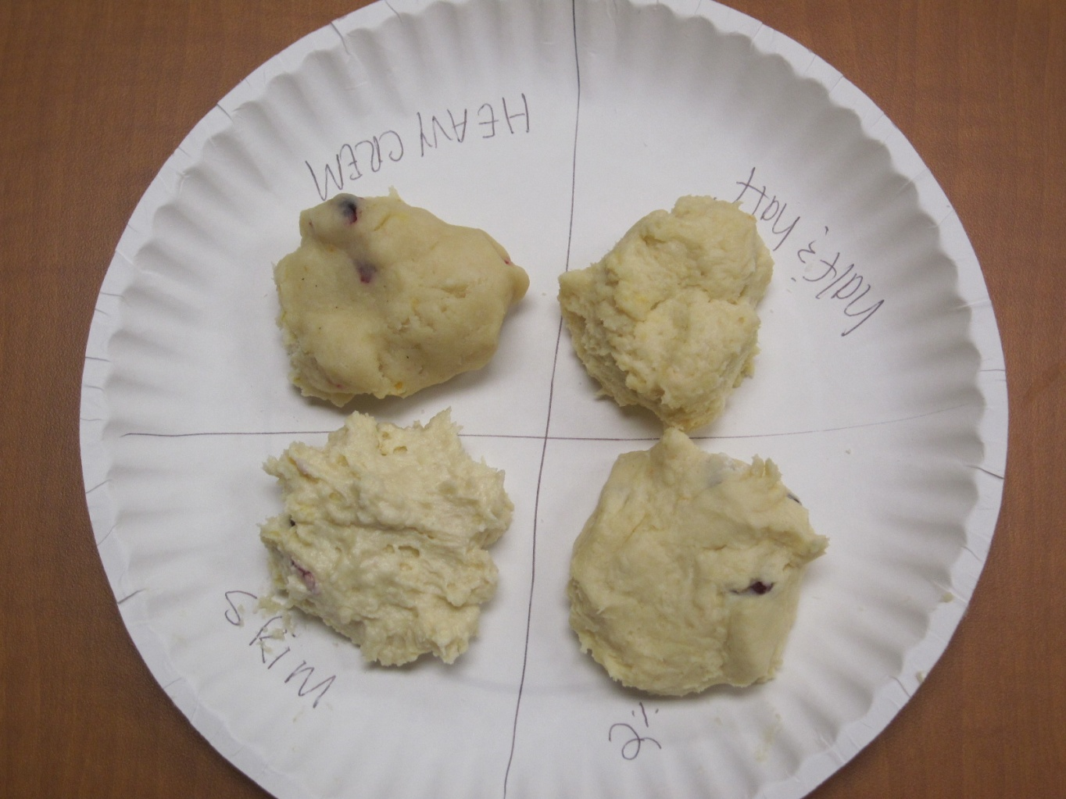
Note. Dough characteristics for each condition.

Appendix I
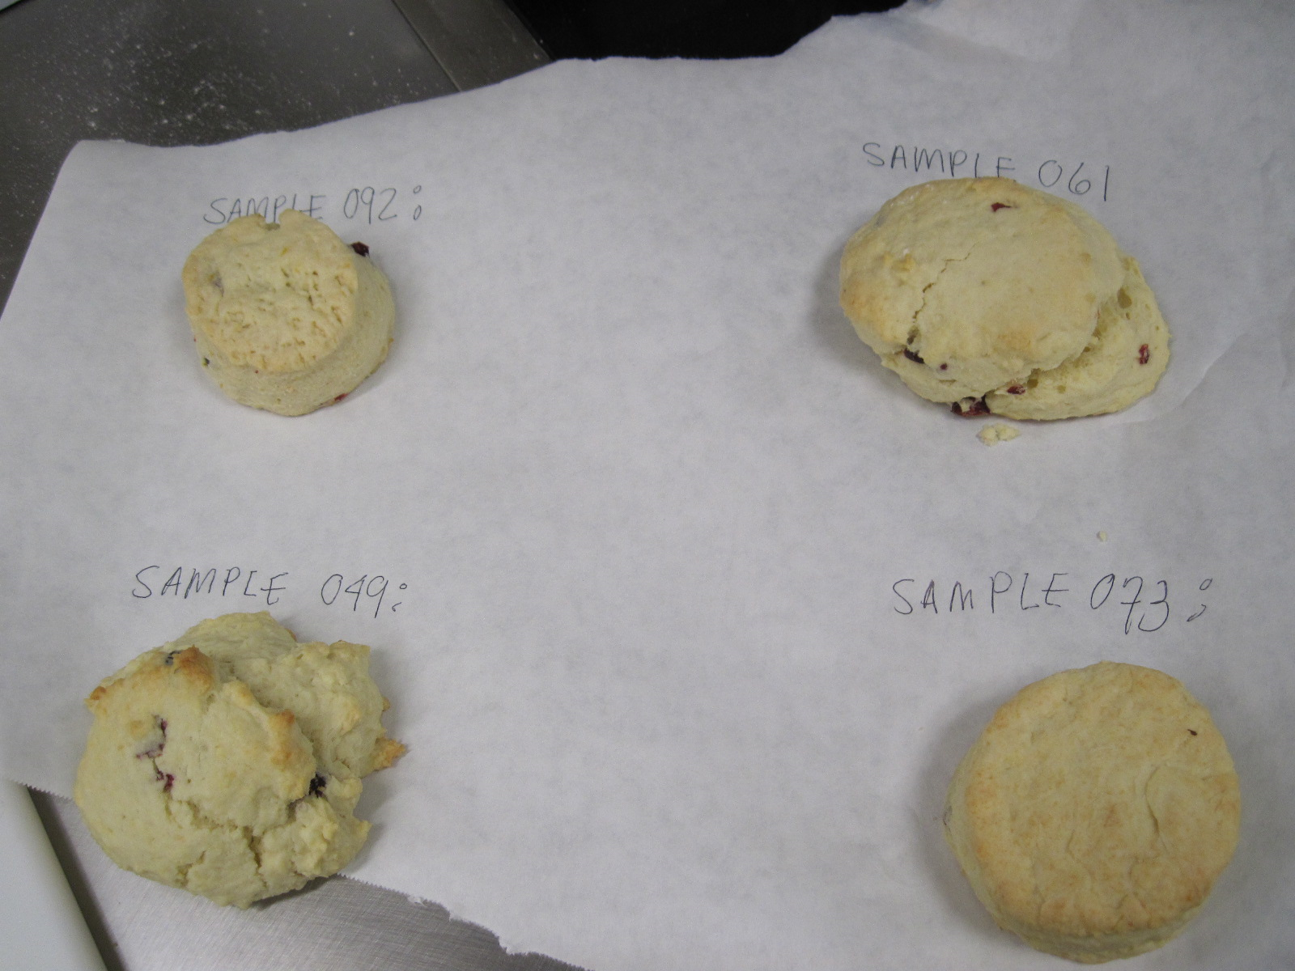
Note. O73: Half and Half 092: Control 061: 2% milk 049: Fat Free milk.
The half-and-half, and control recipes had the greatest physical appeal due to a conformed scone shape.

