Conestoga’s Public Relations program sets grad up for success
By: Hayley Halls

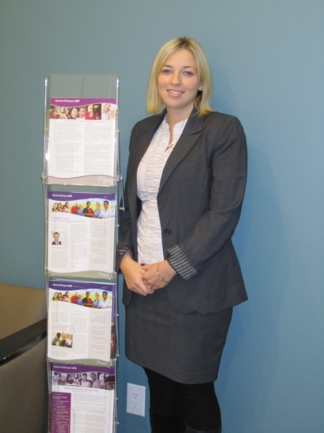

Connie MacDonald
Passion: it is a powerful, compelling feeling that makes people drive with desire and enthusiasm. While some have trouble finding their true passion, Connie MacDonald has always followed her own.
Graduating in 2005, Connie was a graduate of Conestoga’s first ever Public Relations diploma program. The 25 year old is currently working as a Communications Specialist at the Waterloo Wellington Local Health Integration Network (LHIN), and loves writing about patients’ health stories after they’ve opened their hearts to her.
When enrolled in the PR program Connie struggled when deciding which road to take and what field to pursue but her perseverance led her to a challenging work placement at the Grand River Hospital.
Thinking for two years that corporate PR was the field for her, Connie fell in love with the healthcare industry and worked her way up to becoming a Communications Specialist. “Doing this co-op gave me the heart-feel of non-profit but with benefits,” said Connie.
Having a determined, motivated and passionate personality along with the background knowledge and hands on experience from Conestoga’s PR program, people were amazed by her ability to succeed in all work environments. She stated, “You have to be willing to take chances to where you want to be, you can’t be scared or nervous.”
After three years of working at Grand River, Connie took a leap of faith and decided to broaden her horizons. She was hired in Parliament working in political communications and although she started with a ton of stress from 3 press conferences a week to announcements and endless speeches, Connie grew to excel and love what she did.
While still keeping busy with the things she loves like reading, exercising, and recently married hubby, Connie has worked at the LHIN for the past 6 months writing creative communications through their website and newsletters.
Through all of her experiences from healthcare and parliament, Connie believes, “If you want a successful career, you will get it, but you’ve got to want it”. Her determination, passion, and Conestoga skills have led her to be very successful in the PR field today.

Personal sidebar about myself:
Conestoga’s Public Relations course has embedded me with strong working habits. I have enjoyed becoming a stronger writer, doing various projects such as pitches, newsletters and creating my own campaign. I have learned throughout this assignment that passion and determination is key to happiness and success, and if you want something to never quit until it is achieved. Although my career and life after college is very much in the air I hope to explore many job opportunities in the PR field.

