Kalyn Hale
Classroom Management Plan

I believe classroom management is of paramount importance to having a high functioning classroom and successful students. Classroom management can be looked at from several angles. A safe, comfortable and stimulating environment helps the students take risks and participate in active learning. Clearly displayed and discussed rules and routines with consistent enforcement of those rules ensures students are aware of expected appropriate behaviour in the classroom. Engaging lessons with technology and hands on learning will keep the students focused and interested in learning. Fostering a sense of community and mutual respect reduces social problems in the classroom and gives ownership to students and prepares them for their rights and responsibilities as citizens.
Philosophical Statement
I am dedicated to making my classroom a fun place that students are happy to come to every day. I believe that engaging lessons with colourful or technological “hooks” and hands on learning will help the students to focus and will reduce behaviour problems. Lessons should be geared to student’s interests and should involve input from the students themselves. I believe in having choices for the students and allowing creativity in all subjects not just art. I plan to integrate most of my subjects whenever possible to ensure that curriculum is being included from all disciplines allowing for students with different strengths and preferences to be accommodated. I am passionate about having a fair and democratic classroom where all the students feel they have a equal chance and a voice. I want to promote the classroom community by giving the students rights and responsibilities. I will encourage them to think outside the classroom to make connections to their own neighbourhoods and to the global community. I will reward empathy and teach respect. I will motivate students to think critically and to challenge new and old ideas.
I also believe in praise and consequences. Positive reinforcement when used correctly can help build children’s self esteem and maybe even help them find their place in the world. I don’t believe in false praise but in well thought out compliments and constructive criticism. Consequences should be used after a deliberate warning for infractions of the rules. Students should be involved in deciding consequences whenever possible. Most consequences should be reparations directly related to the infraction. However students should feel comfortable expressing their emotions when needed and no child should be consequenced for displaying emotions openly.
I also believe in structure and routine. It is important that students have clear expectations for their behaviour which can be addressed through structure and routine. Routine should be well established from the moment they arrive at school to the time they leave. This helps students feel safe and secure and allows them space to take risks and challenge themselves without risk of being embarrassed or ignored. I hope to keep an open door policy and if students need one on one help they can come talk to me at any time. I plan to stay after school to complete my lesson planning and first thing in the morning I will be there prepared and ready to greet them as they arrive.
Room Arrangement
I believe that the classroom environment is important to student learning. I hope to have technology in the classroom as much as possible and to have the students sitting in desk groups of 4 or at table groups. In my ideal Ontario classroom you would walk into the room and be facing my desk so that I can see out into the hall and be close to the door. On the other side of my desk would be a kidney table where I could do guided reading and work groups. It also will act as a work space to display supplies that the students can come pick up for hands on activities. Behind it is a water fountain and sink for washing up art supplies and washing hands for nutrition breaks.
The students will be seated in group in the centre of the classroom according to who works best with who and with appropriate elbow partners. These may change from time to time. To the right of the room there are computers, ideally 3 or more but realistically whatever the school can afford. To break the room into sections there will be a storage chest beside the computers that will act as a display surface for books and storage for supplies that are accessible to the students. The other section will have a circle carpet with a few extra pieces of carpet in case students don’t all fit on the circle. There will be a book stand behind the carpet area that students can choose from for silent reading and reading buddies. There will be more shelves on the other side of the carpet which will create a cozy and less distracting space. Above the shelves will be a whiteboard which I can use to brainstorm or write things during a lesson.
At the front of the class will be a smart board with a document reader which I can use to make engaging lessons that the students will enjoy and will provide lots of visual instruction and examples. I also plan to have a tv in the classroom with a dvd and vcr because I find that video can be a wonderful tool for learning and it could branch into things like class news casts and maybe student run productions and creations. I will have bulletin boards displaying student work and anchor charts that we have worked on together as a class. I don’t plan on having many things on the walls at the beginning of the year but many things by the end because students will have created them.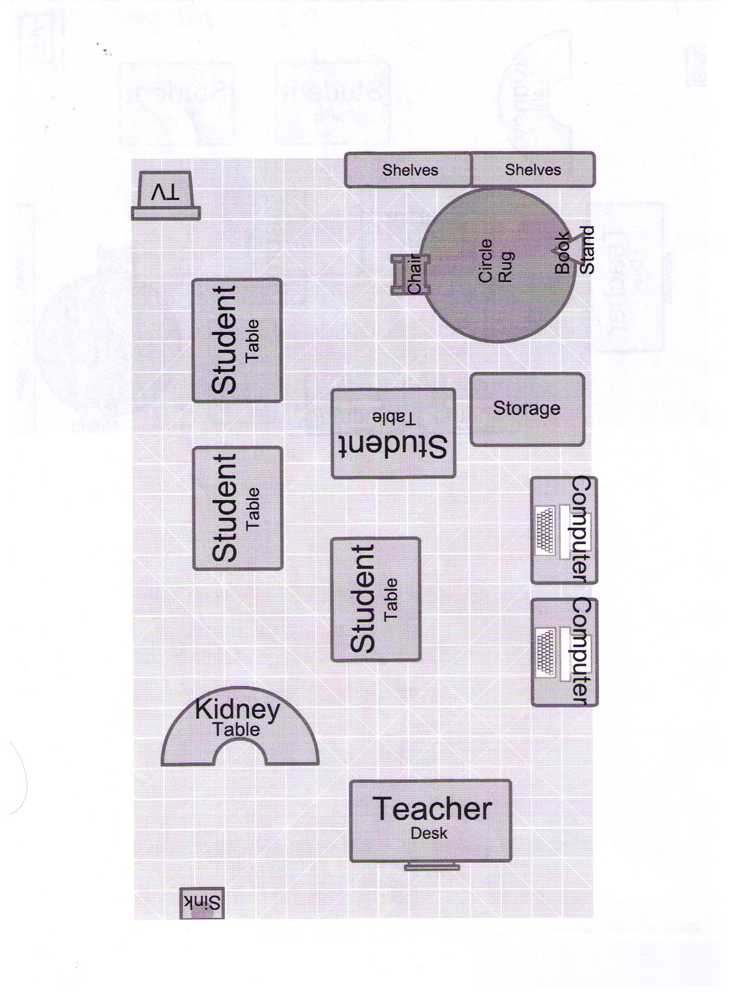 Classroom Rules
Classroom rules will be arrived at through a discussion on the first or second day. We will learn brainstorming techniques by having students shout out ideas as I jot them down on chart paper. There will also be scrap paper passed around for students to write one anonymous rule on then put in the basket. Then we will write a good copy incorporating some of the anonymous rules and some of the jot down ideas as well as many of my own that I reserved the right to add from the beginning. I will then pass out coloured construction paper so students can choose a colour and trace their hands and cut them out. Then depending on the age of the child they will draw on or sign them and tape them to the good copy of the rules which will be displayed on the wall.
I may also have an anti bullying contract which I will draw up and have students sign as a class but that will depend on the grade and the class. I will inform parents of the major rules (especially anything that concerns them such as banned items etc.) in the monthly newsletter and the principal will be invited to come look at our list when he or she comes to the class.
The rules will be mainly things the students come up with (within reason) and then my personal rules will be added if anything is forgotten such as respect one another, ask permission before you borrow something and always return it, clean up your own mess, ask 3 friends then me. There will be specific routine rules but they will be outlined verbally and by lively demonstration rather than a list on the wall. There will also be a discussion about consequences for breaking the rules (on a separate day) and the students can come up with their own suggestions for consequences. Ultimately it will be up to me to decide which consequences to apply but I hope to have their input as well.
Classroom Procedures
I intend to borrow some of the same procedures my associate teacher used. We were always in the hallway to greet the students as they entered the class. The students knew to sit down and take out their agendas open to the correct date and deposit any forms or money into the bin on the desk and then take out a book a begin silent reading. When all the students were seated the teacher would walk around and look at agendas, checking for notes from home and homework completion. The date would be prominently displayed as well as the plan for the day. I plan to open the day with a quick discussion about the plan for the day so that students know what to expect and students can voice any concerns at this time or tell an important story if needed.
Lessons will start by a clapping response rhyme where students have to repeat the clap and tone of the teacher calling. They will finish the same way when it’s time to pack up. I will frontload lessons by telling students what to expect for the hour. Then provide a hook and a short lesson. The students will hopefully do a hands on practice and usually with lots of group work.
Regarding student movement I will have routines like a pencil bucket for exchanges rather than sharpening. I will have a card that students have to take and put on their desk to say they are in the bathroom so only one student can go at a time. I will frontload group and independent work by telling students what volume level I am expecting during the activity. I will make sure to answer any questions and have the students recap the instructions to make sure they understand before I start any activity.
As far as assessment and grading goes I will give exemplars to students before an activity that will be assessed and tell them what they need to be successful. I will show them the difference between a level three and a level four so they can strive for top marks or be aware of what they will get before they get it. I will give students a chance for make up tests and assignments if they do poorly. I will keep parents informed through periodic notes in the agendas and a monthly newsletter. I may even have a website that I will update weekly with news and student work.

Behaviour Management
I intend to encourage students by using positive reinforcement when they do good work or display appropriate behaviour. This would include things like praise and recognition as a reward rather than candy or toys. I will have a shout out board where I will write students names who have done a good deed that should be recognized. The students can even give each other shout outs for doing something positive and at the end of the day I will read them out (only if appropriate though) and place them on the shout out board. There may be a student of the week prize as well giving them a special privilege like first out for recess all next week or a choice between three privileges.
Students that are displaying negative behaviour will be given 2 chances. First I restate the rule e.g., “We listen to the teacher when she is talking.” Then I give a warning like “Johnny, if I hear you whispering again you’ll be sitting on the thinking chair.” Then follow through if I hear him again I say “Johnny go to the thinking chair now please.” I will use tone of voice appropriately and model polite behaviour and respect with my students and expect the same in return.
I also believe in the three basket approach discussed in class which is having three categories of behaviour. When a negative behaviour arises you can place it in one of three categories; deal with immediately because it is serious, planned ignoring, deal with later when there is no audience. I also believe in using non verbal intervention before verbal intervention. Just a simple look or proximity can work wonders. Also when trying to maintain silence or quiet non verbal is more effective because it creates no additional noise and they can see that you are serious.
For more serious infractions of the rules such as bullying or situations involving multiple incidences or whole class participation I will bring the class together for a discussion where people can voice concerns and be heard. I will give bullying talks and teach kids the importance of being the one who stands up to bullies and stands up for their classmates. I will reward those behaviours and keep a tight reign on bullies watching them closely and having private counselling talks (with another teacher in earshot). Another strategy for bullies is to give them a job or some sort of control in the classroom such as “plant caretaker” so they feel like they have some power since bullies often are just trying to get some power.
Conclusion
I believe I am a fair, fun, flexible teacher with both patience and empathy. I care about maintaining a safe space for all students to take risks and about promoting the classroom community. I intend to keep the classroom running smoothly through clearly defined rules, routines, and procedure. I believe my behaviour management style is mainly using positive reinforcement and the three basket approach and I think a well designed environment with engaging lessons tailored to the students interests will give students effective boundaries within which they can grow, explore and get excited about learning.

