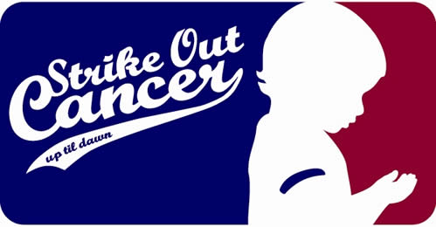
Spring Letter Writing Event
- When: March 16, 2011
- Where: McMindes Hall (Room by the front doors)
- What: Spring Letter Writing Event
- Why: Save a child’s life one letter at a time
- Time: 6:30 p.m. – 9:30 p.m.
- Hosted by Up ‘til Dawn
There will be FREE pizza and pop, and we just ask that you bring at least 30 addresses for your letters. Bring a friend and help make a difference in the life of a child. All proceeds go to St. Jude Children’s Research Hospital.

For more information contact Megan Colson at mecolson@scatcat.fhsu.edu and join us on Facebook! Remember cancer is NOT prejudice!
- Finding Cures Saving Children -

