All Student Email: Cancer Sucks
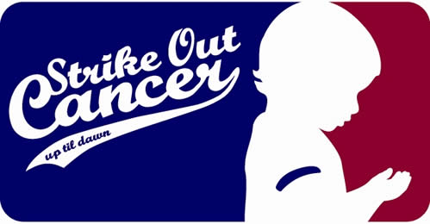

Miss your chance to attend the Up ‘til Dawn annual letter writing event? You’re in luck! The Executive Board was so pleased with the turnout from fall semester they’re hosting another letter writing event! The board has a team goal of raising $40,000 and we need your help to reach our goal.
- When: March 16, 2011
- Where: McMindes Hall (Room by the front doors)
- What: Spring Letter Writing Event
- Why: Save a child’s life one letter at a time
- Time: 6:30 p.m. – 9:30 p.m.
There will be FREE pizza and pop, and we just ask that you bring at least 30 addresses for your letters. Bring a friend and help make a difference in the life of a child. All proceeds go to St. Jude Children’s Research Hospital.
Up 'til Dawn is a student-run program that raises awareness and funds for St. Jude Children's Research Hospital. By joining with other students nationwide, you can help support the lifesaving treatment and research performed at St. Jude. For more information contact Megan Colson at mecolson@scatcat.fhsu.edu and join us on Facebook!
Remember cancer is NOT prejudice!
St. Jude is the only pediatric cancer research center where families never
pay for treatment not covered by insurance. No child is ever denied
treatment because of the family’s inability to pay.

