Café Za Za

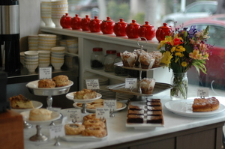

A Gluten-Free lifestyle shouldn’t limit options.

Café Za Za brings flavor and variety to the gluten-free lifestyle. Café Za Za offers all-natural, organic and delicious alternatives free from wheat and gluten. Café Za Za prepares delectable menu items, which promise to please the pickiest of restaurant goers. Café Za Za uses only the freshest and locally grown ingredients available. So go ahead… Discover great taste, and feel good knowing that Café Za Za is committed to helping you lead a healthy and satisfying gluten-free lifestyle…naturally!
Located at 2324 Shartel in the Paseo District. Phone: 873-0987

