Social Judgment Theory
Wouldn’t you like to be this man who is breaking social
and cultural norms with his attire. Both western
professional and eastern professional. Be sharp, classy,
and ready to take on the world from anywhere. This is
what NAPALI can do for you.

National Pacific American Leadership Institute (NAPALI)
This print ad addresses the Social Judgment Theory, which emphasizes and examines “how persuasive messages are processed”. (Frymier and Nadler, p. 76) In this particular approach, the audience can see a message and relate it to a certain perspective. For Polynesians, this picture conveys a very interesting message; some people agree with it and others do not. This man is obviously a Hawaiian who does business in the business suites (Western Culture: U.S. and European standard). Those who do not agree with the message probably believe more in a more traditional way of doing business: face to face and by word of mouth. These tactics have proven somewhat ineffective in growing NAPALI’s audience, so it is time to demonstrate other possibilities without taking away the key component: An Asian man who appears to be on business in the Pacific Rim. The Social Judgment Theory would examine this ad as being a mid-point between eastern and western business practices: A lay for the East (Eastern standard of doing business) and the business suite (Western standard in business practice.) Over all, there are an infinite amount of possibilities and different scenarios that individuals in the Pacific Rim may support when emphasizing business practices and cultural norms for doing business.

Main Audience
The main audience which NAPALI is trying to reach through this theory are men and women who have multiple and wide ranging views. This ad could be promoted for those who are conservative and more traditional while also appealing to those who use 21st century tools from a more western point of view. This ad illustrates two separate cultures integrating business/communication. Because of this, the ad addresses multiple audiences from different points of view, ultimately bring in more individuals who can teach each other about common business practices in their cultures. It is important when reaching the audience that the message clearly represents what is going on in the picture, ultimately demonstrating the process in action.

4 Messages
- Multiple views/opinions in proper business practices used throughout different cultures are important to acknowledge and learn in order to attract a wider array of an audience.
- There are many more views other than the extremes.
- Our outer appearance in business is important, but clothing can seal a deal for multiple audiences if used in a interchangeable way/message.
- Investments change between people of different cultures; demonstrating this in an ad is important to build diversity and learn new or appropriate practices for investments.

Images Created from multiple images found on Google.com

Specific Sites include:

Picture found at:
http://www.gettyimages.com/detail/200020351-002/Riser

Balance Theory on next page

Balance Theory
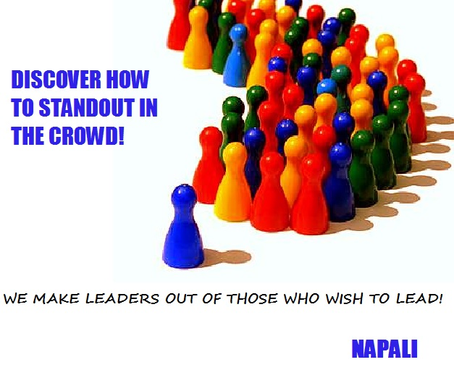
Here at NAPALI we make leaders out of those who wish to lead. It is time to jump out of the line with the followers and try the program for yourself. Within a few short months you could be using newly learnt leadership techniques to guide and strength your relationship with other Pacific Islanders and their communities. In the interest of your future, it just may be time to take the program and experience these promises for yourself.

National Pacific American Leadership Institute (NAPALI)
The Balance Theory is based on one person and then another person or multiple people/ with a similar outlook on a common product that they either both support or oppose. In the Balance Theory, there are always all positive or all negative evaluations of the product in question. In this ad, the product is mentioned in the bottom right corner but not specifically pointed out through the graphic. The graphic above also illustrates:
The front Blue Piece demonstrates the ability to be a leader and NAPALI represents the vehicle in which to develop the skills of leadership. The other pieces represent the people who want to gain these skills NAPALI is offering. This may suggest that the crowd would like to be the leader which is also a positive stance to NAPALI’s program and outreach.
Main Audience
The audience of the future fellows will be enticed to be a leader by viewing the well organized multi-colored pieces following their leader. If we would assume that the pieces represent individuals then we would also assume that the leader put together this organized group. Since the leader is now representing NAPALI’s program, more people will see the positive evaluations of these participants with the product. As a consequence of instinct, positive evaluations generally generate positive responses, ultimately helping NAPALI gain a diverse audience across the Pacific Rim.
4 Messages
- If you want to be this well organized as a leader, NAPALI builds and maintains leadership
- Those who can follow with structured behaviors make the best leaders
- Don’t be afraid to stand out, make a difference by leading others who are like you
- Those who wish to lead already know that they are meant to lead with NAPALI’s program as a tool for the transition.
Images Created from multiple images found on Google.com
Specific Sites include:
Picture found at: http://liicoo.com/Product%20Management.html

Congruity Theory on next page

Congruity Theory
On a nice warm day, friends gather to change the world one community at a time. Their strength, hope, and love for one another create a balance which promote prosperity over the environment. Friends of Pacific Islander communities support NAPALI because it is NAPALI who gives back to the communities by enlisting individuals with the desire to make an impact. Become a friend of Pacific Islander communities and you will realize why they support NAPALI.

National Pacific American Leadership Institute (NAPALI)
This print ad addresses the Congruity Theory, which suggests either associative assertion or disassociative assertion by linking a person or people to a particular product. The ads under this theory are generally simple without any clear connection of why the person or people are associating with the product. In the graphic above, there are a group of people holding hands with each other simply showing the audience that they are connected and or are friends. The heading expresses that they are friends and that they are in support of NAPALI. Explained another way to explain this would be to say that the individuals pictured are linked together through associative assertion based around the NAPALI program.
Main Audience
The main audience has not changed in this theory; still both the future and current Fellows (graduates of the NAPALI leadership program. This ad depicts friends or people who know each other holding hands in support of NAPALI. After reading the headline, the traditional audience should feel like they are a friend of Pacific Islander Communities thus they should check into NAPALI because they are also friends of Pacific Islander Communities.
4 Messages
- If NAPALI are friends of Pacific Islander Communities and I am a friend of Pacific Islander Communities, then I should be involved or a friend of NAPALI.
- Unity is the foundation of strong and lasting friendships that last forever.
- NAPALI brings “friends” together.
- Any friends of Pacific Islander Communities are also friends of NAPALI

Images Created from multiple images found on Google.com

Specific Sites include:

Picture found at:
http://www.ralizadeh.com/groups.html

Cognitive Dissonance Theory on next page

Cognitive Dissonance Theory
When you are looking for direction, don’t use a map.
NAPALI is here and we will give you a direction with purpose,
Where you no longer feel out of place and where others will see you
as a role model.

National Pacific American Leadership Institute (NAPALI)
This print ad addresses the Cognitive Dissonance Theory, which works off dissonance between two objects. In this graphic, the two people are traveling and looking for a certain direction. In the headline the word direction appears to point out that they are using a map to find direction, but really what they need if they want to find direction in life is the NAPALI leadership program. This theory is based in psychology, but in marketing can appear through different situations such as the one listed above. This ad is calling out physical dissonance which is a bit different then mental dissonance working off different objects being analyzed and evaluated. This theory is based on thinking and may or may not make sense to people depending on their place in life or the education needed to make the comparison. Overall, this theory can be useful to spark interest and have audience members think about the product after the message has been completed.
Main Audience
The main audience has not changed, but is looking for the thinkers of the Fellows. In order to understand this ad for being an example of cognitive dissonance theory, a person would probably need some educational background analyzing different physiological or marketing theories. As people look at this graphic, it is the goal to attract an audience open to discovering new direction for their life while also demonstrating a sense of how direction can be applicable to real life scenarios such as map finding skills with a more specific direction in mind.
4 Messages
- We at NAPALI wish for others to understand the importance of good direction in an individual’s life for both the present and future times.
- If you are looking for direction or confused about where to go, check out NAPALI as a source to remedy the situation.
- We confronted with a problem; good direction can be a lifesaver.
- Be a part of a program which promotes safety, practice tools, and knowledge which will help you through life.

Images Created from multiple images found on Google.com

Specific Sites include:

http://www.gettyimages.com/detail/3347887/Hulton-Archive

