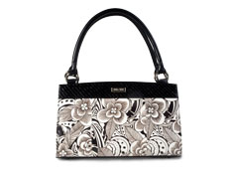
MICHE®
------BAG------

The Ins And Outs Of This Amazing 3 Step Bag!

Table of Contents
About Miche Bag, INC:
Pages 3-4
Miche Bag 101:
Pages 4-5
Opportunities through Miche Bag:
Pages 6-8
Giving Back-A Miche Tradition: Pages 9-10
Contact Information:
Page 11

How Miche Bag Came to Be...

O
n her way home from work in the fall of 2004 Michelle Romero did something most women have done—she spilled coffee on her favorite handbag. Frustrated by the thought of hunting for a replacement then transferring all the contents, she wished there was a way to just change the outside of the bag. The idea immediately popped into her mind to create a bag with changeable covers. Not to be deterred by her lack of sewing skills, Michelle grabbed her super glue and some scrap fabric, took apart the stained bag, and made the very first prototype. With her rough creation in hand, Michelle set out on a mission to bring the Miche Bag to life.

How Do You Pronounce That Name Again?
Michelle felt that the name would be a very important part of the product. After brainstorming many ideas, the name “Miche” (pronounced, “MEE-chee”) was suggested after the nick-name Michelle’s mother-in-law gave her. All of our interchangeable Shells bear women's names too.

A Company is Born
Michelle shared her initial idea and concept with two reputable businessmen, Corbin B. Church and Chris Seegmiller. Corbin had experience running successful businesses and Chris had a background in importing and exporting. The combined expertise of the two put Miche Bag firmly on the road to success. Under the guidance of CEO Corbin Church, Miche Bag has experienced tremendous growth and its employees are excited about the future of the company. Recent growth includes new products being released monthly as well as expansion of the business into international markets.

Miche Today
We think Miche Bags are one of the greatest gifts to womankind since waterproof mascara, and we're always looking for enterprising women just like you to help spread the joy around. If you are looking for a rewarding career with an up-and-coming "now" company or if you want to host a Home Party in your neighborhood, be sure to check out the many opportunities offered by your forward-thinking partners in fashion at Miche Bag. And to think, it all started with a spill!
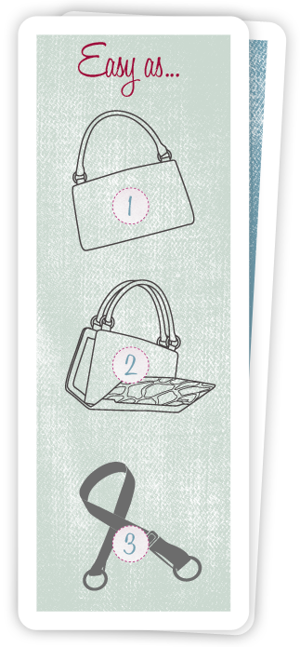
One Bag— Endless Looks!
Being a Miche fan means never having to switch purses again— it's a beautiful thing! You put all of your essentials in just one bag and never have to bother with moving it all to a different purse each time you change your outfit. Imagine—you will always know where your favorite lipstick is!
You start with a Base Bag—Classic, Big Bag, or Mini—then add any one of our stylish Shells and you're ready for your busy day. Which "you" are you feeling like today? Sophisticated? Flirty? Fun? All business? No problem. You can give your Miche Bag the exact look you want in 3 seconds or less. Now that's instant gratification!

Life is Complicated—Ordering Your Miche Bag is Simple!
Your day is busy, busy, busy—but ordering your Miche Bag is a snap! Simply:

Select your Miche Base Bag: we have 3 sizes for your convenience—Classic, Big Bag, & Mini.

Choose your Miche Bag Shells:
We have a wide array of stylish and affordable Shells to select from — one for every occasion, outfit, and mood! So relax, take your time, and discover your inner Miche. Depending on your Base Bag, you will find just what you've been looking for in our exciting selection of Mini Shells, Classic Shells and Big Bag Shells.

Voilà—a new bag! Don't Forget to Accessorize! You can create a truly unique look that's all your own thanks to our wide selection of stylish straps and other extras from our Accessories.

Style, Convenience, Affordability—It's in the Bag!
If you're like most women, you pay a fortune for handbags you may only use a couple of times—then they just sit in your closet gathering dust! A Miche Bag allows you to keep all your essentials in just one purse, frees up your closet space for more important things (like more shoes!), and gives you the freedom to enjoy the latest styles anytime you want without draining your bank account. So you. So now. So Miche. Who says you can't have it all? With Miche Bag—you can!

Making Money With Miche Is In The Bag!
Miche offers you opportunities to earn free product and/or make money in a variety of fun and exciting ways. You're already crazy about our products—why not make it a career? How much or how little you want to do is entirely up to you. So what are you waiting for?

Host a Home Party — It's Fun and Lucrative Too!
Sigh. You love your Miche Bag… don't you wish everyone you know could have such a great purse? Now they can! Help your neighbors, friends and coworkers discover the fashion and convenience of Miche Bag by hosting your very own Home Party: at your home, during your lunch hour, at the park, or wherever you want to enjoy a fun and relaxing party with the most important women in your life. Miche Bags are a product that women actually love and need!

- Have a fun evening with friends
- Earn Free Product
- Share your love of Miche with others

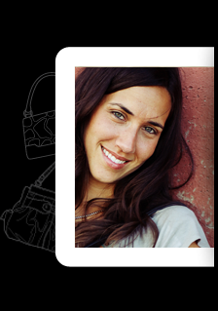
Be a Sales Representative — Your Business. Your Way.
With Miche Bag, you really can have it all: a rewarding and fun career, and the time you want with your family. Do as much or as little as you want. On your own terms. Your way. With no limitations. Yes you can! When you become a Miche Bag Independent Sales Representative you are in control of your own destiny - and you do it with panache and style.

- Flexible: You'll never have to sacrifice going to soccer games again.
- Independent: You are your own boss. Always.
- Secure: Miche Bag is a well-established, international business. You are in good hands!
- Peace of Mind: Earning extra money is a very good thing… you'll sleep better at night.
- Rewarding: You'll help hundreds of happy women fall in love with their purses again.
- Chic: We are always on the cutting-edge of style. Be a part of something beautiful.
- Fun: Because earning a great living doesn’t have to be boring

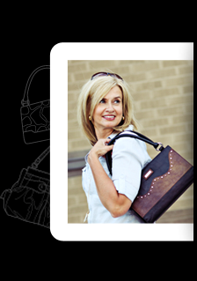
Be an Authorized Distributor— Making Miche Magic with Us
Miche Bag is the hottest thing today in the competitive handbag marketplace. It's what a girl wants. It's what a girl needs. And you can be a part of it by running your own Distributorship business! As an approved Miche Bag Authorized Distributor you offer our chic and happening products via Home Parties and other exciting venues. Some of the benefits include:

- Being an independent business owner and selling a hot product.
- Managing your own team of Sales Representatives and helping them shine and succeed!
- Selling Miche Bag Products in authorized channels of distribution or, when authorized by Miche Bag, in qualifying retail outlets.
- Participating in Miche Bag-sponsored support, service, motivational and recognition functions.
- Participating in many promotional and incentive programs sponsored by Miche Bag for its Distributors.
- Freedom to choose your own hours and be your own boss!
- Real income potential.

Giving Back—a Miche Tradition

Because of the many wonderful things that have happened to our company since the launch of Miche, we often found ourselves asking, "How can we give back?"

Women's warm reception of Miche across the United States and around the world has been truly overwhelming to those of us who work at the Home Office. We appreciate the vast network of hard-working Distributors and Sales Representatives who market our handbags and accessories at Home Parties and other venues, and our amazing customers who have embraced the Miche fashion concept with open arms. With this feeling of gratitude in our hearts, we began seeking ways to make a difference in the world. Our ongoing, wildly-successful "Hope" program and our brand new Project 6 humanitarian efforts are great first steps.
It's about helping each other. It's about reaching out to others around the world. It's about actively spreading care, love and hope. It's about saying "I can do it." It's about—endless possibilities.

Inspired by the people she met and stories she heard at a local cancer treatment center, Chief Design and Production Officer Jennie Platt plunged into developing a Shell design that would reflect the personal feelings of hope displayed by those whose lives are affected by this terrible, life-altering disease. The first Hope Shell was released in early 2010, and a portion of the proceeds from the sale of each Shell was donated to cancer research.
The response was overwhelmingly positive; in its first year, the Hope Program raised hundreds of thousands of dollars—all of which went directly to fighting cancer. New Hope designs are being released on a regular basis, and this ongoing program is making a real difference in the lives of many.

Millions of good people throughout the world are suffering under the burden of extreme poverty, need and disease. Miche Home Office employees and the company's virtual army of Distributors and Sales Representatives are rolling up our sleeves and making a difference in the lives of those less fortunate. Beginning in 2011 Miche is sponsoring a program called Project 6, an ambitious effort to do a yearly on-location humanitarian project in six continents over six years.
This summer, Miche employees and entrepreneurs will be traveling to Lima, Peru at their own expense to provide much-needed relief and services to poor children and their families. Where in the world will we go next? We can't wait to find out!

Contact Miche Bag

Home Office
Miche Bag, LLC
10808 S. River Front Pkwy | Suite 150
South Jordan, UT 84095
[Ph] 801.566.4243 | Monday - Friday, 8 a.m. to 4 p.m.

Frequent Questions
For information about shipping, returns, and becoming a part of Miche Bag please visit our website!

Press Contact
Holly Taylor
hetaylor@rogersandcowan.com
Stephanie Molina
smolina@rogersandcowan.com

Customer Service
Phone: 877-716-4243 Monday - Friday 8am-5pm
Email: support@michebag.com

Top of Form
Bottom of Form
http://twitter.com/#!/michebagdotcom

http://www.facebook.com/officialmichebag

This guide provided by Molly Joy French, Capital University. Information from www.michebag.com
and sales representative Tara J. French

