Memo
Date: March 9, 2011
To: Dr. Sergey Rybas
From: Becca Hassain
Subject: Instructions Project: How to make movie in Windows Movie Maker

Dr, Rybas
For my instructions project, I decided to write a manual instructing others how to make home movies on their own computers. The target audience ranges from college students to everyday adult computers users. I previously had a lot of trouble figuring out all the little steps and finding all the tricks behind Movie Maker. Even when you go on the website for help, some of the instructions are unclear and sometimes do not work if you run into a glitch. My instructions are written in more of a booklet format with step by step instructions. I added visuals of icons so they user will know where the buttons are located. The document is divided into three categories; Creating the movie, editing, and publishing.

How to make a movie presentation using Windows Movie Maker

These instructions explain how to download Windows Movie Maker, how to add photos and videos to a new project, how to add audio, how to edit the movie, and how to publish the movie online. To successfully complete these instructions you need basic computer skills with Windows XP and internet access.

Background on Windows Movie Maker
Windows Movie Maker is a program that allows everyday users to create their own movies using personal photos or videos. You can add special effects including credits, captions, and music. The program also allows you to share your movie with others on social networking sites such as Facebook and YouTube.

Initial Setup
Getting started. To use Windows Movie maker you will need:
- A 600 or higher (MHz) computer with Windows XP Home Edition, Windows XP Professional or Windows XP Professional x64.
- You need at least 128 megabytes of RAM or 32 megabytes of VRAM memory.
Downloading the program. There are three ways to download the appropriate software
- Automatic Updates
- Turn on Automatic updates in Windows XP to load Movie Maker and receive any other updates
- Website
Go to http://windows.microsoft.com/en-US/windows/downloads/windows-live and click downloads.
- Scroll down and click on Movie maker icon
- Click Download Now at top of page
- Save file
- Click wlsetup-web.exe
- Continue
- Install all of Windows Live Essentials
- After its finished click close
- CD
- If first two options do not work, copy the program from a CD, which can be ordered from the Windows XP website.

Operation
Importing photos and video. In order to begin project, first you must add photos or video clips.
Follow these steps:
- Go to Start menu and click on Windows Movie Maker.
- On the home tab click add videos and photos.
- If you have photos saved in a folder click on the image and select Open. The image should appear in the window or in a thumbnail sequence to the right. The time length of your video appears underneath.
- Repeat steps 2-3 until you have selected all photos to be used in the movie.
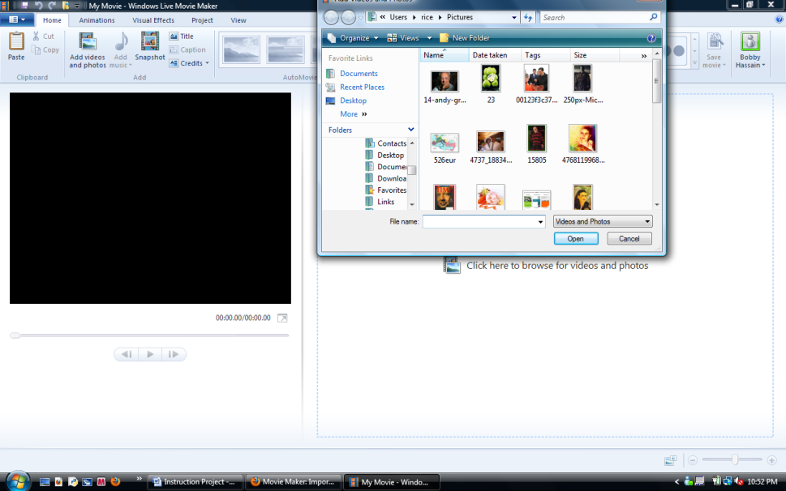
Note: If you want to add photos or videos from you camera, follow these steps:
- Plug in USB cord and power on camera.
- Click import from device and click OK.
- Select the device and click import.
- Click import all new items now and then click next.
- In the Import Photos and Videos window, fill in the check box for any photos or videos you want to use. Then select import.

Auto Movie
Auto Movie is a quick alternative. In the Auto Movie setting the effects and transitions are automatically set. Just import the photos or videos and music.

Special effects.
Title. Now say you want to add a title slide or opening credits.
- In the home tab, in the add group, click the title icon.
- Click in the text box and replace “My Movie” with your desired title.
- The Text Tool tab appears in which you can format fonts, choose background color, and select the entrance of the title. You can set when the title appears and how long it stays on the screen using Start time and Text duration. For example, if the title should appear 1.02 seconds into the slide, click the up arrow until it reads 1.02s. However, if you want the text to appear after one second, type it in.
- Click the up or down arrow to set how long the title should appear on the screen. For instance, text duration of 5.50s means the title will stay up for five and a half seconds.
Captions. Captions are useful for adding dialogue and explanations. To add captions, follow these steps:
- Click on the image and add your information in the Enter text here text box.
- Again, you can select the font size, color, Start time, Text duration, and the entrance of the text.
End Credits. To add final credits:
- On the home tab, click the Credits buttons. The down arrow gives four different options, Credits, Director, Starring, and Location. Select the desired credit title.
Importing Music. To add music you must:
- Click on the add music icon and then click add music again.
However, if you want a song to begin during a specific slide, follow these steps:
- Click on the add music icon and select Add music at the current point.
- After selecting the music file from the appropriate location and folder click Open.
- The Music Tools Tab should appear. Windows Movie Maker gives the option to have music fade in or out. To have the music fade in or fade out do the following:
- Under the Music tools tab, select the Options tab. Next to Fade in choose how fast or slow the music should fade in.
- Under the Music Tools tab, select the Options tab. Next t o Fade out
choose how fast or slow the music should fade out.

Editing
Trimming video clips. To trim video clips, complete the following steps:
- Select the video clip and drag the playback bar to desired start or stopping point.
- To set start point, go to the Edit tab under Video Tools and click set start point.
- To set end point, go to the Edit tab under Video Tools and click set end point.

Split video. Dividing a lengthy movie into separate parts can make the editing process easier. To split the movie, do the following:
- Select the video
- Drag the playback bar to the point in which you want to split the video and click Split in the Edit tab under Video Tools.

Editing music. Windows Movie Maker allows you to add music at any point in the movie. You
can choose when the music begins and ends.
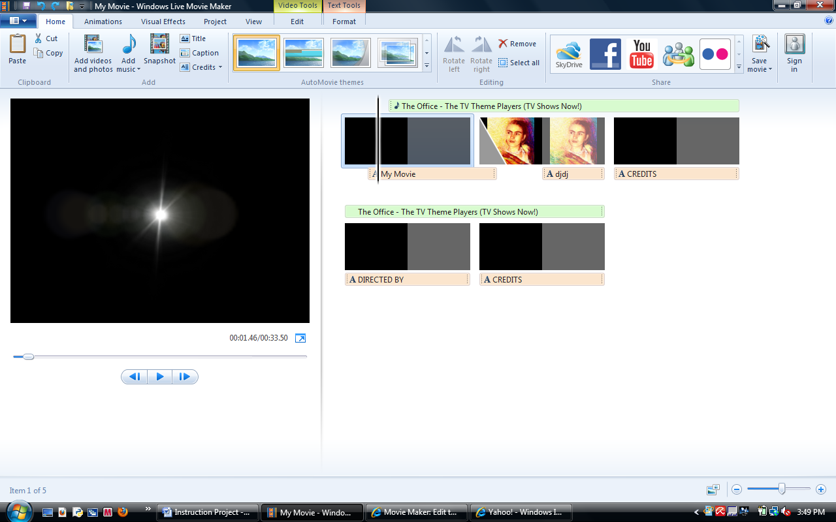
Trimming a song. You can also choose what part of the song you want to play in your
video. To do this, follow these steps:
- Click on the song, normally surrounded by light green, and drag the playback bar to where you want the music to stop or start.
- To set start point for music to begin playing, locate set start point in the Options tab under Music Tools.
- To set end point for music to stop playing, locate set end point in the Options Tab under Music Tools.

Publishing movies
Publishing. In a few easy steps, your movie can be seen by others all over the world. You
have to:
- In the share group located on the home tab, select the website where you want to publish your movie.
- Choose the resolution and sign into Windows Live. Once you are connected to the website, follow the subsequent directions.

Work Cited
Movie Maker: Import Photos and Videos." Windows Live. 2011. Web. 3 Mar. 2011. <http://explore.live.com/windows-live-movie-maker-import-photos-videos-using
?os=other>.

