Alaska Seafood Marketing Institute
311 N Franklin St
Suite # 200, Juneau, AK
907.465.5560
http://www.alaskaseafood.org/

FOR IMMEDIATE RELEASE
PRESS RELEASE 2 -NOT FOR DISTRIBUTION
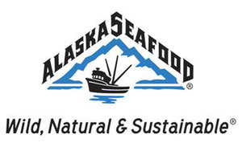
Alaska Seafood Marketing Institute Kicks Off Deadliest Catch Crab Cake Contest

JUNEAU, Alaska, May 1, 2011- Deadliest Catch captain Sig Hansen and Jonathan Hillstrand are using their off-season to team up with the Alaska Seafood Marketing Institute’s Director of Culinary Services, Ralph Coughenour, to search for America’s best crab cake.
The contest, which will run from May 1 to July 23 will culminate with the top four finalists serving a panel of judges, including Discovery Channels “Deadliest Catch” captains Sig Hansen of the F/V Northwestern and Jonathan Hillstrand of the F/V Time Bandit their creations, made from Alaskan crab meat.
The event will take place onboard the famous back deck of the F/V Northwestern during Seattle’s annual Seafair August 7th.
“Jonathan [Hillstrand] and I are very excited to work with the Alaska Seafood Marketing Institute this summer,” said Hansen. “Who knows, maybe some of the crab used in the contest was caught by us.”
One grand prizewinner will receive a cruise to Alaska abroad Princess Cruise lines and bragging rights for the best crab cake in America.

For contest details and entry information contestants should visit www.alaskaseafood.org for more information.

# # #

