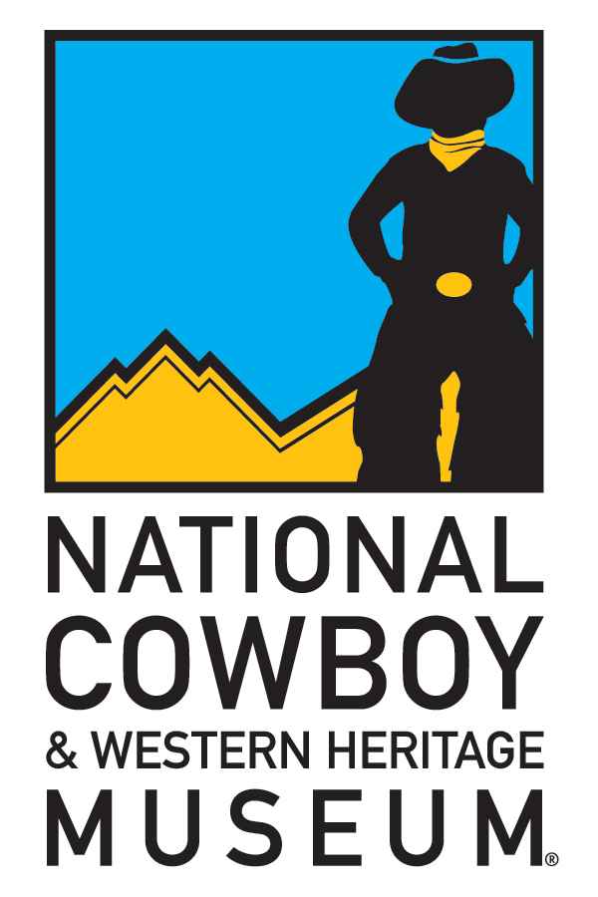
National Cowboy & Western Heritage Museum
Contact: Shayla Simpson – Director of PR & Museum Events
E-mail: ssimpson@nationalcowboymuseum.org
Phone: (405) 478-2250, Ext. 221
Fax: (405) 478-4714
Media Web Link: http://www.nationalcowboymuseum.org/info/MediaRelease.aspx?ID=296

FOR IMMEDIATE RELEASE
March 3, 2011

Learn about cowgirls and shady ladies at the National Cowboy Museum

OKLAHOMA CITY – The National Cowboy & Western Heritage Museum will be holding an adult education class about cowgirls and shady ladies, March 15, as a part of the ongoing Tuesdays At Sundown adult education program. This exciting class will be taught by Marna Davis, a costume designer and experienced fiber artist from Hitchcock, Oklahoma. Davis specializes in Victorian era clothing and holds many living history programs with her husband. Davis will discuss the “wilder side” of Victorian life: from the ranch woman, to the entertainer, to the saloon girl.

Davis has won many awards for her historically accurate costumes. She is very passionate about history and tries to “show history as it really was, down to the last stitch,” according to her website. Students that attend will be sure to learn a few things, while having a great time at the Museum. The class is free for members, and not-yet members are only $5 each. The program will be March 15, from 6:30 p.m. to 8:00 p.m.

The National Cowboy & Western Heritage Museum is provided support from Museum Partners Devon Energy Corporation, Chesapeake Energy Corporation and the E.L. and Thelma Gaylord Foundation.

For a complete Calendar of Events or more information about the Museum, go to www.nationalcowboymuseum.org or call (405) 478-2250.

###

