

## *Sponsors*

MC900149520[1]

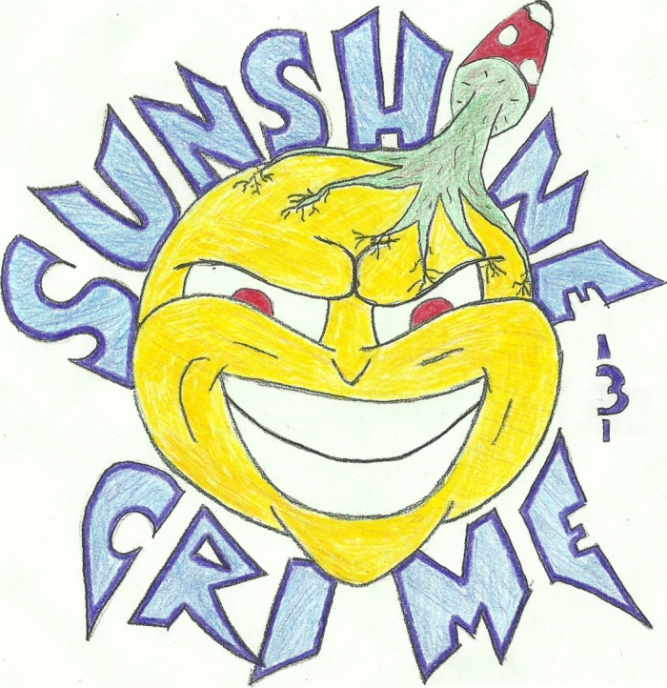

For more information and band registration please contact

Brad Nelms at nelmsb08@students.ecu.edu

Sunshine & Crime

Phone: (301) 996-2672

Web site: http://www.facebook.com/#!/pages/SunShine-Crime/111546988907023

Jammin’

for

Japan

|  |  |
| --- | --- |
| **Time** | Thursday, April 14 at 9:00pm - April 15 at 2:00am |
|  | |
| **Location** | Pirate's Den Downtown Greenville NC |
|  | |
|  |  |
|  | |
| **More Info** | JAM FOR JAPAN  Featuring: Josh Warren and the Revelation and Sunshine & Crime  Cover: $5 Event starts at 9pm Band plays at 10pm  Raffle Tickets will be sold at the door for $1 * Prizes will be given to the winners and there will be more than one drawing and plenty of chances to win prizes  Proceeds go to the AMERICAN RED CROSS to help Japan recover from the devastating disaster they have experienced.  Invite everyone because this event is for anyone and everyone to attend *If you don't go to ECU or PITT or don't live in Greenville come visit your friends who do  There will be Lots of Great Specials that night |

## Help Japan go from…

Ticket Order Form

Note: Remove and send in to address below.

|  |  |  |  |  |  |  |
| --- | --- | --- | --- | --- | --- | --- |
|  | | | | | | |
| Name | | | | | | |
| Address | | | | | | |
|  | | | | | | |
|  | | | | | | |
| Phone | | | | | | |
| E-mail | | | | | | |
| Method of Payment | | | | | | |
| ❒ | Check | ❒ | MasterCard | | |
| ❒ | Bill Me | ❒ | American Express | | |
| ❒ | Visa |  |  | | |
|  | | | | | |
| Credit Card No. | | | |  | Expire Date |
| Signature | | | | | |

Make all checks payable to Jammin for Japan



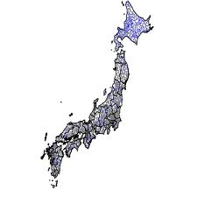

to



Jammin for Japan

312 E 11th St.

Greenville, NC 27858

Phone: (301) 996-2672

E-mail: nelmsb08@students.ecu.edu