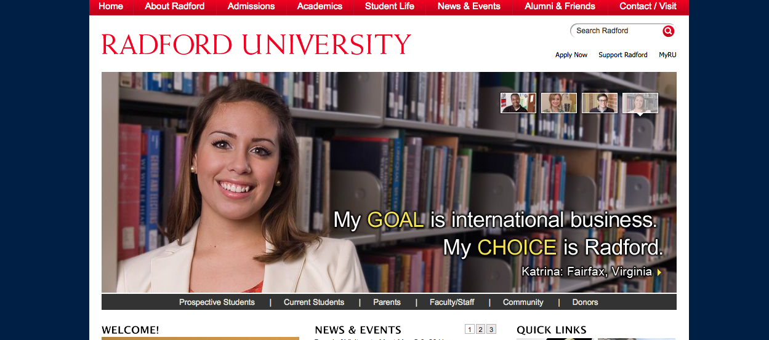

Radford University Revamping Website Design
Radford University hired Digital Wave Technologies (DWT) to take on redesigning their website to make all the pages more similar and navigable.
Even though creating a new website is their essential goal, the representatives from Digital Wave Technologies like to believe that they are, “rethinking your online presence.”
One of DWT’s goals was to redevelop a website where there was a user-centered purpose. To do this, they first started off by researching students, faculty, staff, departments, etc... to find out who RU’s audience was and how they could better reach them. They also wanted to research areas the current website needed to improve on to avoid problems it had in the past. DWT wanted to do all these things while still being able to manage the website effectively for a long time to come.
Robert Stepno (Radford Professor and web producer) believes that some parts of the university's webpages will work for now but, "others are poorly designed, use outmoded technologies like frames and tables, or have broken links. The site looks like no one was "in charge" of enforcing any consistency -- even to simple things like the Highlander plaid versus bold red, versus the beehive logo."
After all of DWT's research they determined that main problem current Radford University website lacked was consistency from webpage to webpage, and was relatively difficult to navigate from webpage to webpage. When navigating the current RU website, the design layout changes and the user has to relearn and accommodate to each individual page making it difficult to achieve their objective.
"Some inconsistency and messiness is natural after 15 years of Web development at a decentralized organization with several changes in leadership, budget cuts, etc. Upkeep is probably in rough shape because old pages weren't well documented, or because staff assigned to update them were given little or no training -- with care of a site added to other secretarial or administrative duties, or because maintenance just wasn't a priority," Stepno said.
The new Radford.edu will consist of a right balance between consistency and individuality. This means that when a user will know that they are navigating through the Radford website and know what individual webpage they are on without getting confused.
The redeveloped website will also have a “powerful Content Management System” to allow users to edit and manage content in their individual Radford webpage easily.
The redesigning process has been several months in the making, and no specific launch date has been set as of yet.

