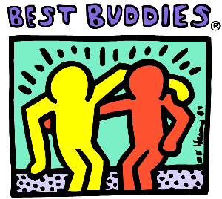
Dec. 16, 2010 Contact Information:
FOR IMMEDIATE RELEASE Heather Schatz
Communications Director
(305) 374-2233 Ext. 207
heatherschatz@bestbuddies.org

BEST BUDDIES CAMPAIGN BEGINS IN OKLAHOMA
MIAMI, Fla. – Buddies in Oklahoma is a campaign that will help to establish Best Buddies programs throughout the state of Oklahoma.
Best Buddies is a non-profit organization that helps create opportunities for one-to-one friendships, integrated employment and leadership development for people with intellectual and developmental disabilities.
Dessi Tzankova, junior at Carnegie Mellon University, met her buddy three years ago through CMU’s Best Buddies program, according to an article on Central Michigan Life’s website.
“People should join because you get more out of it than you put in,” Tzankova said. “When you see your buddy, your worries fade.”
Buddies in Oklahoma will include the five programs that Best Buddies has to offer; Best Buddies Middle Schools, Best Buddies High Schools, Best Buddies University, Best Buddies Jobs and Best Buddies Citizens.
Best Buddies has positively impacted more than 700,000 individuals in this year alone, according to the Best Buddies website. For more information about this campaign or questions on how to get involved, please contact Heather Schatz at (305) 374-2233 Ext. 207 or heatherschatz@bestbuddies.org
###

