Native America

By:
Sloan M Folk

Have you ever wondered what the Creek Native Americans do to celebrate their culture? Since they still have traditions from long ago. Or maybe you’ve learned about Creek Native Americans sitting in history class, but all they told you was about the “Trail of Tears” and various different treaties. Yet, that doesn’t answer any questions about the Indians of today. Some as you may know live on reservation, most live in Oklahoma, South Dakota, North Dakota, Arizona, and scatter throughout various other states. What’s it like being a Creek Native American in today’s world? What are some of their traditions or way of life? How can they communicate with the public to get others to know about their hardships, heritage, traditions, and way of life?
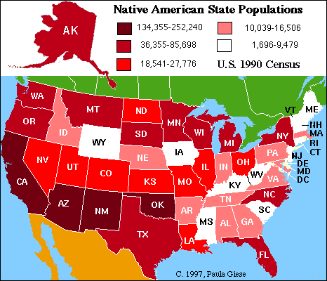
From: www.blog.procricketgear.com
The American Civil War was disastrous for the Muscogee people. The first three battles of the war in Indian Territory occurred when Confederate forces attacked a large of neutral Muscogee (Creeks) led by Opothle Yahola. For the majority of the Muscogee people, desired neutrality proved impossible. Eventually Muscogee citizens fought on both the Union and Confederate sides. The reconstruction treaty of 1866 required the cession of 3.2 million acres -- approximately half of the Muscogee domain. In 1867, the Muscogee people adopted a written constitution that provided for a Principal Chief and a Second Chief, a judicial branch and a bicameral legislature composed of a House of Kings and a House of Warriors; tribal town determined representation in both houses of this Legislative assembly. This "constitutional" period lasted for the remainder of the 19th century. (Ramaker, 2005)
During this time a new capital was established in 1867 on the Deep Fork of the Canadian at Okmulgee. In 1878 the Nation constructed a familiar native stone Council House that remains at the center of the modern city of Okmulgee. In the late 1800s the Dawes Commission began negotiating with the Muscogee Nation for the allotment of the national domain. In 1898, the United States Congress passed the Curtis Act that made the dismantling of the National governments of the Five Civilized Tribes and the allotment of collectively held tribal domains inevitable.
In 1890, the noted statesman Chitto Harjo helped lead organized opposition to the dissolution of Muscogee National government and allotment of collectively held lands. In his efforts he epitomized the view of all Muscogee people that they possessed an inherent right to govern themselves. For individuals like Chitto Harjo it was unimaginable that the Nation could be dissolved by the action of a foreign government. This perception proved to be correct. The end of the Muscogee Nation as envisioned by its architects within the United States Congress did not occur. (Ramaker, 2005)
In the early 20th century, the process of allotment of the National domain to individual citizens was completed. However, the perceived dismantling of the Muscogee government was never fully executed. The Nation maintained a Principal Chief throughout this stormy period. In 1971, the Muscogee people, for the first time since the partial dismantling of their National government, freely elected a Principal Chief without Presidential approval. In the decade of the 1970s the leadership of the Muscogee (Creek) Nation drafted and adopted a new constitution, revitalized the National Council and began the challenging process of Supreme Court decisions affirmed the Nation's sovereign rights to maintain a national court system and levy taxes. The federal courts have also consistently re-affirmed the Muscogee Nation's freedom from state jurisdiction. (Muscogee Nation, 2010)
Present day Mound building located at the Tribal headquarters, houses the National Council Offices and Judicial Offices. In the 1990s, almost 100 years after the dark days of the allotment era, the Muscogee (Creek) people are actively engaged in the process of accepting and asserting the rights and responsibilities of a sovereign nation. As a culturally distinct people, the Muscogee are also aware of the necessity for knowing and understanding their extraordinary historical and cultural inheritance. (Muscogee Nation, 2010)
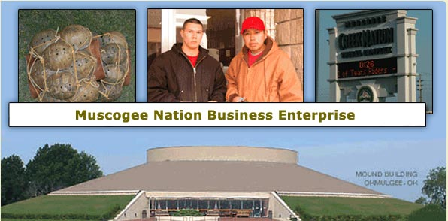Source: www.mnbe.com
Ceremony serves as a great unifying force within the community and is the most important religious expression among Creek Indian people. Only those dedicated few who have shown the wisdom, and understanding to earn the honor are given the knowledge to conduct ceremonies. Every part of ceremony, including the fasting, the oration, and the dances are held with the deepest moral and religious significance. The Green Corn Ceremony which lasts four to eight days, is the most important ceremonial event of the year. It is the annual New Year Harvest Celebration and is held in late summer during the time the new corn becomes ripe. Called, the "Posketv," (or simply "Busk") which means "to fast" the Green Corn Ceremony is regarded as a great peace ceremonial as it marks the time of community renewal. Among individuals, this is the time when differences are settled, wrongs righted and forgiveness shared. All transgressions against the well being of the community, except murder or other serious crimes, are settled and forgiven. Thus, the community slate is wiped clean for the next year. (Creek Indians, 2010)
During the annual Posketv, the ceremonial square is cleaned and a new fire prepared. The ceremonial Fire is extremely important as a symbol of Creator. Four logs are placed radiating out from the center in the four cardinal directions. In solemn ceremony, a new fire is kindled at the center. As an expression of the ‘oneness’ of the community, coals from the ceremonial fire are then carried to each household where old fires have been extinguished; the hearths cleaned and prepared to begin anew.
The final event of the Green Corn Celebration is a great feast. At the newly kindled home fires, the women prepared a variety of dishes from the fresh new corn to be enjoyed by all. Native American culture goes back thousands of years; to a time when these indigenous people lived in what is know known as North America. Native American culture revolved heavily around nature, and every aspect of their lives was based around the Earth. The Native American tribes worshipped the spirits of these animals as gods, but they also killed them for food and clothing. They would never waste any part of the animals though, they would eat the meat, wear the hides, they used the skin to make drums and they used the bones for tools and weapons. They believed the spirit of the animals would live on in spirit within the tribe. They also fashioned totem poles carved out of wood with different animals faces on them, and these faces represented the spirits of family and important tribal figures. (Ramaker, 2005)
In Native American culture they believed that everyone person had the spirit of a certain animal and when they died their spirit would live on inside the animal. The Native Americans also harvested plants and berries that they would use for various things from medicines to dyes. They lived in harmony with the Earth which they lived on and they let nothing go to waste.
Thousands of years ago there were over ten million Native Americans living within the territory that is now the United States. The Native American cultural traditions varied among the thousands of different tribes that were spread throughout the land. Soon settlers started arriving on the shores of the Native American homelands and started pushing the Native American Indians from their homes and eventually off of their tribes land. The European settlers made their new homes on the Native Americans land and interfered with the Native American culture that had relatively lived in peace until now.
When the European settlers arrived here they brought with them many diseases from Europe that killed many Native Americans and many more tribes were forced from their lands. Eventually the United States government set aside land for the Native Americans, and many of these Indian reservations are still around today. There are still signs all over the country of the great Native American culture that once ruled these lands, and Native American art and fashions are more popular than ever. (Creek Indians, 2010)
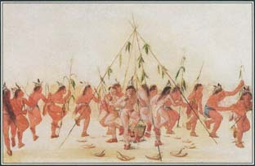
Source: www.manataka.org
Most creeks still celebrate and honor their Native American traditions with feast day celebrations, which often include dances in brilliant attire and sacred rituals. Attending one of these events is an excellent way to experience creek culture; the corn, deer and buffalo dances are commonly open to the public. Each dance tells a different story and serves a different purpose. The ceremonial dress worn by the dancers are more than just decorative; the feathers, jewelry and beads all communicate part of the story. Every dance is considered a prayer, not a performance, and as such, outsiders are privileged to observe them. Drums beat with an insistent cadence and the air is filled with the fragrance of piñon smoke. Red chile ristras (strings) decorate many homes, with the chiles destined to add their distinct flavor to stews and sauces throughout the winter.
Another way to learn about Native American communities is to explore their many arts and crafts including silver and turquoise jewelry, pottery, drums, carvings, clothing and weavings. Or try traditional Indian food such as bread baked in an horno (outdoor oven) or fry bread, hot and honey-drizzled straight from the pan.
The Native American word “pow wow” literally stands for “the one who has visions”. A pow wow can be a term used to describe a meeting of the different tribes, or can be the title given to the shaman that is conducting the ceremony. To understand the significance of the pow wow in today’s Native American society it is important to understand the origins of the ceremony.
Native Americans believe that when the world was created each tribe was given a unique relationship with nature and the world around them. They also believed that their faith could be strengthened through their connection with the earth. Therefore, in times of need or sickness Native Americans would turn towards nature for guidance. They would have a meeting that included all of the surrounding tribes and would pray. A typical Native American prayer included sacrifices, sweats, and fasts. Through these prayers nature would answer their questions. Eventually these meetings started to incorporate dancing and singing as well. To show their respect to nature many Native Americans would imitate animals during their sacred dances. (Ramaker, 2005)
When Europeans discovered these sacred meetings they assumed that the term pow wow was referring only to the dance. However, the Native Americans actually were using the word to describe the spiritual leaders who were conducting the ceremonies. Native American pow wows were later used to resolve conflicts amongst tribes over hunting grounds. They were also used as a means to prepare warriors and protect them. When the warriors returned home safely there was often another Native American pow wow to celebrate their victories and mourn their losses. Some traditional communities still practice Native American pow wows. These meetings are usually meant as a way to honor their ancestors and preserve their heritage and often greatly resemble the pow wows that were seen in the 1600’s. (Creek Indians, 2010)
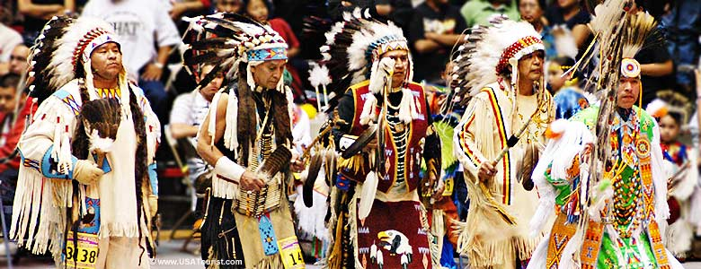
Source: www.forums.gametrailers.com
When reading about the history of the Native Americans, many people have heard of a ceremonial tradition that is known as the Native American rain dance. The Native American rain dance was the most common among the Native American tribes in the southwest of America, since during the summers there they would have long droughts. The droughts could bring serious problems for the natives since having some rain was essential for their survival and their food crops. The rain dance would usually take place in the driest month of the year, so usually this ritual was performed in mid to late August ever year. The Native American rain dance was performed by both the men and women of the tribe, unlike other tribal rituals where only men were allowed. (Ramaker, 2005)
The Native Americans wore special costumes when performing the rain dance ceremony, and these costumes were used just for this specific ceremony every year. The mask that the Indian men wear is a mask with a turquoise strip that stretches from ear to ear across the face of the mask. Then the bottom is a band of blue, yellow, and red rectangles. A fringe of horsehair hangs from the bottom which covers the throat and three white feathers hang from the top of the male mask. The women’s mask is somewhat similar, but instead of a turquoise stripe theirs is white, and they do not have the rectangles on the bottom or the horsehair. The women’s masks have goat hair around the top, and an Eagles feather hangs over their face. The men have their bodies painted up by tribal standards and wear special beads, and they wore a fox skin hung behind them and a silver bracelet, and white apron type cloth, and turquoise moccasins. The women wore a black dress, and no parts of their bodies were shown except, their bare feet. Then they wore a bright colored shawl with one black and one white shawl over that. Then they all lined up and performed the Native American rain dance in hopes of bringing the rain that they desperately need. Many reservations in the southwest still perform this ritual to this day. (Creek Indians, 2010)
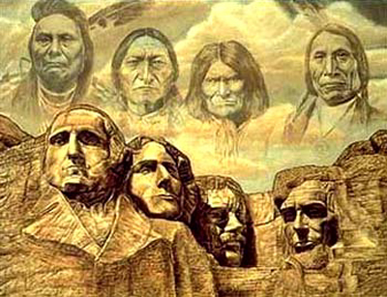
Source: www.legendsofamerica.com
In today’s time we have learned we don’t know all that much about the Indian way of life, unless you are somehow connected to your tribe. For some Dances or traditions anyone is welcome to watch, but not participate. As for learning anything you want about them takes a lot of research on the Internet or contacting the Nation of your tribe. I know the white man may of did the Indians wrong, but that was centuries ago and they should be open for everyone to learn about their culture and traditions, not just because most of them still practice them, but so we have a greater understanding of their culture because it is so different from anyone’s and should be shared. SO, what is it like being a Creek Native American in today’s world? What are some of their traditions or way of life? How can they communicate with the public to get others to know about their hardships, heritage, traditions, and way of life? The communication process should greatly open between the elder creek Indians and whole tribe to let newcomers in and experience their culture and beliefs.

References
“Creek Indians.” A Creek Indian Bibliography. 22 Nov. 2009. 15 March 2010. http://www.rhus.com/Creeks.html/
Native American Culture. 10 Feb. 2010. 16 March 2010. http://www.great dreams.com/native.html.
“Native American Culture.” Oklahoma Native American Culture. 23 Oct. 1996. 16 March 2010. http://www.shopoklahoma.com/native.htm.
“Native American History and Culture.” 3 May 2008. 14 March 2010. http://www.teacheroz.com/Nativeamericans.htm.
Native American Mythology. May 1999. 16 March 2010. http://www.godchecker.com/pantheon/native_american.html.
“Native American Tribes.” U.S. History Images. 11 Oct. 2009. 16 March 2010. http://ushistoryimages.com/native-american-tribes.html.
“Native American Way.” 5 Oct. 2004. 16 March 2010. http://www.legendarysurfers.com/naw.html..
Official cite of Muscogee Nation. 3 Aug. 2008. 16 March 2010. http://www.muscogeenation-nsn.gov.html.
“Overview of Creek Culture.” AAA Native Arts. 1999. 16 March 2010. http://www.aaanativearts.com/article1046.html.
Ramaker, Kyle. “Muscogee (Creek) Indians.” 4 Jan. 2005. 16 March 2010. http://www.mnsu.edu/emuseum/cultural/northamerica.html.
US department of Indian Affairs. 22 Feb. 2010. 16 March 2010. http://www.bia.gov.html.
“Creek Indians.” 22 March 2002. 15 March 2010. http://www.creekindian.com.

