FOR IMMEDIATE RELEASE (5/20/2011 ***draft ***)

Using the CAPA Seal to Shield Against Crime of the 21st Century

Washington, D.C. - The FBI has labeled counterfeiting as the “Crime of the 21st Century.” Counterfeit products are at the forefront of these intellectual property rights violations. Any recognizable brand is at risk of being counterfeited – from clothing and handbags, music and movies, pharmaceuticals and parts of automobiles and heavy-duty trucks and equipment. Counterfeiting is not a victimless crime. Counterfeiting steals good manufacturing jobs. Additionally, counterfeiting destroys brand reputation of legitimate companies and poses product liability claims.

The after-market parts industry has been hit hard by counterfeiting. After-market parts refer to the parts and accessories that are not supplied by the vehicle maker but are added to and/or replaced on the vehicle after it has been purchased. Counterfeit motor vehicle parts pose particularly serious safety risks to unsuspecting consumers when these after-market parts fail to perform in the event of a crash. A wide range of products are being counterfeited, including many safety-related parts, such as brakes and brake pads, brake fluid, tires, structural parts and automotive lighting. These counterfeit parts do not meet safety standards and the criminals who produce these parts frequently use dangerous, inferior materials in production.

The reputations of suppliers and the safety of consumers are both at risk as long as these counterfeit parts are continued to go undetected and purchased unintentionally. These counterfeit parts often look identical to quality, brand name parts and in many instances, the part manufacturer only becomes aware of counterfeit products when responding to warranty claims of a failed product i.e. after the crash has taken place and the injuries have already occurred. As a result, counterfeit after-market parts endanger the repair professional installing the part, the car or heavy duty truck driver operating the vehicle and all motorists traveling the same roads with these vehicles.

However, both consumers and companies can look to the Certified Automotive Parts Association (CAPA) as a source of protection in order to combat this dangerous “crime of the 21st century.” CAPA is not a manufacturing, marketing or sales organization, but rather a non-profit organization that certifies the quality of automotive parts used for collision repairs. The organization was founded to promote price and quality competition in the collision part industry, thereby reducing the cost of crash repairs to consumers without sacrificing quality. In order to achieve certification, parts must first meet quality standards for fit, component materials, and corrosion resistance. The CAPA program provides consumers, auto body shops, part distributors and insurance adjusters with an objective method for evaluating the quality of certified parts and their functional equivalency to similar parts manufactured by automotive companies.

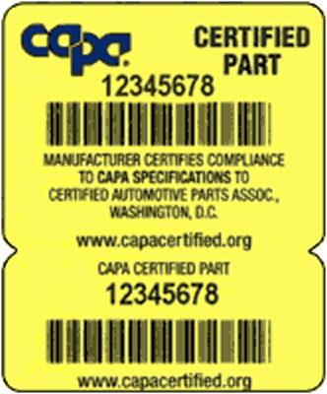
The CAPA Quality Seal is one of the most unique aspects of the CAPA Certification Program. Each CAPA Certified part comes with a tamper-proof, two-part seal containing an individual electronic barcode/number for that particular part. Once the seal is affixed to a surface, it will self-destruct when removed. This ensures that a seal cannot be transferred from a certified part to a non-certified part. Not only does this provide a user-friendly tracking system for shop owners, but it also enables CAPA to monitor and maintain detailed records on each CAPA Certified part.

The CAPA certification program, with its established, mandatory tests and its unique Vehicle Test Fit Program, assures the market that the parts bearing the CAPA quality seal will meet the exacting demands of today’s repairers and consumers. With the recent concerns raised about aftermarket part quality, the market for CAPA-Certified parts has never been better or timelier. As Bob Anderson, of Anderson’s Automotive in Sheffield, OH and current CAPA Board Chair puts it, “As more and more evidence surfaces about the quality of non-CAPA certified aftermarket parts, it has never been more important for shops to insist on CAPA Certified parts that fit, perform and last just like the car company brand parts.”

Remember, if your vehicle is involved in an accident, don’t take chances. Make sure you and your insurer specify CAPA-Certified replacement parts by referring to the CAPA name and seal. If it isn't CAPA-Certified, it isn't a genuine replacement part.

###

The Certified Automotive Parts Association, founded in 1987, is the nation’s only independent, nonprofit, certification organization for automotive crash parts whose sole purpose it to ensure that both consumers and the industry have the means to identify high quality parts via the CAPA Quality Seal. CAPA is an ANSI accredited standards developer for competitive crash repair parts. For more information see CAPAcertified.org.

