Feedback from
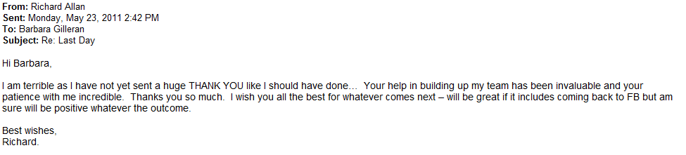
Richard Allan, Hiring Manager - Director Policy (EMEA)

Ayse Dibek – Fraud Analyst, Risk & Payments

Eva Maria Kirschsieper - Policy Manager (Germany)

Carsten Schubsda - Account Executive (Hamburg)

Melina Violari – Policy Manager (Brussels)

Javier Zaporta –Payment Specialist, Risk & Payments

Orna Holland – Staffing Manager (EMEA)
Luis Medina – Payment Analyst (Risk & Payments)

