Internal Relations Assignment

The employees of BP are lacking in their knowledge of the environmental efforts BP is striving towards. To improve this, a monthly newsletter should be sent out detailing what environmental efforts BP has done that month to promote sustainability. On top of that, BP should recognize one employee every month that is doing an exceptional job at “going green”. They will have a picture, a small bio, and a section on how they were being eco-conscious. Besides being recognized, they will receive BP environmentally friendly memorabilia such as water bottles, reusable bags etc. The newsletters would look something like this …

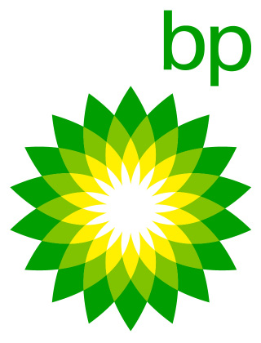 Eco-Newsletter

This month of May has been an exciting one for BP. We have raised over $140,000 for the Bird Relief Effort in the gulf this month alone. We have also been partnering with other oil companies around the globe to share and learn new environmentally friendly ways to obtain oil. Also this month we would like to introduce our first BP Planet Hero

BP Planet Hero

John Smith
John works in Accounting at BP headquarters. He spends his time at work crunching numbers and making sure we all get paid. Outside of work John rides his bike as often as he can, boycotts plastic bottles, and makes sure his recycling is out every week. John is a true BP Planet Hero.

