Project BIOS
B.I.O.S. - Battle Inside Operating System
Version 2.0

George Taray
Robert Weinheimer
Kastner Pagdilao

June 3rd, 2011

Table of Contents
1. Game Overview 5
2. Game Play Mechanics 5
2.1. Placing Towers 5
2.2. Leveling Up 5
2.3. Viruses and Waves 5
2.4. Resources 6
2.4.1. Energy 6
2.4.2. RAM 6
2.5. Infection 6
2.6. Blue Screen of Death 6
2.7. High Scores 6
3. Camera 6
4. Controls 6
4.1. Main Menu and Level Select 7
4.2. In Levels 7
5. Saving and Loading 7
6. Interface 8
7. Menu and Screen Descriptions 9
8. Game Modes 10
8.1. Story Mode 10
8.2. Single Levels 10
9. Levels 10
10. Towers 11
10.1. Laser Cannon Defender (LCD) 11
10.2. Resistor 11
10.4. Liquid Coolant 11
10.5. Firewall 11
10.6. Heat Sink 12
11. Utilities 13
11.1. Extra RAM 13
11.2. External Harddrive 13
11.3. Antivirus Software 13
12. Enemies (Creeps) 14
12.1. Worms 14
12.2. Trojans 14
12.3. Bots 14
12.4. Bugs 14
12.5. Spamtank 14
12.6. Spy 15
12.7. Virus 15
13. Audio Style 16
14. Future Features 17

Version History
March 1, 2011 – Updated with new information on towers, creeps, utilities, controls, interface, menus, and platform. All information brought in-line with shift to Unity platform.
April 28, 2011 – Updated towers, creeps, levels, gameplay mechanics, camera, controls and play modes to bring it in-line with changes made during the development process.
June 3, 2011 – Cut tables out of the tower, creep, and utilities section.
- Game Overview
A tower defense game that pits an unsuspecting computer user against hordes of viruses, trojans, malware, spyware and hackers by erecting defensive units within the computer itself, all based on existing hardware and terminology.
The player character in the game is your generic, everyday computer user. He is bombarded with pop-ups, spam, free offers and phishing sites that his computer is under constant attack from waves upon waves of worms, trojans, bots, keyloggers, and the like. What else would such a person do in this situation? In BIOS, they take the fight back to the pesky viruses and stop them with defense of their own, all inside a computer system.
BIOS is to be developed on the Unity game engine in C# and Javascript. It takes generic computer terminology and turns it into a battle between good and evil. Everyone who has used a computer knows the trouble viruses cause; BIOS gives those people a way to get back at the hours spent debugging their computer.
This game is intended for anyone in their mid-teens up through their thirties. Most people of that age are tech-savvy and would understand the terminology used.
- Game Play Mechanics

2.1. Placing Towers
Like all tower defense games, the primary goal of the player is to place various towers across the map to ensure that the enemy viruses do not make it from one end to the other. To do this, players will drag one of six different tower types from a series of UI buttons to the map, where they are placed on a grid, and begin firing at the enemies immediately as they approach within range.

2.2. Leveling Up
As the player fights more and more viruses they will find their towers a bit too weak to handle the hordes. To compensate for this the player can upgrade their towers. Upgrading each tower costs more and more resources, but in return provides a more powerful defense unit.

2.3. Viruses and Waves
The enemies in BIOS are the hordes of viruses that assail the computer. The defenses the player utilizes are there solely to prevent these viruses to getting to the CPU, where they start to infect (see 2.5 Infection) the computer. Viruses take on several forms, and can have varying resistances or vulnerabilities.
Viruses attack in waves. Each wave is made up of roughly 10 to 20 different viruses. Each wave has a duration on it, and when all the enemies are destroyed, the player can choose to start the next wave, or let the timer continue to count down. This allows the option for some breathing room to upgrade or build towers, or they can start he next wave prematurely.

2.4. Resources
There are two types of resources in BIOS: Energy and RAM.

2.4.1. Energy
To place and upgrade towers the player must expend Energy. The player starts with a set amount of Energy to place towers, and receives a small amount whenever a virus is destroyed. There is no upper cap for a player’s current energy.

2.4.2. RAM
Along with spending Energy to place and upgrade towers, the player will also have to manage a second resource: RAM. Every tower on the field takes up a certain amount of RAM; higher leveled towers take up more RAM. This resource acts as a limit on how many towers a player can field at once. Throughout the course of the game the player will have the option of increasing their RAM, thus allowing for towers to be fielded or upgraded.

2.5. Infection
The player's progress is measured by a pseudo health bar, the Infection Meter (displayed as a percentage of infection). As viruses get by a player's defenses and make it deeper into the computer, the player's Infection level rises. When the Infection level reaches 100% the computer is overwhelmed and crashes, resulting in a Blue Screen of Death.

2.6. Blue Screen of Death
A loving throw-back to the common error in Windows 95, the Blue Screen of Death (also called "BSoD") is BIOS's equivalent to a "game over" screen. When a player reaches 100% Infection during a single level, the player receives the BSoD screen, and is routed to the high score level if they made a high score, or to the main menu if they did not achieve a high score.

2.7. High Scores
BIOS will feature a leaderboard with the top 10 high scores achieved in the game. It will start with 10 default scores, then as the players reach and beat high scores they will be inserted into the ranking. These scores are saved through plays of the game
- Camera
BIOS will sport a player-controlled camera. When the level starts the camera is at a high angle above the game area, but the player can pan, zoom, and roll the camera as they want. The scroll wheel will act as a zoom wheel.
- Controls
BIOS utilizes mouse controls. The mouse is used to click the menu items, drag and place towers, and select options in-game.

4.1. Main Menu and Level Select
The player will navigate menus with the mouse.

4.2. In Levels
Towers will be placed by drag-and-drop actions of the mouse. The player can select a tower to place with a mouse click, then move their mouse into the game area. The tower will appear and hover as a ghost where their mouse is, indicating where the tower will be placed. The four grid squares the tower will occupy will either be green or red, depending on if the spot is available to have a tower placed their (green) or the space is already occupied (red).

When the player clicks on a tower button in the UI, its information will appear in another part of the UI: its cost in Energy and RAM, it’s power, speed and range.

In the game area, the player can left click to select towers that are already placed. This will show the tower’s current stats and the stats for the tower when it is upgraded.

Right clicking will bring up a floating option menu (like a right-click menu) that will give the player several options: Upgrade tower, repair tower, sell tower, and attack options. The various attack options are: attack nearest, attack strongest, attack weakest, and attack closest to goal.

Double left-clicking a tower will automatically begin the Upgrading process, if the player has enough resources (else an error sound will play and a message will pop up informing the player of their lack of resources).

- Saving and Loading
BIOS will implement a high score system, saving a players overall score for any given game. The high score will be persistent through gameplays. Upon entering any given level the player’s score will be 0. At the end of that level the final score will be calculated and stored. If the player continues to the next level, the final score from the last level will be loaded as the starting score for the current level, allowing a player to accumulate a high score by playing through all 5 levels without losing.
Whenever a player exits to the main menu the game will check to see if the player’s current score is a high score, and if so, will intercept the player and instead let them input their name to go on the high score board.

- Interface
Figure 1: In-game user interface
G
F
E
D
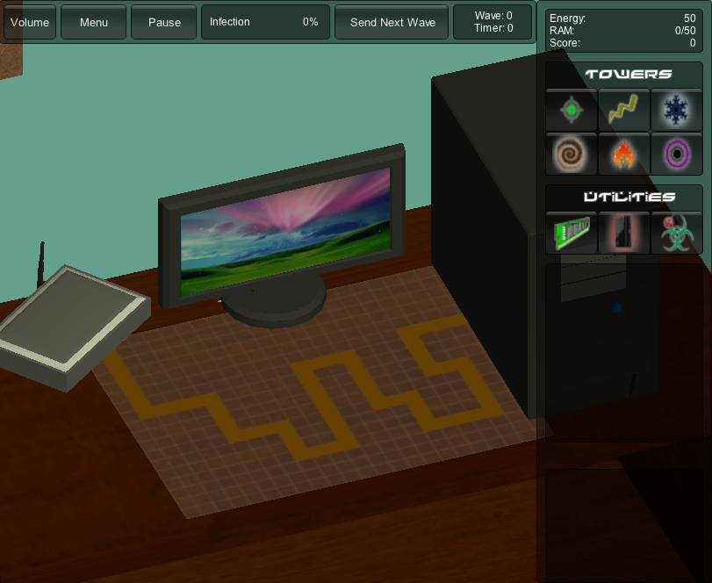
Highlighted Tower/Utility upgrade information
Selected Button/Tower information
Utilities
Towers
Resources
Wave Control
Wave Info
Infection Bar
Game Control Options

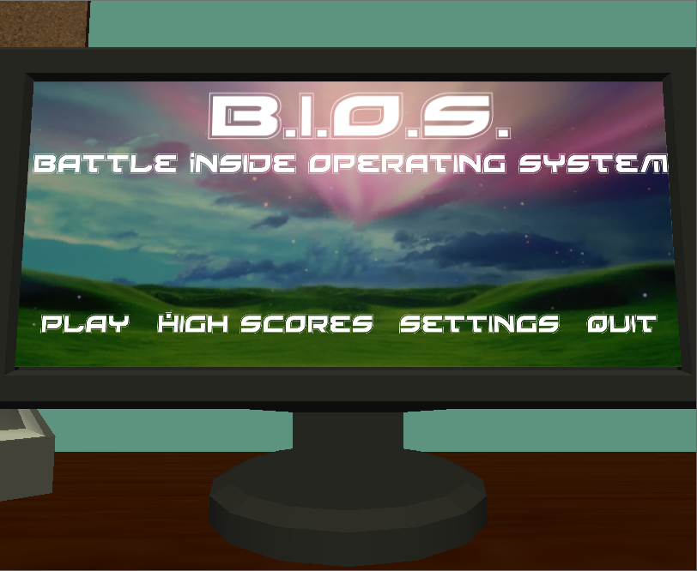
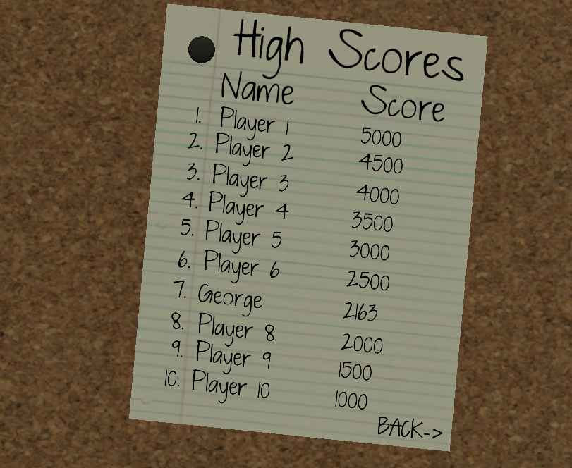
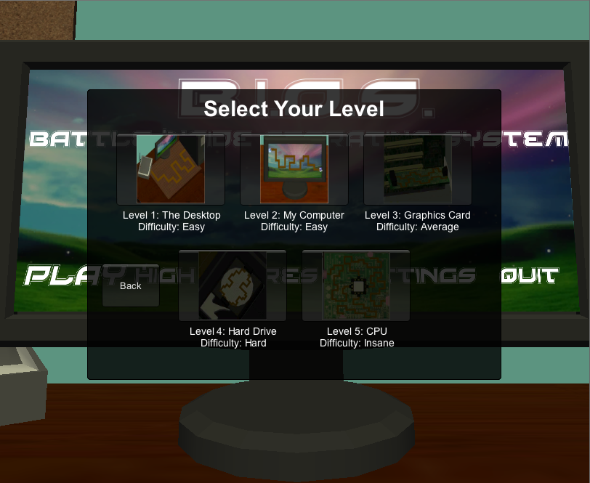
- Menus
Figure 2: High Scores
Figure 3: Main Menu
Figure 4: Level Select
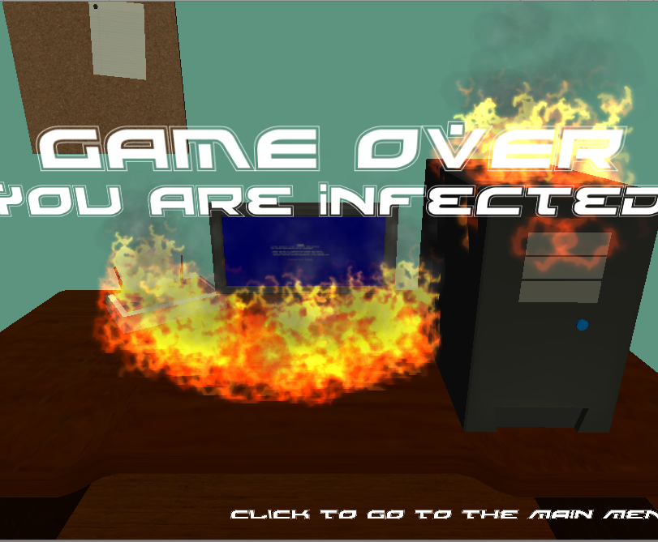
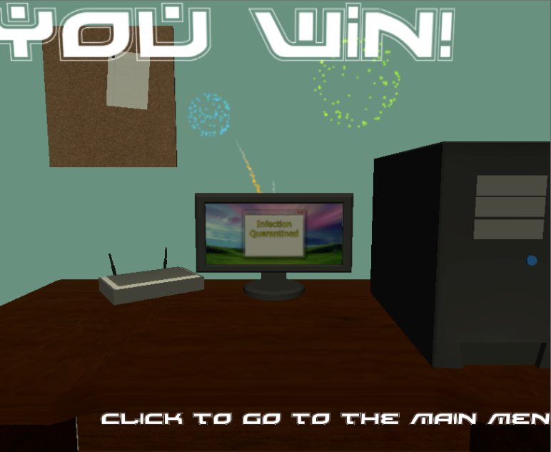
Figure 5: High Score
B
A
C
Figure 6: Game Over Menu
Figure 7: Victory Menu

- Game Modes
There are two ways to play BIOS: story mode, or single levels

8.1. Story Mode

Story mode takes the player through a series of levels, one after another. Each level is made up of 10-20 waves. Once the level is complete, the player is taken to the next level.

There are 5 total levels in progressing difficulty. The first two levels are fairly simple with only one path for creeps to follow. Levels 3 and 4 have two paths, and get harder, while the last level has 4 different paths, and is insanely difficult.

Players moving from one level to another will keep their score, allowing them to get the highest scores for completing a string of levels, as opposed to single levels.

8.2. Single Levels

Players can choose to play a single level from the 5 above, providing they’ve beaten the previous level. Choosing a level this way is exactly the same as playing story mode, but jumping in at a level that’s not the first one, and then leaving the game after the level is done. This is mostly for fun, as high scores will not be as high for a single level.

- Levels
There are five levels, each of which is based around an area in the computer. The levels are progressive in difficulty and features. The levels are as follows

Computer Desk: easy difficulty. The creeps move from the router on the left side of the desk to the tower on the right side of the desk. One path, few waves.
Desktop: easy difficulty. The creeps move from the internet icon to "my computer", while the background looks like a generic desktop. One path, little to moderate amount of waves.
Graphics: moderate difficulty. The creeps move from the left side of a network card inside the computer tower to the right side where they disappear into a computer chip. There are two paths that are more or less parallel. Moderate amount of waves.
Hard Drive: hard difficulty. The creeps have 2 paths that are farther apart than in the previous level. Moderate amount of waves.
Motherboard: hard difficulty. The creeps have four possible paths, at the top, left, right and bottom of the map, and all move to the center where the CPU of the computer is.

- Towers
Towers have 3 basic attributes: Power (or damage), speed, and range. Power is the damage it deals to enemies, speed is how fast the turret shoots (measured in shots/second), and range is the distance the turret can shoot, measured in the standard Unity unit.

10.1. Laser Cannon Defender (LCD)
The basic turret. Cheap and moderately powerful. The LCD is a simple cannon built on top of a circuit chip that fires laser beams at the enemy creeps. It cannot hit flying enemies. Upgrading this tower increases its damage, range and attack speed all by a small amount.

10.2. Resistor
This is the second least expensive tower. It zaps nearby enemies with electricity. It has a moderate range, but low power and high attack speed. Upgrading this tower increases its damage slightly and makes the lightning bolts jump to more enemies. (At level 1 the tower hits a single enemy, at level 2 the tower hits one enemy, then another nearby enemy gets hit as well). This tower can hit flying foes.

10.3. Fan
The fan is the standard anti-air tower. The fan shoots tornadoes that spiral towards flying units. This unit cannot attack ground units. Medium power and speed with medium-long range. Upgrading this tower increase all of its attributes slightly.

10.4. Liquid Coolant
The liquid coolant tower shoots projectiles: globules of liquid coolant at enemies, then splashes when it hits the ground, spraying nearby creeps and slowing them down based on its level. This tower has low-moderate range, low damage and moderate speed. Upgrading increases the percentage the enemy is slowed, along with very slight upgrades all normal attributes.

10.5. Firewall

A very powerful tower. This tower is exactly what it sounds like: A tower that sprays fire in a flame-thrower-like fashion at nearby enemies. This tower has high damage with low range and moderate speed. Upgrading this tower increases damage and range by a small amount.

10.6. Heat Sink

The heat sink is the high end area of effect tower. This tower sucks the energy from nearby units, dealing damage with a chance to stun the enemy. This tower has low range, moderate damage and moderate speed. Upgrades will increase the tower’s attributes by a small amount, as well as increase the chance that an enemy will be stunned upon hit.

- Utilities
There are three different types of utilities. Utilities are not towers. You do not place them on the field. However, you can purchase upgrade for these utilities to increase your abilities more passively.

11.1. Extra RAM

The limit of towers able to be build depends on the amount of RAM. This upgrade will increase the RAM the player has, allowing you to store more towers to defend your CPU. The more you purchase this utility, the more data will be stored. This will cap out after purchases.

11.2. External Harddrive

Upgrading your External Harddrive will effectively increase the amount of infection your computer can hold. For every upgrade you give your External Harddrive you can withstand 5% more infection.

11.3. Antivirus Software

At the end of each wave the antivirus software will run and reduce the amount of infection the player has by an amount determined by the number of upgrades this utility has received.

- Enemies (Creeps)
Enemies, also known as creeps, are the attacking force in BIOS. They are the viruses, trojans, bots, worms, and other malicious entities that seek to destroy the player’s computer. There are several basic types of creep.

12.1. Worms

The most basic and weakest of the malware, Worms form the mainstay of the invasion. They have the lowest amount of health, move at an average speed, and have no offensive or other abilities. Worms can vary in size however from small to large, each a variant degree of difficulty.

12.2. Trojans

Trojans pose a greater threat in that they are much healthier, and better defended. They can withstand a large amount of punishment before falling apart. Upon destruction, several other types of creeps appear where the Trojan was destroyed. The biggest deficit to the Main Trojan is that is very slow moving in comparison to the other malware.

12.3. Bots

Bots are an offensive malware in that if they make it close enough to a tower, it can temporarily stun the tower into not firing. They are slightly quicker than worms, but only sport moderate health

12.4. Bugs

Bugs are a standard flying enemies. They can take different forms: moth, roach, fly or fly. They don’t have any special abilities except that they are flying units. When spawned, a bug will take on a random model but all bugs will have the same stats.

12.5. Spamtank

This is a can of spam with tank treads and a tank turret. Is tougher and has more health because it’s in a can. The Spamtank can fire from its cannon, disabling towers so that they must be repaired before they are useful again.

12.6. Spy

The spy is an offensive creep that can sneak around and avoid your turrets. It looks like a humanoid with a black trenchcoat that turns invisible every now and then. While invisible the spy can avoid most turrets, except for the heat sink, the firewall, and liquid coolant.

12.7. Virus

The virus looks like a human virus, and is a flying unit that can float over towers. It can also zap towers to render them unusable unless repaired.

- Audio Style
The game is hardware based so the sound will be dedicated to computer type music and effects, so the audio will consist of the “old-school” feeling that will entail 8-bit sounding background music with a techno spice to it as well, in order to keep the immersion level for the user high. Each level will have music that goes along with the layout of the level. Sound effects will also include various sounds that correspond to the tower that will be outputting an energy source. For example the laser tower will have a laser sound whenever a laser shoots, for the firewall a burning sound of fire will emit whenever the fire is expelled. The audio is what keeps the user immersed so the sounds will be big and intense.
- Future Features
- Random wave generator for endless play
- Updated graphics
- Towers can be damaged
- Righ-click menu on towers
- Towers can be moved
- More creeps
- Story mode with cut-scenes

