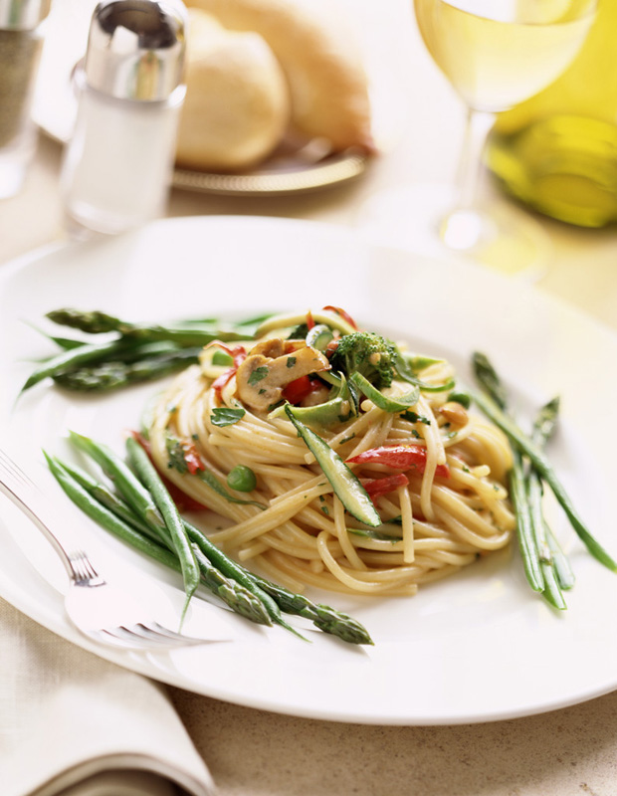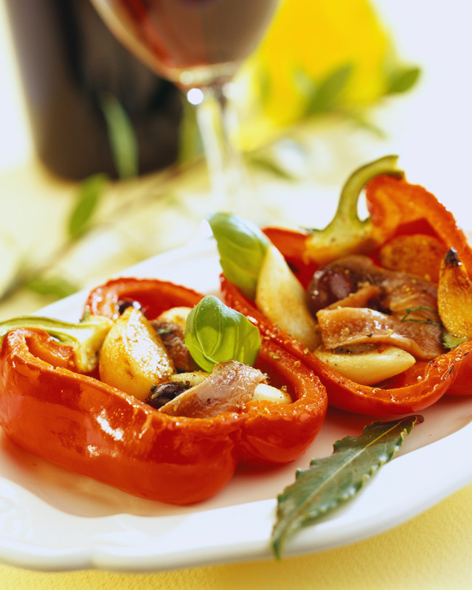

Through their early years of exploration in Italy, Ron and Ilyse built unique relationships with talented small-scale producers around the Italian countryside. Their regional foods told a story of old traditions, the value of diversity and the suggestion of supporting small farm production. It was through these experiences that Ron and Ilyse’s passion was born, and RITROVO ITALIAN REGIONAL FOODS LLC was created.

RITROVO founders Ron Post and Ilyse Rathet spent six years living in Italy, where they studied, traveled and researched the indigenous foods and wines. RITROVO’s product selection showcases Ron and Ilyse’s years of Italian exploration and training in food and wine, accompanied by thousands of hours of personal study, on-site research and close cooperation with artisan producers.

## History of RITROVO

RITROVO now imports over 200+ products from Italy and is passionate about the search for new producers and products.

means a reunion or “gathering again” of friends, family or colleagues. In regional areas such as Tuscan, a ritrovo is a place where people come to eat, drink and be merry.

“Ritrovo”

+

Each RITROVO SELECTIONS product is by definition one-of-a-kind. These products reflect Ron and Ilyse’s culinary knowledge, acknowledgement of quality and ability to translate Italian culinary products and traditions into formats that appeal to international consumers.

+

Summer 2011

RITROVO