Standard 1.4 Stimulating Learning Environment
The Mildred L. Terry library is a new construction. The old building was demolished in 2009. The new building was built with the 2003 SPLOST, private donations and grants. It has 50 computers, a quiet reading area, and a Reading Garden. It is an example of the vast opportunities that are available if one is willing to find alternate funding and seek out available funds. It now serves its community better. It has the kind of access to technology that the area needs.
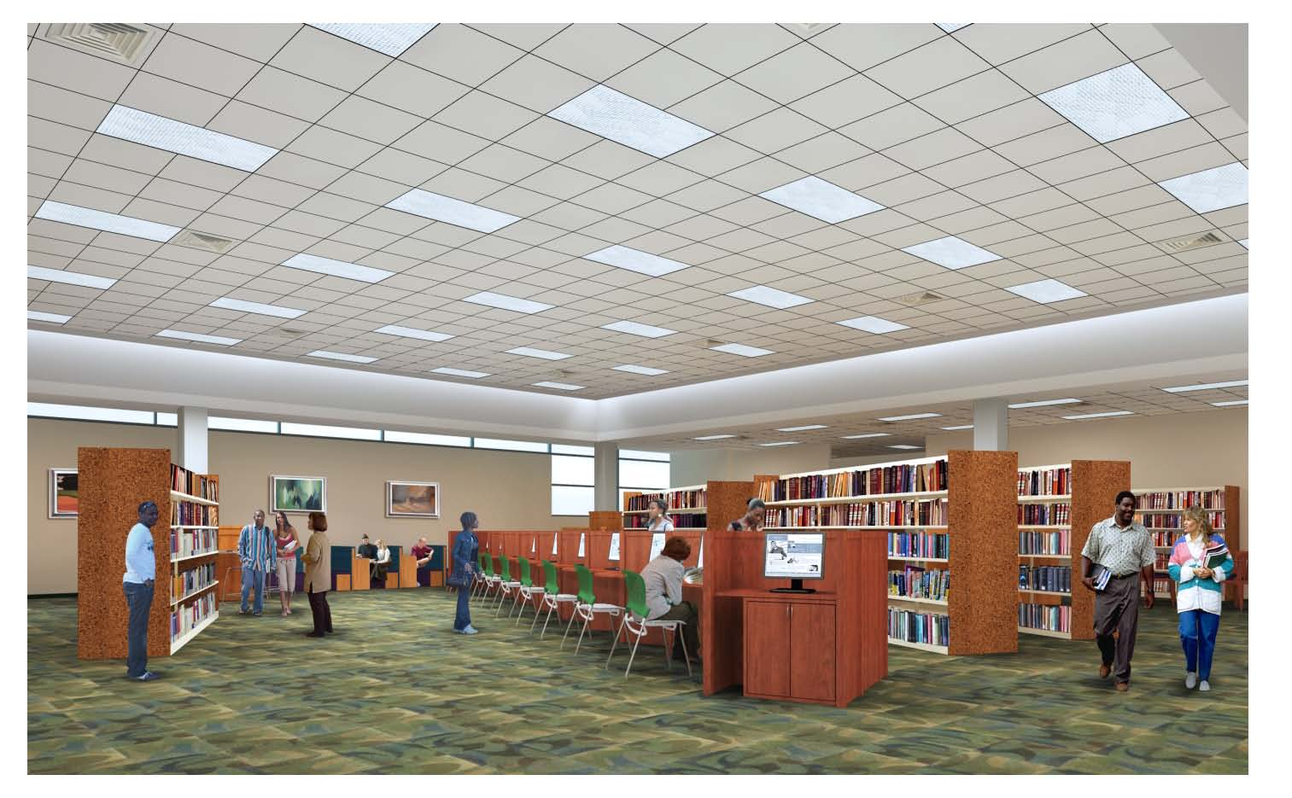

As an LMS, I too will seek out funding opportunities. I want the school that I serve to have the best possible opportunities. I will seek out programs like the Target Library Makeover and the Robin Hood Foundation (pictures below).


