

***Client Target List***

* ***Bite Of Seattle***

Contact: FESTIVALS Inc / New Growth Event Solutions  
320 East Sunset Way Suite 100   
Issaquah, WA   98027  
(425) 283-5050  
<http://www.biteofseattle.com>

* ***Puyallup Fair***

Contact: **Western Washington Fair Association**110 9th Avenue SW  
Puyallup, WA 98371-0162  
(253) 845-1771

<http://www.thefair.com/puyallup-fair>

* ***Seafair***

Contact: Seafair

2200 6th Avenue Suite 400

Seattle, WA 98121

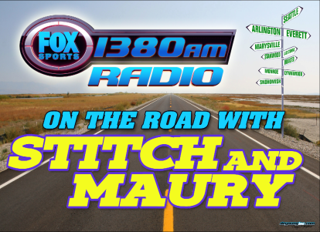(206) 728- 0123

<http://www.seafair.com/default.aspx>

* ***Comcast Arena***

Contact: Comcast Arena

2000 Hewitt Avenue Suite 200  
Everett, WA 98201

(425) 322-2600

<http://www.comcastarenaeverett.com/default.ashx?p=1097>

* ***Monroe City of Commerce***

Contact: Monroe City of Commerce

111 West Main Street  
Monroe, WA 98272-1809

(360) 794-5488

<http://www.monroewachamber.com>

* ***Skagit Speedway***

Contact: **Skagit Speedway**P.O. Box 911  
Burlington, WA 98233

(360) 724-3567

<http://www.skagitspeedway.com/>

* ***Mill Creek Festival***

Contact: Rotary Club of Mill Creek

PO Box 12248

Mill Creek WA, 98082

(425) 745- 3366

<http://www.millcreekfestival.com/index>