My GOMC 2010
Google Online Marketing Challenge (GOMC) is a worldwide competition, which requires competitors to use Google AdWord to run one or more AdWord campaigns to advertise chosen business in three weeks with $200 budget. The 2010 Google Online Marketing Challenge had over 3,000 students from 70 countries around the world taking part in the global online marketing competition. I attended this year’s competition. To me, it’s a precious experience.
GOMC is a team competition. There were four members in my team. I was the analyst and graphic designer. We worked together throughout the campaign, each adding from our individual backgrounds to improve the overall campaign strategy.
In the process, we came up with many ideas. As an analyst, I created a method to analyze keywords. (See Appendix) This method helped us to find effective keywords and brought impressions and clicks. Throughout the campaign, I kept track of which keywords were more effective or less effective by monitoring the number of impressions and click through rates (CTR) that the keywords produced. The keywords whose numbers were high were increased bid price. The keywords whose numbers were low were paused.
The overall performance of the campaign has surpassed our team’s expectations. Although we didn’t meet our CTR for the overall campaign and finished off with a relatively low average cost per click (CPC) of $0.68 (because of the limited budget), we got 187,896 impressions resulting in 294 clicks. The results exceed our target 3,000 impressions and 45 clicks. At last, we were recognized “Strong Campaign”. Except winner, regional winners and semi-finalist, we are the top 10% of teams.
Actually, the result is out of my expectation but stands to reason. We really did a lot in three weeks. Here are my experiences:

- Make objective first and read student guide carefully. It’s so important to make the objective first before starting campaign. High CTR, more impressions and clicks were our main goal. Before starting the campaign, we read “Insider guide to AdWords “, “Student Guide” and many materials about Google AdWords carefully. We did what Google want us to do. I think this is one reason that we got “Strong Campaign”.
- Listen to former competitor’s experience. We studied former winner Deakin University’s GOMC presentation and found some useful information. Also, blogger was a helpful source for us. We got excellent strategy ideas from others’ blogs.
- Always make changes, adjust strategies and keep track of everything. The situation changed every day, for instance, today we have 10 clicks but tomorrow we may have no one click. We not only used strategies and methods but also tested them at the same time. We weren’t able to predict the result before using them. Therefore, making changes and adjusting strategies were critical to the competition. At that time, I had to look at the data everyday and talk with my teammates. Most of the time, we came up with many good ideas.
- Teamwork. When we started, although each of us had own specific role and responsibilities, we helped each other. Every weekend, we reviewed what we did and what we had at that week, also, discussed new strategies. We respected and trusted each other. Our team encouraged innovative ideas. If we had problems, we would bring up and discuss. We had a great group dynamic. This made sure our success.
I learned a lot from this competition. I chose this course because of my interest in social networks. Now I feel search engine is also interesting. During the process, I know more about search engine, what it is, how it works and how can I use it to promote company and brand, also, use Google AdWord and Google Analytics to track navigation paths on the website. Although it’s an internet marketing competition, I could combine it with my marketing analysis knowledge. As I did in market research course, I analyzed data, got trends and customers’ opinions then gave recommendations. However, this project is different from another projects I did before. I worked for real client. Therefore, client communication was very important. I must be patient and sincere. Although working with our client presented us with a set of challenges were not initially expected, it was a great learning experience to work with a client. At last, we got real result that proved we did a good job. This gives me confidence to continue my study in internet marketing.
Overall, it’s a valuable experience to me. I will apply what I learned for my future work.

Appendix
Here are the steps to find proper keywords:
A principle: Words you use on the websites must relate to the words your customer use in searching. A high correlation - note that the website that moves towards the customer.
- Go to http://seokeywordanalysis.com/seotools/, input website Age and Sleep http://www.welldash.com/sleep/agesleep.html ,result: 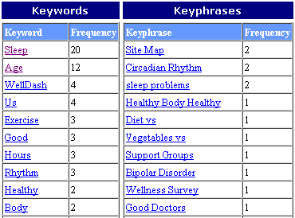
- Choose “sleep”,” age” to make words and phrases. Log in my Ad Words account , click on “Opportunity ” and then chose ”Keyword Tool ”, input “sleep” to get keyword ideas
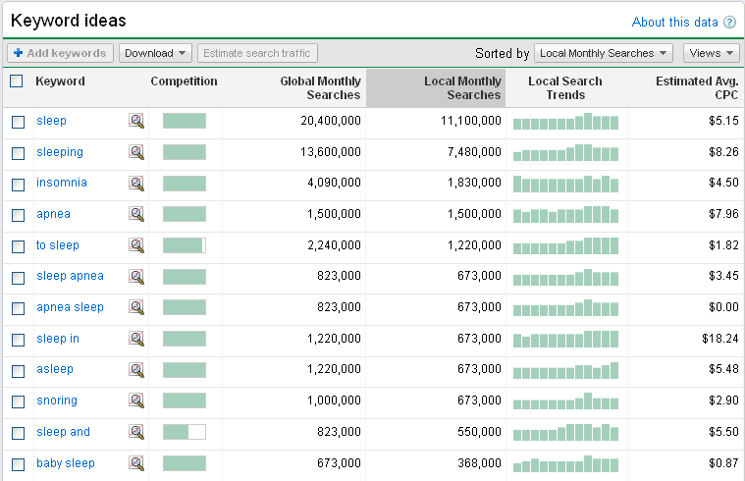

- After I get the ideas, I go to Traffic estimator of “Opportunity” , Input all the words and phrases that I may use in the “Word or phrase” blank.
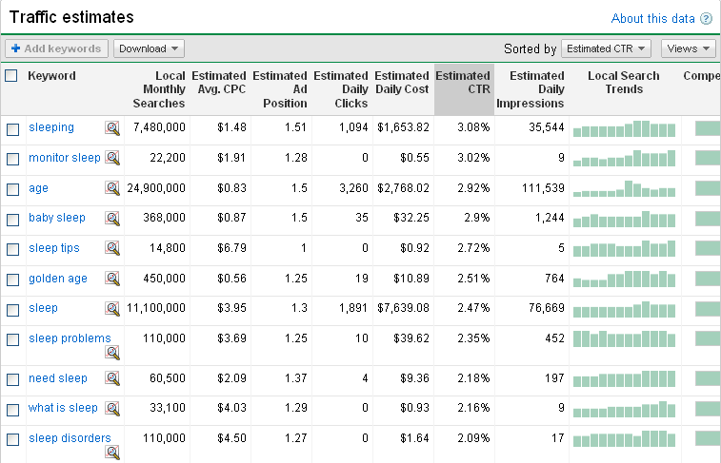

- Because the result is a approximate result, it‘s not a totally convincing result. So I download excel document of this result and then make analysis.

- I sort the data by “Local Monthly searches” , “Estimated daily clicks”, “Estimated CTR” and “Estimated Ad Position”, then I chose top 15 of each column and made a new table.
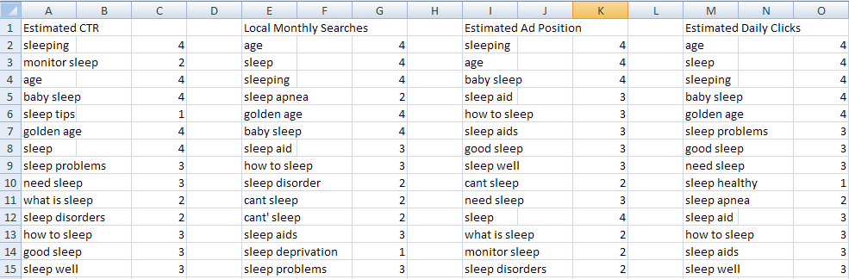

The number next to each keyword means the times it appears in the four columns
- Then I sort the result from the largest times to lowest times.
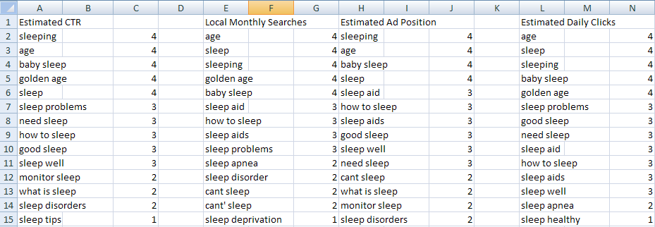

- Alright, Base on the result. I make my decision to choose keywords. Of course, choose the logical keywords. Here are the keywords:

Sleep disorder/disorders
Need sleep
Baby sleep
Golden age
Sleep aid/aids
Can’t /cant sleep
Sleep tips

The keywords like these: “Sleep” “Age” “Sleeping”. I think their high search rates are mostly from phrase searching so I exclude this kind of keywords.

PS: the pictures I used just part of the data output and I made them as examples; please don’t feel confused about the data output and analysis result.

