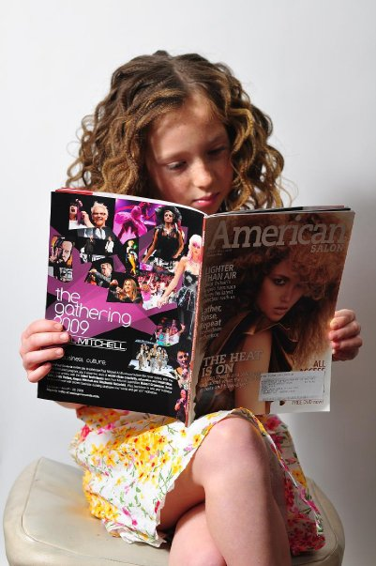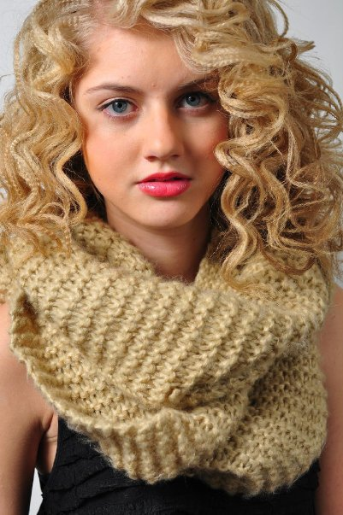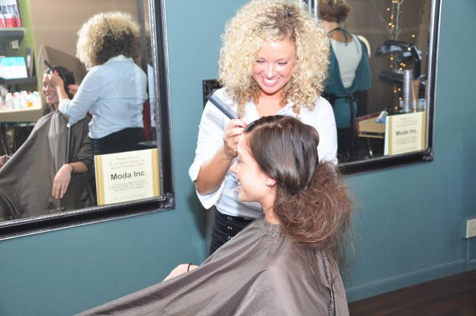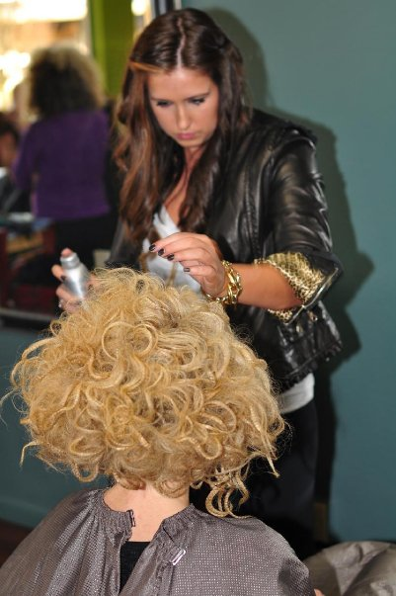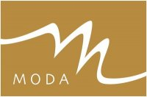\\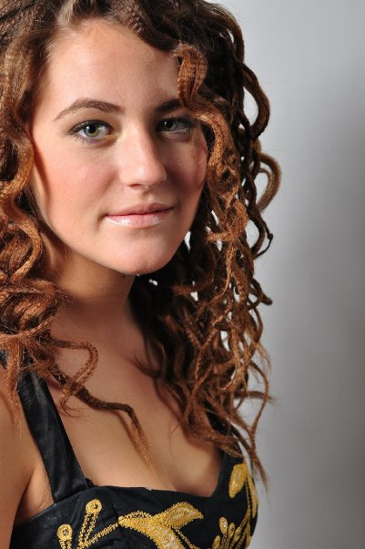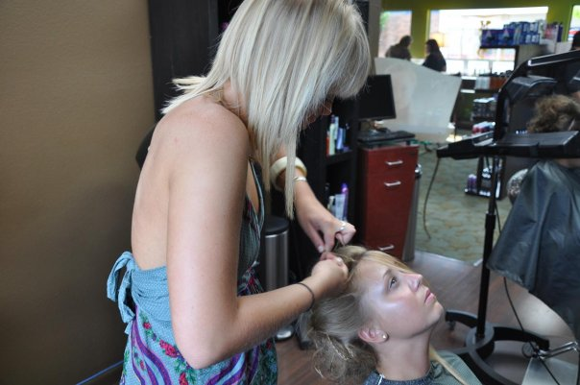

**538 MAIN STREET**

**EDMONDS, WA**

**425.778.6632**

|  |
| --- |
|  |

MODA HAIR CAFÉ AND DAY SPA*

+

MODA hair cafe & day spa is a team oriented salon of genuine service providers. We are committed, passionate and priveledged to be serving the North Seattle area with the latest in style and guest services. MODA is a 'downtown salon without the downtown attitude'. For nearly 15 years owners Fern & Jami -a Mother & Daughter team, have dedicated thier careers to help grow & train future stylists and estheticians in the art of great service, while always applying thier high standards to bring out the very best in our team. MODA is a 'TOP 200 SALON' for Fastest Growing Business and is recognised by the BEAUTY INDUSTRY as a salon with great Leadership and Loyalty 'SUMMIT SALON BUSINESS GROUP'. MODA will continue to offer high quality services and products that can fit into any beauty budget. Our experienced Technnicians -which includes our New Talent, can build a look for you and prescribe the products that will maintain & inspire all your beauty needs. Come to MODA and experience the difference. Get MODAvated ..... get MODAfied!

# What MODA is all about

## **A downtown salon without the downtown attitude**

+

**HAIR CARE**

|  |
| --- |
| Basic Hair Care  Women…………………….$36  Men………………………..$31  Child: (10 & under)……...$25  Bang Trim………………..$13  Beard Trim………………$13  Airwave…………………..$31  Up Style…………………..$50  Bridal……………………..$80 |
| Hair Color  Color……………………………………$51  Mastey 'handcrafted color'………ADD $30  Corrective Color…………………per hour  Full Foil (28+60 )Foils…………………..$81  Partial (11-27) Foils……………………..$66  Placement  Foils…………………………$6 each  Double Foil (61+)………………………..$117 |

+

|  |
| --- |
| Additional Needs  CHEMISTRY Shots PRE or POST.....$20-30  Flat iron w/……………………………..$10  Fresh start w/…………………………..$10  Cat Protien-each………………………..$10  Malibu…………………………………...$25  Glaze w/………………………………….$20  Toner w/………………………………….$20  Men's CAMO Color w/ cut……………..$20  Extra Product-each……………………...$10 |
| Re-Texurizing  Perming……………………..$87  Brazilian Blowout…………..$250  Japanese Straightening……$100 per hour  Great Lengths Extensions…consultation only |

**HAIR CARE**

**SKIN CARE**

|  |
| --- |
| Healthy Hands and Feet  Manicure………………………….$40  Pedicure…………………………...$60  Express Manicure w/spa service….$20  Express Pedicure w/spa service…..$30 |
| Body Repair  Exfoliation………………………$57  Hydration………………………..$73  Sunless tanning………………….$73  Swollen legs……………………..$71 |
| Skin Repair  Deep Pore……………………$87  Hydrating…………………….$77  Firming……………………….$107  Acne Treatment………………$97  Glycolic………………………..$103  Hot Stones……………………..$107  Anti-Aging……………………..$113  M-Class…………………………$43  Men's Fitness……………………$71 |

**Brow…………………………$21**

**Lip…………………………...$17**

**Chin………………………….$17**

**Neck………………………….$21**

**Cheeks……………………….$21**

**Chest…………………………$37**

**Underarm……………………$23**

**Back………………………….$33**

**Toes/Feet…………………….$13**

**1/2 leg………………………..$37**

**Full Leg……………………..$77**

**Arms………………………...$37**

**Classic Bikini………………$33**

**Modern Bikini……………..$43**

**Brazilian Bikini……………$73**

# WAXING:

## PRICES AND SERVICES

+

*We hope you discover the difference that our salon offers in your beauty experience! From the moment you walk in you will know that you have found a special place where the concerns of the day are replaced with comfort and ideas that can inspire change.*

GET MODA-FIED *

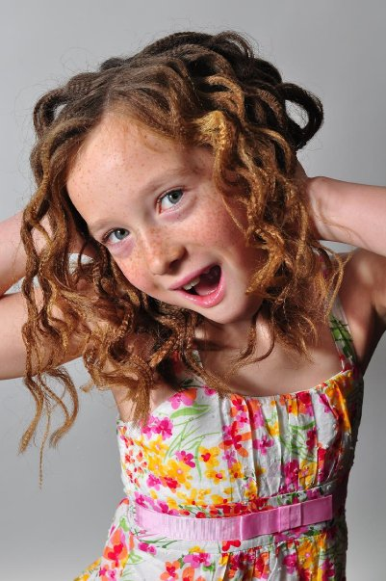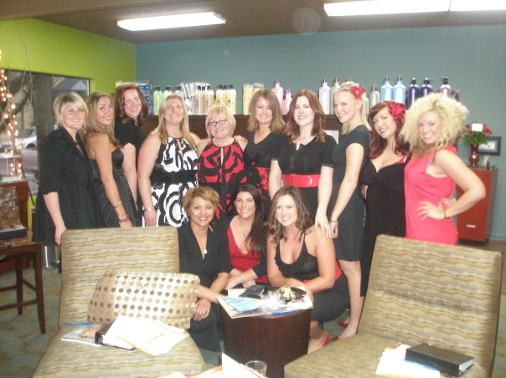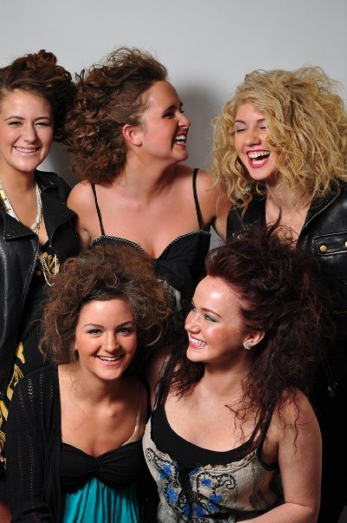

lorem ipsum

24143 w greystone ln.  
woodway, wa98020

[Web Address]