Jump Into the Music
By: Brittany White

Getting involved is an important part of college life. Whether you want to meet new people, fill up extra time or add an extracurricular activity to your resume, the Department of Music at Oklahoma State University has something to offer.
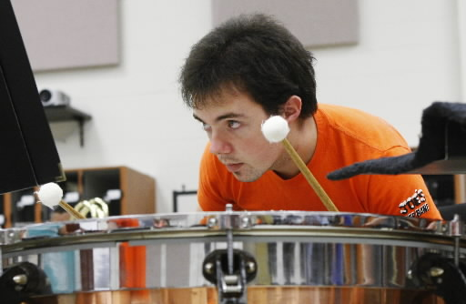
The Department of Music hosts more than 150 concerts and events for students to attend, as well as many classes for all majors. These events include:
- Noon Concert Series
- Guest Artist Concerts (National and International)
- OSU Ensemble Concerts (Percussion, Wind, Jazz and more)
- OSU Choir Concerts
- Student Recitals
- Vocal/Instrument Private Lessons

To participate in the Department of Music at Oklahoma State University visit, http://music.okstate.edu or call (405) 744-6133. If you are interested in attending any of the concerts or events go to, http://music.okstate.edu/calendar.php for a complete listing of all scheduled concerts and more information.

