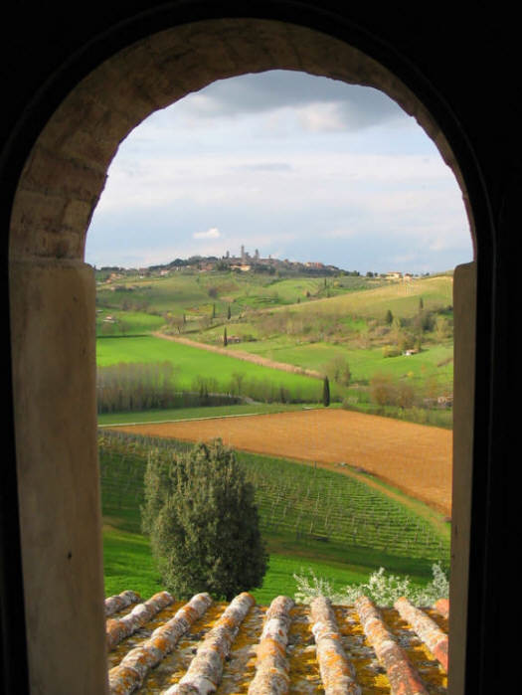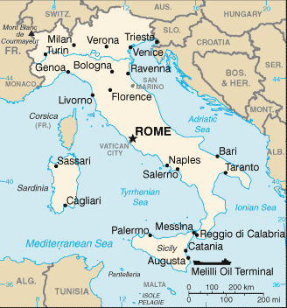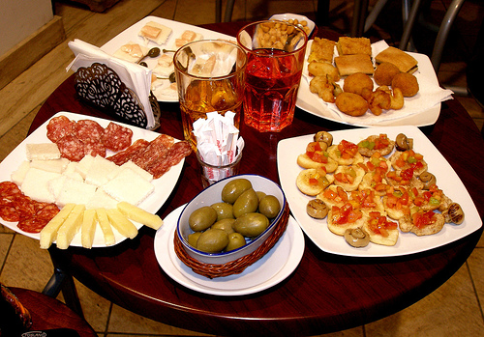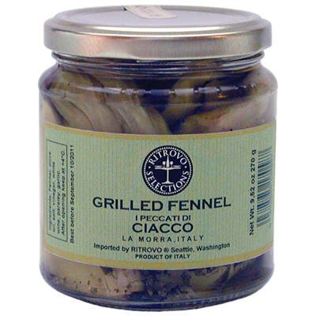

For over a decade RITROVO has been successfully promoting top-quality, regionally-inspired, Italian products in the U.S. specialty food market. RITROVO supports and frequents local farmers’ markets and supports the work of local food artisans and chefs. RITROVO takes shopping and culinary creativity from a variety of international sources as well.

309 S Cloverdale STE D-11 Seattle, Washington 98108 • 206-985-1635

RITROVO

The RITROVO founders Ron Post and Ilyse Rathet lived in Italy for six years, traveling, studying, and researching native foods and wines. Through their adventure they gradually met and built relationships with skilled small-scale producers around the country. Through their experiences they developed a passion for the products they found and have created today. Many of these foods came to tell a story of old traditions, the value of variation and the significance of supporting small-scale farm production.

It is out of this passion of theirs that RITROVO Italian Regional Foods was created.

## Meet Ron Post and Ilyse Rathet of RITROVO

## Think Locally, Eat Globally

RITROVO

Italian Regional Foods

Since Ron and Ilyse’s visit to Trieste last year, a favorite moment when they travel to Italy has become the aperitivo. What they love about the aperitivo is its standing as a mini-meal, defined by its pre-dinner timing, lightness in food eaten and its social nature. The best kinds of aperitivi include free buffets of food bites and may even include regional specialty foods or wines. Small bites and small glasses encourage slow-paced, relaxed snacking. This is the background to the relaxation and conversation that are the main focus of an aperitivo.

Aperitivo-

The occasion to meet with friends and other people, have a drink and pick some tasty finger-food and drinks.

**Answer:** all of the 130+ products are selected according to the same standards, and over ¼ have received critical acclaim by NASFT or elsewhere (NY Times, Gourmet Magazine, O Magazine, etc.). Those products also wearing the label A RITROVO SELECTION have either public appeal which calls for them to be more easily identifiable or these products have the special appeal to us according to our passion.

**Artisanal Quality.** The distinguished selections have full and focused flavors. They are produced in small batches according to the season and focus on the use of local ingredients.

**Regional Diversity.** There are thousands of traditions in Italy and RITROVO seeks to bring the delicious diversity to you through close work with our team of skilled producers and organic focused farms throughout Italy.

What is A RITROVO SELECTION?