Random Acts of Kindness Foundation By: Erin O’Neill

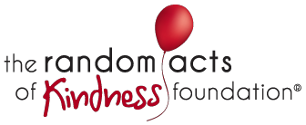

This semester, PRSSA is sponsoring a campaign competition similar to that of the Bateman Campaign. The client is the Random Acts of Kindness Foundation and their goal is to encourage people to commit random acts of kindness on a daily basis. The purpose of the campaign is to create a “toolkit containing messaging, key influencer profiles, media materials, and social media strategies” that will enable the foundation to launch a nationwide initiative at universities.
The group working on the campaign is currently in the research phase of the campaign. A Facebook page has been established and encourages students to leave their ideas of how other students could commit a random act of kindness and make a difference in someone’s life. A link to the page can be found by searching Random Acts of Kindness: SCSU on the Facebook homepage. The group also plans to launch an on-campus event as part of the implementation phase, which is scheduled to run the first two weeks of March.
The Random Acts of Kindness Foundation (RAK) strives “to make a positive impact on the culture by encouraging kindness worldwide.” The goal of the foundation is to inspire individuals and whole communities to perform random acts of kindness on a daily basis. The acts range from small to large in terms of effort and time commitment, but all are equivalent in the eyes of the foundation. To learn more about the foundation or to read the foundation’s “Kindness Act of the Day”, visit www.randomactsofkindness.org.

