Feasibility Report

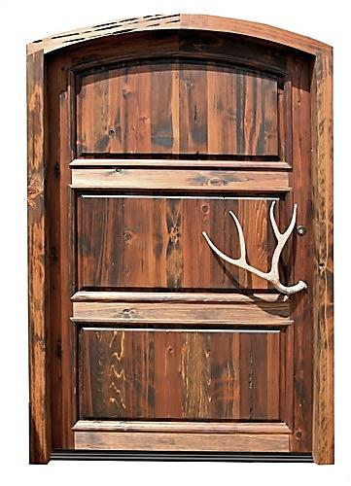

2011

Contents
Executive Summary 3
Jutededoor Background 4
Installation of the network (Weekly meetings) 5
Findings and Recommendations 6
PC Costs Options for Office complex (Total of 161) 7
Cost Options for Plants 9
Software Pricing 15
Marketing Strategy 18
Calculated costs 19
Network setup plan 22
Appendix A 24
Cost Benefit Analysis Options for Office Complex (LOW COST) 24
Appendix B 25
Cost Benefit Analysis Options for Office Complex (MEDIUM COST) 25
Appendix C 26
Cost Benefit Analysis Options for Office Complex (EXPENSIVE COST) 26
Appendix D 27
Cost Benefit Analysis Options for Plants (LOW COST) 27
Appendix E 28
Cost Benefit Analysis Options for Plants (MEDIUM COST) 28
Appendix F 29
Cost Benefit Analysis Options for Plants (EXPENSIVE COST) 29

Executive Summary
The feasibility report will be based on the network setup for the company Jutededoor. The report will include the equipment used and any existing equipment that will be reused from the old complexes. Costing’s for the equipment purchased will also be reviewed and will offer the company three cost solutions which are low, medium and high. The company will choose the best option that suits them.

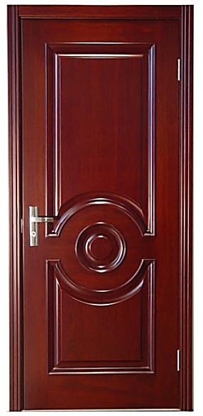

Jutededoor Background
Jutdedoor is a company which makes doors and door frames for all sorts of situations – house front doors, house back doors, kitchen cabinet doors, cupboard doors, - in fact there is no type of door that Jutdedoor does not make. Currently they are undergoing a revamp of its major manufacturing plant in Townsville, Queensland, Australia. The two manufacturing plants and office complex cover an area that extends over 55 square kilometers of Townsville and its surrounding suburbs. The revamp will include such things as a new office building, new plant building and two other support buildings, all located in different parts of the City. Production will not be affected, as there will be a gradual move to the new facilities over a period of time. Along with the new buildings, a new computer network will also be installed, also over a period of time.
The new network will be installed in line with the gradual movement of staff from the old buildings to the new buildings. There will be three complexes two plants and an office. A total of 257 computers and peripheral devices will be used on the new network and will have newly acquired equipment purchased with the addition of five low end routers being added to provide WAN connectivity and help create a sub netted network far in advance of the current one. The routers will be used from the previous setup and no need to be purchased. The routers will be configured and administered by the current PC and network support staff. The company will have a total of 3 new buildings and only a timeframe of 17 to 20 weeks to complete setup. Staff members will be informed about the move in weekly meetings and if any further questions or problems can make an individual meeting to sort out the problem. Staff members will be trained how to use new equipment and software before they are put to work and hopefully everything will be in order after a few weeks after completion. There are no issues with money but the time frame might be hard to follow in terms of getting all the equipment and the setup complete in time.

Installation of the network (Weekly meetings)

Weekly meetings have been carried out by the head of department from Jutdedoor to see how progress has been achieved. The weekly meetings include detailed reports about the progress of the network and about the plans which had been done before hand so only once approved then the setup of the network can commence. All weekly meetings were carried out as planed and discussion about the different problems and progresses of the setup were noted. All meetings were approved and have been documented and recorded so in future if any doubts the staff of Jutdedoor can go back and refer to them. Some of the issues discussed in the weekly meetings were:
- Plans of the setup of the network
- Floor plans of the office space
- Where to locate the equipment
- About the training staff members for the new software
- The alternative cost options for the equipment (Best choice selected)
- The ordering of equipment
- The delivery of equipment
- The use of equipment
- The setup of equipment
- The time frame of the setup
- Any extensions in the time frame that may be needed for the setup
- Any problems that occurred during setup
- How to overcome or how did they overcome the situation/problem
- Staff members and the new setup. How to deal with staff that don’t like change
Staff members might not be happy with the setup or the move of the new network. Flyers have been handed out with extra information about the new setup and individual meetings will be held to discuss with staff individually about the new move and the new software which will be on the network. Staff training will also be included if further assistance is needed

Findings and Recommendations
The best option that would be best suited to the company would be option 2 which is the medium cost for both the office complex and the plant complexes. They have the least number of years for cash payback and they both have 14% on the ROI. Refer back to Appendix B and E.

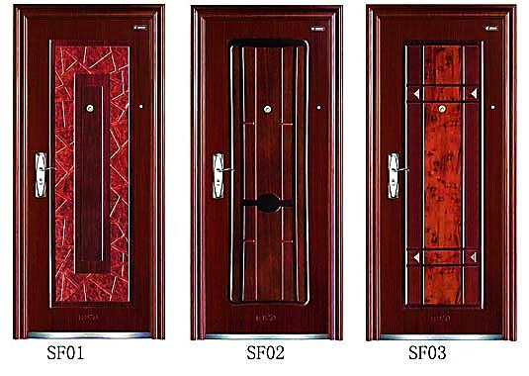

PC Costs Options for Office complex (Total of 161)

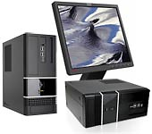
Option 1 (LOW COST)

OFFICE COMPLEX

I Office 5
- New Intel® 1155 socket. i3 / i5 / i7 processor supported
- SATA III and USB 3.0 supported
- Slim Case can be either tower or desktop
- Easier to be extended with full-profile case
- 2 years warranty
- Price $824.00
- http://www.computeronline.com.au/
- Total for department is 824.00 x 161 is $132664

Option 2 (MEDIUM COST)

OFFICE COMPLEX

I5-L5
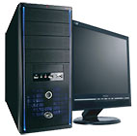
- Intel® Core™ i3 / i5 / i7 LGA-1155 platform
- Fire wire, SATA III & USB 3.0 supported
- Full-sized motherboard
- Price $1025.00
- http://www.computeronline.com.au/
- Total for department is $1025.00 x 161 is $165025

Option 3 (EXPENSIVE OPTION)

OFFICE COMPLEX

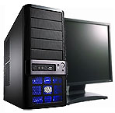
I5-X

- New Intel® Core™ i5 / i7 LGA-1155 platform
- Integrated Bluetooth module
- Quad-GPU SLI™ & Quad-GPU Crossfire™ supported
- Price $1226.00
- http://www.computeronline.com.au/
- Total for department is $1226.00 x 161 is $197386

Cost Options for Plants

Option 1 (LOW COST)

PLANT 1
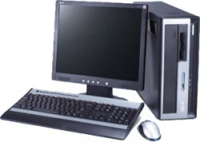
Acer Veriton 5900 Computer Package

  - Intel® Pentium® D Processor 830
  - (2 Cores, 2.8 GHz, 2M Cache, 800 MHz FSB)
  - 2 GB RAM memory
  - 80 GB Hard Disk Drive, DVD-RW (DVD Burner)
  - 19” LCD Monitor
  - Keyboard and optical mouse
  - Price $295.00
  - http://www.recompute.com.au/customise.php?pid=2474&utm_source=myshoppin g&utm_medium=datafeed&utm_campaign=myshopping1
  - Total for department is $295.00 x 48 is $14160
Option 2 (MEDIUM COST)

PLANT 1

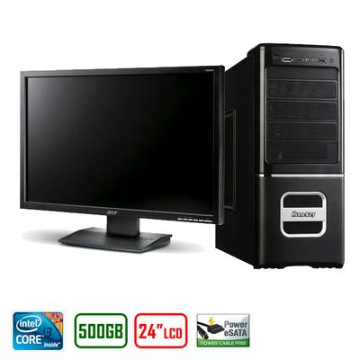
Intel Core i3 Professional PC with LCD

- CPU: Intel Core i3 540 Dual Core (3.06 GHz) - LGA1156
- RAM: 4GB DDR3 1333
- HDD: 500G SATA II 7200RPM HDD
- Optical: 22x DVD-RW Dual Layer Burner
- Motherboard: Intel H55 Motherboard
- Case & PSU: Quality 20 + 4 pin 500watt
- Graphic: Intel Graphics Media Accelerator HD Integrated DirectX 10
- Sound: High Definition Audio 6 Channel
- Network: Gigabit LAN
- LCD: Huge 24" FULL HD LCD Monitor
- OS: Not Included
- Price $999.95
- http://www.oo.com.au/Intel_Core_i3_Professional_PC__P28144.cfm?AFID=15&cm_mmc=MyShopping-_-Electronics-_-ComputersAccessories-_-ELSYSINTI3L2L&utm_source=myshopping&utm_medium=cpc&utm_campaign=Desktop+Computers&utm_term=Intel+Core+I3+Professional+Pc+With+Lcd+Dual+Core+Intel+Media+H
- Total for department is $999.95 x 48 is $47997.6

Option 3 (EXPENSIVE OPTION)

PLANT 1

Intel Core i3 Professional PC with LCD

- CPU: Intel Core i3 540 Dual Core (3.06 GHz) - LGA1156
- RAM: 4GB DDR3 1333
- HDD: 500G SATA II 7200RPM HDD
- Optical: 22x DVD-RW Dual Layer Burner
- Motherboard: Intel H55 Motherboard
- Case & PSU: Quality 20 + 4 pin 500watt
- Graphic: Intel Graphics Media Accelerator HD Integrated DirectX 10
- Sound: High Definition Audio 6 Channel
- Network: Gigabit LAN
- LCD: Huge 24" FULL HD LCD Monitor
- OS: Not Included
- Price $1025.95
- http://www.oo.com.au/Intel_Core_i3_Professional_PC__P28144.cfm?AFID=15&cm_mmc=MyShopping-_-Electronics-_-ComputersAccessories-_-ELSYSINTI3L2L&utm_source=myshopping&utm_medium=cpc&utm_campaign=Desktop+Computers&utm_term=Intel+Core+I3+Professional+Pc+With+Lcd+Dual+Core+Intel+Media+H
- Total for department is $1025.95 x 48 is $49245.6

PC Costs Options for Plant 2 (Total of 48)

PLANT 2

Option 1 (LOW COST)

Goliath - Intel Core i7 2600 *BONUS 24" MONITOR

- Intel Core i7 2600 3.40GHz
- Intel H65/67
- 16GB DDR3
- 64GB SSD memory
- 4TB SATA
- Blu Ray Reader/DVD Burner Combo
- Radeon 6850 1GB OC graphics
- Price $ 999
- http://www.centrecom.com.au/catalog/product_info.php?products_id=51348&utm_source=myshopping&utm_medium=cpc&utm_campaign=Desktop+Computers&utm_term=NEW+Goliath+Intel+Core+i7+2600+BONUS+24+MONITOR+
- Total cost for department is $999 x 48 is $47952
Option 2 (MEDIUM COST)

PLANT 2

Intel Core i3 Professional PC with LCD

- CPU: Intel Core i3 540 Dual Core (3.06 GHz) - LGA1156
- RAM: 4GB DDR3 1333
- HDD: 500G SATA II 7200RPM HDD
- Optical: 22x DVD-RW Dual Layer Burner
- Motherboard: Intel H55 Motherboard
- Case & PSU: Quality 20 + 4 pin 500watt
- Graphic: Intel Graphics Media Accelerator HD Integrated DirectX 10
- Sound: High Definition Audio 6 Channel
- Network: Gigabit LAN
- LCD: Huge 24" FULL HD LCD Monitor
- OS: Not Included
- Price $1027.00
http://www.oo.com.au/Intel_Core_i3_Professional_PC__P28144.cfm?AFID=15&cm_mmc=MyShopping-_-Electronics-_-ComputersAccessories-_-ELSYSINTI3L2L&utm_source=myshopping&utm_medium=cpc&utm_campaign=Desktop+Computers&utm_term=Intel+Core+I3+Professional+Pc+With+Lcd+Dual+Core+Intel+Media+H
- Total cost for department is $1027.00 x 48 is $49296

Option 3 (EXPENSIVE OPTION)

PLANT 2

I5-X

- New Intel® Core™ i5 / i7 LGA-1155 platform
- Integrated Bluetooth module
- Quad-GPU SLI™ & Quad-GPU Crossfire™ supported
- Price $1226.00
- http://www.computeronline.com.au/
- Total cost for department is $1226.00 x 48 $58848

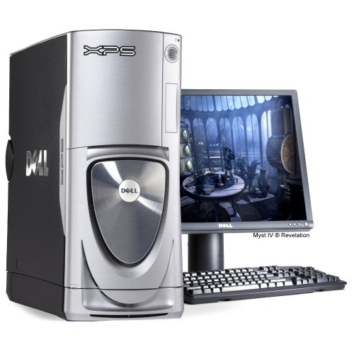

Application Software Prices

Outlined is a list of software that is needed by the company to do required tasks. These tasks may include:

Tasks:
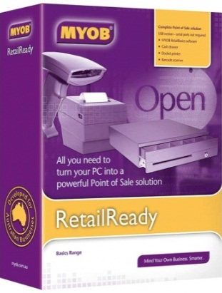
- Type up business reports for the company
- Create and calculate spread sheets for daily and weekly figures
- Accounting and MYOB banking
- Typing up timesheets and pay slips for employees
- Browsing the net
- Updating web sites and creating pages
- Answering emails from staff and customers
- Backup daily work
- Draw up and create door patterns and designs using PC software
- End of day paperwork to be typed

Software Pricing

MYOB Retail Ready

Whether you’re running a retail business or just about to open your doors, the ready-combined software and hardware in MYOB Retail Ready can make your entire operation run smarter and more efficiently. MYOB Retail Ready is simply a smarter way to run your business

Cost $982

http://www.harveynorman.com.au/product/1255509295016/myob-retailready

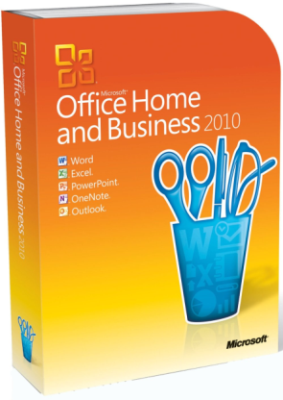
Microsoft Office Home & Business 2010

- New photo, video, and text effects for creating standout documents and presentations
- New communication tools in Outlook 2010 to help you stay in touch and organized
- Makes it easier to manage things in the office, at home, or in between
- Clarify and manage your financial data with new and improved analysis tools, charts, templates and colour formatting in Excel 2010.
- The new Microsoft Office Backstage view replaces the traditional File menu found on previous versions of Microsoft Office.
- This makes it easier to navigate tasks, as well as access and manage files.
- Cost $209.99
- http://www.amazon.com/Microsoft-Office-2010-Business-Version/dp/B0036Z0NZI/ref=sr_1_1?ie=UTF8&qid=1311728979&sr=8-1
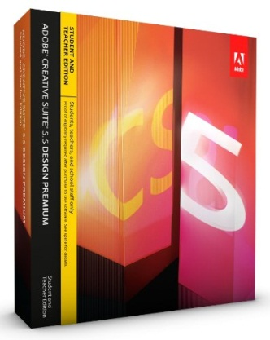
- Comes with each of the PC’s

Adobe CS5.5 Design Premium Student and Teacher Edition
- Ultimate software toolkit for eye-catching print, web, interactive, and mobile design
- Rich code hinting and completion for HTML5 and CSS3 in Dreamweaver CS5.5
- Multiscreen preview in Dreamweaver; Folio Producer tools in Adobe InDesign
- Authoring for the latest platforms and devices with Flash Professional
- Enhanced eBook authoring in InDesign; more efficient delivery of accessible documents
- Multiscreen preview in Dreamweaver; Folio Producer tools in Adobe InDesign Authoring for the latest platforms and devices with Flash Professional
- Ultimate software toolkit for eye-catching print, web, interactive, and mobile design Rich code hinting and completion for HTML5 and CSS3 in Dreamweaver CS5.5
- Cost $429.99
- http://www.amazon.com/Adobe-Design-Premium-Student-Teacher/dp/B004TH7NDW/ref=sr_1_1?ie=UTF8&qid=1311729304&sr=8-1
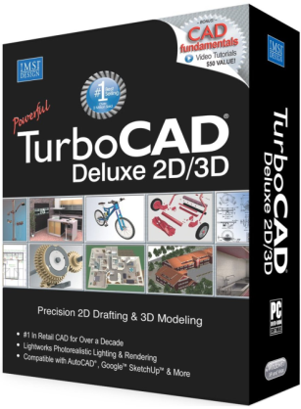

Turbo CAD 17 Deluxe 2D/3D
- Layer Management - The Design Director simplifies layer management with the addition of Line Style, Pen Width and Print Style parameters to Design Director and Drawing Setup
- Layer Filters - Layer filters that help you manage large, complex drawings with ease.
- Section Detail Tool - Enables closed 2D entities (circles, polygons, polylines) to act as a cutting contour with other intersecting 2D objects
- Colour Table (CTB) Print Style Support - AutoCAD Colour Table (.CTB) file support added to existing support of Style Table (STD) print styles
- Cost $63.95
- http://www.amazon.com/TurboCAD-17-Deluxe-2D-3D/dp/B003DUB9FO/ref=sr_1_3?s=software&ie=UTF8&qid=1311729728&sr=1-3

Kaspersky Anti-Virus 2011 3-User
- Kaspersky Anti-Virus 2011 provides real-time protection from viruses, spyware, Trojans, rootkits, bots and more, with technologies to keep your identity safe and secure
- Hourly signature updates, best-in-class unknown threat protection, and application vulnerability alerts give you complete confidence
- Small footprint, tiny updates and intelligent variable scanning lets your machine performs to the max
- Your digital identity and passwords are kept secure when you're shopping, banking or networking online
- New Desktop Security Gadget for easy drag-and-drop virus scanning and instant access to all your security settings
- Cost $23.50
- http://www.amazon.com/Kaspersky-Lab-KAV1103111-Anti-Virus-3-User/dp/B003WT1KHI/ref=sr_1_2?s=software&ie=UTF8&qid=1311730398&sr=1-2

Marketing Strategy

Hopefully with the new move and setup the company can continue to develop the great customer service to its customers. The office complex will be designed and used to answer emails, type up documents and create and update the website and pages. The office complex will use the MYOB software and Microsoft Office. The two plant buildings will be used to create and design doors for its customers. The software that will be used for this is CAD and is a great software program to design objects in 3D on your PC. They will also use Adobe CS5 for its website and pages. The Company will have an online catalogue and feedback forms so hopefully will draw the customer’s attention and get them involved.

Calculated costs

Low Cost Option for Office Complex

Name of Computer or Software | Cost | Total
Intel® 1155 socket. i3 / i5 / i7 processor supported | $824.00 x 161 (Office Complex) | $132664
Kaspersky Anti-Virus 2011 | $23.50 x 161 | $3783.5
MYOB Retail Ready | $982 x 161 | $158102
Total |  | $294549.5

Low Cost Option for Plants

Name of Computer or Software | Cost | Total
Acer Veriton 5900 Computer Package | $295 x 96 (Plants combined) | $28320
Adobe CS5.5 Design Premium Student and Teacher Edition | $429 x 3 (Only some PC’s will have this installed) | $1287
Turbo CAD 17 Deluxe 2D/3D | $63.93 x 96 | $6137.28
Total |  | $35744.28

*Office Comes with each PC (Already Installed)

Medium Cost Option for Office Complex

Name of Computer or Software | Cost | Total
I5-X New Intel® Core™ i5 | $1226.00 x 161 (Office Complex) | $197386
Kaspersky Anti-Virus 2011 | $23.50 x 161 | $3783.5
MYOB Retail Ready | $982 x 161 | $158102
Total |  | $359271.5

Medium Cost Option for Plants

Name of Computer or Software | Cost | Total
Intel Core i3 Professional PC | 1027.00 x 96 (Plants combined) | $98592
Adobe CS5.5 Design Premium Student and Teacher Edition | $429 x 3 (Only some PC’s will have this installed) | $1287
Turbo CAD 17 Deluxe 2D/3D | $63.93 x 96 | $6137.28
Total |  | $106016.28

*Office Comes with each PC (Already Installed)

Expensive Cost Option for Office Complex

Name of Computer or Software | Cost | Total
Intel Core i3 Professional PC | $1027.00 x 161 (Office Complex) | $165347
Kaspersky Anti-Virus 2011 | $23.50 x 161 | $3783.5
MYOB Retail Ready | $982 x 161 | $158102
Total |  | $327232.5

Expensive Cost Option for Plants

Name of Computer or Software | Cost | Total
Acer Veriton 5900 Computer Package | $295 x 96 (Plants combined) | $283020
Adobe CS5.5 Design Premium Student and Teacher Edition | $429 x 3 (Only some PC’s will have this installed) | $1287
Turbo CAD 17 Deluxe 2D/3D | $63.93 x 96 | $6137.28
Total |  | $290444.28

*Office Comes with each PC (Already Installed)

Network setup plan

Appendix A

Cost Benefit Analysis Options for Office Complex (LOW COST)

Year | Future Savings | 1+ interest rate to power (1+ i)^{N} | Present Value of Savings | Cumulative Value of Savings | Initial Cost to Develop System
1 | $731.50 | 1.08 | $ 677.31 | $ 677.31 | $ 1,829.50
2 | $731.50 | 1.1664 | $ 627.14 | $ 1,304.46
3 | $731.50 | 1.2597 | $ 580.69 | $ 1,885.15
4 | $731.50 | 1.3605 | $ 537.67 | $ 2,422.82
5 | $731.50 | 1.4693 | $ 497.85 | $ 2,920.67
Payback Analysis | 0.904171571 | 2.90
 |  | in years
Present Value Analysis | $ 1,091.17
ROI | 12%

Appendix B

Cost Benefit Analysis Options for Office Complex (MEDIUM COST)

Year | Future Savings | 1+ interest rate to power (1+ i)^{N} | Present Value of Savings | Cumulative Value of Savings | Initial Cost to Develop System
1 | $937.23 | 1.08 | $ 867.81 | $ 867.81 | $ 2,231.50
2 | $937.23 | 1.1664 | $ 803.52 | $ 1,671.33
3 | $937.23 | 1.2597 | $ 744.00 | $ 2,415.33
4 | $937.23 | 1.3605 | $ 688.89 | $ 3,104.22
5 | $937.23 | 1.4693 | $ 637.86 | $ 3,742.09
Payback Analysis | 0.752914286 | 2.75
 |  | in years
Present Value Analysis | $ 1,510.59
ROI | 14%

Appendix C

Cost Benefit Analysis Options for Office Complex (EXPENSIVE COST)

Year | Future Savings | 1+ interest rate to power (1+ i)^{N} | Present Value of Savings | Cumulative Value of Savings | Initial Cost to Develop System
1 | $772.35 | 1.08 | $ 715.14 | $ 715.14 | $2,032.50
2 | $772.35 | 1.1664 | $ 662.17 | $ 1,377.30
3 | $772.35 | 1.2597 | $ 613.12 | $ 1,990.42
4 | $772.35 | 1.3605 | $ 567.70 | $ 2,558.12
5 | $772.35 | 1.4693 | $ 525.65 | $ 3,083.77
Payback Analysis | 1.068631579 | 3.07
 |  | in years
Present Value Analysis | $ 1,051.27
ROI | 10%

Appendix D

Cost Benefit Analysis Options for Plants (LOW COST)

Year | Future Savings | 1+ interest rate to power (1+ i)^{N} | Present Value of Savings | Cumulative Value of Savings | Initial Cost to Develop System
1 | $130.32 | 1.08 | $ 120.67 | $ 120.67 | $ 372.34
2 | $130.32 | 1.1664 | $ 111.73 | $ 232.40
3 | $130.32 | 1.2597 | $ 103.45 | $ 335.85
4 | $130.32 | 1.3605 | $ 95.79 | $ 431.64
5 | $130.32 | 1.4693 | $ 88.69 | $ 520.33
Payback Analysis | 1.35275 | 3.35
 |  | in years
Present Value Analysis | $ 147.99
ROI | 8%

Appendix E

Cost Benefit Analysis Options for Plants (MEDIUM COST)

Year | Future Savings | 1+ interest rate to power (1+ i)^{N} | Present Value of Savings | Cumulative Value of Savings | Initial Cost to Develop System
1 | $474.86 | 1.08 | $ 439.69 | $ 439.69 | $ 1,104.34
2 | $474.86 | 1.1664 | $ 407.12 | $ 846.80
3 | $474.86 | 1.2597 | $ 376.96 | $ 1,223.76
4 | $474.86 | 1.3605 | $ 349.04 | $ 1,572.80
5 | $474.86 | 1.4693 | $ 323.18 | $ 1,895.98
Payback Analysis | 0.683201 | 2.68
 |  | in years
Present Value Analysis | $ 791.64
ROI | 14%

Appendix F

Cost Benefit Analysis Options for Plants (EXPENSIVE COST)

Year | Future Savings | 1+ interest rate to power (1+ i)^{N} | Present Value of Savings | Cumulative Value of Savings | Initial Cost to Develop System
1 | $1,210.18 | 1.08 | $ 1,120.54 | $ 1,120.54 | $ 3,025.46
2 | $1,210.18 | 1.1664 | $ 1,037.53 | $ 2,158.07
3 | $1,210.18 | 1.2597 | $ 960.68 | $ 3,118.75
4 | $1,210.18 | 1.3605 | $ 889.52 | $ 4,008.27
5 | $1,210.18 | 1.4693 | $ 823.63 | $ 4,831.90
Payback Analysis | 0.90289041 | 2.90
 |  | in years
Present Value Analysis | $ 1,806.44
ROI | 12%

