Hi ,
Could smartphone applications replace your children’s coloring books? Over the past few years, a technological revolution has been taking place in classrooms, homes and even in minivans. A recent study by AVG Technologies revealed that more kids between the ages of two and five can play with a smartphone application (19 percent) than tie his or her shoelaces (9 percent). In addition, almost as many two to three year olds (17 percent) can play with a smartphone application in comparison with four to five year olds (21 percent).
As technology continues to transform, more and more children are exposed to gadgets at a younger age making it difficult for parents to stay up-to-date with the latest trends. Recently, Nick Jr.’s favorite 6 ¾ year old little girl, Olivia, debuted an iPad application, “OLIVIA the Great 1.0,” helping parents incorporate new learning systems into the latest technology.
While many kids could probably teach their parents a thing or two about smartphones, the iPad makes it easy for parents to transform their children’s learning experiences by incorporating fun and engaging games into their everyday lives. Children love watching Olivia on television at home, and now with Olivia’s iPad application (also available on iPhone and iTouch), they are only a touch, tap and swipe away from interacting with their favorite little adventurer on-the-go.
If you are interested in reviewing the new “OLIVIA the Great 1.0!,” please contact me at ma@formulapr.com or 212-219-0321.
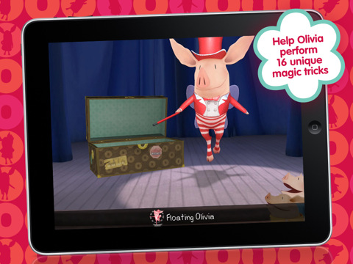
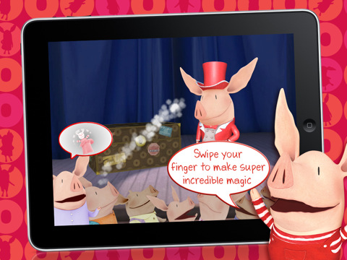

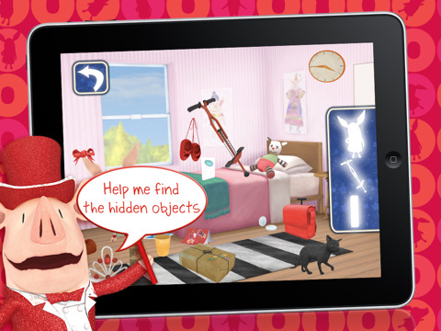

About “OLIVIA the Great 1.0!”
Olivia wishes to become a great magician and she needs your help! Olivia is not able to perform her super incredible magic tricks unless you help her find the missing items to perform her tricks. Olivia can help your child challenge their appetite for adventure through this one of a kind, interactive hidden object and memory match game.
Visit www.facebook.com/OLIVIATV to learn more about Olivia and to see what she is up to every day! Olivia’s Facebook page will also help keep you up-to-date on the latest Olivia news, tips and more from the star herself.
Best,
Han

