C.H.A.N.G.E.
Team Contract
Created February 7, 2011
Updated April 20, 2011

Mandatory Meetings
Time: Every Sunday at 3PM.
(Unless otherwise noted)

Location: Greenwood Library
*Everyone is responsible for attending all meetings.

-A 24-hour notice must be provided if a member is unable to attend a weekly meeting. Contact Team Leader: Allison Leisner or Team Manager: Emily Morone.

-If additional meetings are needed during the week team members will receive an email from either the team leader, Allison Leisner, or the team manager, Emily Morone.

Group Member Responsibilities:

- Team Meetings
  - Procedures:
    - Team members will come to meetings prepared for what will be discussed that day or they will be dismissed.
    - Agenda items for the next meeting will be discussed at the end of each meeting and the team manager will send out an email.
  - Participation:
    - Attendance at meetings is required. No if’s and’s or but’s.
    - Be open to new ideas.
    - If a problem arises, we will discuss the process and explore how it can be improved.
    - Attending class is important to group awareness and cohesiveness; repeated failure to attend class will affect the individual evaluation and final grade.
  - Communication:
    - Seek to understand your group members
    - Practice active, effective listening skills.
    - Keep discussions on track
  - Problem Solving:
    - Make decisions based on data
    - Seek to find the needed information or data.
    - Discuss concerns with other team members during the team meetings or privately with another team member if needed.
  - Handling Conflict
    - Seek to understand the interests and desires of each party involved before arriving at a solution.
    - Choose an appropriate time and place to discuss and explore the conflict.
    - Listen openly to other points of view & acknowledge valid points that the other person has made.
    - Be open to all improvements and accept mistakes made with a positive attitude.
    - State our points of view and our interests in a non-judgmental and non-attacking manner.
    - Seek to find some common ground for agreement.

- Commitments
  - As a group, we will only agree to do work that we are qualified to do.
  - We are ALL responsible to check our e-mail and text messages as often as possible.
  - Be realistic in planning and reporting project scope, schedule, staffing and cost.
  - Operate in a proactive manner, anticipating potential problems.
  - Promptly notifying each other of any change that could affect the schedule or well-being of our group.
  - Keep team members informed of schedules and agendas weekly
  - Our client’s information is personal and should not be shared with anyone other than our group members.
  - See the project through to completion and take responsibility for the assigned tasks.

If a problem arises in the group, contact Allison Leisner immediately so the issue can discussed with the group. If needed, further action will be taken to resolve the issue in a timely and effective manner.

Team Goals:
- Establish good relationship with client
- Keep close touch with our client by keeping them up to date as new information develops
- Listen tentatively to concerns of client
- Develop a successful team through cohesiveness
- Aiding team members
- Creating a comfortable environment
- Strive to raise profits for our client
- Plan and carry out a fundraising event applying skills and knowledge from communication experiences

Team Roles:
Team Leader- Allison Leisner:
- Coordinates and assigns tasks to ensure productive teamwork and cooperation
- Ensure all positions and tasks are clear and understood
- Assist with individual positions if needed
- Take lead on setting deadlines and overall planning
- Meet with the instructor on a regular basis
- Conduct performance evaluations and reports to team members and instructor

Team Manager- Emily Morone:
- Record minutes for distribution to team members and for use in the Team Notebook
- Work closely with the team leader to ensure all tasks are delegated in an efficient manner and on time
- Provide meeting and tasks reminders
- Assist with individual positions if needed
- Write press releases before and after event to appropriate media outlets
Event Planner/Public Relations- Erin Mungo:
- Coordinate with host venue and any vendors to ensure all needs and details are clear
- Develop timeline for event
- Develop roles for team members during the event
- Develop contingency plans, safety plans, and any other plans needed for event
- Ensure client’s mission is well-explained and understood by event participants
- Make contact with key participants to ensure that the event is well-attended
Creative Design- Caroline Nye:
- Design all visual materials including, but not limited to, all marketing pieces
- Ensure team brand is consistently represented through all work
- Work with Shelby Peterson to ensure all promotional materials are approved for posting
Marketing/Publicity- Shelby Peterson:
- Obtain donations from local businesses (as allowed by Longwood University)
- Work to obtain location donation
- Work with public relations to ensure event is well-attended and well publicized
- Utilize sources of marketing such as social media marketing, traditional marketing, and word-of-mouth marketing
Client Liaison- Timothy Quigley:
- Answer all questions the primary contact may have in a timely manner.
- Help PR and Marketing to successfully achieve all goals of our organization.

Group Member Self Evaluation

Name | Temperament | Strengths | Weaknesses
Allison Leisner | Idealist | -Organized  -Assertive  -Writing skills | -Public speaking  -Easily stressed
Emily Morone | Artisan | -Outgoing and assertive  -Good speaker  -Creative ideas | -Editor  -Able to work with little time  -Willing and eager to learn
Erin Mungo | Idealist | -Organized  -Writing Skills | -Editing
Caroline Nye | Artisan | -Creative  -Resourceful | -Writing skills  - Procrastinates
Michelle Griffin | Artisan | -Communicates  well  -Works well in  team setting  -Outgoing | -Unorganized at  times  -Procrastinates
Shelby Peterson | Idealist | -Organized  -Experienced  -Reliable | -Editing  - Public Speaking
Timothy Quigley | Artisan | - Assertive  - Outgoing  - Good Speaker | - Procrastinates  - Unorganized at times

Quality of Work 10%
1. Consistently completes work in a timely manner that is accurate, thorough, and neat. Produces high quality work. Exact and precise most of the time.
2. Presented quality of work is generally unsatisfactory, does just enough to get by, work is generally below what is expected, makes frequent errors.
3. Minimum requirements not met, work is not satisfactory. Assigned tasks need revisions and corrections.
Dependability 10%
1. Through successful performance, instills the feeling of trust and dependability. Seeks additional responsibility, carries through effectively, very reliable.
2. Usually takes care of tasks with reasonable promptness, reliable.
3. Does not accept responsibility; not reliable. Other members must do their work for them. Group leaders must consistently check up on progress of group member to ensure reliability.
Initiative 10%
- Does not require work direction; exhibits persistence an initiative; puts forth a consistent, energetic effort; assumes full and complete responsibility, does not have to be asked to contribute to assignments.
- Requires little work direction, shows little interest in offering ideas and suggestions, rarely contributes to group cohesiveness and team goals.
- Unwilling to demonstrate interest in gaining new knowledge. Does not offer any insight or new ideas to group. Group leaders must constantly try to get group member to complete tasks. Puts in very little effort and takes no initiative.
Attendance 20%
1. Attendance and punctuality are very important in maintaining a normal work load and efficient schedule, group member is always on time and dependable. Always attends group meetings, weekly client meetings, and interviews.
2. Usually present and on time, sometimes allows personal factors to interfere.
3. Absent often, frequently late. Has frequently missed class and team meetings. Does not attend weekly client meetings, and has not participated in client interviews.
Attitude 30%
1. Ability to maintain a positive and harmonious attitude in the work environment, very cooperative. Seeks guidance when needed.
2. Adapts to others and most situations, sometimes defensive.
3. Fails to consider others’ feelings, defensive and argumentative, not courteous
Overall Performance 20%
      - Establishes high standards of conduct and job performance, needs little or no direction.
      - Usually takes care of tasks with reasonable promptness, requires some attention
      - Often fails to meet deadlines, unreliable, requires close supervision. Meets minimum requirements for above guidelines.

Overall Performance Rating Scale

Excellent: Performs at an above and beyond level. Consistently makes significant contributions.
Above Expectations: Consistently performs at a level that meets and often exceeds expectations of the position.
Meets Expectations: Adequate performance. Consistently displays competent performance that meets the basic expectations of the position.
Needs Improvement: Meets minimum job expectations, but needs improvement in key areas of accountability.
Unsatisfactory: Fails to meet minimum expectations; needs immediate and effective attention.

 | Excellent | Above Expectations | Meets Expectations | Needs Improvement | Unsatisfactory
Quality of work
Dependability
Initiative
Attendance
Attitude
Overall
Performance

- I will demonstrate great interest to participate in the group, share my ideas, and discuss them openly with other team members.
- There is a majority vote ruling.
- I am solely responsible for any assigned material by the team. I will submit my work on time and with my best effort
- In case of an unanticipated absence it is my responsibility to promptly contact my team members and learn of any new matter. I must also give my team leader advanced notice.
- In case of a negative performance I will be issued a warning.
- The team holds the right to release me after the third (3rd) strike (decided by majority of votes).
- Reason(s) to issue a strike may be but are not restricted by the following reasons:
  - Unable to submit an assignment on time.
  - Lack of team participation.
  - Does not take initiative in projects, and must constantly be asked to complete tasks and attend meetings.
  - Constant negative attitude and unwillingness to handle individual responsibility.
- I am not allowed to leave the group at any time.

I will uphold the guidelines of this contract:

Signature____________________________________ Date_____________________
Signature____________________________________ Date_____________________
Signature____________________________________ Date_____________________
Signature____________________________________ Date_____________________
Signature____________________________________ Date_____________________
Signature____________________________________ Date_____________________

Agency Profile

Our Mission:

Our approach to community-based fundraising begins by having the CAUSE be known. We strive to achieve the current endeavors our clients hold by HELPING the client organize existing ideas to create immediate plans of action. Our mission is to ACHIEVE the conceivable and accomplish the imaginable. We value NON-PROFIT organizations specifically, and seek to GENERATE the lasting support and recognition to establish eternal success. We do all of this by EXERCISING strength through leadership to ensure lasting stability of our clients.

Agency Capabilities:
- Interpersonal skills
- Creative thinking
- Leadership skills
- Critical thinking
- Extensive knowledge regarding communication theory
- Problem solving

Associate Profiles:
Public Relations:
Michelle Griffin
Marketing Coordinator:
Shelby Peterson
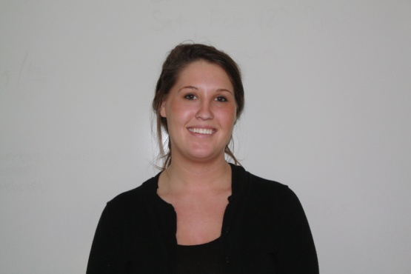
Team Manager:
Emily Morone
Team Leader:
Allison Leisner
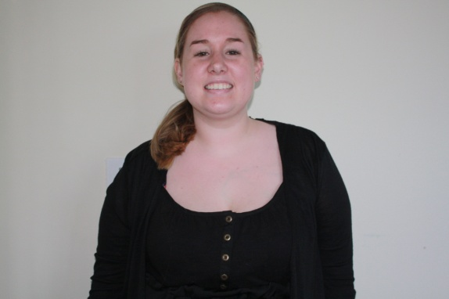
Event Planner:
Erin Mungo

Creative Design:
Caroline Nye

Marketing Coordinator:
Shelby Peterson
Public Relations:
Michelle Griffin

Client Liaison:
Timothy Quigley
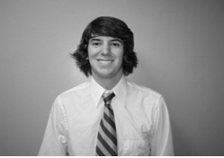

C.H.A.N.G.E. Contact Information:
Liaison-
Timothy Quigley: (804)-690-1475 Team Manager-
timothy.quigley@live.longwood.edu Emily Morone: (434)-962-6191
emily.morone@live.longwood.edu
Team Leader-
Allison Leisner: (703)-822-322
allison.leisner@live.longwood.edu

