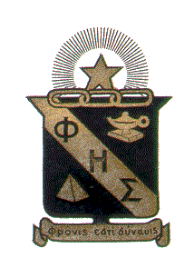
Phi Eta Sigma
National Freshman Honor Society

Alpha Chapter
The University of Alabama
September 28, 2011

372 Rose Administration Building
Box 870301
Tuscaloosa, AL 35401

Dear Student:

It is with pleasure to invite you to join Phi Eta Sigma, the national freshman academic honor society. Your scholastic average at The University of Alabama has qualified you to receive this invitation. Only students who have between 12 - 45 hours with at least an overall 3.5 quality point average are eligible for membership. This is one of the highest honors attainable by an undergraduate student and we extend to you our sincere congratulations upon this achievement. Induction will be held on Tuesday, November 8, 2011 at 6:00 p.m. in the Theatre, located in the Ferguson Student Center.

Phi Eta Sigma is a national scholastic honorary and has been a member of the Association of College Honor Societies since 1937. The University of Alabama chapter was chartered in 1930. The expense of becoming a member is $50.00. This fee is paid only once and constitutes the only expense of joining. There are no further dues, fees or assessments collected after you become an active member. The $50.00 covers the cost of your membership certificate, the society magazine, your membership key, a graduation honor cord, and information on the services and scholarships offered by our national office. Our campus chapter offers a $750.00 scholarship which is awarded each spring to a new Phi Eta Sigma member. To apply for the chapter scholarship, please complete the University of Alabama general scholarship form available at http://scholarships.ua.edu. National scholarship applications, the minimum award is $1,000, are available in our office each January. You may apply each undergraduate year and also for graduate school.

I hope to have the pleasure of welcoming you into The University of Alabama Chapter of Phi Eta Sigma Honor Society.

Sincerely,

Natalee M. Briscoe Molly Lawrence
Natalee M. Briscoe Molly Lawrence
Chapter President Faculty Advisor
President, National Phi Eta Sigma

