Executive Summary:
The aim of Direct Public Relations campaign is to increase foster care families for Sunbeam Family Services Oklahoma City. Direct Public Relations goal is to recruit three new foster care families after the implementation of our campaign. A current lack of awareness in the Oklahoma City area for Sunbeam’s foster care program have disabled the new recruitment of potential families and others who might be willing to get involved with the program. Our team has spent countless hours extensively researching who Sunbeam Family Services best target audience for foster care should be. Our research, using surveys and in-depth interviews aided our team in discovering that the target audience is women and men between the ages of 45 and 55, who regularly attend church, and are philanthropic as they are involved in the community.
Direct Public Relations campaign aims to raise this low awareness level among this target audience, and recruit new and caring families. We plan to do this by utilizing social media tools like blogs, Twitter, and Facebook to reach our audience. This campaign also strives to gain awareness through the use of public service announcements, digital newsletters, and fliers in the Oklahoma City area.
By utilizing and implementing these strategies Direct Public Relations can successfully increase the foster family numbers for Sunbeam Services and better target people curious about foster care in the future. It is recommended by Direct Public Relations that Sunbeam Services takes these strategies and move forward in promoting foster care in the Oklahoma City area.
Sincerely,
The DIRECT PUBLIC RELATIONS TEAM
Rylie Burns Courtney Crossfield

Jordan Jones Annessa Burrell

Jonna Reavis

Situation Analysis:
Sunbeam Family Services is a non-profit organization that host different programs like foster care in the Oklahoma City area. Sunbeam currently is in the middle of challenge of gaining awareness for their foster care program. This lack of awareness is causing a major decline in families interested in fostering children in the area. Direct PR plans to increase this number by first implementing surveys and in-depth interviews and then taking that information and applying it our campaign for prospective families. We know by using research we can better find and contact prospective homes for these children.

SITUATION ANALYSIS:
Environmental Scanning:
Governmental/Legal/Public Policy
- The new government regulations for foster care will become enforced starting Jan. 1, 2012.
- The act that the president signed on family support and foster care will ensure all other support and resources are exhausted to help the biological family before turning to foster care.

Economic Conditions
- Most states reimburse foster parents significantly less than the actual cost of raising a foster child.
- To adequately cover the cost of rearing a child, base payments in Oklahoma would have to increase by 51-75 percent.
- Poverty, homelessness and unemployment are some of the factors that have contributed to children ending up in foster care.
- “The ensuing economic crisis has likely halted plans for any future government increase in funding for children currently in foster care.”

Technology
- A recent trend has been happening through the use of technology, such as foster children communicating with birth parents and other blood relatives through social networks.
- The use of technology can be helpful by giving more support to the children and parents through texts, e-mails and open forums to discuss what is going on. It allows everybody to keep a closer eye on the child.

Resources
- Sunbeam offers several different resources for families who are enrolled in the foster care program.
- They have counseling for both the children and parents in foster care.
- Several youth feel that when leaving foster care services it helps them learn to live on their own, find employment, and educational help would be useful.

Society/Culture
- The socioeconomic trends of fostering children strongly indicate the lack of willing people because lack of funds and lack of support from the government.
- There is a stigma that goes along with foster children. People do not want to do foster care because the children are viewed as “damaged.”

News Media (not ads and current PR)
- Foster care tends to be a difficult subject in news coverage. Even with how important the topic is, the main medium that cover foster care is television. We often are shown a bleak image of what it is to be a foster parent.
- For example, Diane Sawyer had a news series for foster parenting that was primarily focused on children who ended up being abused, and even a case in New York where a young girl died.
- It is important that the news go beyond headlines of negative stories, and explain foster care in a more positive, uplifting way.
- Competition (direct and indirect)

Indirect: All adoption agencies in the Oklahoma City area. They are indirect competition as they do not offer foster care services directly, but they are reaching out to potential fostering families and marketing the idea of adoption instead.

Direct:
- Southwest Foster Care Inc.
- Bair Foundation
- Choices For Life
- Angel Foster Family Network
- Oklahoma Department of Health Services

Who are the major competitors?

Southwest Foster Care
- Southwest Foster Care of Oklahoma Inc.
- Bair Foundation
- Choices for Life
- Angel Foster Care
- Oklahoma Department of Health Services

How do they compete?

Southwest Foster Care
- According to the Southwest Foster Care Web site, they are a therapeutic foster care agency designed to provide therapeutic family placement and specialized services to youth ages 3 to 18 who have been assessed through the Department of Mental Health and determined eligible to receive services according to the medical necessity criteria.
- They take youth that have been diagnosed with emotional or behavioral problems, and similar to Sun beam, they offer therapy for both the children and families. The therapy is in home on a weekly basis with both child and family. They also have 24 hour crisis management.

Bair Foundation
- They offer therapeutic foster care for youth with emotional and behavioral needs, traditional foster care for children who need placement outside of their biological families, kinship care for children staying with relatives and medically needed foster care for children with special medical needs.

Choices for Life
- It offers Multi-dimensional treatment foster care, which they have created to be a research oriented program. They have an office in Oklahoma City and surrounding areas. They specialize in therapeutic foster care and the parents are professionals on dealing with special needs children.

Angel Foster Care
- According to the Angel Foster Care Web site, they are a private foster child placing agency in OKC that rescues infants and toddlers who have suffered a traumatic experience while living in the emergency shelters or even the short term foster care homes if they were abused, neglected, or abandoned by their own parents.

Oklahoma Department of Health Services
- To sum up the foster care philosophy of OKDHS, “Foster Care is a planned, goal-directed service that provides 24-hour-a-day substitute temporary care and supportive services in a home environment for children birth to 18 years of age in OKDHS custody.”

What are their strengths and weaknesses?

Southwest Foster Care
- The strengths of this organization is all the supportive techniques they offer to the children in foster care. By giving weekly therapy and 24 hour crisis management it gives the foster parent a sense of security.
- A weakness that Southwest Foster Care has is the range of children they have in foster care. They foster from ages 3-18. While all children deserve to have a family, it makes it that more difficult to find families who are willing to take on all those age groups.

Bair Foundation
- The strength of Bair Foundation is the amount of offices that they currently run. It allows them to take in more children as well as have more places for people to sign up to be foster parents.
- The weakness of Bair Foundation is they operate in all states. Sunbeam offers counseling for clients and with Bair having clients outside of where their home offices are located they cannot be as personable with all youth and family.

Choices for Life
- The strength of Choices for Life come from the amount of focus being put on training the parents on how to work with special needs children. If children with emotional and behavioral problems are placed within a home, it is comforting to know that the parents will know what they are doing.
- The strength for this organization also doubles as a weakness. When reviewing the Web site, it puts so much emphasis on training the parents. It can lead other parents who want to help become discouraged because of all the steps it takes to foster.

Angel Foster Care
- The strength of the Angel Foster Care foundation is they have concentrated on one demographic of children for foster care, which is 3 years old and younger. Just like Sunbeam focuses on infants, it makes the chances of getting a foster parent better. Statistics show people favor adopting babies more.
- The weakness is this is a private owned organization and relies solely on private investors. While they are not as regulated by the government, Direct PR believes that this makes it harder to make guarantees of financial support to those parents wanting to be a foster parent.

Oklahoma Department of Health Services
- The strength of OKDHS is the amount of children they are able to bring in at any given time.
- The weakness is how impersonal they are. Children need nurturing and care and they make it seem like a business. It is straight to the point on the job of a foster parent. Everything is black and white.

Image

Southwest Foster Care
- The Southwest Foster Care builds up a strong image of what their organization is by having success stories on the internet of children that have improved their lives through the care of Southwest Foster Care. This is also a very similar technique used by Sunbeam.

Bair Foundation
- The Bair Foundation is centered on being a Christian, nonprofit organization. This helps to appeal to those that choose to be foster parents because they are doing what their faith tells them is God’s work. They say you must have a “servant’s attitude” to help others in foster care.

Choices for Life
- The image of Choices for Life is dedicated to promoting their need to have professional parents. The youth they take in do not fit the society norms and they base all of their criteria and training around those characteristics.
- They offer similar services that Sunbeam has; screening and matching of treatment parents and children, 24-hour availability for additional support/crisis services, and support group and family therapy.

Angel Foster Care
- The image of Angel Foster Care appeals to people’s emotions. They paint a mental picture of an abused infant and challenge people to do something about it. They have helped rescue more than 100 infants. People tend to have a softer side the younger a child is. Direct PR thinks this helps appeal to a wider audience.

Oklahoma Department of Health Services
- The image of OKDHS is the transitional place between taking a child, and placing them in one of these other foster care nonprofit organizations. They are there to simply get a child out of a harmful situation, and get them directly to a foster parent.

Costs and fees

Southwest Foster Care
- When providing foster care for a child, they recommend that your income alone is able to meet the needs of raising a child. The incentives offered by Southwest Foster Care are $30 per day, per child reimbursement, as well as all foster youth who are enrolled in Medicaid that covers medical and dental care, including prescriptions.
Bair Foundation
- Before fostering a child with the Bair Foundation, one must be financially stable to foster a child. The Bair Foundation offers a competitive per diem to cover the financial cost of fostering, and medical cards are provided for each placement.

Choices for Life
- The only cost that could arise for this organization is the finger printing you are required to have during training.
- They offer the following monetary assistance: $30 per, day per child, $200 referral bonus, $100 teenage placement bonus, a Christmas bonus, and a paid respite.

Angel Foster Care
- Because of the private ownership and strict guidelines that Angel Foster Care adheres to, it is important that your income can support a child.
- You are given Medicaid for the children and a stipend of about $400 per month to cover formula and diapers.

Oklahoma Department of Health Services
- With OKDHS being a direct affiliation of the government, a foster parent must be prepared to support the children solely on their income.
- A based rate is paid to parents to meet basic needs. But the amount paid does not cover the real price in raising a child.

Organizational Analysis:
From what Direct PR has found, Sunbeam Family services, as an organization is extremely strong internally. Their broad span of programs ranging from adoption services to foster care is not being properly funded at this time due to lack of interest in the community. While holiday months such as Thanksgiving and Christmas bring in more funds from the community, other months struggle to gain attention.
- Client Needs: Clients of Sunbeam’s needs are currently being met by follow up meetings after a child is placed in a home. Counseling services are also provided for families and children after placement to ensure that all is running smoothly. Sunbeam effectively uses and distributes kits to new foster families answering all types of questions about fostering and bringing a new child into your home. These kits have proved effective, and positive feedback has been shown in meetings and through word of mouth. It has been shown word of mouth and personal testimonies are the best tools to engage and increase further interest about Sunbeam. Direct PR would like to further this tool and increase word of mouth by raising awareness in the community through fliers in churches.

- Past and Current Effectiveness: Current communications on Twitter and Facebook are used to raise awareness and are shown to be effective as the public can visibly see when a child is placed in a home or any success stories Sunbeam shares. One can see the feedback on these social media sites through retweets, comments and mentions. On Twitter, Sunbeam currently has 313 followers; Direct PR plans to raise this number though through putting out flyers in the community and tweeting more about Sunbeam from our personal Twitter.

- Public Perception: Currently Sunbeam’s name is viewed as a helping hand in the community, a saving grace for some, and a confusing topic for others. Sunbeams confusing perception stems from its ties to DHS and its negative connotation that follows. Because Sunbeam is a branch of DHS it gets a bad reputation for being highly government regulated, impersonal and unorganized. This perception must be fixed by showing Sunbeam standing on its own in the community and proving negative perceptions wrong by making every foster case a personal one.
Target Audiences/Markets:
- Who: The target audience or markets for foster care are people who attend church regularly, are ages 45 to 55, people of philanthropic nature and are active in the community currently.

- Which are influential: We found that the most the influential people to get interested in fostering children would be the people that are involved in church or in their community. The people who are more involved are more willing to help out in the community. Also research has been shown that women are the primary voices in households, because of this we would like to mainly target the voice in our campaign toward women.

- Why do they have an impact: These people have a greater impact than people who are not involved in a church or the community, because they know what is going on in the area. They would also be able to show others and tell others about the fostering system and Sunbeam Family Services. As for women being the influencers in a household, they hold the voice as they are shown to be primary caretakers with motherly instincts. Thus making them the influencer when bringing a child into the home. A woman could convince her husband that the choice to foster would be an important one as she is an influence in the home on family type decisions.

- What are their reasons: The reason that the target audience wants to be involved in fostering children would be because they care about children and they also want to give back to the community. This audience also feels obligated for faith reasons to give back to the community and do the “right thing”.

- How do they affect the organization: These people also affect the organization by hosting children, having positive experiences, and then sharing their experiences with the community. These people reflect on the organization and are the main voice in the community.
Primary Research Plan
Objective:
The goal of creating a survey for our research is to better understand why adults or families choose to become foster families and what their backgrounds are. These surveys will take an in-depth look at psychographics as well as demographics of our participants. By conducting a survey we will be able to pin point a target audience to gear our campaign toward, and understand their needs. Direct Public Relations would like to take Sunbeam’s current list of potential or interested foster families and send them the links to our survey. We also would like to post our survey to Sunbeam’s Web site and take local church email list to attract those interested and include them in our survey. These surveys will ask specific questions using the likert scale, open-ended questions they may have about becoming foster families, and also what might be holding them back from becoming foster families. This type of research will be extremely useful in our campaign as we can easily quantify what age groups are interested, their income levels, and how interested they are.

Methodology:
The survey will be conducted online at zoomerang.com and will be brought to participant’s attention by being posted on Direct PR’s social media outlets like Facebook and Twitter. We plan on implementing our survey on these sites by contacting and gaining permission from Kelli Dupuy at Sunbeam. We will keep the survey up until October 4, 2011 so we have ample amounts of time to reach participants.

Sample:
Our anticipated respondents are those who are possibly interested or even curious about foster care programs in the Oklahoma City area. We foresee adults ages 27 to early 50s being interested in fostering. These adults would also have to have steady occupational schedules, where amounts of time could be spent in the home with the children depending on which care program they were more interested in being a part of. Direct PR also projects that these adults or couples will have some sort of faith background, as a lot of information regarding foster care and adoption is currently offered in Churches like Church of The Servant and Saint Monica’s in Oklahoma City.

Research Instrument:
The following pages contain the survey Direct PR has put together for potential foster care families:

Primary Research Plan Continued:
Objective:
Our second research method we plan to use is a one on one interview with a foster parent. The goal of this to get a hands on idea of what exactly it means to be a foster parent, the logistics of children coming in and out of a home, and their feelings toward the low numbers of foster families today. This information will give us not only a better idea of why someone would want to become a foster parent, but also a better idea of what is keeping some from fostering a child today. This sit down conversation can let our team see exactly what a foster parent is dealing with on a day-to-day basis and how exactly they feel. This information will be quantifiable as we will be able to ask the person what their income level is and what money the government is funding to them.
Methodology:
Through the use of a one on one interview we plan to contact five people directly related to foster care. By asking each of these women the same list of questions concerning their views on foster care and personal questions we developed, we will be able to gather helpful information for our campaign. All of the interviews will be conducted inside the women’s homes or over the phone should they not be able to meet the day of. The interviews will be collected September 22nd through the 24th, and our team members have decided to split up to interview each person individually to make them feel more comfortable. We will be using phones as recording devices during the interviews as well as taking notes.
Sample:
Our anticipated respondents are Susan Miller, Shannon Hooper, Judy Brander, Linda Ruby, and Cynthia Collinsworth. Each of these women has agreed to meet with our team and answer our questions about foster care, their outside occupations and income if they feel comfortable discussing. While we current know very little about each of our respondents we feel we will be able to get better ideas once face to face. These women selected are extremely appropriate to interview as they currently are foster parents or have been a part of a foster care program recently thus giving us the best inside look on the topic and how we can better our campaign. While we do have a tight schedule, Direct PR see’s it necessary to interview five women to make sure results and answers are measurable for research purposes.
Research Instrument:
The following page contains the interview questions we will ask in our in-depth, one-on-one interviews with current foster parents:

INTERVIEW QUESTIONS:
- How long have you been a foster parent?
- What was your biggest fear before taking on this new responsibility?
- How many foster children have been temporary members of your family?
- Have you ever considered adopting one or multiple children that have been in your care?
- Do you have children – if so, have there ever been any adjustment issues with bringing new individuals into your home?
- Have variances in demographics, such as backgrounds, financial levels, race or religion differences, ever been an issue to overcome with a foster child?
- What has been the most uplifting experience you’ve had to date since becoming a foster parent?
- Do you find it hard to separate from the child, due to adoption or being returned to their parents, once they have been in your care for a period of time?
- If you could suggest something to your agency, as far as an additional service to offer, increased provisional funding, or more involvement with the families, what would it be?
- Do you receive help from your community, or support from an affiliate religious or social program?

PRIMARY RESEARCH FINDINGS:

Research Method: In-depth, One-On-One Interviews
Objective:
The goal of our research was to create in-depth interview questions to obtain personal testimonies from those who are familiar with foster care. Our questions were created carefully in order to get on a more personal level with our interviewees. These personal testimonies not only allowed us to gain a better understanding of the audience we wish to target but it will also allow others to have his or her questions answered. Many people who are interested in foster care are skeptical and have many fears. By asking these questions, Direct PR feels we can help those who are skeptical get a better understanding of how foster families work. Previously, foster care services have had a negative reputation. Our intention with the in-depth, one-on-one interviews was to separate Sunbeam from any negative reputation. Our campaign is designed to set Sunbeam Family Services apart from other foster care services by accentuating their strengths.
The interviews were qualitative by using open-ended questions to get a better understanding of the lives of foster care parents. Direct PR created a series of 10 questions to use in our interviews. We started off with basic questions such as, “How long have you been a foster parent?” and “How many foster children have been temporary members of your family?” We learned that the average length of being a foster parent has been five years. We also learned that many of the parents share the same fears, concerns and excitements when housing a foster child. All of the foster parents found that although it was challenging, it was very rewarding. These discoveries have helped Direct PR able to answer questions for those who are interested and have concerns about being a foster parent.

Methodology:
Our interviews were conducted within the home of five different foster parents: Delores Boone, Tammy Parker, Shannon Hooper, Judy Brander, and Cynthia Collinsworth. Each of these women were more than happy to assist Direct PR in our research. We conducted our interviews of a course of a weekend in September 2011.

Sample:
Our first interviewee was Delores Boone. Mrs. Boone is a 46-year-old woman who lives Tulsa, Okla. is an English teacher. Her annual household income she didn’t want to confide in us. She assured us that it was enough for her and her husband to live and to take in foster children. We found Ms. Boone appropriate for our one-on-one interviews because she is a foster parent, herself. Our goal with the interviews was to silence to fears and answers the questions that potential foster care parents might have.
Our second interviewee was Tammy Parker. Mrs. Parker is 64 years old and lives in Tulsa, Okla. Mrs. Parker used to work for the City of Tulsa. Also, she did not want to share her annual household income. We chose Mrs. Parker for the interview because she has been a foster parent for 10 years. She has had several children come and go from her care and she has faced many difficulties as well as blessings while housing these children.
Third, we interviewed Shannon Hooper. Ms. Hooper is 48 years old and is unmarried and living in Sapulpa, Okla. Ms. Hooper works in marketing for a company in Tulsa. Ms. Hooper told us that her annual household income was between $60,000 and $70,000. We chose Ms. Hooper as an interviewee because she is on the younger side of most foster parents and because she is unmarried. A lot of people believe that you need to be married in order to be approved to be a foster parent. By having Ms. Hooper answer our questions, we believe she will be able to provide an uplifting personal testimony for those who want to foster, who are single, but are afraid to.
Fourth, was Judy Brander. Mrs. Brander is a 55-year-old woman who lives in Glenpool, Okla with her husband. She has children who are older. Mrs. Brander did not wish to reveal her annual household income. We asked Mrs. Brander to help us with our research because of her involvement with the community and her church. She has had the privilege of being a foster parent for three years and we believe she has a lot of great advice within the interview that will help our potential foster parents.
Last, we interviewed Cynthia Collinsworth. Mrs. Collinsworth is a 57-year-old woman who lives in Tulsa, Okla. with her husband. She has other children who are currently in school and married. Mrs. Collinsworth also did not wish to reveal her annual household income. We chose to interview Mrs. Collinsworth because she has other children who have been involved while fostering a child. We knew she had genuine advice to give to those who have fears about putting a foster child and their own children together.

Key Findings & Implications
- Within our in-depth interviews, we have found that all of our interviewees had the same fears to start off with. They were all afraid that the child would no adjust properly and they were afraid that they wouldn’t be able to provide financially and emotionally for a child. There were also fears from those interviewees that had their own children that they wouldn’t get along and there would be problems.

- By interviewing these women in their homes we were able to get a glimpse of each of their lifestyles. Although all but one wished to not reveal their annual household income, we were able to guess that there were financially stable enough to provide for themselves, their family and any other foster child they were willing to take in.

- The age of the interviewees were generally in the same category. There was only one woman that was on the younger end of the age spectrum. Most foster care parents are older than 50, which all but one of are participants are.

- Although our interviewees had many of the same fears, they also had been uplifting experiences with these children. It appeared that at times, foster children had a hard time adjusting. Eventually, the children would adjust to the family and their lifestyle as well as their school and church family. It gave them a sense of belonging.

- We noticed that each interviewee had a different outlook on ever wanting to adopt a child they had fostered. Some women were open to the idea; while others liked that they were a temporary home. They were a place to help a child and to love a child and were sent back to their own parents.

- Almost all of our interviewees had suggestions for the foster care agency. They wished that they would provide more counseling sessions for the children, seeing as they have a hard time telling someone how they feel when going through such a difficult transition. Another interviewee suggested that they had more involvement with other foster parents outside of the agency. They want more events with foster parents and their children they are fostering. It lets one another know what they are going through, as well as the children.

Cynthia Collinsworth
INTERVIEW QUESTIONS
- How long have you been a foster parent?
- Five years
- What was your biggest fear before taking on this new responsibility?
- My biggest fear was that I would fail the kids.
- How many foster children have been temporary members of your family?
- I have had 10 children.
- Have you ever considered adopting one or multiple children that have been in your care?
- Honestly, no, I personally haven’t considered adoption. I’m 57 years old, and I don’t think I would be able to manage an adoption.
- Do you have children – if so, have there ever been any adjustment issues with bringing new individuals into your home?
- I do have children, but they are grown and out of the house. My children often come over and play with the foster children. But I haven’t noticed any adjustment issues. I have noticed adjustment problems with the foster children getting used to the other foster children.
- Have variances in demographics, such as backgrounds, financial levels, race or religion differences, ever been an issue to overcome with a foster child?
- Depending on the child, there is always going to be an issue with something. I have noticed more behavioral issues.
- What has been the most uplifting experience you’ve had to date since becoming a foster parent?
- The most uplifting moment for me, is when a child gets to go home to their biological parent. I know that I helped that child out while his parents were able to get help.
- Do you find it hard to separate from the child, due to adoption or being returned to their parents, once they have been in your care for a period of time?
- Yes, it is always hard when a child leaves, but I usually get another child soon after one child leaves.
- If you could suggest something to your agency, as far as an additional service to offer, increased provisional funding, or more involvement with the families, what would it be?
- The only thing I would suggest, would be counseling for the children that have issues interacting with other foster children that I have.
- Do you receive help from your community, or support from an affiliate religious or social program?
- I receive support from my community and the school system. The school system seems to support me and the foster children the most.

Delores Boone
INTERVIEW QUESTIONS:
- How long have you been a foster parent?
- 4 years
- What was your biggest fear before taking on this new responsibility?
- My biggest fear is that the children will not adjust properly.
- How many foster children have been temporary members of your family?
- Two children. I did foster care within the family of my great niece and nephew.
- Have you ever considered adopting one or multiple children that have been in your care?
- I considered adopting them, but I feel that when their mom was able to take back responsibility of them, that was best.
- Do you have children – if so, have there ever been any adjustment issues with bringing new individuals into your home?
- I have children but they are all adults.
- Have variances in demographics, such as backgrounds, financial levels, race or religion differences, ever been an issue to overcome with a foster child?
- I think because I was a family member they felt that they would do better in my care. None of those issues played a part in the decision for them to stay with me.
- What has been the most uplifting experience you’ve had to date since becoming a foster parent?
- I think the most uplifting moment was when the kids started to finally adjust in school and church and making new friends. They were stand offish at the beginning and over time that changed.
- Do you find it hard to separate from the child, due to adoption or being returned to their parents, once they have been in your care for a period of time?
- While I miss the children, I know that I will see them again at family events and they are better off with their mother.
- If you could suggest something to your agency, as far as an additional service to offer, increased provisional funding, or more involvement with the families, what would it be?
- Not sure. I didn’t feel like I needed assistance.
- Do you receive help from your community, or support from an affiliate religious or social program?
- The family helped support me as well as my church.

Judy Brander
INTERVIEW QUESTIONS
1.How long have you been a foster parent?
- I have been a foster parent for 3 years.
- What was your biggest fear before taking on this new responsibility?
- Becoming a parent in general was my biggest fear. Just knowing that I would be taking care of a child was a little scary, but I quickly adjusted to fostering children.
- How many foster children have been temporary members of your family?
- Since I have been fostering, I have had four children.
- Have you ever considered adopting one or multiple children that have been in your care?
- Yes, I have considered it, but I think I will wait a while before I actually adopt.
- Do you have children – if so, have there ever been any adjustment issues with bringing new individuals into your home?
- I do not have any children of my own.
- Have variances in demographics, such as backgrounds, financial levels, race or religion differences, ever been an issue to overcome with a foster child?
- I would say the hardest thing to overcome would be the different backgrounds the children come from. They have all been raised differently, so it is sometimes hard for them to cope with coming into a different environment.
- What has been the most uplifting experience you’ve had to date since becoming a foster parent?
- I find the most uplifting experience to be when a child first tells me that he/she loves me. That is when I know that the child feels comfortable and safe with me.
- Do you find it hard to separate from the child, due to adoption or being returned to their parents, once they have been in your care for a period of time?
- Yes, I always find it hard when a child leaves, but I know they are moving to benefit them in the long-run.
- If you could suggest something to your agency, as far as an additional service to offer, increased provisional funding, or more involvement with the families, what would it be?
- So far my agency has been very helpful.
- Do you receive help from your community, or support from an affiliate religious or social program?
- Yes, I have a lot of support, mainly from my church. Mt whole church family is very welcoming to each child I have fostered.

Shannon Hooper
INTERVIEW QUESTIONS
- How long have you been a foster parent?
- I’ve been a foster parent for 3 years.

- What was your biggest fear before taking on this new responsibility?
- I think my biggest fear about being a foster parent is being able to provide enough financially and emotionally for a child. Moving from place to place and having to transition and adjust every single time cannot be easy on a child.

- How many foster children have been temporary members of your family?
- In and out, I’ve had 5 children.

- Have you ever considered adopting one or multiple children that have been in your care?
- Definitely. If I ever have the option of adopting a child, I would. They are a blessing and all I want to do is help in any way I can.

- Do you have children—if so, have there been any adjustment issues with bringing new individuals into your home?
- There are always adjustment issues. But kids are kids. They really just want someone to play with and my kids are happy to do it.

- Have variances in demographics, such as backgrounds, financial levels, race or religion differences, ever been an issue to overcome with a foster child?
- When something like this does occur, like we get an African American child or Latino child, there is an adjustment to lifestyle. It’s never been an issue though. I believe that these kids just need love and attention and food and shelter and a warm bed. I think by providing that you are gaining trust and an understanding for one another and it’s something we all have to adjust to.

- What has been the most uplifting experience you’ve had to date since becoming a foster parent?
- Any experience when the child begins to trust you and warm up to you is an uplifting experience. They begin to depend on you for things and you are capable of being there unlike anyone else that child has been with.

- Do you find it hard to separate from the child, due to adoption or being returned to their parents, once they have been in your care for a period of time?
- Yes. Every time a child has to leave me, it’s hard. I try and look at this like my job. I was put here on earth to foster these children, give them love, food and shelter and anything else they need to shape them and prepare them for the future. It’s always difficult, but it’s always a blessing to get another child to be able to do the same thing for him or her.

- If you could suggest something to your agency, as far as an additional service to offer, increased provisional funding, or more involvement with the families, what would it be?
- I don’t think it’s their job to provide funding for the foster parents. They find well-equipped and appropriate families, and that’s their job. They do that job marvelously. I think all foster parents would like more involvement. Maybe something to get other foster parents together and the kids together. Not necessarily meetings, but fun things to do with each other. It might give us and the kids some sunshine in a not so great situation.

- Do you receive help from your community, or support from an affiliate religious or social program?
- Our church has “love offerings” about once a month for the foster families in our church community. It’s very helpful and we’re grateful for it.

Tammy Parker
INTERVIEW QUESTIONS:
  - How long have you been a foster parent?
- Over 10 years
2. What was your biggest fear before taking on this new responsibility?
- The biggest fear is whether or not my kids will get along with them, or if I can be the support the child needs. I have never had any of these problems, but I never want to not think they could happen.
3. How many foster children have been temporary members of your family?
- 7
4. Have you ever considered adopting one or multiple children that have been in your care?
- I have adopted one of the children that started as a foster child. He just seemed like the right fit for my family. We needed him as much as he needed us.
5.Do you have children – if so, have there ever been any adjustment issues with bringing new individuals into your home?
- At the beginning it was hard to explain to them what the children were doing in our home, but over the years they have gotten older and learned to love bringing in new children.
6.Have variances in demographics, such as backgrounds, financial levels, race or religion differences, ever been an issue to overcome with a foster child?
- I don’t feel any of those have been an issue for me fostering children.
7.What has been the most uplifting experience you’ve had to date since becoming a foster parent?
- The most uplifting was bringing in Albert. He came to us when he was 5 and had a hard time adjusting at first. But my children loved him like a brother and we knew he was meant to be in our family.
8.Do you find it hard to separate from the child, due to adoption or being returned to their parents, once they have been in your care for a period of time?
- Anybody with a heart would have a hard time separating from a child. When you get to know a child’s personality and smile, it is hard to let go. But I know it is for the better and I am happy to see them find a permanent home.
9.If you could suggest something to your agency, as far as an additional service to offer, increased provisional funding, or more involvement with the families, what would it be?
- I believe it would be better to have more programs in which the foster children could visit with someone and be able to talk weekly about their feelings. Just because I think sometimes they have a problem telling you how they feel.
10.Do you receive help from your community, or support from an affiliate religious or social program?
- My church has been both financially and spiritually supportive.
PRIMARY RESEARCH FINDINGS:

Research Method: Online Interactive Survey
Objective:
The goal of our research was to create measurable survey questions to reach out to people curious or familiar with foster care. Our questions were created so we could categorize subjects into groups to see how familiar or unfamiliar they were with foster care, if they were interested, and other demographic information. By asking these questions Direct PR feels we can better reach subjects and give them information about foster care, or see what is keeping them from foster care currently. From previous research and failed campaigns within Sunbeam prior to Direct PR’s attempts it has been shown a negative stigma is associated with foster care. Direct PR wants to rid the organization of this stigma and create a campaign that is both friendly and approachable for families, highlighting Sunbeam’s strengths.
This surveys results were quantifiable as we were able to put participants answers about income, marital status, and how interested they were in foster care on a likert scale. By seeing where we currently stood to participants we could better target the audience we found to be most interested in foster care. These people were ages 36 to 45, those who had a background in faith or belonged to a church, and those who were married. These findings could better help Direct PR target our efforts into this demographic of people.
Methodology:
Our research was conducted online and distributed through social media sites like Twitter and Facebook. We were able to get an overwhelming response from not just our peers, but also family and friends who are out of school and reached out to complete our survey. The information was counted up for us online by the survey source so we were able to measure different responses and groups of people. These findings were then categorized and put into our appendix so we could better see who we needed to target and what questions they had about foster care that we could answer.
Sample:
The respondents were reached out to on social media sites were first our followers or “friends” on Facebook who then were told to pass it along to others. We also reached out to Sunbeam’s public relations woman, Kelly Dupuy who we asked to tweet the survey from the organizations twitter page. 73.2 % of our respondents were between the ages of 36 and 45, and 53.6% of them had income levels between $56,000 and $65,000. This income came as a surprise as it was a lot higher than we projected. Another surprise we found was more than half of respondents did not have children currently.
This information collected will immensely help us target those between the ages of 36 and 45 in the Oklahoma City area with currently do not have children. With this information we can better gear our campaign towards this age group at churches in adult bible studies. Currently adults between these ages are extremely active on Facebook, so distributing our survey using the social media site as a platform was our best option.

Key Findings & Implications:

1. Within our applicants surveyed 73.2% fell within the age group of 36-45 years old. This fact is important because it will specify an age demographic for the Sunbeam marketing campaign; age affects all aspects extending from content maturity to determining social patterns with which to utilize in advertising.

2. From those surveyed, 53.6% of the participants claimed to receive between $56,000-65,000 as an annual household income. Finances are a critical factor within consideration because they are one of the largest pivoting points in the foster care decision process through the following: basic ability to qualify as a caretaker, reliability of source for future needs, and ability to suffice unpredicted necessities that arise.

3. The majority of survey participants, specifically 74.2%, had children of their own. The basis of this understanding narrows the focus of the campaign to those with their own children, prior the possibility of foster care. Such positioning should not exclude applicants that are outside this realm; however it respects that those with experience have a chance of feeling more up to the challenge of becoming a foster parent.

4. Full-time employment, standing at 47.8%, was the greatest option selected within the working choice alternatives. This fact supports the subtle implications made through the finances discovery, and reinforces the projected demographic characteristics of those the marketing campaign outlines for targeting.

5. More candidates were married, in the traditional heterosexual arrangement, with the ranking of 73.7%. This notion compliments the nuclear family unit suggestions, as seen through prior suggestions, and signifies the particular lifestyle that is most prevalent.

6. Survey results disclosed that 87.9% claimed that their partner also works, supplementing their income to create the annual total claimed initially. Both parents working full-time is no longer taboo in today’s society, thus this information solidifies assumptions about lifestyle and social patterns.

7. From those questioned, 67.1% answered that they were only “Somewhat Familiar” with foster care. This startling fact reaffirmed the nature of the future campaign, which will be designed for the purpose of informing. Advertising tactics must extended beyond simple publicity, and involve engagement so that the audience develops a greater understanding about Sunbeam and the services offered.

- Age groups:
25-35 | 18.6%
36-45 | 73.2%
46-55 | 6.1%
56+ | 2.1%

- Household Income:
$25,000-$35,000 | 4.7%
$36,000-$45,000 | 11.5%
$46,000-$55,000 | 22.3%
$56,000-$65,000 | 53.6%
$66,000+ | 5.2%

- Have Children:
Yes | 74.2%
No | 25.8%

- Occupational Schedule:
I don’t work 23.7%
I work part time 16.4%
I work full time 47.8%
I work 60+ 12.1%

- Relationship Status:
Single | 25.1%
Married | 73.7%
Domestic Partnership | 1.2%

- Partner Work Status:
Yes | 87.9%
No | 12.1%

- Familiar with Foster Care:
Not Familiar | 11.8%
Somewhat Familiar | 67.1%
Very Familiar | 21.1%

- How interested are you in becoming a foster parent:
Not Interested | 46.2%
Somewhat Interested | 33.5%
Very Interested | 20.3%

SWOT:
- Strengths

- Ability of the staff to relate to the consumer on an interpersonal level from basic communication extending to forecasting individual needs.
- Intimate involvement with participants directed by a relations-based mission statement.
- Welcoming and non-threatening atmosphere allowing for new applicants to feel comfortable and at ease.
- Attitude of support, transcending delegated services, to incorporate all active participants into a social circle of positive reinforcement.
- Internal faculty structure is intertwined to create a collaborative force, rather independently operating divisions.

- Weaknesses

- Weight of need is accumulating faster than the resources to suffice the burden.
- Limited funding causing inevitable constraints ranging from staff employment to services rendered.
- Inability to foster ample support due to procedural litigation, governmental parameter and personnel bias or politics.
- Lack of public recognition: ultimately hindering communal involvement, potential donations of various formats, and external support.

- Opportunities
- Expanding outreach allows for the increased ability to help more families and children through Sunbeam’s foster care services.
- New territory opens doors for new partnerships with complimentary organizations and businesses that were previously unachievable.
- Incorporating a larger target market increases the number of able participants with which to include in future programs or operations.
- Ability to administer an effort to grow public awareness within innovative procurements, utilizing new mediums to connect with the community such as the following: social media websites, organizing a database for direct and email, sponsoring local efforts for a co-shared effort, and redesigning the simplistic brick and mortar design of physical visuals.

- Threats

- Collaborative efforts, such as teaming up with another cause, always fall victim to a level of criticism, thus selection is critical so that Sunbeam’s reputation is not tarnished from a poorly chosen link.
- The new demographic might be unresponsive or reject the new brand within its community if not marketed appropriately.
- Financial support might not be sufficient, in regards to the presumable spike in need that follows expansion.
- Local regulations might inhibit Sunbeam procedures, or cause a difficulty within business operations.

Secondary Research Findings:

Company:
The articles attached each showcase an aspect of Sunbeam Family Services as an organization, a brand, their image in the market, technology they use, experience and their goals. These articles are all different in nature ranging from newspapers articles to social media sites. Each of these though drive home key points that need to be understood when taking a look into Sunbeam Family Services.
The article from “The Daily Oklahoman” Web site discusses Sunbeam’s goals to move forward in finding a new location. The organization has held its headquarters in the same place since 1907 and because of rapid growth must move to a larger location so they can better serve the community (Mize, Page 2). The article showcases the organizations positive spirit toward expanding and being able to aide more people in need in the Oklahoma City area. While the project isn’t final due to lack of funding, it makes clear Sunbeam sets goals and is an active organization. Another article concerning the organization also came from Oklahoma City’s local newspaper, “The Daily Oklahoman”. This article, titled, “For 2, Orphanage held a family-like comfort” shows a glimpse inside Sunbeam’s years of service and dedication to people. A man from a broken home was sent to Sunbeam 53 years ago, and today, visits the building and recalls his life changing memories at Sunbeams shelter and how they showed him a “happier life” (Painter, Page 2). This article not only reflects Sunbeam’s positive image and reputation in the market, but also its commitment to serving those in need.
Sunbeams commitment to service is also reflected on social media sites like Twitter. Sunbeam is extremely active on Twitter, updating several times a day so those interested can stay up to date with the organization. Followers on Twitter can be updated when a child is put into a foster home, adopted, and what is currently going on with their foster care programs. Twestival, a event site for Oklahoma City also supports Sunbeams events to raise awareness by advertising on their Web site. This site states the goal for the event and statistics about success stories at Sunbeam. This site also showcases Sunbeam’s updated use of technology and different ways they are being innovative in communicating.

Consumer:
The consumer position, in regards to the Sunbeam campaign, is the potential or current foster parent families. The target market is designated by location, restricting consideration to individuals within a forty mile radius of Oklahoma City. More specific characteristics are involved within the application process and include the following: minimum of twenty one years of age, able to financially support oneself and the projected increase of persons within the household, able to successfully complete an allotment of training courses, and lastly to pass all government background and personal screenings (Barker, A).
Market growth is the ultimate goal, as well as to increase the general awareness of the label within the community for support and fundraising purposes (Twestival 2011). Market segments incorporate a vast array of demographics, but hinge upon a moral feature that is difficult to gage. Outreach for the purpose of growing the consumer base is systematically broken into two categories: general and specific. The general subgroup aims at evolving the level of awareness within the outlined physical boundaries. Making the people within the selected radius familiar with the name brand will eventually help grow future partnerships, involvement with other entities to gain volunteers, and spread the word about the fiscal need that inevitably follows such social programs. The more specific group takes on a narrowed scope from within the general collection and slowly starts the elimination process with the aforementioned prerequisites to find qualified foster parents (Foster Care).
This campaign must take a cautious and appropriate approach with the underlying sales pitch, because it is important to realize that a product is not being sold; rather an ability to serve the community is being offered to those who are eligible. What the potential consumer needs to be informed is that the benefits of being involved with Sunbeam are experienced not only by themselves, but also by the children they engage with. The reward for making this sacrificial decision is intangible, yet far outweighs any denoted monetary value. Foster parents are endowed with a feeling of accomplishment, and in some cases happiness for doing a utilitarian act for society. Motivation stems from the nature of the service and the purpose and doing something proactive to make the world a better place for others to live in.
The actual purchasing process is more specifically the application procedures and formal initiation of a new foster candidate. Decision making is positioned on either side of the transaction, but Sunbeam has the final say on whether or not the individual has been selected to participate. Retail channels for inclusion reside strictly within the Sunbeam facilities through their faculty and personnel. The purchasing process is lengthy and multifaceted; interested persons must complete several levels of prerequisite formalities proving they have the minimal constraints satisfied before entering a series of interviews. Following the questionnaires, referrals are then requested while simultaneously the resume is critiqued and background check performed. After acceptance, the foster parent is perpetually prone to check-ups and continual involvement from the Sunbeam staff for regulatory purposes.
Frequency in purchase and seasonal changes are not appropriate concepts when discussing the foster parenting process, but for the sake of metrics can be contrasted with the frequency in child addition and bell curve for numbers added to the Sunbeam list. Children typically stay were their designated foster families between fifteen and twenty-two months before they are either adopted or returned to their families (About Foster Parenting). Seasonal changes hardly have an effect on the number of children entered into the foster program, yet theories have grown about the relationship between the national economic scale and the number of children entering into similar social organizations.

Competition:
Sunbeam Family Services outweighs its competitors by far. Sunbeam Family Services is all about helping the community. Adopt Us Kids is another foster/adoption agency in the Oklahoma City area that competes with Sunbeam Family Services. Adopt Us Kids isn’t as personal as Sunbeam Family Services is. When you look at Sunbeam Family Services’ Web site, you are drawn in by all the stories of people that have been saved from a horrible life with the help of Sunbeam. Adopt Us Kids Web site is straight forward, and doesn’t give you the warm feeling that Sunbeam gives. One thing that Adopt Us Kids does that Sunbeam doesn’t do, would be giving out the contact information of other adoption agencies in the Oklahoma City area. That would be a weakness for Adopt Us Kids, because people might decide to go with another choice.
Another adoption article that the adoption media posted was also straight forward. The article mentioned how most kids that are able to be adopted were older, that doesn’t give much of a variety. Sunbeam Family Services fosters by first come first serve. OKDHS also pushes adoption from all over the country and world. Sunbeam Family Services helps the children around the Oklahoma City area. Sunbeam seems to be in a different playing field than some of the other foster/adoption agencies in the Oklahoma City area.

Current Environment:
The new government regulations for foster care will become enforced starting January 1, 2012. The act that the president signed on family support and foster care will ensure that all other support and resources are exhausted to help the biological family before turning to foster care. This is intended to help the amount of children ending up in orphanages. The guidelines on what it takes to be a foster parent are very strict, however, according to the article about foster care in Oklahoma, children are being tossed around so much, and still suffering abuse that may indicate that there needs to be a better screening system.
With past Oklahoma trends with foster car, it has shown that Oklahoma has been one of the consistent states with some of the worst records of documenting the abuse of children in foster care or group homes. The system of foster care is not only flawed in this manner, but Oklahoma is also coming up short with the amount of foster parents, social workers, and needed therapies for families. In 2007 alone, there were 16,000 children in the system and an estimated 8,000 on any given day, and the numbers continue to increase. Sasha Gray, who has been in foster care from age four said there would be years that went by without her so much as seeing a case worker. Dynda Post, a district judge for three counties northeast of Tulsa, said, “The entire system is broken, and there’s a lack of accountability to the courts.”
Another issue that arises is the lack out funding for those parents willing to do foster care. While the requirement for a foster parent is to be financially fit enough to care for a child, this often stifles the amount of people willing to foster a child. According to a blog in 2008, “most states reimburse foster parents significantly less than the actual cost of raising a foster child, complicating the task of finding good homes for children who need them.” To adequately cover the cost of rearing a child, base payments in Oklahoma would have to increase by 51-75%. “The bottom line is that when these rates don’t reflect the real expenses that foster parents face, it’s the children who suffer,” said Karen Jorgenson, executive director of the Foster Parent Association. The socioeconomic trends of fostering children strongly indicate the lack of willing people because lack of funds and lack of support from the government.

Public Analysis:
Overall, we want to reach as many people as possible and to gain awareness and interest in becoming foster care families for Sunbeam Family Services. While we have conducted research, Direct PR has more specific characteristics for our targeted publics:
- The age range we believe would benefit the most from our information and research about foster care would be people from ages 45 to 55.
- The group size we wish to target would be around 65 people. Direct PR knows that if we decided on a smaller group, we wouldn’t reach as many people.
- There isn’t any specific race or ethnicity that we wish to target to be foster care parents. Foster care is a tough but rewarding job for anyone of any color or ethnic background.
- Religious affiliation is something Direct PR believes to be unimportant. Again, foster care is open to anyone who is willing to love a child and give him or her a temporary or possibly a permanent home.
- Females are the sole decision maker of a household. Women are maternal and Direct PR knows that by targeting females more than males, there would be a higher success rate.
- Being able to foster a child, especially when you already have a family of your own to provide for, can be financially difficult. Direct PR has decided to choose a public with an annual household income of $60,000 or more.
- Typically, in order to earn an annual household income of $80,000 or more, the providers of the household will need at least a high school diploma or GED, college or vocational school.
Level of Development: Direct PR has taken the time to assess what type of public we are addressing during this campaign for Sunbeam Family Services. We believe the public we are targeting are considered an aware public. Our target audience is aware of Sunbeam Family Services, but not necessarily what they do and therefore have not taken any action. For those that are aware of the foster care system, we have noticed they are more willing to be involved. Our issue at hand is creating awareness to get more people involved and willing to help.
Direct PR believes that our audiences, women from ages 45 to 55 with a household income of $60,000 or more are concerned with the issue of foster care. We have noticed that many people aren’t aware of Sunbeam Family Services, but those who are aware of the foster care system and Sunbeam, are concerned with the topic. Women are more maternal and are therefore more likely to be willing to get involved.

Relevant public beliefs: true or false facts
Sunbeams concern, regarding public belief, rests on a macro and micro level scale; more specifically the focus encompasses direct opinions about Sunbeams and about foster care services in general.
      - Sunbeams’ reputation within the community is an imperative priority because the conceptual image asserts a level of respect and professionalism. Every attribute of the company must function with consistency to assure that each individual customer experience received optimal service. Areas of public relations, within social service organizations, are maintained with delicacy due to the needed balance of personalization with basic corporate standards.
- On a macro level, this campaign concerns itself with how the public understands foster care as an entity. Based on the surveyed participants, the understanding of the Sunbeam community regarding foster care is not up to optimal par level. With general knowledge being acknowledged, the campaign accepts the assumptive role of initial education, as far as the specifics of the Sunbeam brand label are involved. Supportive information leads the creation of the advertising scheme to create an overall plan of action that begins with informative appeals and messages, for the purpose of foster care and Sunbeam facilities.

Relevant public values: good or bad, right or wrong
Relevant public values:
Immediate public values, based on research for the purpose of this campaign, reveal an audience with the appropriate mindset and moral regards suited for adopting such a general purpose, but sadly disclosed a public uneducated on the details of such an industry.
- The greater percentage of those interviewed about foster care and Sunbeam facilities were unable to recognize the brand label and were reluctant to comment about the voluntary services involved with taking care of state represented children. The attitude received implied a negative connotation, but with further interpretation, along with contrast against the subject matter, one is able to ascertain that the misguided negativity stems from unfamiliarity with the basic subject matter at hand.

- Relevant public needs and motives
- The first needs of the public are physiological and safety needs. In order to care for someone else, it is important that they can take care of themselves, which includes basic needs of food, shelter, employment, and health.
- The second groups of needs are love/belonging and esteem. Fostering a child can help to fulfill both of these needs. With the demographics of our target audience, most of them have had children in the home, or our still raising a child so a sense of family is of great importance. Also, esteem can both a combination of self esteem, respect for yourself and others, and your achievements. The motive behind becoming a foster parent we can give our audience is people forming a higher respect for you by giving back and in turn raising their self esteem.

- Intercessory Groups/Opinion Leaders
- An opinion leader for the campaign is Kevin Durant, forward for the Oklahoma City Thunder. He is based right out of Oklahoma City, and has already come forward as being outspoken when it comes to foster care and lending a hand to help. Because he was a foster child himself, the subject is very important to him. He has a very high influence in the community, and already gives back to organizations such as Caring for the Children in which he hosts a “Kevin’s Christmas” charity event. Celebrities are among some of the top people who have influence in their community, and with everything he has done, people will respect his opinion on why becoming a foster child is important.

- Mental sophistication
- With the majority of our audience this is not their first time hearing about or asking to be involved in foster care. More than half have stated that they are somewhat familiar with foster care, but only a third of them are interested in becoming a foster parent. The education levels of our target audience are college graduates, who are now working full time jobs. The thought process of our target audience is of significant importance because they process messages in a responsible way, and rationalize information they have been given. The amount of experience they have on foster care allows them to fully analyze information received and make judgment calls based on what former knowledge they have.

Communication Behaviors
- The audience relies primarily on news media as a source of information. News media consists of a wide variety of sources such as print, broadcast, and even internet based sources. This target audience seeks information that lines up with prior beliefs that they already have. With using this type of communication it makes selective exposure to news media messages easier. They can pick in choose messages in which to accept or reject.

Personality Preferences

Information presentation:
- The information we present to the target audience must have more facts than ideas. The thought process of the audience is one in which they are given a fact and need to form their opinion based off of the facts. The audience will be given information that is very literal in its meaning, but also helps to present a vision of what we are trying to accomplish. They are not completed away from abstract thinking so the message can point to what might be, but they want to feel as if their own logic got them to this point.

Information content:
- The messages the audience will be more likely to receive are addressed to the heart. Women tend to be more emotional and sentimental and will therefore be more willing to respond to a message with the same characteristics. When sending a message that foster children are in homes and not being adopted, it triggers sentiment and emotion to a woman that will more likely trigger a feeling in her heart to help. Help meaning, donations, volunteer work, being a foster parent or even adopting.

Problem Statement:
Sunbeam Foster Care Services is presently facing the challenge of entering into a new marketplace, Oklahoma City. The main office for operations presently resides within the desired parameter; however, the majority of volunteer families live outside of these boundaries. Ultimately, the purpose behind the Direct PR efforts is to increase local community awareness and inspire involvement from new parties. Roadblocks unveiled through research indicate the following problematic areas: majority of those interviewed did not have a complete understanding of the processes involved with fostering a child, hardly any participants were familiar with the brand label Sunbeam, and finally, the marketing campaign design must be crucially dictated so that a balance remains between informative and attractive. Direct PR is taking on the challenge of educating the public on a social service, promoting a specific brand for involvement, and publicizing the various programs offered by Sunbeam.

Goal:
Direct PR’s overall goal is to systematically combine a macro and micro campaign into a complementary hybrid educating the public about the nature of foster care, and more specifically the services offered through Sunbeam.
Objective #1:
- Direct PR’s first objective is to recruit up to three foster care families that reside within the Oklahoma City boundaries by March 2012.
Strategy:
- Direct PR plans to attain up to three newly recruited foster families through extensive informational outreaches. Such presentations will assume a relaxed atmosphere with educated staff available to give person testimony and answer all questions.

Tactics:
• We will send news releases to local newspapers in the area about the great work Sunbeam is doing, their progress and how they can get involved. Date: Jan. 2 we will send out the news releases.
• Create a blog that will be located on blogger.com. The blog will have continuous updates of the progress Sunbeam is making and what they have accomplished thus far. Date: We will set up the blog by Jan. 3 and update it every third Wednesday of the month.
• We will put up fliers in local businesses and grocery stores our target audience shops at, which gives information about Sunbeam. Date: Create the flier by Jan. 5 and we will post the fliers the following day, Jan. 6.
Rationale:
- Setting metrics, which are both challenging and feasible, to guide the growth process insures procedural operations. Systematic predetermined checkpoints allow for the continual analytical scope to calculate present success or fail ratios at any given time.
Objective #2:
- Direct PR will teach those who are unfamiliar with Sunbeam, who they are and what they do. We will do this by sending out newsletters on a monthly cycle, sending surveys every three months, and posting fliers at local churches. These will take place beginning on Jan. 10.
Strategy:
- The multi-dimensional campaign will encompass a portion to enlighten the audience with basic facts and information about foster care services; simultaneous efforts will instigate publicity specifically for the Sunbeam label.

Tactics:
• We will create a digital newsletter to be mailed out to the current foster parents that Sunbeam has as well as surrounding neighborhoods each month. Date: Newsletter will be created and sent by Feb. 1 and continue to be sent on the first of every month.

• We will send out quarterly surveys to our target audience to gauge how much knowledge they have acquired throughout our different tactics. Date: First Survey will be sent Jan. 10 and every three months after that.
• We will ask local churches to put up fliers and informational material. Date: Jan. 13 we will take the fliers to churches to post and hand out to those who are interested.
Rationale:
- Public education through the various contact efforts will raise awareness about the various services provided through Sunbeams. Knowledge instigates proactive members of the community to become involved with the company and take ownership of the label, furthering the growth within the localized environment.

Objective #3:
- Direct PR will increase awareness for Sunbeam Family Services by creating new videos for their YouTube page, posting a virtual tour to the Web site, and offering internship opportunities in the various professional areas at Sunbeam.
Strategy:
- Research defined females, between the ages of 45 to 55 and with the annual income above $60,000, to be most responsive target demographic. Social activities, membership organizations, venues of frequent visit, and communication channels of this market will be the focus for the microscopic campaign.
Tactics:
• We will create new videos and post them onto Sunbeam’s YouTube page such as various testimonials from foster parents, as well as children. Date: We will begin posting new videos by Jan. 30.
• We will make a viral video over the facilities and explain how with the help of the new families it can help to improve the services that Sunbeam provides, and send it to all the addresses on Sunbeam’s e-mail list. Date: We will do a virtual tour on the Jan 17. and post it Jan. 31.
• We will offer internship opportunities for students. In many cases word-of-mouth can be the most effective technique. Date: The internships will not begin until March 1 in order to give us time to create a training manual.
Rationale:
- Aiming efforts at the most responsive demographic reinforces energies by investing within the sanction providing the greatest percentage of return. Delegating attention to this subgroup, from evidence uncovered, proves to be the best investment contrasted to various opportunity costs.

Objective #4:
- Direct PR will maximize its audience size by broadcasting a PSA and a commercial about Sunbeam, its services and upcoming community events by the end of the campaign on March 31.

Strategy:
- Sunbeams potential growth rate, as with any solitary operating company, must respect limitations. With the efforts from the campaigns, Sunbeam will achieve communal acknowledgment and causal reaffirmation, which will open doors for potential business relationships allowing the Sunbeam Foster Care Services to exceed their expectations and overhead imaginations.
Tactics:
• We will create a PSA and broadcast it on several local radio stations in the area. Date: PSA will be created on Feb. 10 and be sent to radio stations by Feb. 15.
• Also, we will shoot a commercial about Sunbeam, which will play between the prime time hours our target audience watches television on a local station. Date: Commercial will be shot Jan. 8 and with editing and getting with the networks, they will start broadcast on Feb. 15 and run for a month.
• We will host a community event in which children and foster parents can mingle with the community. It will give the target audience who is interested in foster care an opportunity to ask questions. Date: The community event will be held Feb. 25.
Rationale:
- Joint ventures will grow Sunbeams social programs, stretch communal involvement, and directly involved members of society will be able to partner with the cause through a variety of approved channels.

Big Idea
Our big idea for implementing these tactics is to recruit three new foster families within the Oklahoma City area for Sunbeam Family Services. With each objective, we have provided three tactics. Our tactics will outline our plan to recruit these three families. Each of the tactics are conducted to hit close to home within in the region of Oklahoma City and our target audience

Timeline:
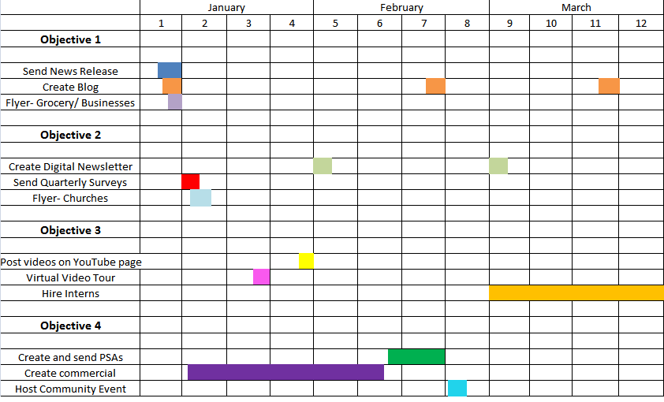
Calendar 2012

January 2, 2012 Create and send news releases to local papers about what Sunbeam is doing.

January 3, 2012 Create a blog that will be updated with Sunbeam’s accomplishments.

January 5, 2012 Create flyers to put up in local businesses, grocery stores , and churches where our target audience would shop.

January 6, 2012 Hang up flyers at local businesses and grocery stores.

January 8, 2012 Shoot a commercial about Sunbeam to play between the prime time hours our target audience watches television on a local stations.

January 10, 2012 Send out a surveys to people in the surrounding area and gauge their
knowledge on becoming a foster parent.

January 13, 2012 Hang up flyers at local churches in the surrounding area.

January 17, 2012 Create a virtual video of Sunbeams’ facilities.

January 30, 2012 We will create new videos and post them onto Sunbeam’s YouTube page such as various testimonials from foster parents, as well as children.

January 31, 2012 Post the virtual tour on Sunbeam’s YouTube page.

February 1, 2012 Make a digital newsletter to send out to those interested in more
information.

February 10, 2012 Record a PSA for Sunbeam Family Service about the importance of becoming
a foster parent.

February 15, 2012 Send PSA to local radio stations for broadcast.

February 15, 2012 Start broadcasting our commercial.

February 25, 2012 Host a block party event for the community to give more information
about becoming a foster parent.

March 1, 2012 Open up an internship opportunity for students.

Budget:
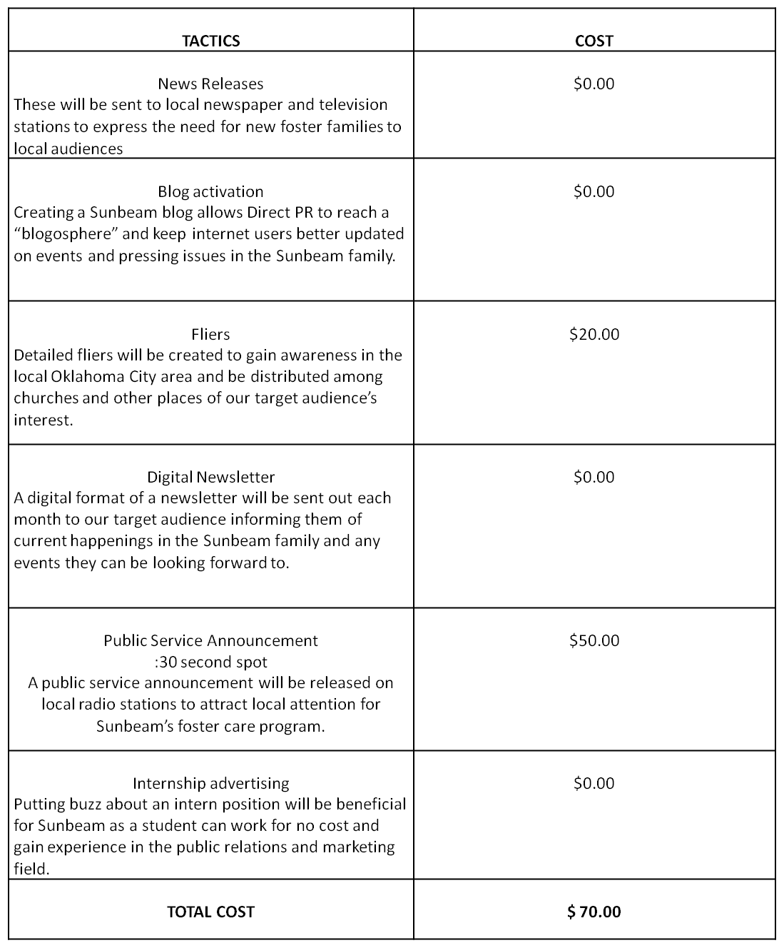
Evaluation:
- Direct PR will send out news letters once a month to inform the public about what Sunbeam Family Services has planned for each month, updates and good news to share. This monthly news letter will inform people about what is going on with Sunbeam and how they can get involved in the events Sunbeam Family Services has scheduled. The newsletters will be sent out in the Oklahoma City area. By dispersing the newsletters this will allow the surrounding neighborhoods to Sunbeam within the Oklahoma City area to be aware of new things going on with foster care, children being adopted, current and upcoming events, and anything Sunbeam feels the public needs to know.

- Sunbeam will send news releases to local newspapers in hope they will publish news stories about Sunbeam and events and epic moments that Sunbeam feels to be newsworthy. If published into the local newspapers, the news releases will maximize our target audience and will reach as many readers as possible. By reaching readers, this will allow Sunbeam an opportunity grasp readers’ interests in foster care, volunteer work and/or donations.

- Direct PR will continuously post new information on the blog for Sunbeam. Our team has also decided to link the Sunbeam blog to the Sunbeam and Direct PR Twitter and Facebooks pages with the intent to get more followers. By creating a blog and linking it to the Twitter and Facebook pages, Sunbeam Family services will be introduced to the social media world. This will allow Sunbeam to communicate with a different type of audience. There is a specific audience that is Internet and social media savvy. Newspapers aren’t always a person’s first choice for news. By using Twitter and Facebook we are ensuring that the portion of our audience who use these sites, are getting their news directly from us. This also might be considered a quicker way to receive updates from Sunbeam.

- Direct PR will put up fliers as often as possible about Sunbeam Family Services in local businesses and grocery stores. By doing this Direct PR will be able to increase awareness of Sunbeam Family Services about upcoming events. These fliers, we hope, will trigger interest in becoming foster parents.

Appendices:

PSA:
SUNBEAM FAMILY SERVICES
Radio Public Service Announcement (PSA)
:30 second

Sunbeam Family Services and Foster Care

30 SECOND SPOT
LIVE COPY (ANNOUNCER):

DO YOU ENJOY BEING AROUND CHILDREN? ARE YOU LOOKING FOR A WAY TO GET INVOLVED IN YOUR LOCAL COMMUNITY AS A PART OF YOUR NEW YEAR’S RESOLUTION? SUNBEAM FAMILY SERVICES HAS THE ANSWER FOR YOU! SUNBEAM FAMILY SERVICES IN OKLAHOMA CITY IS SEEKING FRIENDLY FACES TO AID IN THEIR FOSTER CARE PROGRAMS NOW.

CONTACT US TODAY TO CHANGE A CHILDS LIFE AND REGISTER FOR OUR EMERGENCY OR PERMANENT FOSTER CARE PROGRAMS. THESE CHILDREN NEED YOU.

TO LEARN MORE, CALL 405- 528- 7721 OR
VISIT US AT WWW.SUNBEAMFAMILYSERVICES.ORG

A PUBLIC SERVICE MESSAGE BROUGHT TO YOU BY DIRECT PUBLIC RELATIONS AND SUNBEAM FAMILY SERVICES

News Release:
Direct PR
222 Paul Miller Building
Stillwater, Ok.74075
555-555-5555

News Release
FOR IMMEDIATE RELEASE FOR MORE INFORMATION, CONTACT: Rylie Burns
Account Executive of Direct PR
2146633727
rylie@okstate.edu

Sunbeam Family Services tries to increase Number of foster Families
Stillwater, OK. — Direct PR has been working with Sunbeam Family Services with the intention of increasing the number of foster families Sunbeam is able to host. Direct PR has been doing surveys and interviews trying to raise awareness about becoming a foster parent for Sunbeam Family Services.
Sunbeam family Services has been in business since 1907. Since then they have been improving their services. Direct PR would like to help improve Sunbeam Family Services, by have an event on Dec. 21, 2011. This event will be held to get the community involved with what Sunbeam Family Services is doing. The event will be a dinner and an information session so the people can get to know more about Sunbeam Family Services, if they don’t already know.
Direct PR plans to send out a newsletter to inform the community about the event on Dec. 1, 2011. Direct PR is excited to see the turn out for the dinner and information session.

###

Social Media Samples:
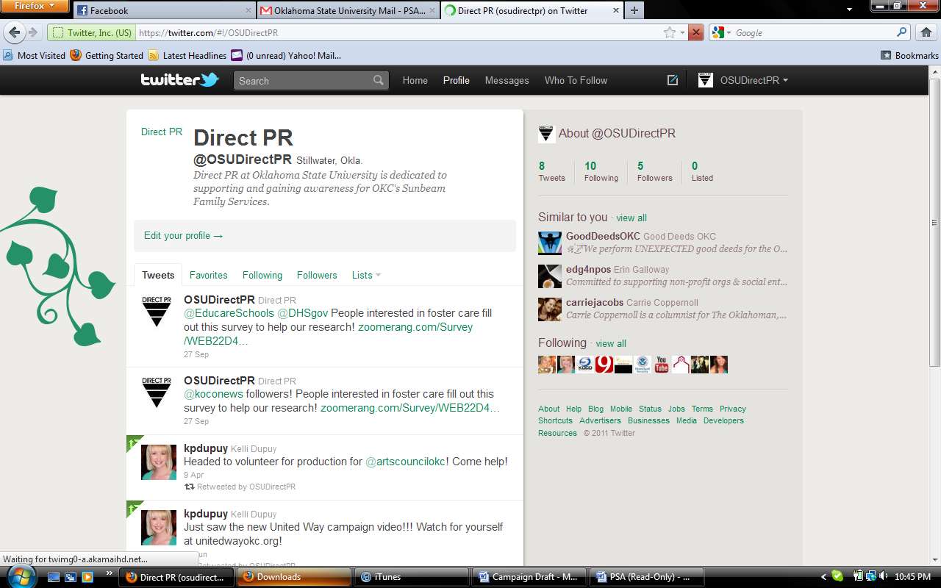

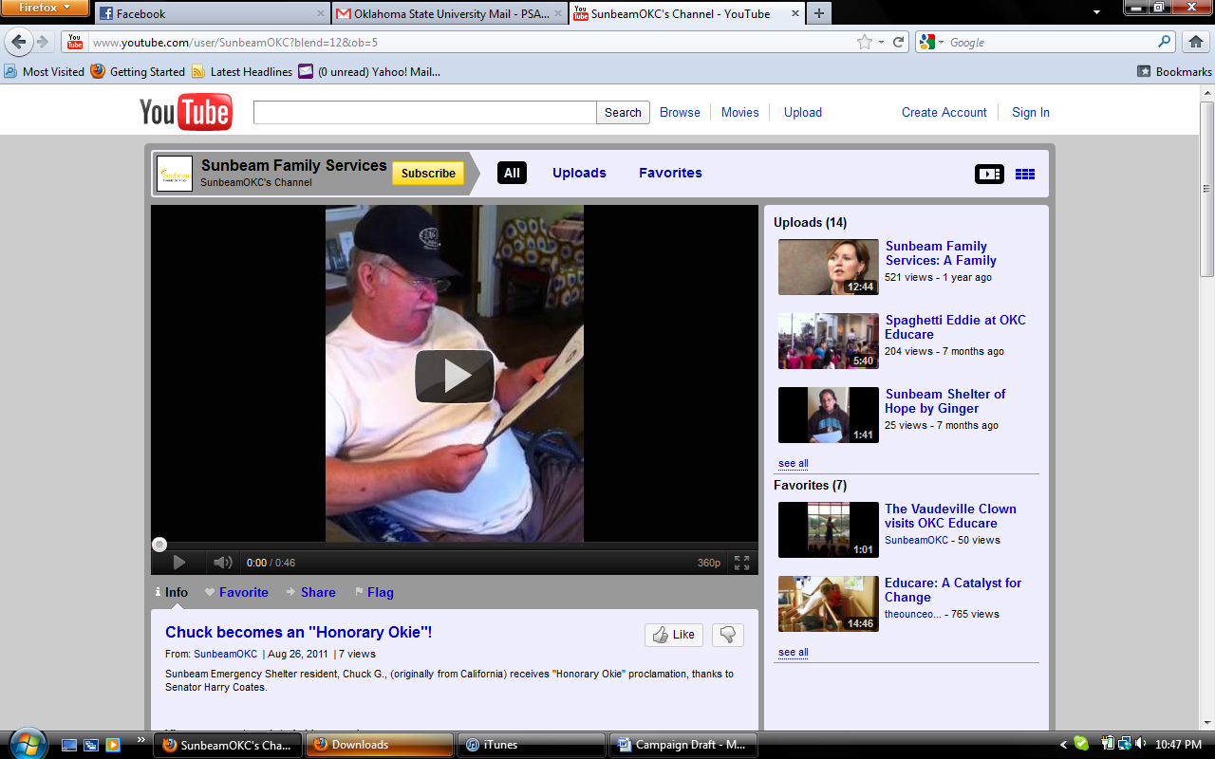

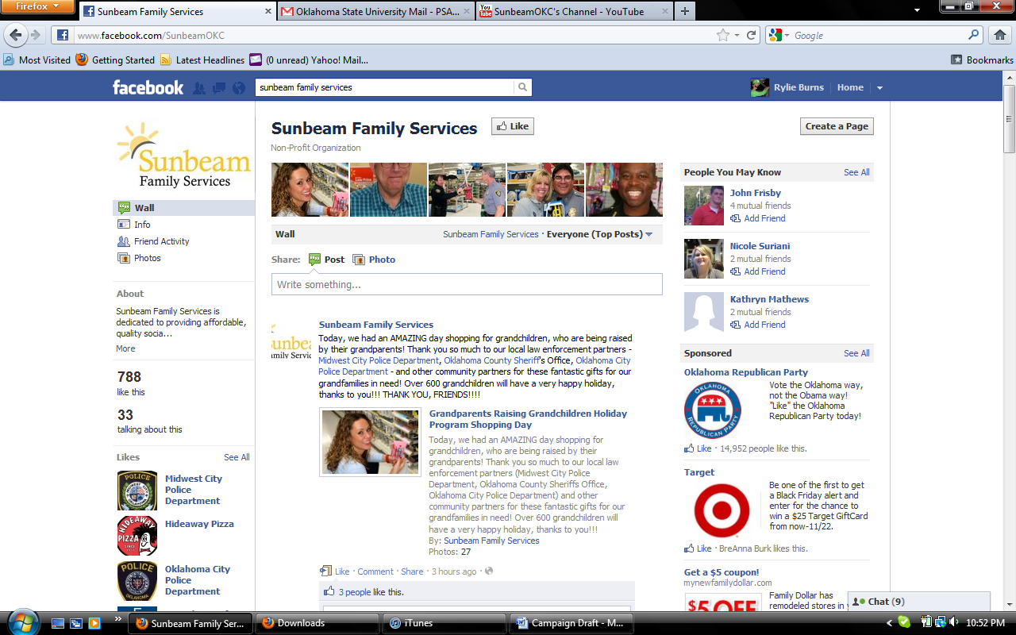

Sunbeam New Years Flier:
SEE ATTACHED FOR SAMPLE

Sunbeam Monthly Newsletter:
SEE ATTACHED FOR SAMPLE

References:

